Assignment 1 - Key
EC306 - Fall 2025
- Begin by creating the following dummy variables using the generate command:
- white: 1 if the respondent is white, 0 otherwise
- dropout: 1 if education = grade 12 but no diploma, 0 otherwise
- hsdip: 1 if education = high school diploma, 0 otherwise
- ba: 1 if education = bachelor’s degree, 0 otherwise
- married: 1 if the respondent is married, 0 otherwise
Create a table of averages, standard deviations, minimums, and maximums for the following variables:
- Labor force participation (lfp)
- Unemployment (unemployed)
- Age (age)
- Respondent is white (white)
- Education level Grade 12, no diploma (dropout)
- Education level High school diploma (hsdip)
- Education level Bachelor’s degree (ba)
- Respondent married (married)
Your table should follow this format:
Variable | Mean | Std. Dev. | Min | Max
Labor Force Participation (%)
Unemployment Rate (%)
Age
White (dummy)
Grade 12, no diploma (dummy)
High school diploma (dummy)
Bachelor’s degree (dummy)
Married (dummy)
Comment on the results.
Stata code:
gen white = race == 100
gen dropout = educ == 71
gen hsdip = educ == 73
gen ba = educ == 111
gen married = marst <=2
tabstat lfp unemployed age white dropout hsdip ba married, statistics(mean sd min max) columns(statistics)

Variable | Mean | Std. Dev. | Min | Max
Labor Force Participation (%) | 0.770 | 0.421 | 0 | 1
Unemployment Rate (%) | 0.050 | 0.217 | 0 | 1
Age | 40.1 | 8.545 | 25 | 54
White (dummy) | 0.779 | 0.415 | 0 | 1
Grade 12, no diploma (dummy) | 0.010 | 0.100 | 0 | 1
High school diploma (dummy) | 0.231 | 0.422 | 0 | 1
Bachelor’s degree (dummy) | 0.268 | 0.443 | 0 | 1
Married (dummy) | 0.575 | 0.494 | 0 | 1
In this dataset, about 77% of the population is participating in the labour force, and about 5% are unemployed (note: technically if you take the mean of the unemployed variable you get the unemployed as a fraction of the population rather than as a fraction of the labour force. If you did this rather than compute the actual unemployment rate, that is fine). The average person is about 40 years old, most of them white, about a quarter have a high school diploma only, a quarter have a bachelor’s degree, one percent finished grade 12 but did not graduate, and 58% are married.

- Focus on women with young children at home ($sage_kid=1$). Compare the means of labour force participation and unemployment during COVID-19 (March 2020 and later, $post=1$) to the means before COVID-19 (prior to March 2020, $post=0$). Describe the results. One of the effects of covid is that when the pandemic started many child cares were closed, which substantially reduced the number of children in child care. Is comparing the means of these labour market variables during covid versus before covid a good way to estimate the child care effect? Explain why or why not.
Stata code:
bysort post: sum lfp unemployed if sage_kid == 1

Variable | Post = 1 | Post = 0
lfp | .732 | .758
unemployed | .068 | .030

During the COVID years, the labour force participation is lower by 2.6 percentage points, and unemployment is 3.8 percentage points higher. This is likely not a great way to estimate the child care effect because there are other things happening between those two time periods that affect these outcomes. The biggest issue is that COVID itself closed down many businesses, so it is not surprising to see that people are dropping out of the labour force or becoming unemployed. This might not be related to child care at all. We need a way to control for this, which we do in the next question.
- Repeat the same exercise as (2), but for women without young children at home ($sage_kid=0$). What does this suggest about the ability to tell the effect of child care closures on mothers with young children by simply comparing means before and after covid?
Stata code:
bysort post: sum lfp unemployed if sage_kid == 0

Variable | Post = 1 | Post = 0
lfp | .785 | .798
unemployed | .072 | .027

As we can see, even among women with no young children at home – who presumably are not affected by child care closures – there is a drop in labour force participation by 1.3 percentage points and an increase in unemployment by 4.5 percentage points. This is our estimate of the time trend in these variables in the absence of any child care effect. If we subtract these differences from the ones in the previous question, we can estimate the effect of child care.
- Save the data to a file called temp.dta in the same directory as your dofile and original data file. Then use the collapse command to create a dataset with the average of labour force participation by year/month ($period$) and whether they have children at home. Plot the monthly labor force participation rate separately for women with young children and without. You can do this using the twoway line command, noting that to plot two graphs together with the same variable on the horizontal axis you could type twoway (line y x) (line z x). The difference-in-differences approach measures the effect of a policy by comparing the change from before to after the intervention in an outcome for a group affected by the policy to the corresponding before–after change for a group not affected. In this case, the intervention of interest is the closure of child care centers in March 2020 and beyond. A key assumption behind this method is that, before the policy change, the two groups follow parallel trends in the outcome variable. In other words, absent the policy, the two groups would have continued to evolve in the same way. Does the evidence suggest that this parallel trends assumption is satisfied here? Explain.
Stata code:
save temp.dta, replace
collapse (mean) lfp unemployed, by(period sage_kid)
twoway (line lfp period if sage_kid == 1) (line lfp period if sage_kid == 0), xline(26) title("Labour Force Participation over Time")
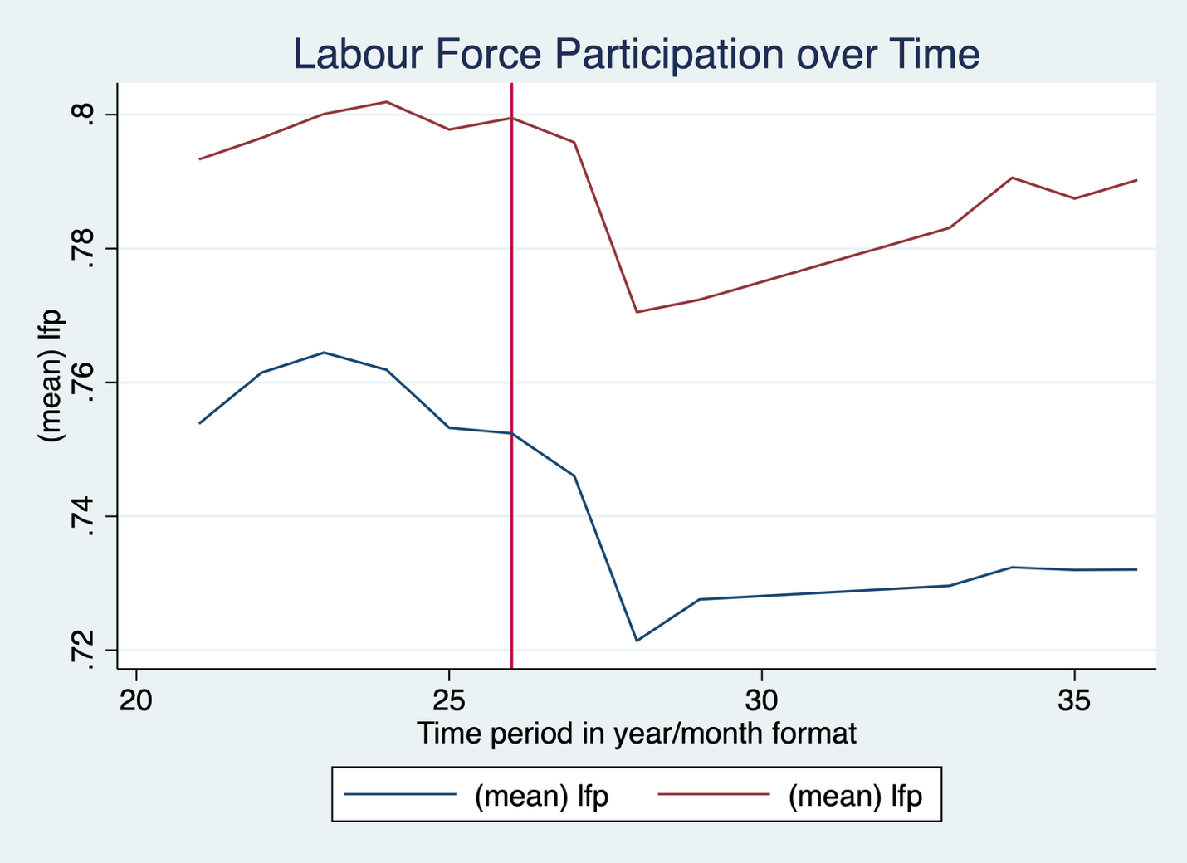
Prior to the policy change (the period after the red line in the graph), women with and without young children at home are trending in roughly the same way. There might be a slightly steeper trend down for women without children (blue) right before March 2020, but they are pretty close. If we were doing a more rigorous analysis, we could do some statistical tests to see if the trends are the same, but here we are just eyeballing. Based on that, the parallel trends assumption is met.

- Open temp.dta. Repeat the exercise in question (4), but create one graph for women who have a bachelors degree, and another for high school dropouts. Are there any notable differences in the trends for these two education groups? Explain.
Stata code:
use temp.dta, clear
keep if ba == 1
collapse (mean) lfp unemployed, by(period sage_kid)
twoway (line lfp period if sage_kid == 1) (line lfp period if sage_kid == 0), xline(26) title("Labour Force Participation over Time - Bachelors")

use temp.dta, clear
keep if dropout == 1
collapse (mean) lfp unemployed, by(period sage_kid)
twoway (line lfp period if sage_kid == 1) (line lfp period if sage_kid == 0), xline(26) title("Labour Force Participation over Time - Dropouts")
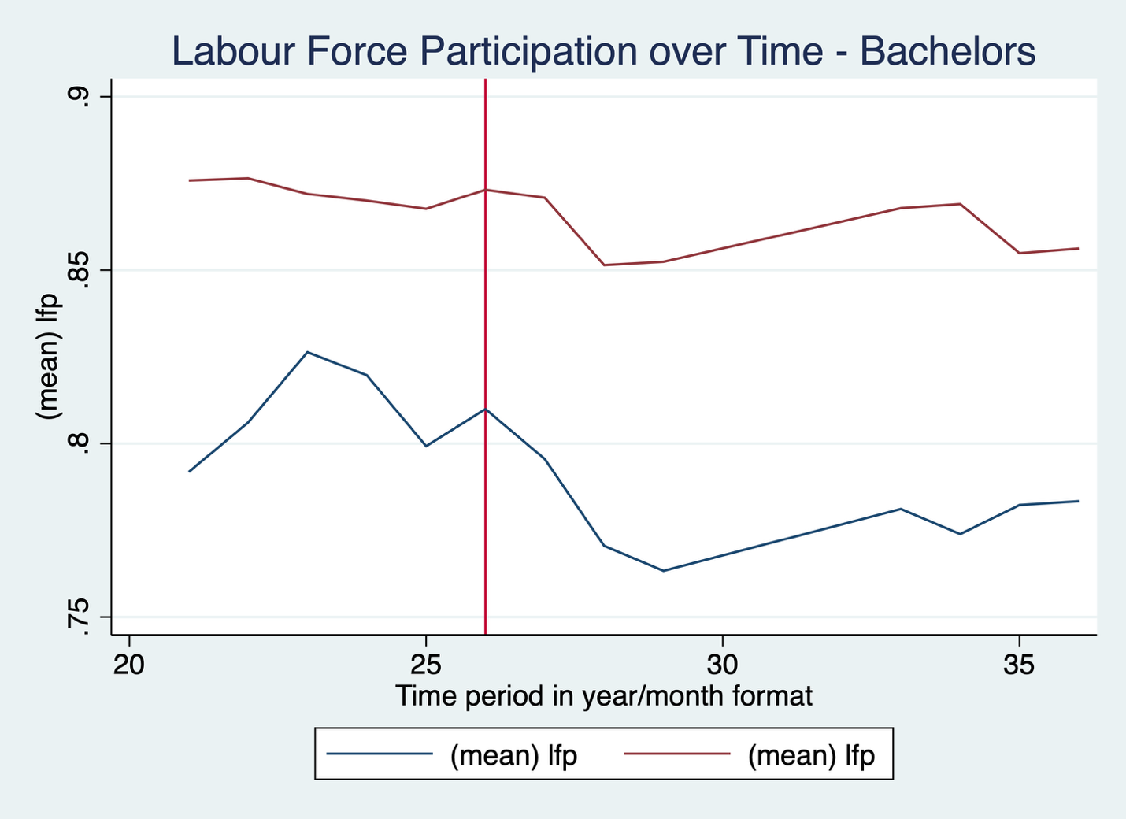
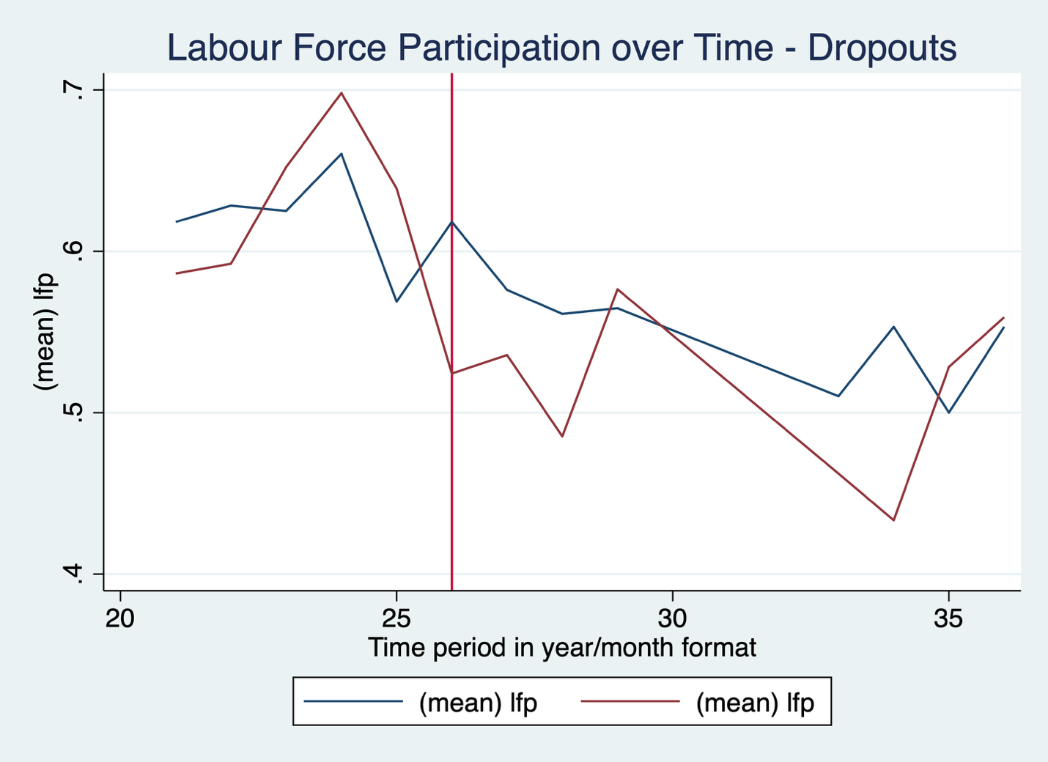

For women with bachelors degrees, the drop among women without young children (red) is smaller than the drop for women with children, which is expected because people with higher levels of education are generally affected less by economic downturns. However, the drop among women with children is larger, which implies a bigger effect of child care among this group.
For dropouts, there does not seem to be much difference between women with and without young children. There could be several reasons for this. First is that they are more likely to work in jobs deemed “essential” during COVID and as such they were less affected by shutdowns. There may also be less child care usage among this group.

- Open temp.dta once again. Estimate the regression:
$$lfp_{i}=α+β_{1}post_{i}+β_{2}sage_kid_{i}+β_{3}\left(post_{i}×sage_kid_{i}\right)+ϵ_{i}$$
Interpret the results of this regression. If you are unfamiliar with the interpretation of coefficients of a difference in differences regression model, you can read about it here: https://www.publichealth.columbia.edu/research/population-health-methods/difference-difference-estimation.
Stata code:
use temp.dta, clear
regress lfp i.post##i.sage_kid

Coefficient | Estimate | Standard Error | P-value
Post | -0.140 | 0.002 | 0.000
Sage_kid | -0.043 | 0.002 | 0.000
Post * Sage_kid | -0.126 | 0.003 | 0.000

In this regression, the difference in differences estimate is the coefficient on the interaction term, and represents the pre-post differences among women with children, minus the pre-post difference for women without young children.
The estimate is -0.013, which means child care lowered labour force participation by about 1.3 percentage points (if all assumptions of the model are met). Note also that the slope on the variable “post” tells us the time trend for women without children, which says that labour force participation was falling by roughly the same amount. The slope for “sage_kid” tells us the difference between women with and without children prior to COVID, which is -0.040, suggesting that women with children were less likely to participate.

- Repeat the regression from question (6), but add controls for age (age), education (educ), race (race), and marital status (married). Interpret the coefficient on the interaction term. How does it compare to the estimate from question (6)? Explain why they might be different. Note that some of these controls might be categorical variables.
Stata code:
regress lfp i.post##i.sage_kid age i.educ i.race i.married
Coefficient | Estimate | Standard Error | P-value
Post | -0.170 | 0.002 | 0.000
Sage_kid | -0.019 | 0.002 | 0.000
Post * Sage_kid | -0.105 | 0.003 | 0.001

The coefficient on the interaction term is now -0.011. It is very close, suggesting that there is no significant omitted variables bias that affects the estimate.
- Suppose we view the child care closures as an increase in the cost of child care. Use the income-leisure framework to illustrate how an increase in the cost of child care could drive some women out of the labour force.
In the graph below, the person is initially optimizing at utility curve U0 with positive work hours (T-L0). In this situation the cost of child care is zero, but it doesn’t have to be. Once the child care costs increase because of COVID, the budget constraint shifts down to the red line and the associated red dot. The discontinuity arises because there are no costs if children stay at home and work hours are zero. If the costs rise by enough, the person optimizes where the utility curve U1 sits at the red dot, which involves zero work hours.

