Recursive functions

A function may call other functions, including calling itself. A function that calls itself is known as a ***recursive function***.

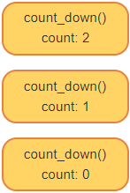

def count_down(count):

if count == 0:

print('Go!')

else:

print(count)

count_down(count-1)

count_down(2)



1. Each call to count_down creates a new namespace for the local scope of the function.
2. The script makes the first call to count_down(), creating a namespace with the count argument bound to the integer value 2.
3. That first function call prints 2, and calls count_down() with an argument of 1.
4. A new namespace is created again for the local variables in count_down()'s local scope with the count argument bound to the integer value 1.
5. That second function call prints 1, and calls count_down() with an argument of 0.
6. That third function call prints GO!, and then because count == 0 is true, returns.
7. The second function call is then done (no call) so it returns.
8. The first function call is then done (again, no call) so it returns.
9. Finally, the script finishes.
10. Function calls = 3, or n+1
11. For instance, count_down(0) would have 1 function call: (GO!)

# Recursive algorithm: Search