Replication of the nAMD BCVA Absolute-Change Network Meta-analysis
Methods and Results Summary
Prepared May 5, 2026

Source Study
This document replicates the neovascular age-related macular degeneration (nAMD) best-corrected visual acuity (BCVA) absolute-change network meta-analysis reported by Friedman et al. The source article is: Friedman SM, Xu Y, Sherman S, Kuznik A, Mojebi A, Keeping S, Chan K, Leng T, Patel N. Aflibercept 8 mg versus Faricimab Treat-and-Extend for Diabetic Macular Edema or Neovascular Age-Related Macular Degeneration: A Bayesian Fixed-Effect Network Meta-analysis of Clinical Trials. Ophthalmology and Therapy. 2025;14:2919-2936. doi:10.1007/s40123-025-01247-3. PMCID: PMC12534626.
Article link: https://pmc.ncbi.nlm.nih.gov/articles/PMC12534626/.

Summary
Objective: To replicate the published Bayesian fixed-effect network meta-analysis (NMA) estimate for absolute change from baseline in best-corrected visual acuity (BCVA) in neovascular age-related macular degeneration (nAMD), comparing aflibercept 8 mg with faricimab treat-and-extend (T&E).
Methods: A three-treatment evidence network was reconstructed using PULSAR, TENAYA, and LUCERNE. BCVA outcomes were analyzed as approximately 2-year efficacy outcomes. Follow-up timing differed across trials: PULSAR contributed week 96 data, whereas TENAYA and LUCERNE contributed values averaged over weeks 104, 108, and 112. In the published study, injection counts were standardized to 104 weeks, but BCVA was not statistically adjusted to a common time point.
Results: The replicated estimate for aflibercept 8 mg versus faricimab T&E was -1.18 ETDRS letters (95% credible interval [CrI], -3.48 to 1.11). The corresponding published estimate was -1.14 ETDRS letters (95% CrI, -3.53 to 1.25). The replication was highly concordant with the published result and did not indicate a statistically credible difference between treatments.

Methods

Clinical Endpoint and Population
The replicated endpoint was absolute change from baseline in BCVA, expressed in Early Treatment Diabetic Retinopathy Study (ETDRS) letters, at approximately 2 years of follow-up. This endpoint was selected because BCVA change is a patient-relevant measure of visual function and was one of the principal efficacy outcomes in the published nAMD NMA.
The population was restricted to nAMD. Disease-specific replication was used because nAMD and diabetic macular edema differ in disease biology, baseline prognosis, treatment history, and trial design. Combining the two conditions would require an additional assumption that relative treatment effects are exchangeable across diseases, which was not needed for the published nAMD analysis.

Evidence Network
The network included three randomized trials and three treatment nodes. PULSAR connected aflibercept 8 mg to aflibercept 2 mg. TENAYA and LUCERNE connected faricimab T&E to aflibercept 2 mg. Aflibercept 2 mg served as the common comparator linking the two active treatment strategies of interest.
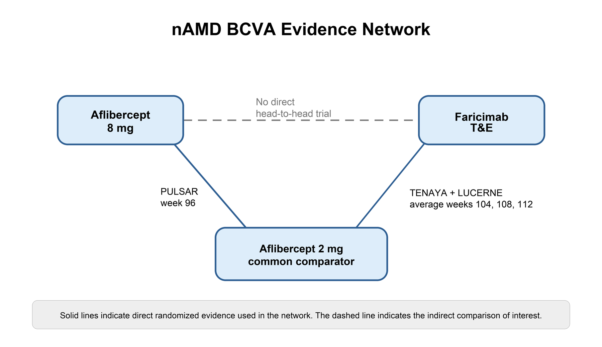
Figure 1. Evidence network for the nAMD BCVA comparison.
Study | Comparison informing the network | Follow-up window used for BCVA
PULSAR | Aflibercept 8 mg vs aflibercept 2 mg | Week 96
TENAYA | Faricimab T&E vs aflibercept 2 mg | Average over weeks 104, 108, and 112
LUCERNE | Faricimab T&E vs aflibercept 2 mg | Average over weeks 104, 108, and 112
No closed loop was present in the network. As a result, direct and indirect evidence could not be compared within a loop, and formal local inconsistency testing was not applicable. This is a structural limitation of the evidence network.

Follow-up Timing
Follow-up timing differed across the trials contributing to the nAMD BCVA network. PULSAR evaluated BCVA at week 96, whereas TENAYA and LUCERNE reported BCVA averaged over weeks 104, 108, and 112. The published analysis addressed differences in observation period for injection counts by standardizing injection numbers to 104 weeks. However, for efficacy outcomes such as BCVA, the available values were analyzed as approximately 2-year outcomes rather than being statistically adjusted to a shared 104-week time point.
This decision is clinically pragmatic because all three measurements occur near 2 years, but it introduces a transitivity consideration: the indirect comparison assumes that the relative treatment effects for BCVA would not materially change between week 96 and weeks 104 to 112. This should be interpreted as a limitation when evaluating the certainty of the indirect comparison.

Effect Measure and Data Format
Mean difference was used as the effect measure because BCVA change is a continuous outcome measured on the same ETDRS-letter scale across trials. On this scale, negative values for aflibercept 8 mg versus faricimab T&E indicate fewer letters gained with aflibercept 8 mg, whereas positive values indicate more letters gained with aflibercept 8 mg.
Contrast-level data were used because the trial outputs were available as adjusted relative treatment effects and uncertainty intervals. This preserves the randomized comparison within each trial and uses the treatment effect scale required for the NMA.
Study | Contrast entered | Mean difference (ETDRS letters) | Standard error
PULSAR | Aflibercept 8 mg vs aflibercept 2 mg | -1.050223 | 0.896151
TENAYA | Faricimab T&E vs aflibercept 2 mg | 0.400000 | 1.199002
LUCERNE | Faricimab T&E vs aflibercept 2 mg | -0.200000 | 1.147980
Standard errors were derived from reported 95% confidence intervals where needed, using the normal approximation SE = (upper confidence limit - lower confidence limit) / (2 x 1.959964). This approach is commonly used when publications report an estimate and confidence interval but do not report the standard error directly.

Bayesian Fixed-Effect NMA Model
A Bayesian NMA estimates a posterior distribution for each relative treatment effect by combining the observed trial evidence with prior distributions. The 95% credible interval is interpreted as the range that contains 95% of the posterior probability for the treatment effect, conditional on the model and data.
A fixed-effect model assumes that, for a given treatment comparison, all trials estimate one common underlying relative treatment effect. Differences among trial estimates are attributed to within-study sampling error rather than between-study heterogeneity. This assumption is stronger than a random-effects model, but it is often preferred when the network is very sparse.
A random-effects model allows the true relative effect to vary across studies and estimates a between-study heterogeneity parameter. In this network, only three trials were available and each active comparison was informed by either one or two studies. Under these conditions, between-study heterogeneity is poorly identified, and random-effects estimates can become unstable. Therefore, a fixed-effect model is a defensible primary model and is consistent with the published analysis rationale.
A consistency model was used because the network assumes that treatment effects are coherent through the common comparator. For example, the relative effect of aflibercept 8 mg versus faricimab T&E is inferred from the aflibercept 8 mg versus aflibercept 2 mg evidence and the faricimab T&E versus aflibercept 2 mg evidence.

Prior Distributions and Sampling
Vague normal priors were used for study intercepts and treatment effects, each specified as N(0, 100^2). These priors are intentionally broad on the ETDRS-letter scale so that the posterior estimates are driven primarily by the trial data rather than by strong prior assumptions.
The identity link was used because the outcome is continuous and modeled directly on the mean-difference scale. No transformation, such as a log or logit link, is required for an outcome measured in letters.
The model was estimated using Markov chain Monte Carlo sampling. Four chains were run with 1200 iterations per chain and 600 warmup iterations per chain, yielding 2400 post-warmup posterior draws. Multiple chains are used to evaluate whether independent simulations converge to the same posterior distribution. Warmup iterations allow the sampler to tune its algorithm before retaining posterior samples.
Model convergence was evaluated using the potential scale reduction statistic (Rhat). Values close to 1 indicate that between-chain and within-chain variability are similar, supporting convergence. The maximum Rhat in the replicated nAMD model was 1.0075, which is consistent with adequate convergence for this analysis.

Methodological Alignment With the Source Study
The source publication and its supplementary methods were re-reviewed before finalizing this replication. The replication follows the source study in restricting the nAMD BCVA network to PULSAR, TENAYA, and LUCERNE; using aflibercept 2 mg as the common comparator; estimating mean differences for absolute BCVA change; applying a Bayesian fixed-effect consistency model; and treating the absence of closed loops as a reason that formal local inconsistency testing was not applicable.
The fixed-effect model was selected for the same substantive reason reported by the source study: the nAMD network is sparse, with one aflibercept 8 mg trial and two faricimab T&E trials informing the two direct comparisons. With so few studies per comparison, the between-study heterogeneity parameter in a random-effects model is poorly identified and may widen credible intervals without improving model fit. Under these conditions, a fixed-effect model is a defensible primary analysis, provided the transitivity assumption is stated transparently.
The principal practical difference is computational rather than conceptual. The source study implemented the Bayesian models using JAGS with two chains after a large burn-in, whereas this replication used multinma through Stan with four chains, 1200 iterations per chain, 600 warmup iterations per chain, adapt_delta 0.99, and seed 20260414. The inference was highly concordant despite the different Bayesian sampling engine.
A second limitation is data availability. The source study used clinical study report data for 96-week PULSAR, whereas this replication used publicly available 96-week PULSAR information and the published 2-year TENAYA and LUCERNE data. Standard errors were calculated from reported confidence intervals where not directly provided. No additional treatment effects were imputed by the analysis workflow.

Results

Network and Model Fit
Metric | Value | Interpretation
Number of studies | 3 | Sparse evidence base; each active comparison was informed by one or two trials.
Number of treatment nodes | 3 | Aflibercept 8 mg, faricimab T&E, and aflibercept 2 mg.
Closed loops | No | Formal inconsistency testing was not possible.
BCVA follow-up alignment | Not time-adjusted | All BCVA values were treated as approximately 2-year outcomes.
DIC | 4.1372 | Model-fit statistic used primarily for comparing alternative Bayesian models.
Total residual deviance | 2.1349 | Close to the number of data points, suggesting no obvious lack of fit.
Maximum Rhat | 1.0075 | Consistent with adequate MCMC convergence.

Primary Treatment Effect
The replicated NMA estimated that aflibercept 8 mg was associated with 1.18 fewer ETDRS letters gained than faricimab T&E, with a 95% CrI from 3.48 fewer letters to 1.11 more letters. Because the credible interval crossed 0, the analysis did not provide evidence of a statistically credible difference between treatments for BCVA change.
Comparison | Replicated estimate, MD [95% CrI] | Published estimate, MD [95% CrI] | Conclusion
Aflibercept 8 mg vs faricimab T&E | -1.18 [-3.48, 1.11] | -1.14 [-3.53, 1.25] | Highly concordant; no credible difference.

Interpretation
The replicated nAMD result was highly consistent with the published NMA. The point estimate differed by 0.04 ETDRS letters, and the credible intervals were nearly identical. This degree of agreement supports the conclusion that the available randomized evidence does not demonstrate a meaningful BCVA difference between aflibercept 8 mg and faricimab T&E at approximately 2 years.
The uncertainty interval was wide relative to the point estimate, reflecting the sparse network and reliance on indirect comparison through aflibercept 2 mg. Therefore, the result should be interpreted as evidence of no clearly demonstrated difference, not as proof of equivalent efficacy.
The most important methodological limitations are the absence of closed loops and the non-identical BCVA follow-up windows. Without a closed loop, the internal consistency of direct and indirect evidence cannot be empirically assessed. Because BCVA was not adjusted to a common time point, the analysis also assumes that the relative effects observed at week 96 and at weeks 104 to 112 are sufficiently comparable for an approximately 2-year indirect comparison.
The validity of the indirect comparison therefore depends on the transitivity assumption: that the included trials are sufficiently similar with respect to factors that could modify relative treatment effects, such as baseline visual acuity, disease activity, prior anti-VEGF exposure, follow-up timing, and retreatment criteria.

Conclusion
The nAMD BCVA absolute-change NMA was replicated using a Bayesian fixed-effect consistency model. The replicated estimate for aflibercept 8 mg versus faricimab T&E was -1.18 ETDRS letters (95% CrI, -3.48 to 1.11), closely matching the published estimate of -1.14 ETDRS letters (95% CrI, -3.53 to 1.25). The analysis supports the same inference as the original study: no statistically credible difference in BCVA absolute change was detected between the two treatments at approximately 2 years.
Follow-up timing should be considered when interpreting this finding. Injection counts were standardized in the published analysis, but BCVA outcomes were analyzed as approximately 2-year measurements without statistical time adjustment. This does not invalidate the result, but it should be reported transparently as a limitation of the evidence network.

Visual Verification of Generated Analysis Output
The completed analysis was visually checked in the analysis interface on localhost after reloading the nAMD project. The output displayed a completed Bayesian run generated on May 5, 2026 at 7:50:57 AM, with 3 treatments and 3 studies. The visible diagnostics identified the engine as multinma / Stan, reported 2400 posterior draws, maximum Rhat of 1.008, DIC of 4.137, and total residual deviance of 2.135. The execution notes stated that contrast-based studies were passed to multinma as supplied relative effects with normal likelihoods and the consistency-model parameterization. This confirms that the displayed result was generated by the R-backed Bayesian analysis path rather than entered or imputed as a final answer.
Figure 2. Visual proof of the completed nAMD analysis output and R/multinma diagnostics.

Figure 2a. Completed nAMD result screen showing the generated analysis timestamp, rankings, pairwise estimates, and evidence coverage.

Figure 2b. Bayesian diagnostics and execution notes showing multinma / Stan execution and supplied contrast-level inputs.

