**MFE 405 HW 4**

**Yong Jia (Justin) Tan**

***1. Convergence of Different Binomial Methods***

The convergence of each of the 4 different binomial methods are showcased in the plot below:

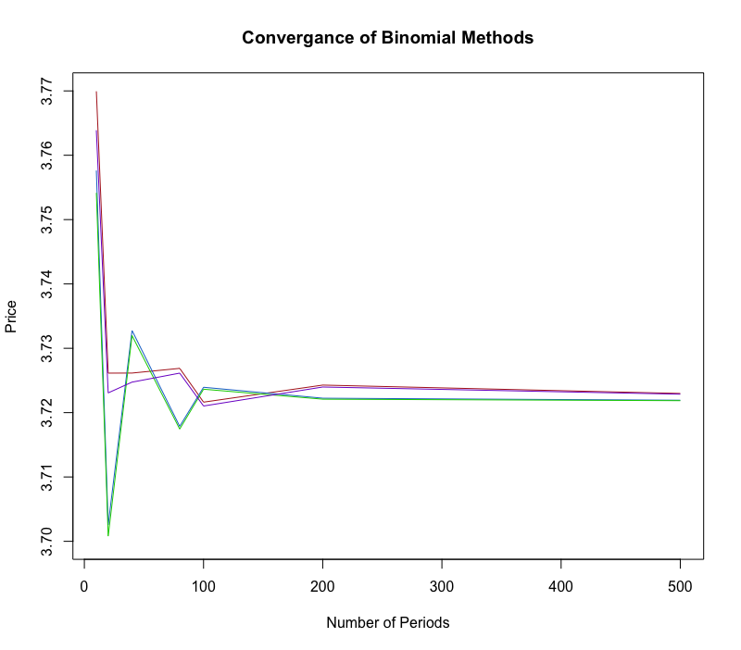

In this plot, the red line is method (a), the blue line is method (b), the green line is the Jarrow-Rudd (JW) model, and the purple line is the Cox-Ross-Rubinstein (CRR) model. We can clearly see that both the JW and the CRR models converge very quickly, but all 4 methods converge well and quite quickly to the “true” value.

***2. Binomial Pricing of GOOG Call Option***

The closing price for GOOG on Feb.6, 2019 is $1,115.23. Using the historical prices of GOOG from the past 60 months and find the volatility of returns, we find the volatility to be around 23.47%. Using this price, this volatility, and assuming an annual risk-free rate of 2%, we calculate the price of a call option on GOOG with a strike price of $1,220 to be **$67.39**. This value is actually very close to the actual last price of the corresponding option on the market, which was noted as **$68.50**. The small difference in value could be due to not using a more precise risk-free rate or estimating a slightly different volatility than the market. To have the same call price, the volatility should instead be around **23.75%**.

***3. Binomial Estimation of Greeks***

Using the CRR Binomial model, we estimate all the Greeks of the indicated stock, as well as how Delta varies with time T. The plots are as below:

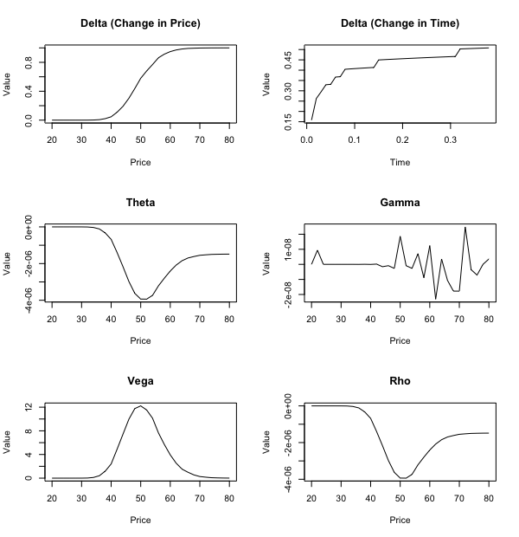

***4. Binomial Method to Price European and American Put Options***

The difference between pricing European and American put options is that while for European put options, I only need to continuously find the continuing values (as early exercise is not possible), for pricing American put options I would need to compare the continuing values with the exercise values in each period and choose the higher value.

The computational results are showcased in the plot below:

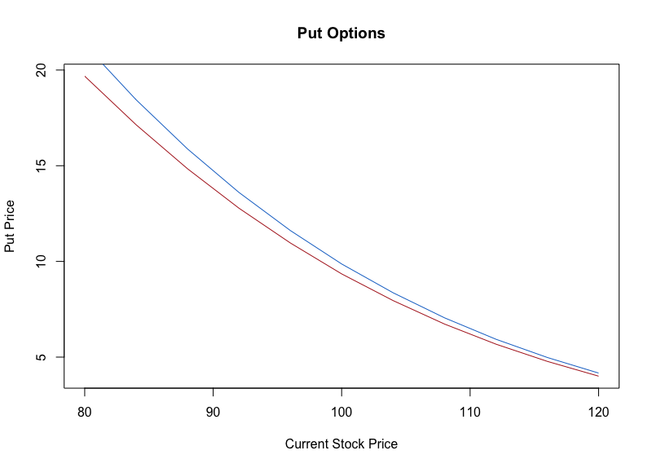

As we can see, the American put option is consistently priced higher than the European put option, which intuitively makes sense as well.

***5. Trinomial Method to Price European Call***

The Trinomial method is similar to the Binomial methods. However, instead of having *n* ending values for *n* periods, the Trinomial tree has *n* x 2 + 1 amount of values. First, we try the Trinomial method with the usual stock price process, and then we try the Trinomial method assuming a log stock price process.

The computed prices, corresponding with the number of periods in the Trinomial tree, is shown in the plot below:

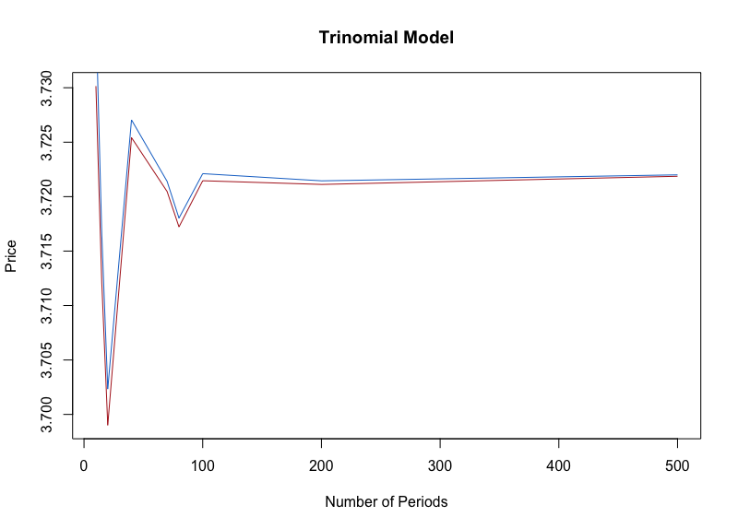

We see that both methods converge very well and very quickly.

***6. Using Halton Sequence Generated Random Normal Variables to Simulate European Call Prices***

In this case, instead of using uniformly distributed random numbers in the Box-Muller method to generate normal numbers, we use numbers from two Halton sequences. To test this method, I set the initial stock price as $50, the strike price as $55, time to expiration as 2 years, risk free rate of 2%, and volatility of 20%. I use base 2 and base 7 Halton sequences in my simulations, and after 1,000 simulations, I compute a call price of **$4.46**.