**Exercise 1: Telephone Number Generator**

//*********************************************************************************//

//Name: Justin Tran

//

//Class: CSCI 1106

//

//Program: The program convert list of phone numbers to letters that are assigned

// to digit(s) through text file processing. Then making a new text file for all

//the letter converted to numbers.

//********************************************************************************//

#include <iostream>

#include <fstream>

#include <iomanip>

using namespace std;

int main() {

ifstream infile;

ofstream outfile;

int digit;

char letters;

//checking if file is open correctly

infile.open("oldPhone.txt");

if (!infile) {

cout << "File cannot be open..." << endl;

exit(1106);

}

//checking if file is open correctly

outfile.open("newPhone.txt");

if (!outfile) {

cout << "File cannot be open..." << endl;

exit(1106);

}

infile >> letters;

while (infile) {

for (int i = 0; i < 7; i++) {

if (letters > 'Z')

letters = static_cast<char>(letters - 32); //converting all lowercase that is read in the textfile to uppercase

if (letters > 'W') //making a shift of the value to digit 9 instead of 10

letters = 'W';

if (letters > 'P')

letters--; //making a shift of value greater than P by 1 digit

digit = static_cast<int>((letters - 'A') / 3 + 2); //mathmatical comparison equation to assign letters to their proper digit

outfile << digit;

infile >> letters;

}

outfile << endl;

}

infile.close();

outfile.close();

system("pause");

}

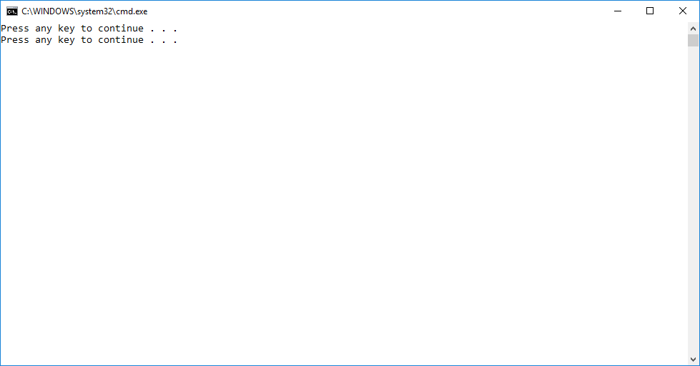 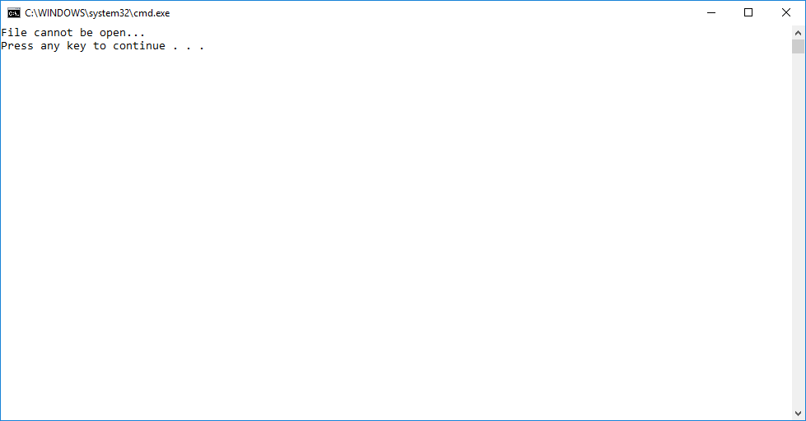

(Changing text file to get a “File cannot be open”)

