**CSCI 1106 Programming Assignment #2**

For this assignment you are to write a program to simulate playing the lottery game PowerBall. The rules for PowerBall can be found by clicking on this link: <http://www.mnlottery.com/games/lotto_games/powerball/> or by clicking on this link: <http://www.powerball.com/powerball/pb_howtoplay.asp>

## Prizes and Odds of Winning

|  |  |  |
| --- | --- | --- |
| **Match** | **Win** | **Approx. Odds** |
| 5 of 5 + Powerball | JACKPOT* | 1 in 292,201,338 |
| 5 of 5 numbers | $1,000,000 | 1 in 11,688,054 |
| 4 of 5 + Powerball | $50,000 | 1 in 913,129 |
| 4 of 5 numbers | $100 | 1 in 36,525 |
| 3 of 5 + Powerball | $100 | 1 in 14,494 |
| 3 of 5 numbers | $7 | 1 in 580 |
| 2 of 5 + Powerball | $7 | 1 in 701 |
| 1 of 5 + Powerball | $4 | 1 in 92 |
| Powerball ONLY | $4 | 1 in 38 |

**What you must do:**

1. You are to ask the user to input their numbers for the PowerBall drawings. Your program needs to perform input validation for each number entered by guaranteeing the number has not already been chosen and that it is a valid number for the lottery game PowerBall. The **first five numbers** must be between **1 and 69 inclusive** and the **powerball must be between 1 and 26 inclusive**. The first five numbers are the white balls and the powerball is the red ball.
2. Your program will simulate the PowerBall drawing by using a random number generator to randomly select the 5 white balls and the one red ball for the lottery game. The program must guarantee each number generated for any of the five white balls has not already been selected. If the number has already been selected your program should generate a new number. **You do not need to do this with the PowerBall number since only one number is selected.**
3. NOTE: The PowerBall selection can be one of the numbers selected for the five white balls. For example: Suppose the user enters 1 2 3 4 5 for the first five numbers (the white balls), the user can also select as their PowerBall number 5 or 4 or 3 or 2 or 1. Uniqueness of the numbers only pertains to the white balls that are randomly generated and those values that are input from the user.
4. Determine the amount of money the user has won based upon the rules shown above.
5. Demonstrate your program works by including test data where the user has won each prize.
6. **Do not implement the power play option for the game.**

**Functions must be used to solve this problem. The number of functions should be significant since you have multiple tasks to perform. I.e. A program solution with only two functions would not be acceptable. Main will not be considered as one of the functions of the programming solution. You will be graded on program optimization, i.e. redundant code based upon testing scenarios will be penalized. Using a brute-force approach to determine if the user is a winner will also be penalized. i.e. too many if or case statements where you can develop mathematical relationships to determine the amount won.**

**What to turn in:**

1. Copy and paste your source code into a word document.
2. Paste screen shots of the execution of your program in the word document under your source code.
3. Compress the word file and the .cpp file using your name and the progasg2. I.e. timwrennprogasg2.zip.
4. Place the compressed file into the drop box folder called Programming Assignment Two.

**Optional:**

The **term** ***expected value*** is used in statistics to specify what values you should expect from the event taking place or the experiment. For example, if I play a game and the average winnings are $3, then I would expect over a period of time my average winnings would be $3.

Calculate the expected value of playing PowerBall with a $3000 investment. Your program should determine if it would have been better to invest the $3000 into an account with a 2% return of your money after 30 days (simple interest calculation).

#include<iostream>

#include<ctime>

#include<iomanip>

#include<string>

using namespace std;

const int WHITEBALLS_MAX = 69; //max number for white balls

const int POWERBALL_MAX = 26; //max number for powerball

const int WHITEBALL_ARRAY = 5; //size of array for white balls

const int POWERBALL_ARRAY = 1; //size of the array for power ball

const int WHITE_MATCH_SIZE = 6; // size of matching white balls

const int POWER_MATCH_SIZE = 2; //size of matching power ball

const int winning[POWER_MATCH_SIZE][WHITE_MATCH_SIZE] = { {0,0,0,7,100,100000 } ,{4, 4, 7, 100, 50000, 1000000000} }; //finding the winning in array

void displayArt();

void userInput(int user[], int WHITEBALL_ARRAY, string first, string last);

void userPowerBall(int userPower[], int size2);

void displayUserBall(int user[], int userPower[], int size);

void whiteBallRandom(int white[], int size);

void powerBallRandom(int actualPB[], int size2);

void displayWhiteBall(int white[], int actualPB[], int size);

int matchingWBalls(int user[], int white[], int size, int &matchWhiteCount);

int matchingPBalls(int userPower[], int actualPB[], int size2, int &matchPBallCount);

void displayWin(int &matchWhiteCount, int &matchPBallCount);

int main() {

int yourTicket[WHITEBALL_ARRAY],

whiteBall[WHITEBALL_ARRAY],

userPB[POWERBALL_ARRAY],

powerBall[POWERBALL_ARRAY],

matchWhite = 0,

matchPower = 0;

string firstName, lastName;

displayArt(); //display my beautiful logo banner

userInput(yourTicket, WHITEBALL_ARRAY, firstName, lastName); //calling for user's input and infomation.

userPowerBall(userPB, POWERBALL_ARRAY); // user enter their powerball number

displayUserBall(yourTicket, userPB, WHITEBALL_ARRAY);// display white ball from the user input

whiteBallRandom(whiteBall, WHITEBALL_ARRAY); //generate random white ball number for lottery

powerBallRandom(powerBall, POWERBALL_ARRAY); //generate a random powerball number for loto

displayWhiteBall(whiteBall, powerBall, WHITEBALL_ARRAY); //display white ball AND also powerball

matchingWBalls(yourTicket, whiteBall, WHITEBALL_ARRAY, matchWhite); //matching the white balls

matchingPBalls(userPB, powerBall, POWERBALL_ARRAY, matchPower); //matching the power ball

displayWin(matchWhite, matchPower);

return 0;

}

//==========================================================================

// Banner

//==========================================================================

void displayArt() {

cout << "===================================================================================" << endl;

cout << " WELCOME TO THE LOTTERY GAME: POWERBALL! " << endl;;

cout << "===================================================================================" << endl;

}

//==========================================================================

//Name: userInput

//

//Pre: an array for the user's input, size of the array, string for user's names

//

//Post: The function as for the user's first name and last, name then an array is

//set up to ask for user's input then the if statment verifies the user's number

//after that the function lists the user's number.

//==========================================================================

void userInput(int user[], int WHITEBALL_ARRAY, string first, string last) {

int num;

bool checkDup[70] = { 0 }; // to check for duplicates

cout << "Please enter your FIRST and LAST name..." << endl;

cin >> first >> last;

for (int i = 0; i < WHITEBALL_ARRAY; i++)

{

cout << "Enter your number... " << endl;

cin >> num;

if ((num >= 1) && (num <= 69))

{

if (checkDup[num] == false)

{

user[i] = num;

checkDup[num] = true; //flagged true

}

else

{

cout << "Number has already been used..." << endl;

i--;

}

}

else

{

cout << "Numbers from 0-9 only..." << endl;

i--;

}

}

}

//==========================================================================

//Name: userPowerBall

//

//Pre: getting the array with size one to let user put in

//a number in the array

//

//Post: user put a number in the array for their powerball.

//==========================================================================

void userPowerBall(int userPower[], int size2) {

int num, i=0;

for (int i = 0; i < POWERBALL_ARRAY; i++) {

cout << "Now enter your Powerball number..." << endl;

cin >> num;

if ((num >= 1) && (num <= 26)) {

userPower[i] = num;

}

else {

i--;

cout << "Number is out of range..." << endl;

}

}

}

//==========================================================================

//Name: displayWhiteBall

//

//Pre: none

//

//Post: Display the numbers of the user's inputs

//==========================================================================

void displayUserBall(int user[], int userPower[], int size) {

cout << "Your Numbers are..." << endl;

for (int i = 0; i < WHITEBALL_ARRAY; i++) {

cout << user[i] << " ";

}

cout << endl;

cout << "Your Powerball number is..." << endl;

cout << userPower[0];

}

//==========================================================================

//Name: whiteBallRandom

//

//Pre: random number generator, array that contains size 5, and a do while

//loop to check for dupicate genrated numbers.

//

//Post: this function generates white balls without any duplicate numbers

//through a loop.

//==========================================================================

void whiteBallRandom(int white[], int size){

srand(time(NULL));

for (int i = 0; i < WHITEBALL_ARRAY; i++)

{

bool check;

int num;

do

{

num = 1 + rand() % WHITEBALLS_MAX;

//check or number is already used:

check = true;

for (int j = 0; j < i; j++)

if (num == white[j]) //if number is already used

{

check = false; //set check to false

}

} while (!check); //loop until there is a unique number

white[i] = num; //store the generated number in the array

}

}//==========================================================================

//Name: powerBallRandom

//

//Pre: random number gen. with array for pb

//

//Post: Putting unqiue random number into the pb array

//===========================================================================

void powerBallRandom(int actualPB[], int size2) {

srand(time(NULL));

for (int i = 0; i < POWERBALL_ARRAY; i++) {

actualPB[i] = 1 + rand() % POWERBALL_MAX;

}

}

//==========================================================================

//Name: displayWhiteBall

//

//Pre: none

//

//Post: display output of white ball array and powerball array.

//==========================================================================

void displayWhiteBall(int white[], int actualPB[], int size) {

cout << endl;

cout << "The lottery white balls are..." << endl;

for (int i = 0; i < WHITEBALL_ARRAY; i++) {

cout << white[i] << " ";

}

cout << endl;

cout << "The lottery Powerball is..." << endl;

for (int i = 0; i < POWERBALL_ARRAY; i++) {

cout << actualPB[i] << endl;

}

}

//==========================================================================

//Name: matchingWBalls

//

//Pre: getting user input, and random number gen array and check for matching

//

//Post: everytime the user input there wb number and the random num gen, randomized

//for white balls, the function tries to match and the counter is added by 1.

//==========================================================================

int matchingWBalls(int user[], int white[], int size, int &matchWhiteCount) {

for (int i = 0; i < WHITEBALL_ARRAY; i++)

for (int j = 0; j < WHITEBALL_ARRAY; j++) {

if (user[i] == white[j]) {

matchWhiteCount++;

}

}

return matchWhiteCount;

}

//==========================================================================

//Name: matchingPBalls

//

//Pre: getting user input, and random number gen array and check for matching

//

//Post: everytime the user input there pb number and the random num gen, randomized

//for power ball, the function tries to match and the counter is added by 1.

//==========================================================================

int matchingPBalls(int userPower[], int actualPB[], int size2, int &matchPBallCount) {

for (int i = 0; i < POWERBALL_ARRAY; i++)

for (int j = 0; j < POWERBALL_ARRAY; j++) {

if (userPower[i] == actualPB[j]) {

matchPBallCount++;

}

}

return matchPBallCount;

}

//==========================================================================

//Name: displayWin

//

//Pre: getting white match count and match pb count

//then we assign those to a variable (i, j) and the user matches

//can output their prize form the 2d array

//

//Post: match counters will determin the player's win and the amount they get

//if user get 5 matches for wb and 1 for pb then jackpot will pop up.

//==========================================================================

void displayWin(int &matchWhiteCount, int &matchPBallCount) {

int i, j;

cout << "________________________________________________________________________" << endl;

cout << "You have " << matchWhiteCount << " white ball(s) matching." << endl;

cout << "You have " << matchPBallCount << " power ball matching." << endl;

j = matchWhiteCount;

i = matchPBallCount;

if (i == 0 && j <= 2) {

cout << "You lose..." << endl;

}

else

if (0 <= i && 0 <= j) {

cout << "CONGRATULATION, You won..." << "$" << winning[i][j] << endl;

}

if (i == 1 && j == 5) {

cout << "\n\n";

cout << "====================================" << endl;

cout << "HOLY $%#@, You have won the jackpot!" << endl;

cout << "====================================" << endl;

}

}

**Demonstration of validation of user entering out of the range of 1-69 for white balls, and repeated inputs.**

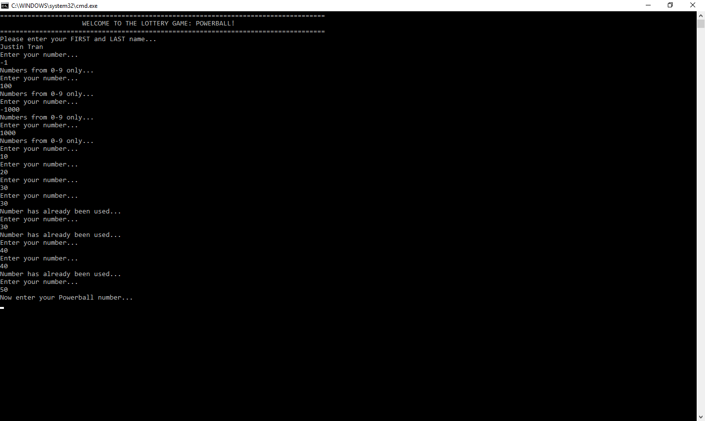

**Demonstration of validation of user entering out of the range of 1-26 for power ball.**

