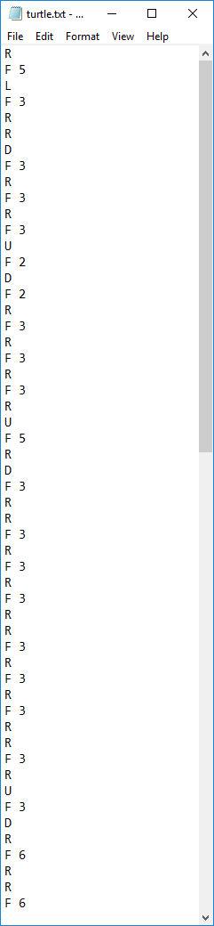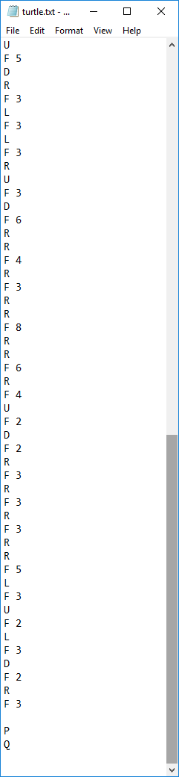

R

F 5

L

F 3

R

R

D

F 3

R

F 3

R

F 3

U

F 2

D

F 2

R

F 3

R

F 3

R

F 3

R

U

F 5

R

D

F 3

R

R

F 3

R

F 3

R

F 3

R

R

F 3

R

F 3

R

F 3

R

R

F 3

R

U

F 3

D

R

F 6

R

R

F 6

R

F 3

R

F 3

R

F 3

R

F 3

R

U

F 5

D

R

F 3

L

F 3

L

F 3

R

U

F 3

D

F 6

R

R

F 4

R

F 3

R

R

F 8

R

R

F 6

R

F 4

U

F 2

D

F 2

R

F 3

R

F 3

R

F 3

R

R

F 5

L

F 3

U

F 2

L

F 3

D

F 2

R

F 3

P

Q