Software Requirements Specification

For

Attendance monitoring system

Version 1.0 approved

**Table of Contents**

**Table of Contents 2**

**Revision History 2**

**1. Introduction 1**

1.1 Purpose 1

1.2 Document Conventions 1

1.3 Intended Audience and Reading Suggestions 1

1.4 Product Scope 1

1.5 References 1

**2. Overall Description 1**

2.1 Product Perspective 1

2.2 Product Functions 2

2.3 User Classes and Characteristics 3

2.4 Operating Environment 3

2.5 Design and Implementation Constraints 3

2.6 User Documentation 4

2.7 Assumptions and Dependencies 4

**3. External Interface Requirements 4**

3.1 User Interfaces 4

3.2 Hardware Interfaces 6

3.3 Software Interfaces 6

3.4 Communications Interfaces 6

**4. System Features 6**

4.1 System Feature 1 6

4.2 System Feature 2 (and so on) 7

**5. Other Nonfunctional Requirements 8**

5.1 Performance Requirements 8

5.2 Safety Requirements 8

5.3 Security Requirements 8

5.4 Software Quality Attributes 8

5.5 Business Rules 8

**6. Other Requirements 8**

**Appendix A: Glossary 9**

**Appendix B: Analysis Models 9**

**Appendix C: To Be Determined List 10**

**Revision History**

|  |  |  |  |
| --- | --- | --- | --- |
| **Name** | **Date** | **Reason For Changes** | **Version** |
|  |  |  |  |
|  |  |  |  |

1.**Introduction**

1.1 **Purpose**

The Attendance Monitoring System is a software application that provides a way to record and track attendance. This system automates the process of attendance management and eliminates the need for paperwork. It also provides management with real-time access to attendance data, enabling them to make timely decisions.

The purpose of this Software Requirement Specification (SRS) document is to outline the requirements and specifications of the Attendance Monitoring System .

1.2 **Document Conventions**

1.3 **Intended Audience and Reading Suggestions**

This document is intended for the users, developers and testers. Users will be able to view whether the document covers all the tasks which were to be accomplished according to them. Developers and testers will be able to verify the working they’ll do with the help of this document. This Document contains data related to each and every requirement, user interfaces, attributes and the working of the project with the help of various diagrams. An easy way to understand the document easily is to thoroughly read the first portion of the document which tells about the product’s features, the environment and interface. And to understand the working of the tasks, readers can view the diagrams at the end - as visual representation of the project will be easy to interpret

1.4 **Product Scope**

The Attendance Monitoring System will be used by organizations to monitor and manage their student’s attendance. It will provide students with an easy way to clock in and out, while providing management with real-time reports on attendance data. This system will also help to reduce the time and effort required for manual attendance management.

1.5 **References**

2. **Overall Description**

2.1 **Product Perspective**

The Attendance Management System is intended to replace the manual model of

attendance record keeping by means of roll call and paper records. The roll call and paper records are replaced with a single interaction between the professor and the Attendance Management System. Professors will be able to view details regarding attendance of individual students on their mobile and quickly maintain attendance records. The features expressed in this Software Requirements Specification document are intended to be fully implemented in version 1.0. The system will be developed in such a way to provide easy addition of enhanced features, which may be desired in subsequent versions.

2.2 **Product Functions**

The main feature of the Attendance Management System is that it keeps a record

of all essentials details of each individual student. At the end of a specified

period this system creates a defaulters list as well as the non-defaulters list.

Attendance Percentage of each student in every subject would be displayed in

this list Also, the system allows the professor to view pertinent statistics on

student’s attendance record for the specified class. Finally, another feature of

Attendance Management System is its flexibility and ease of use.

2.3 **User Classes and Characteristics**

Professors:

A professor is a faculty member of College .There are n number of faculty members at the college and it is estimated that almost all faculty members will utilize the

Attendance Management System. Professors will have multiple classes and interaction with the system will occur at multiple times throughout the day from multiple professors. The professor should be allowed to take, edit, and view attendance records at any desirable time. All professors have Internet access through their mobiles . This provides the backbone of the Attendance Management System.

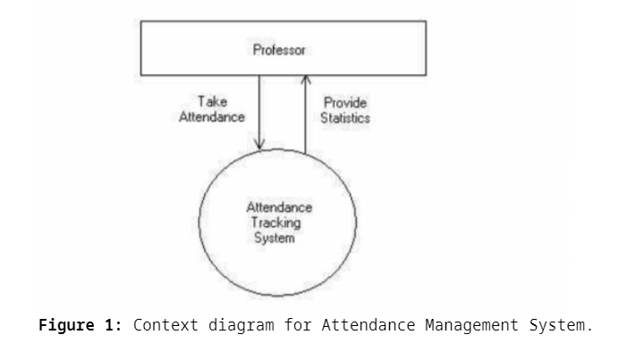

2.4 **Operating Environment**

2.5 **Design and Implementation Constraints**

2.6 **User Documentation**

2.7 **Assumptions and Dependencies**

3. **External Interface Requirements**

3.1 **User Interface**

3.2 **Hardware Interfaces**

3.3 **Software Interfaces**

3.4 **Communications Interfaces**

4. **System Features**

4.1 **Add a report**

4.1.1 **Description and Priority:**

4.1.2 **Stimulus/Response sequences**

4.1.3 **Functional Requirements**

4.2 **Emergency call**

4.2.1 **Description and Priority:**

4.2.2 **Stimulus/Response sequences**

4.2.3 **Functional Requirements:**

5. **Other Non-functional Requirements**

5.1 **Performance Requirements**

5.2 **Safety Requirements**

5.3 **Security Requirements**

5.4 **Software Quality Attributes**

5.5 **Business Rules**

6. **Other Requirements**

**Appendix A: Glossary**

**Appendix B: Analysis Models**

**Appendix B: Analysis Models**