Name: Justin V Kalappura
Roll No: 10
Batch: Mca - B
Date:12/5/2022

NETWORKING & SYSTEM ADMINISTRATION LAB

Experiment No.: 21

Aim:
write a shell script program to find sum of all digit in a number

Procedure:
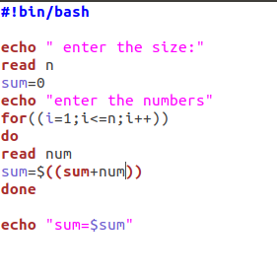

Output Screenshot:
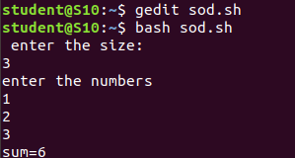

Experiment:22

Aim:
write a shell script to find the average of the number entered in a command line
Procedure:
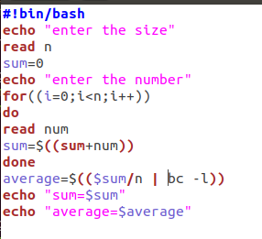

Output Screenshot:
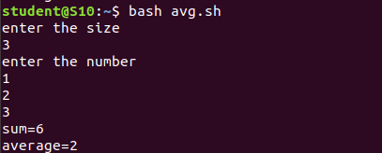

Experiment No.: 23
Aim:
write a shell script arithmetic operations using switch case
Procedure:
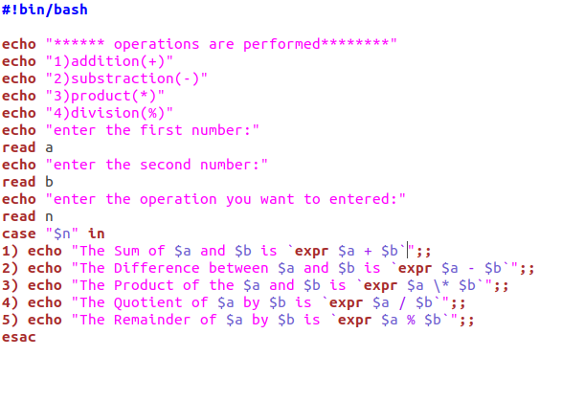

Output Screenshot;
