Name: Justin V Kalappura
Roll No: 10
Batch: MCA
Date: 05/05/2022

NETWORKING & SYSTEM ADMINISTRATION LAB

Experiment No.: 10

Aim:
Write a program shell scripting to print sum of two numbers.

Procedure and Output Screenshot:
gedit sum.sh – to open the editor.

Editor screenshot:
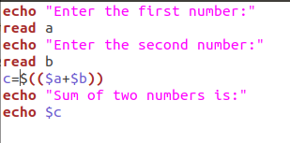

Terminal screenshot:
