Name: Justin V Kalappura
Roll No: 10
Batch: MCA B
Date: 04-04-2022

NETWORKING & SYSTEM ADMINISTRATION LAB

Experiment No.: 6

Aim
Familiarization of basic Linux commands.

Procedure
1. cp
This commands in Linux allows you to copy a file or an entire directory to another
Directory specified.
Syntax:- $ cp file_to_be_copied directory_name
Output:-
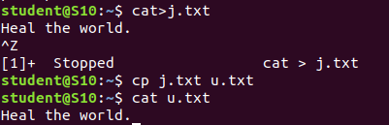

2. cp –r
This command in Linux allow us to copy an entire directory into another directory
Syntax:- $ cp –r source_directory destination_directory
Output:-
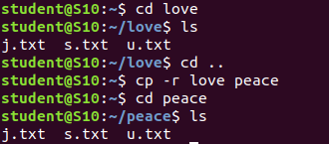

3. cp - i
This command helps to make a decision regarding overwrite that may happen in case of copying a same named file (but different in content) from the source folder to the destination folder.
Syntax:- $ cp - i filename destination_folder
Output:-
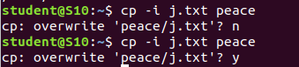

4. mv
This command will move a specific file or directory to another directory
Syntax:- $ mv file_name/directory_name destination_directory
Output:-
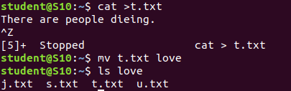

5. mv -i
This command enables a dialog to take a wise decision about overwrite in case of moving
A file with the same name as that of one already exist in the destination directory.
Syntax:- $ mv - i filename destination_path

Output:-
