Name: Justin V Kalappura
Roll No: 10
Batch: MCA
Date: 05/05/2022

NETWORKING & SYSTEM ADMINISTRATION LAB

Experiment No.: 9

Aim:
Write a program shell scripting to print the basic details.

Procedure
1. vi sample.sh – to open an file in the terminal itself.
OUTPUT:
Press i to start inserting data;
And to save and exit, type “:wq”;
Then press enter.
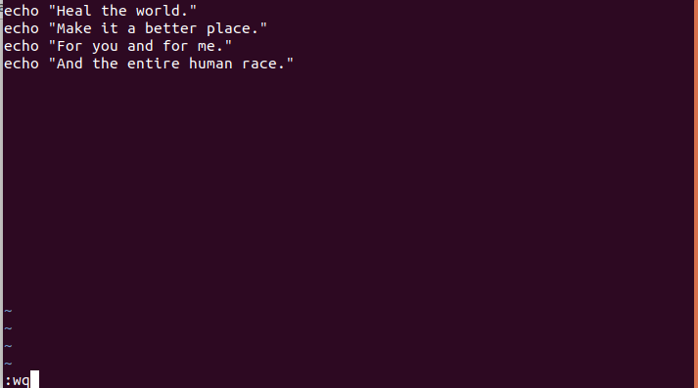

2. chmod +x sample.sh – to give the permission to read the file.
OUPTUT:

3../sample.sh – to excute the program .And print the output.
OUPTUT:
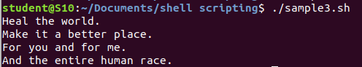

4.bash sample.sh - to excute the program .And print the output.
Output Screenshot:
