Name: Justin V Kalappura
Roll No: 10
Batch: MCA
Date: 05/05/2022

NETWORKING & SYSTEM ADMINISTRATION LAB

Experiment No.: 11

Aim:
Write a program shell scripting to find the largest of two numbers.

Procedure and Output Screenshot:
gedit sum.sh – to open the editor.

Editor screenshot:
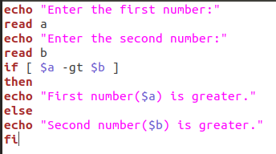

Terminal screenshot:
