Name: Justin V Kalappura
Roll No: 10
Batch: S2 mca -B
Date: 23/05/2022

NETWORKING & SYSTEM ADMINISTRATION LAB

Experiment No.: 24

Aim:
Steps for installing Docker.

Procedure:
1. Open the terminal on Ubuntu.
2. Remove any Docker files that are running in the system.
Command: $ sudo apt-get remove docker docker-engine docker.io
After entering the above command, you will need to enter the password of the root and press enter.
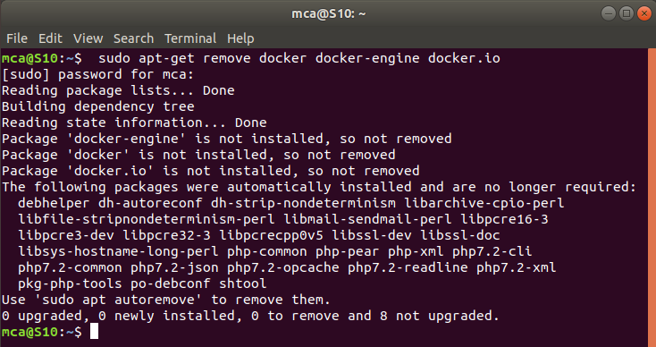
3. Check if the system is up-to-date.
Command: $ sudo apt-get update
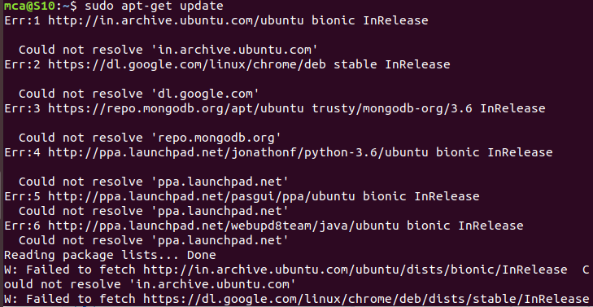
4. Install Docker.
Command: $ sudo apt install docker.io
You’ll then get a prompt asking you to choose between y/n - choose y
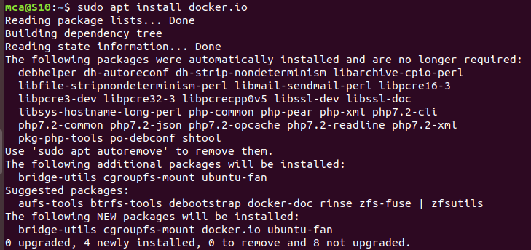
5. Install all the dependency packages
Command: $ sudo snap install docker
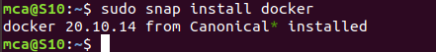
6. Before testing Docker, check the version installed
Command: $ docker –version
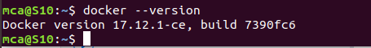

7. Pull an image from the Docker hub
Command: $ sudo docker run hello-world
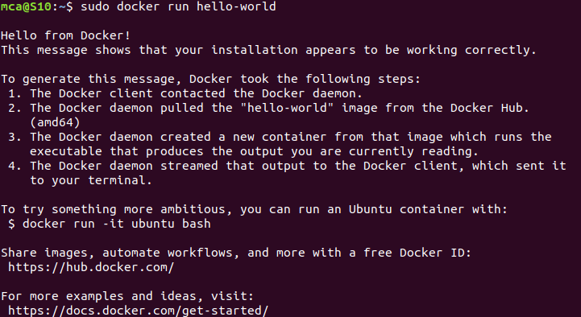
8. Check if the docker image has been pulled and is present in your system
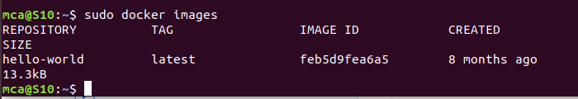
Command: $ sudo docker images

9. To display all the containers pulled
Command: $ sudo docker ps -a
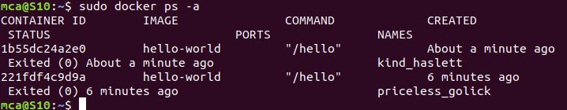
10. To check for containers in a running state
Command: $ sudo docker ps
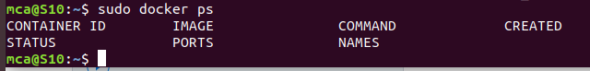

Successfully installed Docker on Ubuntu!!!!!

