COMPSCI 340 Assignment 3

Question 1

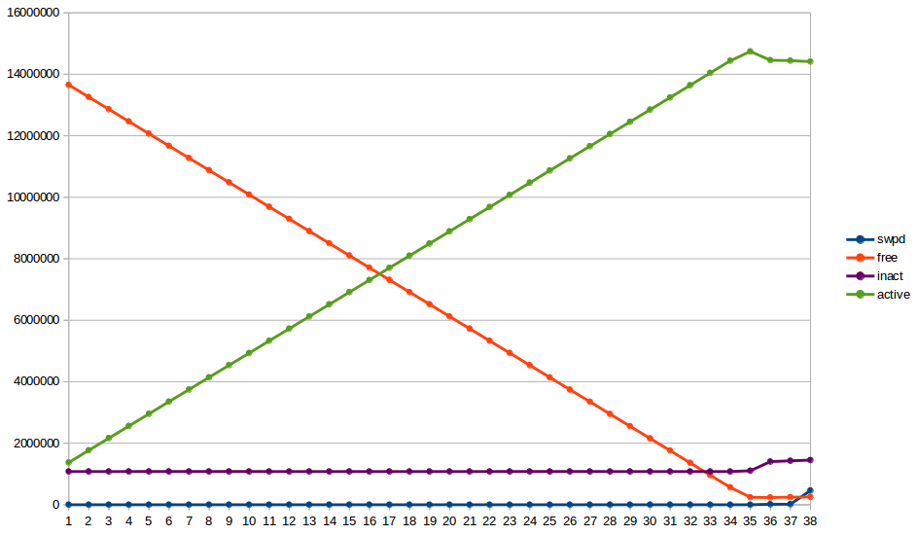
From the plot above, I can see that as the mem_filler.py process continues to iterate, the active memory rises while the free memory drops. There is an obvious explanation for this, in that mem_filler.py is being allocated more and more memory as it is being executed, meaning free memory is being used to store active data (active memory).

Once the active memory hits approximately 14.75 GiB and the free memory drops to about 237 MiB, the usage of swap space memory starts to rise. This is because the operating system starts to allocate memory in the swap space, as it has run out of free memory to allocate (even though the free memory isn’t zero, I think it holds onto some free memory for operating system concerns).

Once the swap space hits roughly 450 MiB, the mem_filler.py crashes due to an OSError: [Errno 12] Cannot allocate memory error. This would be due to the operating system not allowing more of the swap space to be allocated to the process.

I ran this on my own personal laptop natively running Ubuntu 16.04 LTS with 16 GB of RAM and 4 GB designated for swap space.

Question Two

Interestingly, for every execution of mem_filler.py after the first, the swap space usage remained from the first execution even though that process had crashed. My explanation for this is that either the python3 process was still running and was holding onto that memory or the memory was never released.

I checked my processes list in the system monitor and there were no python3 processes running at the time, so I would chalk this up to the memory allocation not being released by the process i.e. a memory leak.

Question Three

Inactive memory is the memory of of recent resources that are no longer needed. The reason it sticks around instead of being deleted (and converted into free memory) is because there is a significant chance that the computer will need that resource again and keeping it around makes the repeated read request much faster, as it does not need to transfer the resource all the way from the hard drive etc.

The only problem with inactive memory is that it is taking up space, where there could be free memory. However, inactive memory can be overriden at any time anyway as it is not in active use and can therefore be used for something else.

Question Four

subprocess.run( is a python function in the subprocess library that allows system calls to be made within a python program.

[‘cat /proc/meminfo | egrep “MemFree|MemAvailable”’] is a python list containing all of the Bash commands to be executed, however in this case there is only a single command.

As for the actual bash command:

cat /proc/meminfo reads the /proc/meminfo resource.

The pipe, | will transfer the output of the cat command into the egrep command as input.

The egrep command returns all entries which match the given expression "MemFree|MemAvailable", read as MemFree or MemAvailable, which results in the following output.

MemFree: 14801560 kB
MemAvailable: 14873400 kB

Question Five

This lists all of the memory allocations to each process, with their starting memory address and ending memory address and other memory information.

Question Six

Question Seven

First In First Out (FIFO)

 | 1 | 7 | 3 | 4 | 3 | 5 | 6 | 7 | 7 | 1 | 6 | 5 | 4 | 6 | 2 | 6 | 1 | 7 | 1 | 2
0 | 1 | = | = | = | = | = | 6 | = | = | = | - | = | = | - | = | - | = | = | = | =
0 | = | 7 | = | = | = | = | = | - | - | 1 | = | = | = | = | = | = | - | = | - | =
0 | = | = | 3 | = | - | = | = | = | = | = | = | = | = | = | 2 | = | = | = | = | -
0 | = | = | = | 4 | = | = | = | = | = | = | = | = | - | = | = | = | = | 7 | = | =
0 | = | = | = | = | = | 5 | = | = | = | = | = | - | = | = | = | = | = | = | = | =

9 Page Faults

Least Recently Used (LRU)

 | 1 | 7 | 3 | 4 | 3 | 5 | 6 | 7 | 7 | 1 | 6 | 5 | 4 | 6 | 2 | 6 | 1 | 7 | 1 | 2
0 | 1 | = | = | = | = | = | 6 | = | = | = | - | = | = | - | = | - | = | = | = | =
0 | = | 7 | = | = | = | = | = | - | - | = | = | = | = | = | 2 | = | = | = | = | -
0 | = | = | 3 | = | - | = | = | = | = | = | = | = | 4 | = | = | = | = | = | = | =
0 | = | = | = | 4 | = | = | = | = | = | 1 | = | = | = | = | = | = | - | = | - | =
0 | = | = | = | = | = | 5 | = | = | = | = | = | - | = | = | = | = | = | 7 | = | =

10 Page Faults

Least Frequently Used (LFU)

 | 1 | 7 | 3 | 4 | 3 | 5 | 6 | 7 | 7 | 1 | 6 | 5 | 4 | 6 | 2 | 6 | 1 | 7 | 1 | 2
0 | 1 | = | = | = | = | = | 6 | = | = | = | - | = | = | - | = | - | = | = | = | =
0 | = | 7 | = | = | = | = | = | - | - | = | = | = | = | = | = | = | = | - | = | =
0 | = | = | 3 | = | - | = | = | = | = | = | = | = | 4 | = | = | = | = | = | = | =
0 | = | = | = | 4 | = | = | = | = | = | 1 | = | = | = | = | = | = | - | = | - | =
0 | = | = | = | = | = | 5 | = | = | = | = | = | - | = | = | 2 | = | = | = | = | -

9 Page Faults

Optimal

 | 1 | 7 | 3 | 4 | 3 | 5 | 6 | 7 | 7 | 1 | 6 | 5 | 4 | 6 | 2 | 6 | 1 | 7 | 1 | 2
0 | 1 | = | = | =
0 | = | 7 | = | =
0 | = | = | 3 | =
0 | = | = | = | 4
0 | = | = | = | =

