COMPSCI 367 Assignment 2
Name: Justin Vos
UPI: jvos137
ID: 6914129

1(c)
My implementation of the queryReason(list_evidence) finds the hypothesis with the highest probability and returns it to the user.
I had an solution in mind how to find exactly what could be the root cause of the problem, however it seemed out of scope of this assignment as it involved decision trees and searching on them.

I would expect a user of this system to use it to find the most influential node of the circuit and then investigate the physical state of that node and return to enter that new piece of evidence in the system. Through this cycle, a user would be able to find the root cause of the problem after a few uses and new evidence gathering after each use.

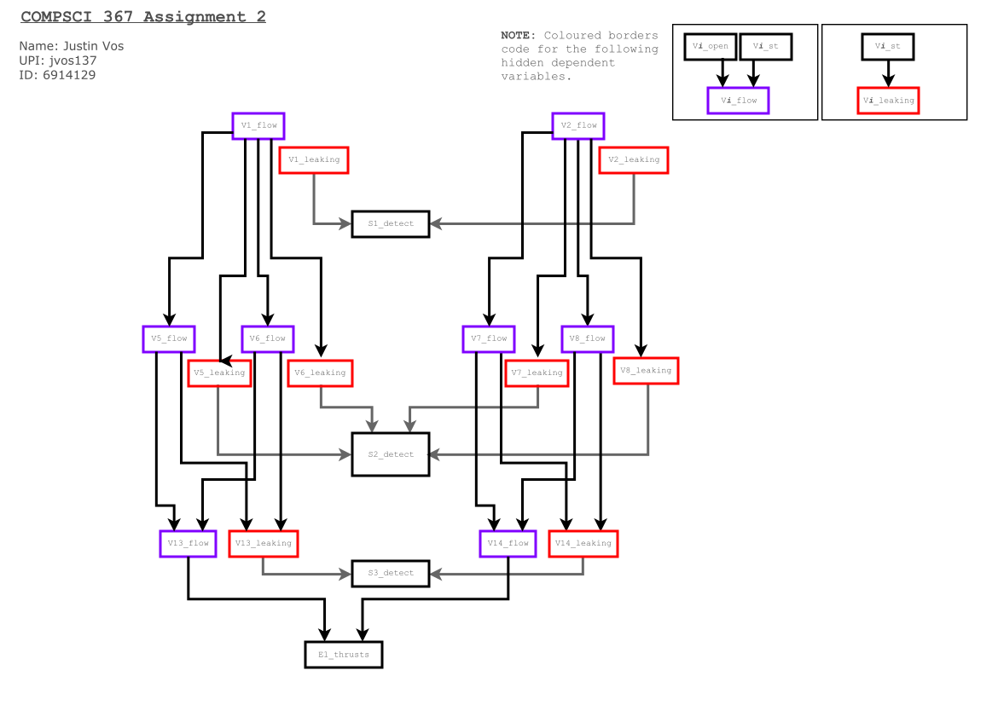
2(a)

