Module 4: Deep Learning — 9 Lessons (Summary)

# Lesson 1 — What is Deep Learning?

Deep learning is a subfield of machine learning that uses multi-layer neural networks to automatically learn hierarchical features from data. Unlike traditional ML that often depends on handcrafted features, deep learning discovers useful representations directly from raw data such as images, speech, and text. Its ability to scale with large datasets and computing power makes it the foundation of modern AI breakthroughs.

*Key terms: deep neural network, hierarchy, representation learning*

# Lesson 2 — Core Concepts

Deep Neural Networks (DNNs) are built from layers of neurons connected by weights. The forward pass computes outputs layer by layer, while the backward pass (backpropagation) adjusts weights using gradients to minimize error. Activation functions such as ReLU or sigmoid provide non-linearity, enabling networks to learn complex patterns. Together, these mechanisms power the learning process.

*Key terms: DNN, activation, forward pass, backpropagation*

# Lesson 3 — Training Challenges & Solutions

Training deep networks can be unstable. Problems like vanishing/exploding gradients, overfitting, or slow convergence often arise. Solutions include weight initialization strategies, batch normalization to stabilize activations, dropout to reduce overfitting, and modern optimizers (SGD with momentum, Adam). These techniques make deep models both trainable and more generalizable.

*Key terms: vanishing gradient, batch normalization, dropout, optimizer*

# Lesson 4 — Popular Architectures

Different tasks call for different architectures. CNNs (Convolutional Neural Networks) extract local image features through filters and pooling. RNNs (Recurrent Neural Networks) process sequential data but struggle with long dependencies, improved by LSTMs and GRUs. Transformers, with attention mechanisms, dominate natural language processing and now extend to multimodal AI.

*Key terms: CNN, RNN, LSTM, GRU, transformer, attention*

# Lesson 5 — Real-World Applications

Deep learning is everywhere: self-driving cars detect objects with CNNs, RNNs support speech recognition and financial forecasting, and Transformers power translation,

summarization, and AI assistants. Recommendation systems, fraud detection, and medical imaging further showcase its versatility across industries.

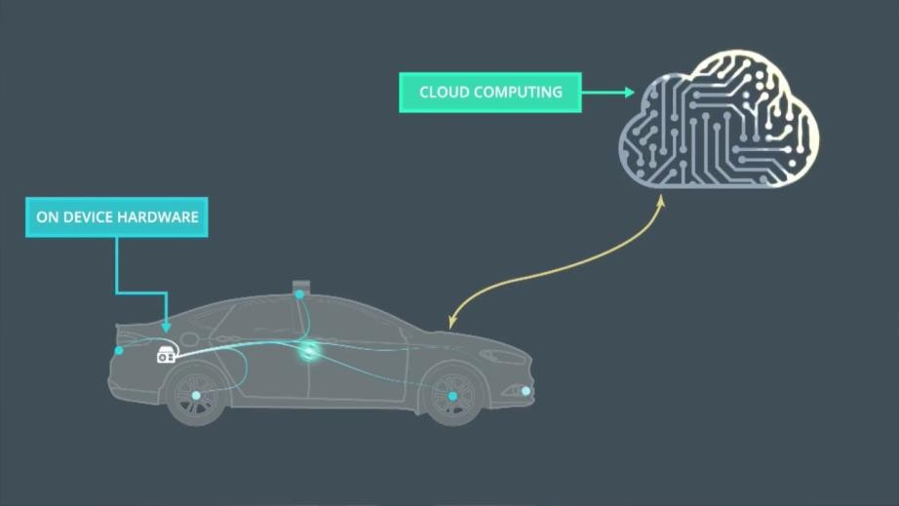

*Key terms: vision, speech, recommendation, LLM*

# Lesson 6 — Training Efficiency & Hardware Acceleration

Modern deep learning depends on specialized hardware and training techniques. GPUs and TPUs accelerate massive matrix operations, while frameworks like TensorFlow and PyTorch simplify model building. Techniques like mini-batch training, mixed precision, and distributed training help scale models efficiently. Understanding the computational side is critical for deploying real-world AI.

*Key terms: GPU, TPU, mini-batch, distributed training*

# Lesson 7 — Future Directions

Research continues to push deep learning further. Efficient architectures like MobileNet and TinyML aim to run models on devices with limited power. Federated learning enables training without centralizing data. Neuromorphic chips and spiking neural networks mimic the brain for energy-efficient AI. These trends point toward smaller, faster, and more trustworthy models.  
*Key terms: MobileNet, TinyML, federated learning, neuromorphic*

# Lesson 8 — Deep Learning Demo (JS — Forward Pass Only)

A simple demo illustrates how inputs pass through linear layers, weights, and activation functions to produce outputs. This “forward pass” highlights how feature representations are progressively transformed at each stage. Even without training, the demo clarifies matrix operations, dimensionality changes, and the intuition behind how deep models process information.

*Key terms: forward pass, linear layers, activations*

**Lesson Quick-Check MCQs (Module 4: Deep Learning) Lesson 1 — What is Deep Learning?**

**Q: What chiefly distinguishes deep learning from “classic” ML approaches?**

* A. Avoiding non-linear functions
* B. Using many-layer networks to learn features automatically ⬛
* C. Requiring only small datasets
* D. Not using neural networks

**Lesson 2 — Core Concepts**

**Q: What is the role of the backward pass in a DNN?**

* A. Produce final predictions
* B. Compute gradients to update weights ⬛
* C. Normalize inputs before training
* D. Reduce the number of layers

**Lesson 3 — Training Challenges & Solutions**

**Q: Which method helps stabilize learning in deep networks?**

* A. Increasing dataset noise
* B. Batch normalization ⬛
* C. Removing activation functions
* D. Using only shallow layers

**Lesson 4 — Popular Architectures**

**Q: Which architecture relies on attention to focus on relevant parts of a sequence?**

* A. CNN
* B. RNN
* C. Transformer ⬛
* D. Autoencoder

**Lesson 5 — Real-World Applications Q: Which pairing is most appropriate?**

* A. CNN — speech recognition; RNN — image segmentation
* B. RNN — stock forecasting; Transformer — translation ⬛
* C. Transformer — edge detection; CNN — language modeling
* D. RNN — object detection; CNN — next-word prediction

**Lesson 6 — Training Efficiency & Hardware Acceleration**

**Q: Which hardware is most commonly used to accelerate deep learning training?**

* A. CPUs
* B. GPUs ⬛
* C. FPGAs
* D. Microcontrollers

**Lesson 7 — Future Directions**

**Q: Which approach enables training without centralizing user data?**

* A. Reinforcement learning
* B. Federated learning ⬛
* C. Data augmentation
* D. Gradient clipping

**Lesson 8 — Deep Learning Demo (Forward Pass) Q: The forward-pass demo primarily illustrates:**

* A. How to tune learning rates
* B. How data flows through layers to produce outputs ⬛
* C. How to compute validation metrics
* D. How to split train/validation/test