# Module 4: Deep Learning — 8 Lessons (Paragraph Edition)

**With Key Terms and Lesson Quick■Check MCQs**

**Lesson 1 — What is Deep Learning?  
Deep learning is a subfield of machine learning that uses multi-layer neural networks to automatically learn hierarchical features from data. Unlike traditional ML that often depends on handcrafted features, deep learning discovers useful representations directly from raw data such as images, speech, and text. Its ability to scale with large datasets and computing power makes it the foundation of modern AI breakthroughs.  
Key terms: deep neural network, hierarchy, representation learning**

**Lesson 2 — Core Concepts  
Deep Neural Networks (DNNs) are built from layers of neurons connected by weights. The forward pass computes outputs layer by layer, while the backward pass (backpropagation) adjusts weights using gradients to minimize error. Activation functions such as ReLU or sigmoid provide non-linearity, enabling networks to learn complex patterns. Together, these mechanisms power the learning process.  
Key terms: DNN, activation, forward pass, backpropagation**

**Lesson 3 — Training Challenges & Solutions  
Training deep networks can be unstable. Problems like vanishing/exploding gradients, overfitting, or slow convergence often arise. Solutions include weight initialization strategies, batch normalization to stabilize activations, dropout to reduce overfitting, and modern optimizers (SGD with momentum, Adam). These techniques make deep models both trainable and more generalizable.  
Key terms: vanishing gradient, batch normalization, dropout, optimizer**

**Lesson 4 — Popular Architectures  
Different tasks call for different architectures. CNNs (Convolutional Neural Networks) extract local image features through filters and pooling. RNNs (Recurrent Neural Networks) process sequential data but struggle with long dependencies, improved by LSTMs and GRUs. Transformers, with attention mechanisms, dominate natural language processing and now extend to multimodal AI.**

**Key terms: CNN, RNN, LSTM, GRU, transformer, attention**

**Lesson 5 — Real-World Applications**  
Deep learning is everywhere: self-driving cars detect objects with CNNs, RNNs support speech recognition and financial forecasting, and Transformers power translation, summarization, and AI assistants. Recommendation systems, fraud detection, and medical imaging further showcase its versatility across industries.  
**Key terms: vision, speech, recommendation, LLM**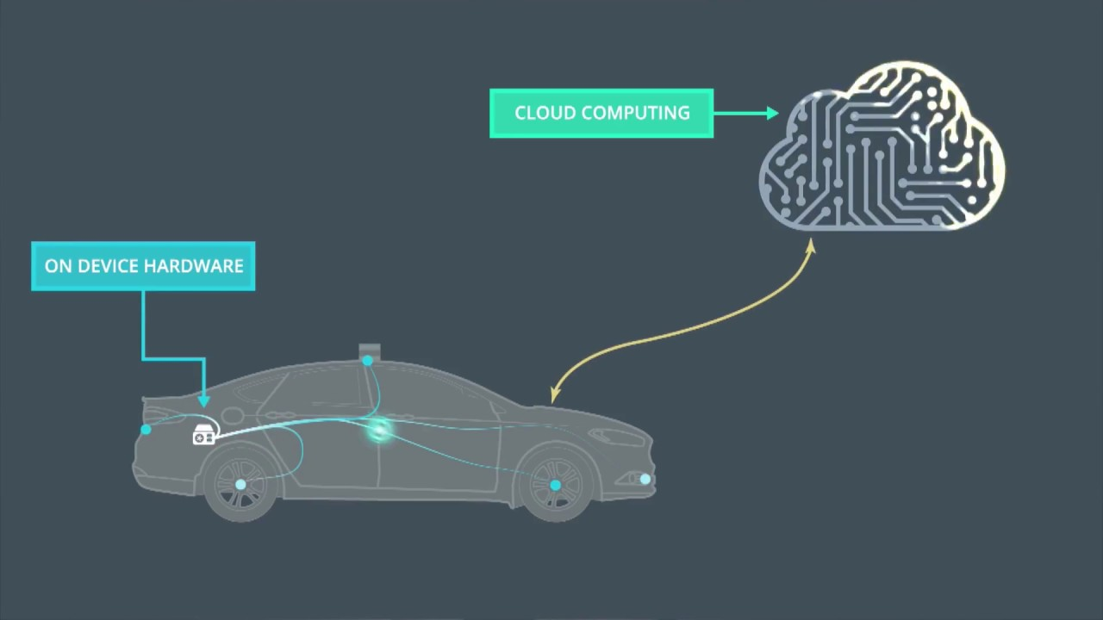

**Lesson 6 — Training Efficiency & Hardware Acceleration**  
Modern deep learning depends on specialized hardware and training techniques. GPUs and TPUs accelerate massive matrix operations, while frameworks like TensorFlow and PyTorch simplify model building. Techniques like mini-batch training, mixed precision, and distributed training help scale models efficiently. Understanding the computational side is critical for deploying real-world AI.  
**Key terms: GPU, TPU, mini-batch, distributed training**

## **Lesson 6 — Key Takeaways** Deep learning = multi■layer networks that learn features automatically; forward pass computes outputs, backpropagation trains; different architectures fit different data types and tasks. Small demos help build intuition about information flow. Key terms: generalization, architecture, training

## **Lesson Quick■Check MCQs (Module 4: Deep Learning)**

**Lesson 1 — What is Deep Learning?**  
Q: What chiefly distinguishes deep learning from “classic” ML approaches?  
A. Avoiding non■linear functions  
B. Using many■layer networks to learn features automatically ✅  
C. Requiring only small datasets  
D. Not using neural networks  
🔹 Hint: The word “deep” means stacking many layers.

**Lesson 2 — Core Concepts**  
Q: What is the role of the backward pass in a DNN?  
A. Produce final predictions  
B. Compute gradients to update weights ✅  
C. Normalize inputs before training  
D. Reduce the number of layers  
🔹 Hint: This is the “training” step that adjusts weights.

**Lesson 3 — Popular Deep Learning Architectures**  
Q: Which architecture relies on **attention** to focus on relevant parts of a sequence?  
A. CNN  
B. RNN  
C. Transformer ✅  
D. Autoencoder  
🔹 Hint: Think GPT, BERT, and modern translation models.

**Lesson 4 — Deep Learning Demo (JS — Forward Pass Only)**  
Q: The forward■pass demo primarily illustrates:  
A. How to tune learning rates  
B. How data flows through layers to produce outputs ✅  
C. How to compute validation metrics  
D. How to split train/validation/test  
🔹 Hint: It shows the flow of data, not the training process.

**Lesson 5 — Real■World Applications**  
Q: Which pairing is most appropriate?  
A. CNN — speech recognition; RNN — image segmentation  
B. RNN — stock forecasting; Transformer — translation ✅  
C. Transformer — edge detection; CNN — language modeling  
D. RNN — object detection; CNN — next■word prediction  
🔹 Hint: Match each architecture to the task it’s best at.

**Lesson 6 — Key Takeaways**  
Q: According to the lesson, which process **trains** a deep network by reducing error?  
A. Principal Component Analysis  
B. Backpropagation ✅  
C. Data augmentation  
D. k■means  
🔹 Hint: This is the algorithm that propagates error backwards.