**Study 1**

|  |  |  |  |  |  |
| --- | --- | --- | --- | --- | --- |
| **Image** | **Story** | **Impossible** | **Improbable** | **Immoral** | **Possible** |
| **1b** | This is Henry. Henry is standing in line at a grocery store when he sees a candy bar that he really would like. He is very hungry after school and asks his mom if she will buy him the candy. But his mom says no. | Henry throws his hat in the air and it turns into a candy bar. | Henry tells the man at the store that he should get all the candy bars in the store for free, and the man gives them to him. | Henry takes the candy bar without paying and doesn’t tell his mother. | Henry waits to get home to eat his favorite snack. |
| **2b** | This is Timmy. This is Jack and this is Jack's ball. Jack is playing with his ball. Timmy wants to play with the ball together, but Jack says that he wants to play with the ball by himself. | Timmy claps his hands really loudly and a new ball appears on top of his head. | Timmy tells Jack that balls aren’t fun to play with, so Jack gives the ball to Timmy forever. | Timmy gets mad and takes Jack’s ball away when Jack is playing with it. | Timmy gets disappointed but plays with his friend Sandy instead. |
| **3b** | This is Jake. This is Peter. Jake and Peter are twin brothers. Peter is wearing a shirt that Jake likes a lot. Jake wanted to wear that shirt today, but Peter doesn’t want to give away his shirt. | Jake blinks his eyes and all of Peter's clothes disappear and then reappear in Jake's closet. | Jake makes his parents buy him 100 shirts just like Peter's so he can wear it every day. | Jake grabs the shirt and takes it away from Peter and then wears it all day. | Jake wears his other favorite shirt instead. |
| **4b** | This is Alex. Alex doesn’t want to go to school because he doesn’t want to leave his dad. He always misses his dad a lot when he goes to school. | Alex snaps his fingers and suddenly it's Saturday so he doesn’t have to go to school. | Alex asks his father to go to school with him, and his father agrees and goes to all of his classes. | Alex lies about feeling sick so he doesn’t have to go to school. | Alex brings a picture of his dad to school and looks at the picture when he misses his father. |
| **5b** | This is Tom. This is James. Tom is on the school basketball team and wants to be picked to play in the big game. James is better at basketball than Tom, so Tom thinks that James will get to play instead. | Tom jumps into the air and floats above the ground so he becomes taller and better at basketball. | Tom tells James that doing chores is more fun, so James quits the basketball team and Tom gets to play. | Tom beats James up so that he can’t play in the big game, and Tom will be selected instead. | Tom practices every day and then eventually becomes better at basketball than James. |
| **6b** | This is Harry and this is Harry’s best friend Mark. This is Zach. Zach just moved to the town and is a new kid in Harry’s class. Zach wants to be friends with Harry’s best friend Mark, but Harry is scared that Zach will take his best friend. | Harry stamps his foot and Zach flies up into the air and lands in a city far away. | Harry convinces Zach’s parents to move to a different country forever. | Harry makes Mark to be really mean to Zach , so Zach has to be friends with somebody else. | Harry makes friends with Zach, too, so that Harry, Zach, and Mark become friends together. |
| **7b** | This is Jimmy. Jimmy sees a boy standing in line in front of him at the movie theatre who has a ticket in his back pocket. Jimmy wants to see a movie, but doesn’t have any money. | Jimmy puts his wallet under water and a movie ticket appears in his wallet. | Jimmy asks the ticket person if he can see the movie for free, and she lets him. | Jimmy steals the boy’s ticket when he is buying popcorn. | Jimmy goes back home and brings some money to see the movie. |
| **8b** | This is Nick. Nick wants to play with his friends, but his parents say he has to do his chores before he can play with his friends. | Nick turns the lights off in his room and when he turns them back on, all his chores are done. | Nick pays his mom 1 dollar to do the chores for him, and his mom agrees, so Nick doesn't have to do his chores. | Nick lies to his mom and says he finished his chores, and goes to play with his friends without cleaning up. | Nick does his chores and then goes to play with his friends. |

|  |  |  |  |  |  |
| --- | --- | --- | --- | --- | --- |
| **Image** | **Story** | **Impossible** | **Improbable** | **Immoral** | **Possible** |
| **1g** | This is Holly. Holly is standing in line at a grocery store when she sees a candy bar that she really would like. She is very hungry after school and asks her mom if she will buy her the candy. But her mom says no. | Holly throws her hat in the air and it turns into a candy bar. | Holly tells the man at the store that she should get all the candy bars in the store for free, and the man gives them to her. | Holly takes the candy bar without paying and doesn’t tell her mother. | Holly waits to get home to eat her favorite snack. |
| **2g** | This is Tina. This is Jenna and this is Jenna's ball. Jenna is playing with her ball. Tina wants to play with the ball together, but Jenna says that she wants to play with the ball by herself. | Tina claps her hands really loudly and a new ball appears on top of her head. | Tina tells Jenna that balls aren’t fun to play with, so Jenna gives the ball to Tina forever. | Tina gets mad and takes Jenna’s ball away when Jenna is playing with it. | Tina gets disappointed but plays with her friend Sarah instead. |
| **3g** | This is Tracy. This is Linda. Tracy and Linda are twin sisters. Linda is wearing a shirt that Tracy likes a lot. Tracy wanted to wear that shirt today, but Linda doesn’t want to give away her shirt. | Tracy blinks her eyes and all of Linda's clothes disappear and then reappear in Tracy's closet. | Tracy makes her parents buy her 100 shirts just like Linda's so she can wear it every day. | Tracy grabs the shirt and takes it away from Linda and then wears it all day. | Tracy wears her other favorite shirt instead. |
| **4g** | This is Ally. Ally doesn’t want to go to school because she doesn’t want to leave her dad. She always misses her dad a lot when she goes to school. | Ally snaps her fingers and suddenly it's Saturday so she doesn’t have to go to school. | Ally asks her father to go to school with her, and her father agrees and goes to all of her classes. | Ally lies about feeling sick so she doesn’t have to go to school. | Ally brings a picture of her dad to school and looks at the picture when she misses her father. |
| **5g** | This is Becca. This is Erin. Becca is on the school basketball team and wants to be picked to play in the big game. Erica is better at basketball than Becca, so Becca thinks that Erin will get to play instead. | Becca jumps into the air and floats above the ground so she becomes taller and better at basketball. | Becca tells Erin that doing chores is more fun, so Erin quits the basketball team and Becca gets to play. | Becca beats Erin up so that she can’t play in the big game, and Becca will be selected instead. | Becca practices every day and then eventually becomes better at basketball than Erin. |
| **6g** | This is Harriet and this is Harriet’s best friend Mary. This is Zoe. Zoe just moved to the town and is a new kid in Harriet’s class. Zoe wants to be friends with Harriet’s best friend Mary, but Harriet is scared that Zoe will take her best friend. | Harriet stamps her foot and Zoe flies up into the air and lands in a city far away. | Harriet convinces Zoe’s parents to move to a different country forever. | Harriet makes Mary to be really mean to Zoe, so Zoe has to be friends with somebody else. | Harriet makes friends with Zoe, too, so that Harriet, Zoe, and Mary become friends together. |
| **7g** | This is Jenny. Jenny sees a girl standing in line in front of her at the movie theatre who has a ticket in her back pocket. Jenny wants to see a movie, but doesn’t have any money. | Jenny puts her wallet under water and a movie ticket appears in her wallet. | Jenny asks the ticket person if she can see the movie for free, and she lets her. | Jenny steals the girl’s ticket when she is buying popcorn. | Jenny goes back home and brings some money to see the movie. |
| **8g** | This is Nora. Nora wants to play with her friends, but her parents say she has to do her chores before she can play with her friends. | Nora turns the lights off in her room and when she turns them back on, all her chores are done. | Nora pays her mom 1 dollar to do the chores for her and her mom agrees, so Nora doesn't have to do her chores. | Nora lies to her mom and says she finished her chores, and goes to play with her friends without cleaning up. | Nora does her chores and then goes to play with her friends. |

**Study 2 & 3**

|  |  |  |  |  |  |
| --- | --- | --- | --- | --- | --- |
| **Image** | **Story** | **Impossible** | **Improbable** | **Immoral** | **Possible** |
| **1b** | This is Henry. Henry is standing in line at a grocery store when he sees a candy bar that he really would like. He is very hungry after school so he asks his mom if she will buy him the candy bar. But his mom says no. | Henry throws his hat in the air and it turns into a candy bar. | When Henry walks out of the store, a boy is giving away candy bars for free. It's exactly the candy bar that Henry wanted. | Henry takes the candy bar without paying for it and then doesn’t tell his mom. | Henry waits to get home to eat his favorite snack instead. |
| **2b** | This is Timmy. This is Jack and this is Jack's ball. Jack is playing with his ball. Timmy wants to play with Jack's ball together, but then Jack says that it's his ball and today he wants to play with his ball by himself. | Timmy claps his hands really loudly and a new ball appears on top of his head. | Jack buys an extra ball that's even better than his and gives it to Timmy to play with. | Timmy gets mad and takes Jack’s ball away from Jack when Jack is playing with it. | Timmy gets disappointed but plays with his other friend Sandy instead. |
| **3b** | This is Jake. This is Peter. Jake and Peter are twin brothers. Peter is wearing a shirt that Jake likes a lot, and Jake wanted to wear that shirt today. But Peter says that it's his shirt and he doesn’t want to give it up. | Jake blinks his eyes and all of Peter's clothes disappear and then reappear in Jake's closet. | Jake's mom and dad drive to the store and buy him two new shirts just like Peter's, so Jake can wear them if he wants to. | Jake grabs the shirt away from Peter and wears it all day, and Peter has to find another shirt to wear. | Jake wears his other favorite shirt instead. |
| **4b** | This is Alex. Alex is supposed to go to school today, but Alex doesn’t want to go to school because every time he goes to school, he always misses his dad a whole lot. | Alex snaps his fingers and suddenly it's Saturday so he doesn’t have to go to school anymore. | Alex's dad says that it's okay to not go to school today and they go to the park instead. | Alex lies to his dad about feeling sick so he doesn’t have to go to school anymore. | Alex brings a picture of his dad to school and looks at the picture when he misses his dad. |
| **5b** | This is Tom. Tom is on the school basketball team. And this is James. James is also on the school basketball team. Tom wants to be picked to play in the big basketball game that's coming up. But Tom knows that James is better at basketball than he is, so Tom thinks that James will be picked to play instead of him. | Tom jumps into the air and floats above the ground so he becomes taller and better at basketball than James. | Tom's basketball coach changes the rules so that everyone can play at the same time. | Tom trips James on purpose so that James hurts his leg really badly and he can't play in the big game. Then Tom gets to play instead. | Tom practices every day and then eventually becomes better at basketball than James. |
| **6b** | This is Harry and this is Harry’s best friend Mark. This is Zach. Zach just moved to the town and is a new kid in their class. Zach wants to be best friends with Harry’s best friend Mark, but Harry is scared that Zach will take his best friend away from him. | Harry stamps his foot and Zach flies up into the air and lands in a city far away. | Harry tells Zach that he can be best friends with his little sister instead, and Zach agrees. | Harry makes Mark to be really mean to Zach, so Zach is sad and has to be friends with somebody else. | Harry makes friends with Zach, too, so that Harry, Zach, and Mark become friends together. |
| **7b** | This is Jimmy. Jimmy is standing in line at a movie theatre when he sees a boy in line in front of him who has a ticket sticking out of his back pocket. Jimmy really wants to go see the movie, but Jimmy doesn't have enough money to buy a ticket right now. | Jimmy puts his wallet under water and a movie ticket appears in his wallet. | Jimmy goes home and his dad tells him that he just bought the movie Jimmy wanted to see, and they watch it together. | Jimmy steals the boy’s ticket when the boy is buying popcorn. | Jimmy goes back home and gets some more money, and then goes to see the movie. |
| **8b** | This is Nick. Nick wants to go play with his friends, but his parents say he has to do his chores before he can go play with his friends. So now Nick has to clean up his room. | Nick turns the lights in his room on and off and when he turns them back on, his room is totally clean. | Nick asks his moms to do the chores for him, and his mom agrees, so Nick can go play with his friends. | Nick lies to his mom and says he finished his chores, and goes to play with his friends without cleaning up his room. | Nick does his chores and then goes to play with his friends. |

|  |  |  |  |  |  |
| --- | --- | --- | --- | --- | --- |
| **Image** | **Story** | **Impossible** | **Improbable** | **Immoral** | **Possible** |
| **1g** | This is Holly. Holly is standing in line at a grocery store when she sees a candy bar that she really would like. She is very hungry after school and asks her mom if she will buy her the candy bar. But her mom says no. | Holly throws her hat in the air and it turns into a candy bar. | When Holly walks out of the store, a girl is giving away candy bars for free. It's exactly the candy bar that Holly wanted. | Holly takes the candy bar without paying for it and then doesn’t tell her mom. | Holly waits to get home to eat her favorite snack instead. |
| **2g** | This is Tina. This is Jenna and this is Jenna's ball. Jenna is playing with her ball. Tina wants to play with Jenna's ball together, but then Jenna says that it's her ball and today she wants to play with her ball by herself. | Tina claps her hands really loudly and a new ball appears on top of her head. | Jenna buys an extra ball that's even better than hers and gives it to Tina to play with. | Tina gets mad and takes Jenna’s ball away from Jenna when Jenna is playing with it. | Tina gets disappointed but plays with her other friend Sarah instead. |
| **3g** | This is Tracy. This is Linda. Tracy and Linda are twin sisters. Linda is wearing a shirt that Tracy likes a lot, and Tracy wanted to wear that shirt today. But Linda says that it's her shirt and she doesn’t want to give it up. | Tracy blinks her eyes and all of Linda's clothes disappear and then reappear in Tracy's closet. | Tracy's mom and dad drive to the store and buy her two new shirts just like Linda's, so Tracy can wear them if she wants to. | Tracy grabs the shirt away from Linda and wears it all day, and Linda has to find another shirt to wear. | Tracy wears her other favorite shirt instead. |
| **4g** | This is Ally. Ally is supposed to go to school today, but Ally doesn’t want to go to school because every time she goes to school, she always misses her dad a whole lot. | Ally snaps her fingers and suddenly it's Saturday so she doesn’t have to go to school anymore. | Ally's dad says that it's okay to not go to school today and they go to the park instead. | Ally lies to her dad about feeling sick so she doesn’t have to go to school anymore. | Ally brings a picture of her dad to school and looks at the picture when she misses her father. |
| **5g** | This is Becca. Becca is on the school basketball team. And this is Erin. Erin is also on the school basketball team. Becca wants to be picked to play in the big basketball game that's coming up. But Becca knows that Erin is better at basketball than she is, so Becca thinks that Erin will be picked to play instead of her. | Becca jumps into the air and floats above the ground so she becomes taller and better at basketball than Erin. | Becca's basketball coach changes the rules so that everyone can play at the same time. | Becca trips Erin on purpose so that Erin hurts her leg really badly and she can't play in the big game. Then Becca gets to play instead. | Becca practices every day and then eventually becomes better at basketball than Erin. |
| **6g** | This is Harriet and this is Harriet’s best friend Mary. This is Zoe. Zoe just moved to the town and is a new kid in their class. Zoe wants to be best friends with Harriet’s best friend Mary, but Harriet is scared that Zoe will take her best friend away from her. | Harriet stamps her foot and Zoe flies up into the air and lands in a city far away. | Harriet tells Zoe that she can be best friends with her little brother instead, and Zoe agrees. | Harriet makes Mary to be really mean to Zoe , so Zoe is sad and has to be friends with somebody else. | Harriet makes friends with Zoe, too, so that Harriet, Zoe, and Mary become friends together. |
| **7g** | This is Jenny. Jenny is standing in line at a movie theatre when she sees a girl in line in front of her who has a ticket sticking out of her back pocket. Jenny really wants to see the movie, but Jenny doesn't have enough money to buy a ticket right now. | Jenny puts her wallet under water and a movie ticket appears in her wallet. | Jenny goes home and her dad tells her that he just bought the movie Jenny wanted to see, and they watch it together. | Jenna steals the girl’s ticket when the girl is buying popcorn. | Jenny goes back home and gets some more money, and then goes to see the movie. |
| **8g** | This is Nora. Nora wants to play with her friends, but her parents say she has to do her chores before she can play with her friends. So now Nora has to clean up her room. | Nora turns the lights in her room on and off and when she turns them back on, her room is totally clean. | Nora asks her mom to do the chores for her, and her mom agrees, so Nora can go play with her friends. | Nora lies to her mom and says she finished her chores, and goes to play with her friends without cleaning up her room. | Nora does her chores and then goes to play with her friends. |

**Images: Studies 1-3**

**1b.**

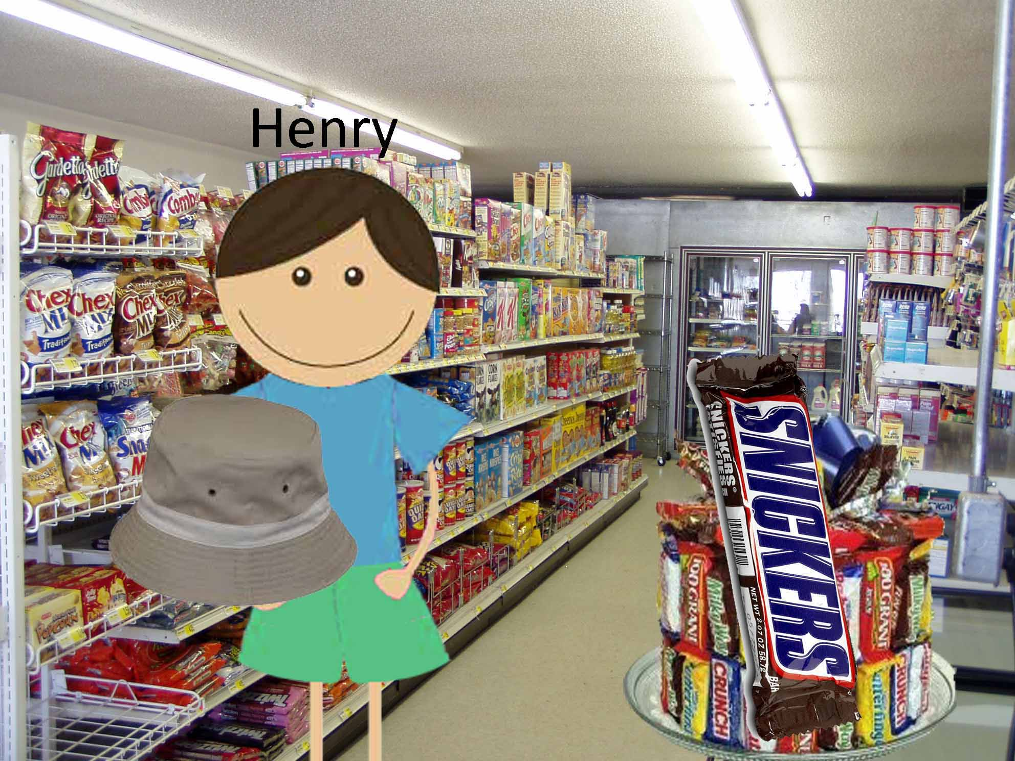

**2b.**

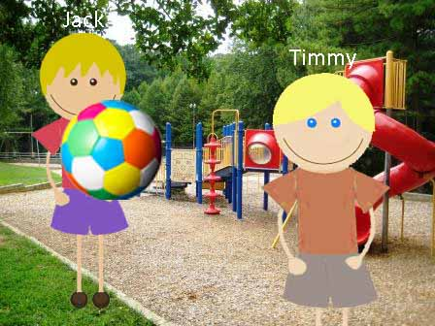

**3b.**

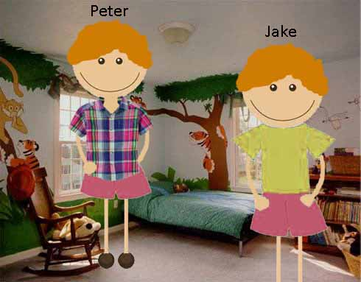

**4b.**

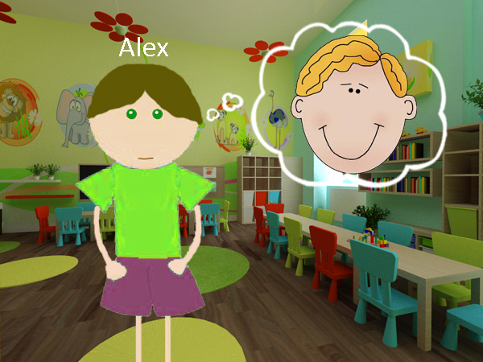

**5b.**

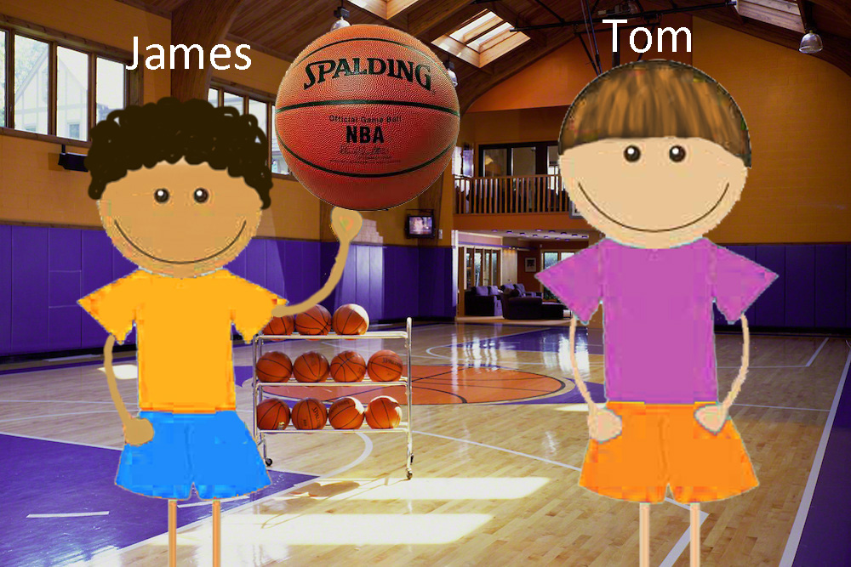

**6b.**

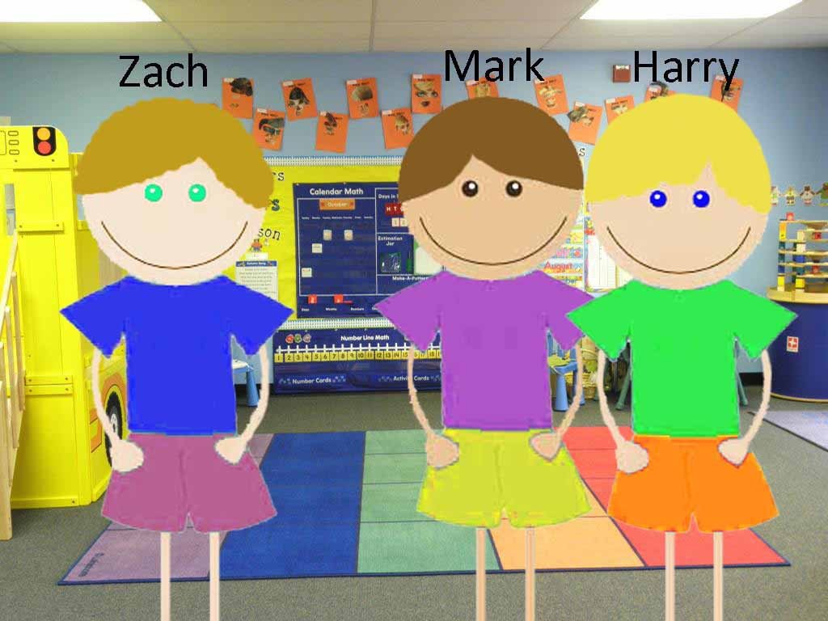

**7b.**

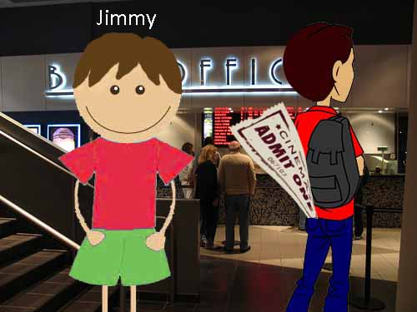

**8b.**

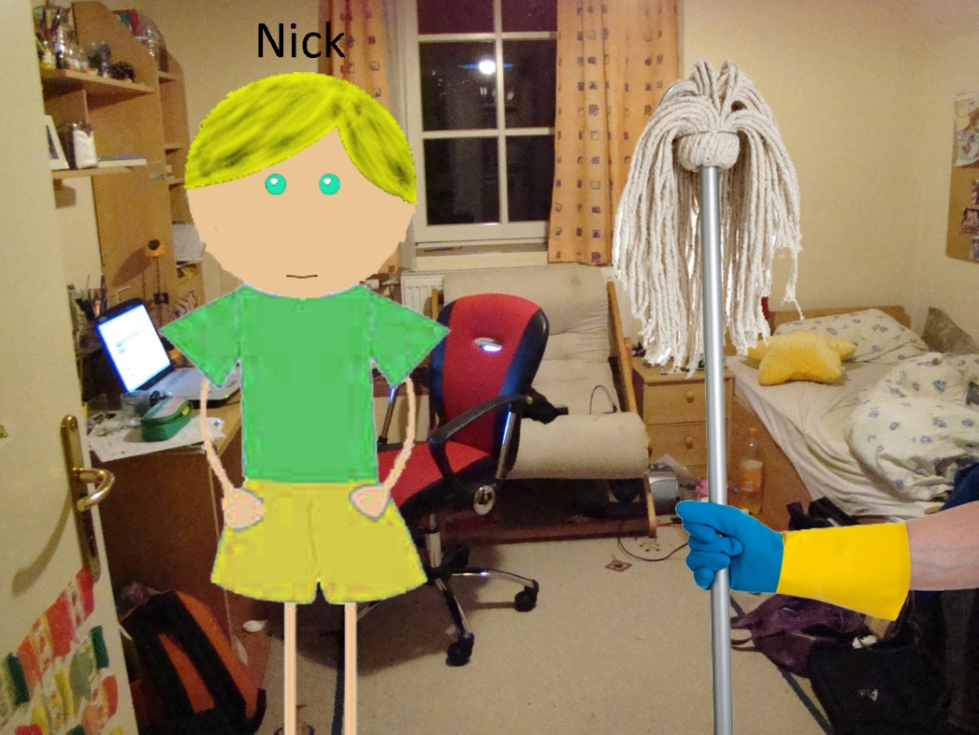

**1g.**

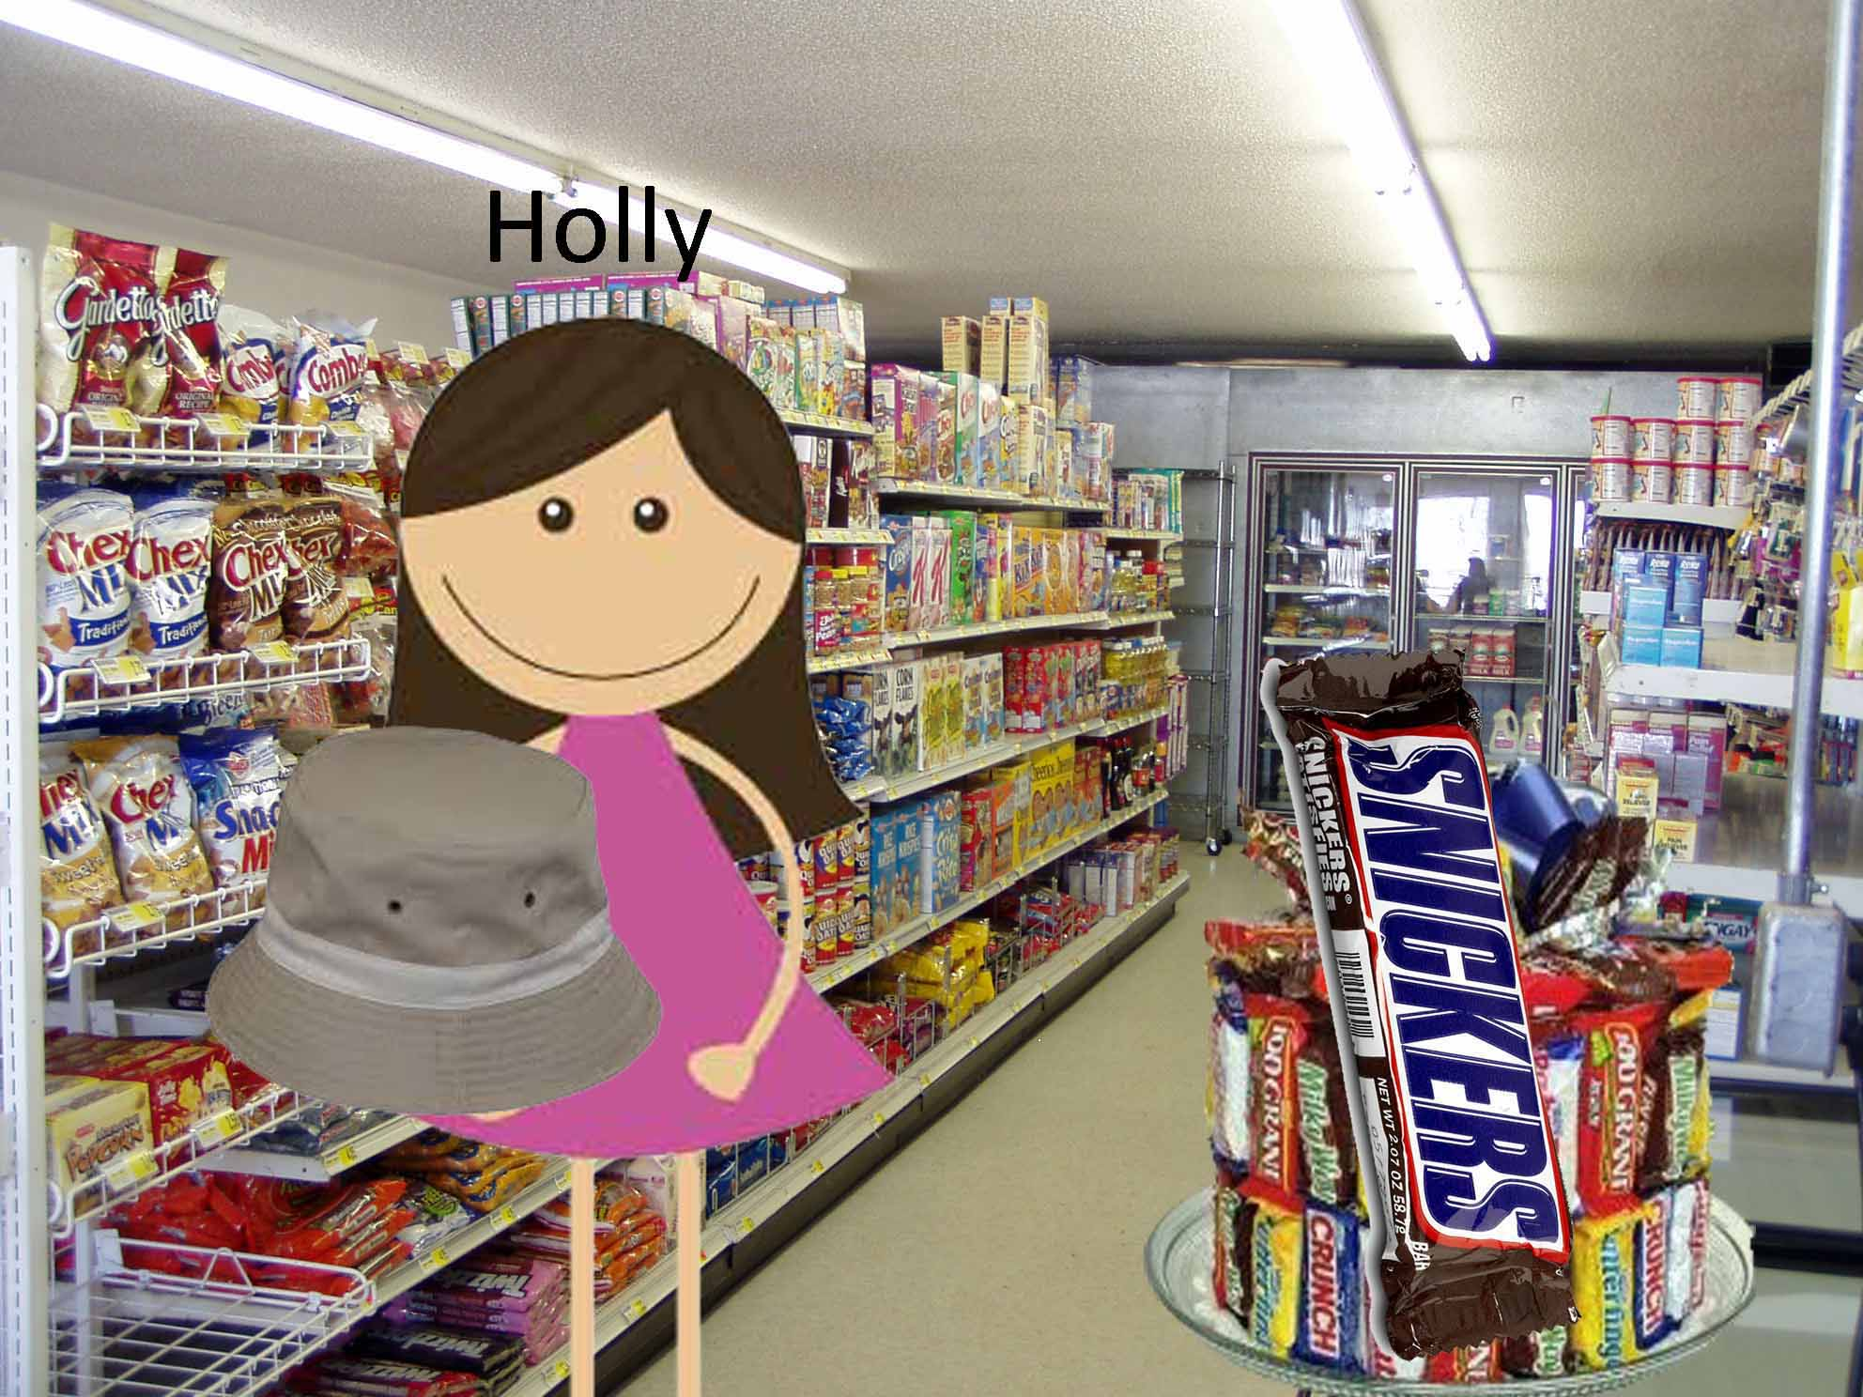

**2g.**

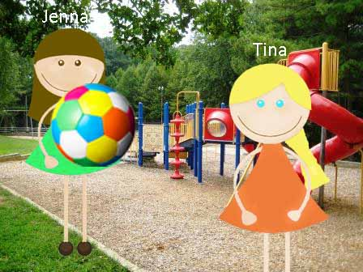

**3g.**

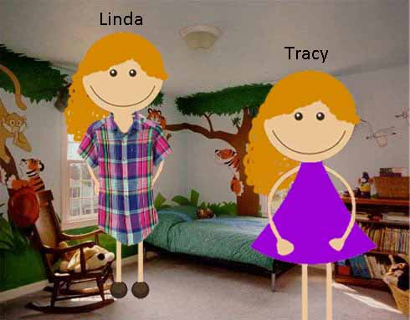

**4g.**

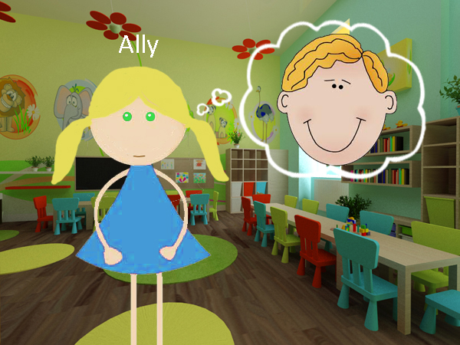

**5g.**

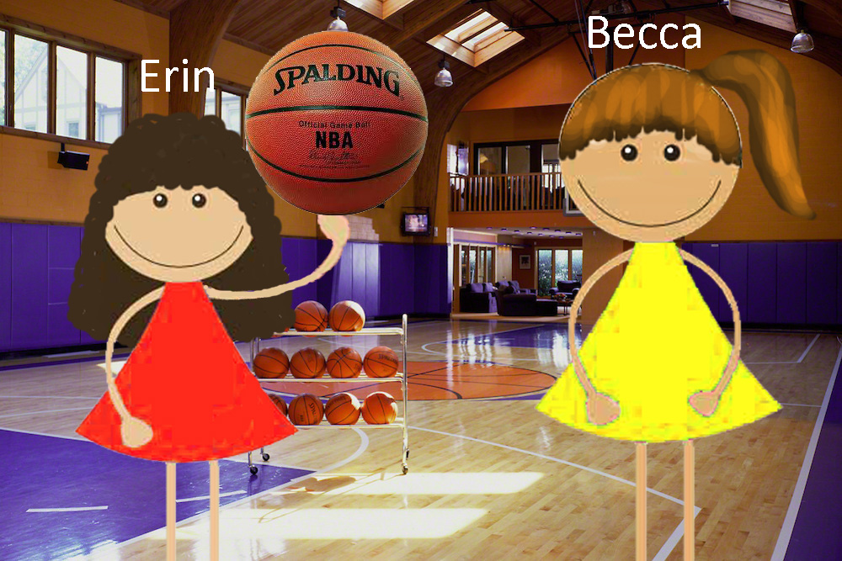

**6g.**

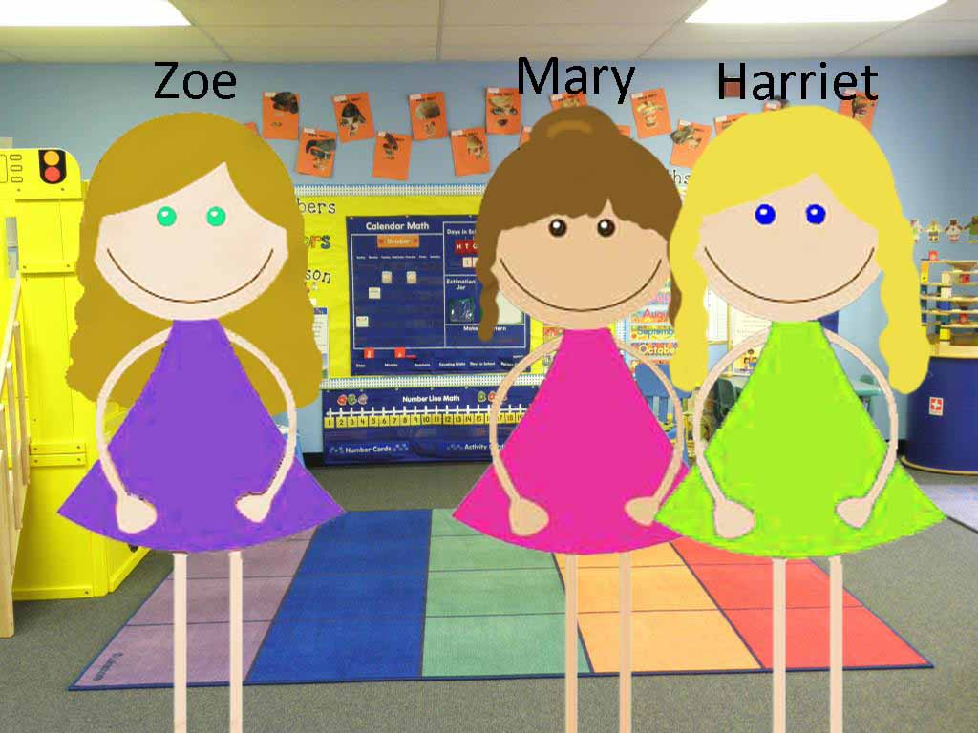

**7g.**

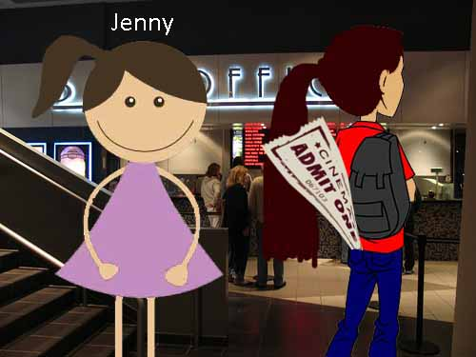

**8g.**

