RentalApp
Peer-to-Peer Library of Things
SET09102 - Software Engineering
Report detail | Value
Student | Justin Wylie
Matriculation number | 40535392
Target | 70% band: complete Tier 1 and Tier 2 plus advanced State Pattern
Submission date | 26 July 2026
Public GitHub URL | ADD PUBLIC URL BEFORE SUBMISSION

Evidence status
All source-based sections are populated and one real Near me screenshot is included. Before submission, add the public repository URL, seven remaining emulator captures, the coverage-report screenshot, and a green GitHub Actions run.

1. Project overview
RentalApp is a compact Android marketplace in which community members list useful items, find nearby listings, request rentals, progress a controlled rental workflow, and leave verified reviews. The implementation deliberately completes the brief's Tier 1 and Tier 2 requirements and adds the State Pattern and automatic overdue detection from Tier 3.

Submission claim
Evidence-based position
The source is shaped for the 70% band, but a grade is not guaranteed by feature count. The presentation is worth 50% of the module and requires the student to explain and defend the design. The final verified 86.4% line coverage exceeds the brief's 80% distinction testing threshold.

Technology stack
Area | Technology | Evidence
Client | .NET 10 / .NET MAUI | Android XAML, Shell, Secure Storage, GPS, address geocoding
API | ASP.NET Core 10 | Minimal API endpoints, JWT bearer authentication, Problem Details
Data | EF Core 10 | DbContext, migrations, repositories, Unit of Work
Spatial | PostgreSQL 16 + PostGIS | Geography point, SRID 4326, GiST, radius query
Quality | xUnit + Coverlet | 65/65 passing tests; 86.4% line coverage
DevOps | Docker Compose + GitHub Actions | Healthy local services, test/coverage job, signed APK job
Environment | VS Code Dev Container | .NET 10 Noble image and C# / Docker extensions

Report map
Architecture 3-6 | Features 7-9 | Testing 10-11 | CI/CD 12 | Patterns 13-14 | AI use 15 | References and final gates 16

2. Architecture documentation

2.1 Component diagram
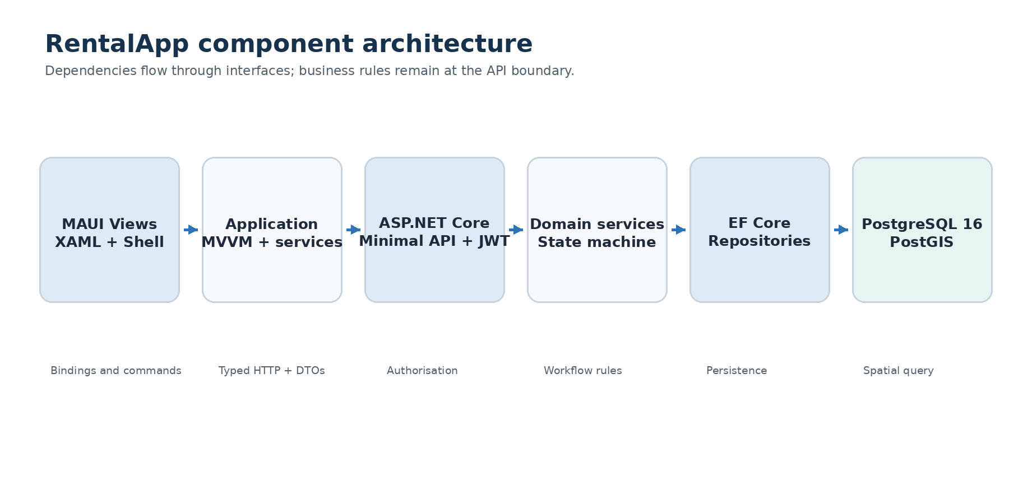
Figure 1. Component boundaries and dependency direction.
The mobile client never connects directly to PostgreSQL. Views bind to ViewModels, application services call the authenticated HTTP client, and the API owns security and business rules. EF Core repositories isolate persistence and spatial queries. This supports testability and a clear separation of concerns.
Design rationale
Interfaces keep Android concerns out of ViewModel tests, while the API remains the authoritative boundary even if a client bypasses the UI.

2.2 Database schema
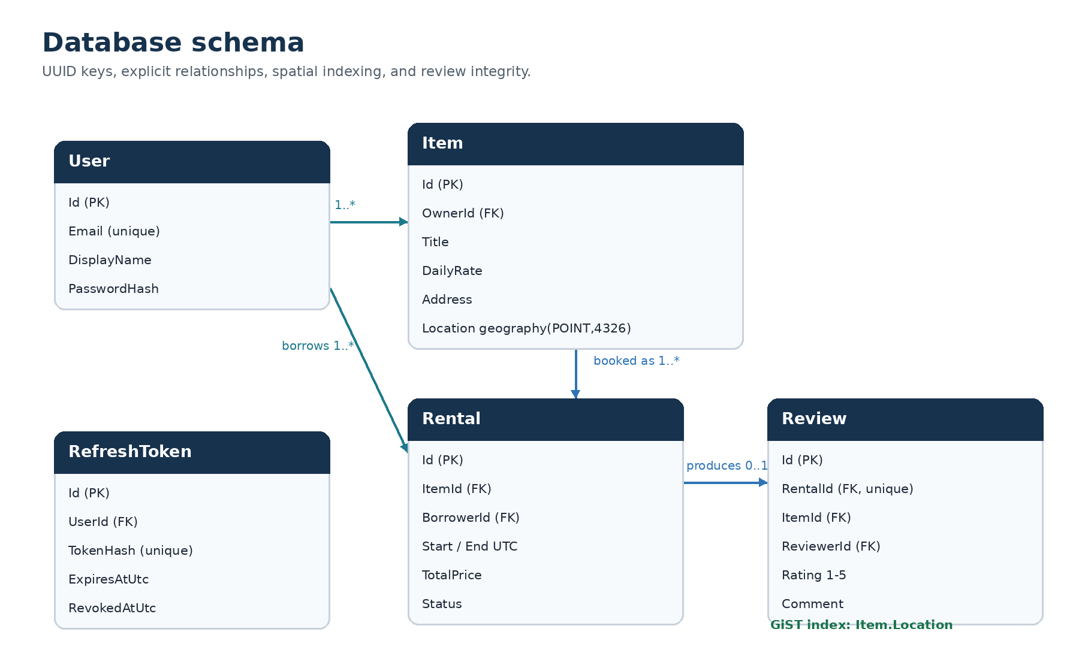
Figure 2. Core entities and integrity relationships.
Item.Address stores the readable collection address; the MAUI client forward-geocodes typed addresses or reverse-geocodes device GPS. Item.Location is mapped to geography (point, 4326), giving distance in metres. A GiST index supports the nearby predicate. Reviews have a unique RentalId and rating check constraint.

2.3 Rental request sequence
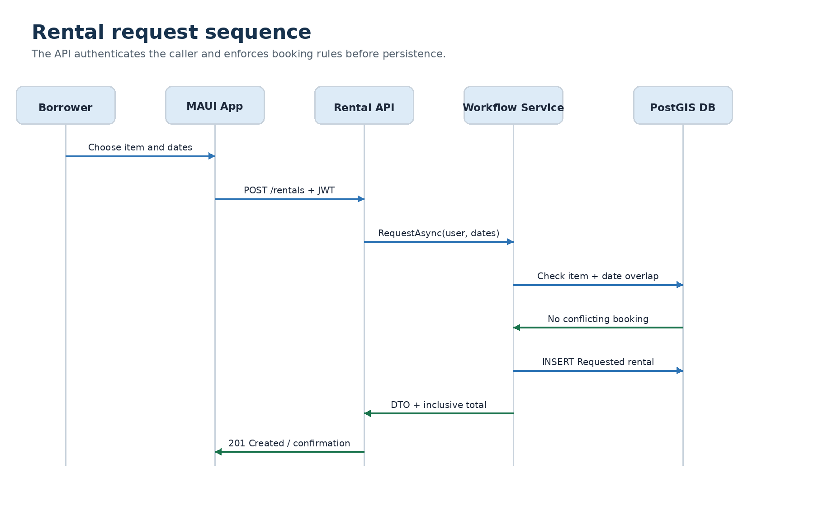
Figure 3. Successful rental request from the MAUI app to PostgreSQL.
RentalWorkflowService validates future dates, availability, self-rental, and inclusive overlap before calculating price and committing. The response includes the Requested status and total price. Exceptions are converted to consistent API errors and displayed by the ViewModel.

2.4 Rental state diagram
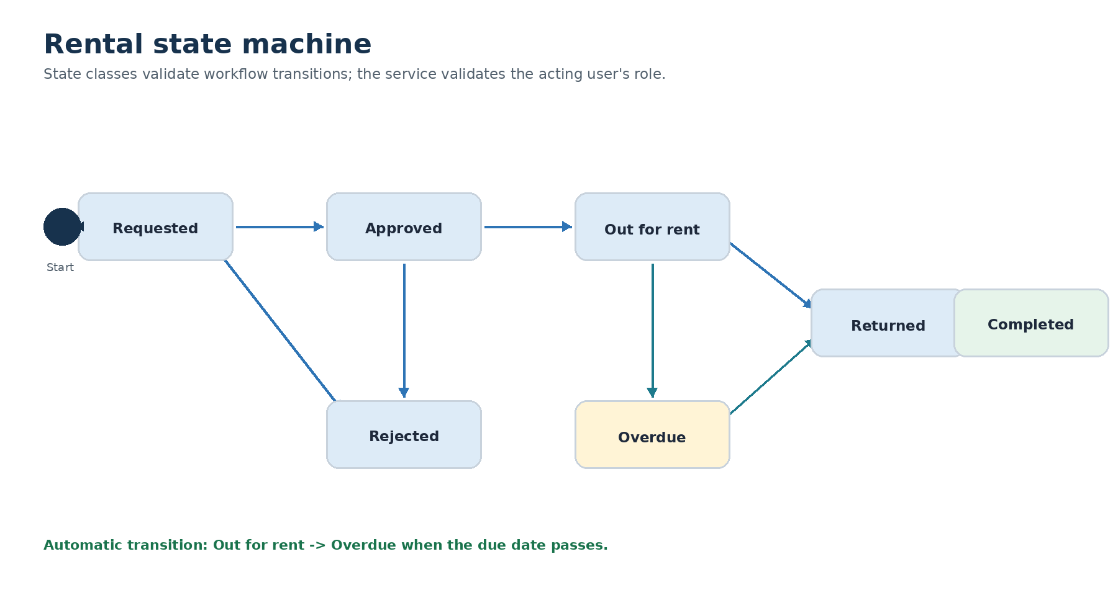
Figure 4. Permitted workflow transitions implemented by state classes.
Each state declares its permitted successors. Role authorisation is intentionally separate: owners approve, reject, start, and complete; borrowers return. The background overdue worker checks expired out-for-rent records and applies the same state machine.

3. Feature implementation checklist
Done | Requirement | Implementation evidence
YES | Registration and sign-in | Password hashing, JWT access token, rotating hashed refresh token
YES | Authenticated client | Bearer injection, refresh flow, Secure Storage, sign-out
YES | Item catalogue | Address entry/geocoding, create, browse, detail, owner edit, availability
YES | Nearby discovery | Address or GPS position, category/radius filters, distance result
YES | PostGIS | Geography point, GiST index, IsWithinDistance query
YES | Rental request | Future dates, inclusive price, self-rental and overlap prevention
YES | Rental workflow | Incoming/outgoing lists and role-aware actions
YES | Verified reviews | Borrower only, completed rental only, one review per rental
YES | MVVM | Observable ViewModels, RelayCommand, binding-first XAML
YES | Repository / Unit of Work | Generic plus item, rental, and review repositories
YES | Service Layer | Client services and API business services
YES | State Pattern | Seven state classes with parameterised transition tests
YES | Overdue detection | Hosted worker moves expired records to Overdue
YES | Testing | 65/65 tests and 86.4% line coverage, including HTTP/PostGIS integration
YES | CI/CD source | PR/push pipeline, PostGIS service, coverage artifact, signed APK
YES | Docker / Dev Container | Compose health checks and .NET 10 Noble environment
YES | Code documentation | XML summaries on key public contracts and 29 presentation-point comments
NO | MediatR / CQRS Lite | Optional; excluded to keep the system compact and explainable
NO | SonarCloud | Optional; coverage artifacts are implemented instead
Scope decision: the brief makes MediatR and SonarCloud optional. The implementation invests in a fully explained State Pattern, PostGIS integration test, mobile workflow, and reproducible deployment instead of adding optional infrastructure without evidence.

3.1 Feature screenshots - authentication and catalogue
Replace each marked evidence slot with a cropped emulator screenshot. Keep the caption and ensure user data contains no private credentials.
A. Login / registration  INSERT RUNNING-APP SCREENSHOT  Show both actions and validation feedback. | B. Browse items  INSERT RUNNING-APP SCREENSHOT  Show seeded catalogue and category filter.
C. Item detail / request  INSERT RUNNING-APP SCREENSHOT  Show rate, owner, reviews, and date selection. | D. Owner edit  INSERT RUNNING-APP SCREENSHOT  Show owner-only fields and availability control.

3.2 Feature screenshots - spatial, workflow, and review
E. Create item  INSERT RUNNING-APP SCREENSHOT  Show category, daily rate, address lookup, and confirmation. | F. Near me  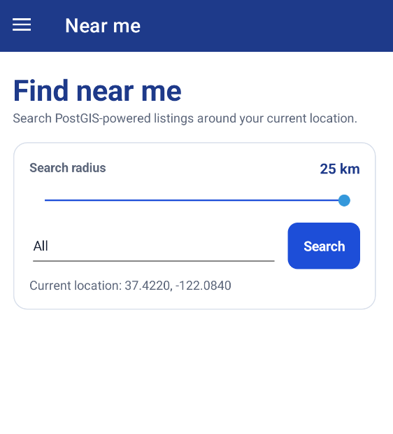  Real emulator capture showing radius/category controls and device coordinates.
G. Rental workflow  INSERT RUNNING-APP SCREENSHOT  Show incoming/outgoing status and valid action buttons. | H. Verified review / profile  INSERT RUNNING-APP SCREENSHOT  Show completed-rental picker and profile summary.
High-value demonstration
Use Mike to request, Sarah to approve/start, Mike to return/review, and Sarah to complete. This proves role-based actions and the state workflow rather than only static screens.

4. Testing documentation

4.1 Verified result and coverage
Verified Docker test run - 26 July 2026
65 total | 65 passed | 0 failed | 0 skipped | 16 seconds. Cobertura line coverage: 86.4%.

Distinction testing threshold met
The final build's measured 86.4% line rate exceeds the brief's 80% distinction threshold. Insert a screenshot/export of the Cobertura or generated HTML report as visual evidence.

Test group | Cases | Primary concern
RentalApiTests | 3 | Full authenticated HTTP workflows against PostGIS
ItemRepositoryTests | 1 | Real PostgreSQL/PostGIS radius integration
API client + client services | 11 | HTTP, refresh, auth, item, rental, and review routes
API application services | 19 | Validation, ownership, price, overlap, review, JWT, overdue
RentalStateMachineTests | 11 | 7 valid + 4 invalid transition cases
ViewModel tests (8 classes) | 20 | Busy/error state, role-aware commands, navigation, reviews, profile
Total: 65 cases across 19 test classes. Theory and InlineData cases are counted as executed xUnit cases.

4.2 Representative test excerpts
Example 1 - parameterised State Pattern test
[Theory]
[InlineData(RentalStatus.Requested, RentalStatus.Approved)]
[InlineData(RentalStatus.OutForRent, RentalStatus.Overdue)]
[InlineData(RentalStatus.Returned, RentalStatus.Completed)]
public void EnsureValidTransition_AllowedTransition_DoesNotThrow(
RentalStatus current, RentalStatus next)
{
var exception = Record.Exception(
() => _machine.EnsureValidTransition(current, next));
Assert.Null(exception);
}
Example 2 - business rule test
[Fact]
public async Task RequestAsync_OverlappingDates_RejectsSecondRequest()
{
var data = await SeedUsersAndItemAsync(context);
var start = DateTimeOffset.UtcNow.Date.AddDays(4);
await service.RequestAsync(data.Borrower.Id,
new(data.Item.Id, start, start.AddDays(2)));
await Assert.ThrowsAsync<BusinessRuleException>(() =>
service.RequestAsync(data.SecondBorrower.Id,
new(data.Item.Id, start.AddDays(1), start.AddDays(3))));
}
Example 3 - real PostGIS integration test
[Fact]
public async Task GetNearbyAsync_ItemsInsideAndOutsideRadius_ReturnsOnlyNearbyItem()
{
var results = await repository.GetNearbyAsync(
55.9533, -3.1883, 2, ItemCategory.Tools);
Assert.Contains(results, x => x.Item.Id == nearby.Id);
Assert.DoesNotContain(results, x => x.Item.Id == distant.Id);
Assert.All(results, x => Assert.InRange(x.DistanceMetres, 0, 2_000));
}
The tests follow Arrange-Act-Assert, use descriptive names, and combine fast in-memory/mocked tests with one real spatial database fixture where an in-memory substitute would not prove translation to PostGIS.

5. CI/CD evidence
The workflow runs on pushes and pull requests to main. The backend job starts PostgreSQL 16 with PostGIS, restores, builds, executes tests, creates HTML/Cobertura/text coverage, and uploads evidence. A separate Android job installs Java and the MAUI workload, creates an ephemeral coursework signing key, publishes a signed Release APK, and uploads it.
.github/workflows/build.yml (abridged)
on:
push:
branches: [main]
pull_request:
branches: [main]
jobs:
backend-tests:
services:
postgres:
image: postgis/postgis:16-3.5-alpine
steps:
- run: dotnet test RentalApp.Test/RentalApp.Test.csproj
-c Release --no-build --collect:"XPlat Code Coverage"
- uses: actions/upload-artifact@v4
android-build:
steps:
- run: dotnet workload install maui-android
- run: dotnet publish RentalApp/RentalApp.csproj
-c Release -f net10.0-android
- uses: actions/upload-artifact@v4
INSERT GREEN WORKFLOW SCREENSHOT
Capture the GitHub Actions run showing both backend-tests and android-build green. Also download the test-results-and-coverage and rentalapp-android artifacts. A workflow file alone earns only half of the CI/CD report evidence marks.

6. Design patterns implementation

6.1 MVVM
Views define layout and bind to observable state. ViewModels expose commands and depend on abstractions, so catalogue behaviour can be tested without a page or emulator. Generated ObservableProperty and RelayCommand members reduce repetitive notification code.
MVVM example - ItemsListViewModel
public partial class ItemsListViewModel(
IItemService items, INavigationService navigation) : ViewModelBase
{
public ObservableCollection<ItemSummaryDto> Items { get; } = [];
[RelayCommand]
private Task LoadAsync() => RunBusyAsync(async () =>
{
var results = await items.GetAllAsync(category);
Items.Clear();
foreach (var item in results) Items.Add(item);
});
}

6.2 Repository and Unit of Work
Repositories centralise EF Core expressions and eager-loading choices. The Item repository is the only layer that knows the spatial predicate. Unit of Work provides one explicit SaveChanges boundary for service operations.
Repository example - PostGIS radius query
var origin = new Point(longitude, latitude) { SRID = 4326 };
var radiusMetres = radiusKilometres * 1_000;
var results = await Context.Items
.AsNoTracking()
.Where(item => item.IsAvailable &&
item.Location.IsWithinDistance(origin, radiusMetres))
.Select(item => new {
Item = item,
DistanceMetres = item.Location.Distance(origin)
})
.OrderBy(result => result.DistanceMetres)
.ToListAsync(cancellationToken);

6.3 Service Layer
RentalWorkflowService is the authoritative use-case layer. It coordinates repositories, validates rules, calculates inclusive price, checks actor permissions, invokes the state machine, and commits. Endpoints remain thin and ViewModels cannot bypass these rules.
Service example - validation and inclusive pricing
if (item.OwnerId == borrowerId)
throw new BusinessRuleException("You cannot rent your own item.");
if (await rentals.HasDateOverlapAsync(item.Id, start, end, cancellationToken))
throw new BusinessRuleException("The item is already booked for those dates.");
var numberOfDays = (end.Date - start.Date).Days + 1;
var rental = new Rental {
ItemId = item.Id,
BorrowerId = borrowerId,
StartDateUtc = start,
EndDateUtc = end,
TotalPrice = item.DailyRate * numberOfDays
};

6.4 State Pattern (advanced)
A state object owns the allowed outgoing transitions for one RentalStatus. Adding a state or transition is localised instead of extending a large conditional. RentalWorkflowService separately checks roles, preserving single responsibility.
Advanced pattern example - explicit state classes
public abstract class RentalState : IRentalState
{
private readonly HashSet<RentalStatus> _allowed;
protected RentalState(params RentalStatus[] allowed)
{
_allowed = new HashSet<RentalStatus>(allowed);
}
public abstract RentalStatus Status { get; }
public bool CanTransitionTo(RentalStatus next)
{
return _allowed.Contains(next);
}
}
public sealed class OutForRentState : RentalState
{
public OutForRentState()
: base(RentalStatus.Overdue, RentalStatus.Returned) { }
public override RentalStatus Status => RentalStatus.OutForRent;
}

7. AI tool usage
Tools used: ChatGPT Codex for architecture, implementation support, refactoring, test design, debugging, and documentation review; Visual Studio Code C# Dev Kit for compiler diagnostics, navigation, and debugging.
Interaction | Suggestion | Evaluation / modification | Validation
Architecture | Separate MAUI, application, API, data, migrations, and test projects. | Accepted for testability and security. Rejected optional MediatR/SonarCloud to control scope. | Build, dependency, service, and integration tests.
Spatial search | Use SRID 4326 Point, geography column, GiST, and IsWithinDistance. | Checked X=longitude, Y=latitude; validated coordinate/radius bounds. | Real PostGIS fixture returns near item only.
Rental workflow | One class per state; keep role checks in the service. | Accepted to demonstrate Open/Closed design; overlap and inclusive-price rules retained. | Theory tests plus price, overlap, role, and overdue tests.
Android debugging | Use Logcat to diagnose splash exit and details crash. | Changes tied to observed stack traces: embed assemblies, correct App initialisation, harden route. | Clean rebuild/install and focused ViewModel tests.
Address entry | Forward-geocode typed addresses and reverse-geocode GPS. | Store readable address plus validated PostGIS point; remove raw coordinate fields from UI. | ViewModel and authenticated API workflow tests.
Unified accounts and review UX | Derive actions from listing-creator/requester relationships and carry review counts through DTOs. | Kept every API ownership and requester check; the UI is helpful but is not the security boundary. | Final regression: 65/65 tests and 86.4% coverage.

Reflection
AI accelerated repetitive implementation and exposed alternatives, but it did not replace engineering judgement. Suggestions were narrowed to an explainable scope, compiled with warnings as errors, and tested at the appropriate boundary. Database and Android defects were diagnosed from evidence instead of accepting speculative changes. In the presentation, the student must explain every excerpt above and the trade-offs behind it.

8. References
- Microsoft (2026), .NET MAUI documentation
- Microsoft (2025), Spatial data in Entity Framework Core
- Microsoft (2025), Configure JWT bearer authentication in ASP.NET Core
- PostGIS Project, ST_DWithin reference
- NetTopologySuite project, API documentation
- xUnit.net, Getting started with xUnit.net v3
- Docker, Docker Compose documentation
- GitHub, Building and testing .NET

Final evidence gate before PDF submission
- Add the public GitHub URL to the cover and verify it while signed out.
- Replace the seven remaining screenshot evidence slots with actual emulator captures.
- Insert the coverage-report screenshot showing the verified 86.4% line rate.
- Insert a screenshot of one green GitHub Actions run with both jobs visible.
- Confirm the public repository contains source, tests, workflow, README, and genuine commit history.
- Export to PDF and verify it remains under the 20-page limit.
- Rehearse the eight-minute demonstration and explain the four patterns without reading notes.
Current honest status
Source: 70%-targeted and presentation-readable. Tests: 65/65 passing with 86.4% line coverage. One real emulator screenshot is included. Remaining: final live workflow check, public GitHub URL/history, green workflow evidence, seven app screenshots, coverage screenshot, and oral defence.

