**1.Link to Our Video :** <http://www.youtube.com/watch?v=rwX8g4dKJdE&feature=youtu.be>

2. Files that we have created :

a) AdrenalinAgent.py

b) UtiltiyAgent.py

3. Agent files already present in the framework - baselineTeam.py

**Instructions to play the game from keyboard:**

1. go to command prompt and set the project directory.

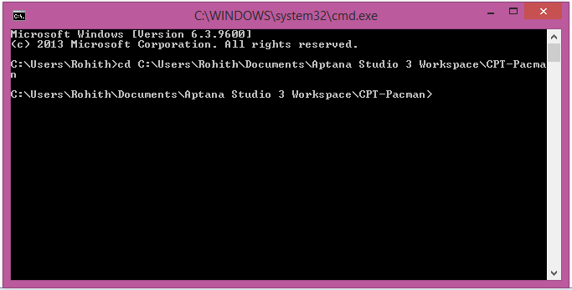

1. Now execute the following command.

capture.py --keys0

capture.py --keys1 (to play as Red Team)

capture.py --keys2

capture.py --keys3 (to play as Blue Team)

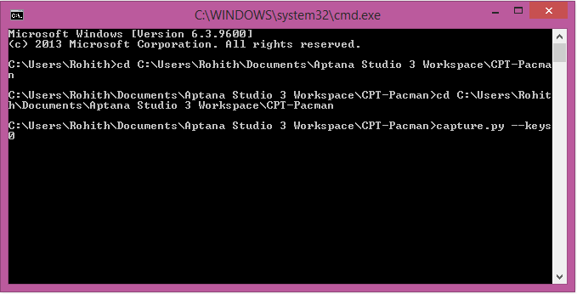

**Instructions to change in Agents in the code:**

1. Open the 'capture.py' file in the project and go to "readCommand( argv ):" definition. Below you can see the agents for the red and blue teams.

We created AdrenalinAgent and UtilityAgent. So to test it, just replace either AdrenalinAgent or baselineTeam seen in the below code with the agents we created. By default we are adding AdrenalinAgent.



2. If you want to make a team of AdrenalinAgent and UtilityAgent then open the UtilityAgent.py.

* Add the following code in the imports section .

**from** AdrenalinAgent **import** AdrenalinAgent

* Below imports find the following definition.



* Change either first or second to AdrenalinAgent.



* Now save it and run capture.py

**Instructions to change fps(frames per second) of the game:**

1. Open capture.py and go to definition 'readCommand( argv )' definition.

2. Below find the option to change fps.



3. Change the fps value in default attribute.



**Reference:**

Background Score: UT 2004 Soundtrack - Deck17/Hyperblast Theme

<http://www.youtube.com/watch?v=Aup9SAnt6lQ>