**Computationally analyzing strategic probabilities of the dice game in RISK**

Justin Zhao, Columbia University, New York, NY 10027

**This report investigates the probabilities of dice game battles in the popular Risk board game beyond the rigid and theoretical mathematical work of previous scientists’ investigations. With computer science, we are able to examine a larger-scale picture of the dice game by changing and manipulating various parameters and can further understand the conquering of territories in Risk and reveal insights previously unaddressed or undiscovered. I verify previous theoretical mathematical results, confirm classic Risk strategies, but also discuss the design of the board game, providing new strategic insights by examining the consequences of rule manipulation.**

*Risk* is a strategic board game produced by Parker Brothers, now a division of Hasbro. It is aturn-based game for two to six players, played on a board depicting a political map of the Earth, divided into forty-two territories, grouped into six continents. The primary object of the game is "world domination," or "to occupy every territory on the board and in so doing, eliminate all other players." Starting with some initial number of troops, players use these armies to capture territories from other players. Niceties of Risk such as turn stages, collecting and trading in Risk cards, fortifying, and continent bonuses aside, however, the results of these battles to conquer territories is based on a simple game of dice.

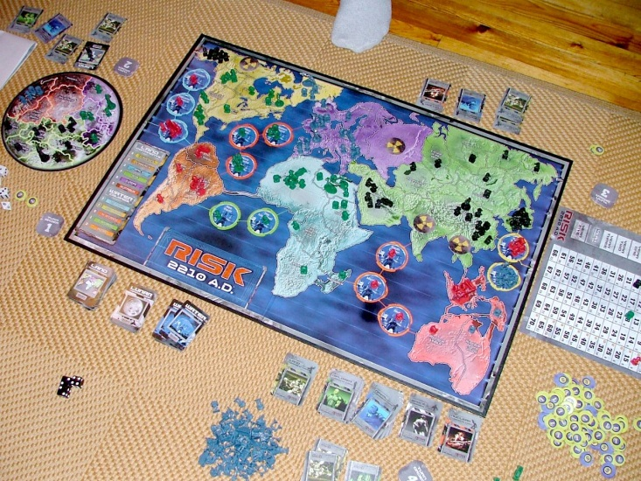

Mathematicians and statisticians, students and research scientists alike, show great interest in the mathematical aspects of the Risk dice game. In general, modeling games is interesting because of how these models and trends appear in simple real life situations. In regards to Risk, mathematicians ask the classic questions: What is the probability that if you attack a territory, you will capture that territory? If you engage in war, what is the expected number of losses based on the number of defending armies on that territory?

People like Jason Osborne in his paper “Markov Chains for the RISK Board Game Revisited” or Sharon Blatt in her paper “RISKy Business: An In-Depth Look at the Game Risk” describe relatively similar mathematical models to answer these questions – something to do with Markov-chains, state-space models, and probability matrices. Unfortunately, what these papers don’t realize is that these rigid and static, hard, thought-out mathematical and theoretical models become inflexible if we manipulate and change the game. While their level of comprehension is more than sufficient for the specific rules of Risk, but what if a rule is changed? What if we play the game differently?

Herein lies my motivation for embarking on this project. I will attempt to understand Risk in a way that no mathematical model has and hopefully, I will offer further perceptive insights into Risk world domination strategy or even how Risk was designed as a game.

**The dice game**

Quoted from the rulebook, I’ve summarized some key details of the Risk dice game:

1. “Before rolling, both you and your opponent must announce the number of dice you intend to roll, and you both must roll at the same time.”
2. “The attacker will roll 1, 2 or 3 red dice: You must have at least one more army in your territory than the number of dice you roll.”
3. “The defender will roll either 1 or 2 white dice: To roll 2 dice, he or she must have at least 2 armies on the territory under attack.”

To decide a battle, the players compare the highest die each rolled. If the attacker’s is higher, the defender loses one army from the territory under attack. But if the defender’s die is higher, the attacker loses one army from the attacking territory. If both players rolled more than one die, “now compare the next-highest die and repeat the process”.

*The Essential Rule*

This dice game, at first, seems greatly rigged for the attacker. In the simplified case of just one die versus the other, the probability of the attack or defense winning the battle is exactly 50%. The attacker, however, has the power to use more dice than the defense to obtain the highest dice values. If the attack were to roll three dice and the defense two, it is much more likely for one of the attacker’s rolls to be higher than one of the defender’s.

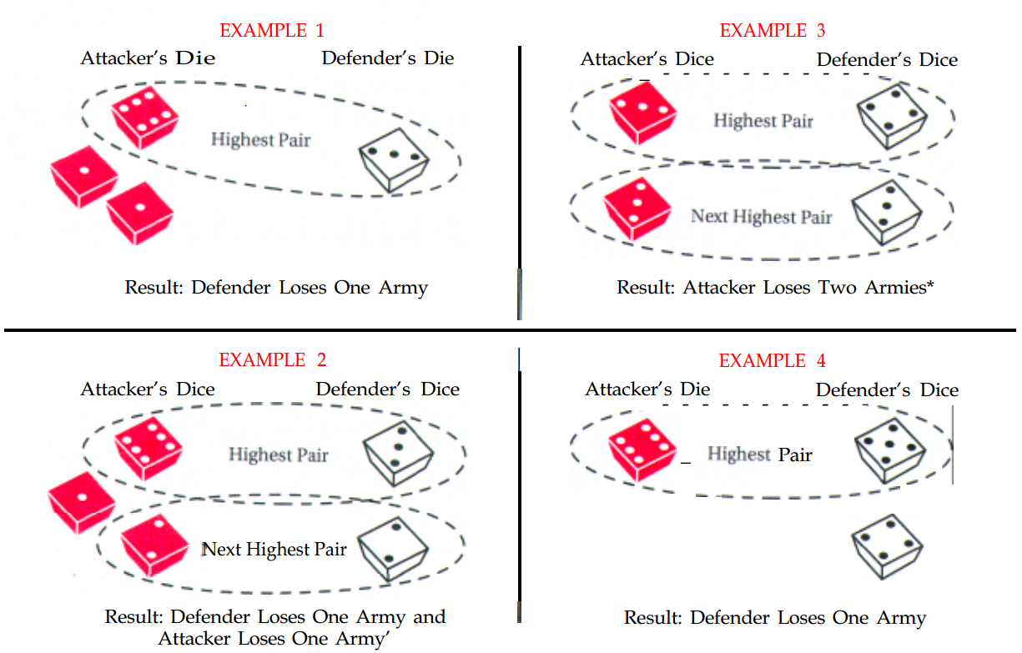

**Figure 1.** Dice game examples based on traditional RISK rules.

Arguably the most frustrating rule for attackers in Risk, however, is this: “*In the case of a tie, the defender always wins*”. Below is an example of a Risk battle.

|  |  |  |  |  |  |  |  |  |
| --- | --- | --- | --- | --- | --- | --- | --- | --- |
| Roll # | #. Armies | | # Dice Rolled | | Outcome | | # Losses | |
|  | Attacker | Defender | Attacker | Defender | Attacker | Defender | Attacker | Defender |
| 1 | 4 | 3 | 3 | 2 | 5,4,3 | 6,3 | 1 | 1 |
| 2 | 3 | 2 | 3 | 2 | 5,5,3 | 5,5 | 2 | 0 |
| 3 | 1 | 2 | 1 | 2 | 6 | 4,3 | 0 | 1 |
| 4 | 1 | 1 | 1 | 1 | 5 | 6 | 1 | 0 |
| 5 | 0 | 1 |  |  |  |  |  |  |

**Figure 2.** Example of a series of battles based on traditional RISK rules.

Here, we can define all the parameters of the dice game.

1. The number of attacking dice (red)
2. The number of defending dice (white)
3. The number of dice that are considered (all common dice). If the attack rolls 1 dice vs. 2 defense dice, the number of dice that are considered for battle is just 1.

**Research questions**

I’ve listed a few research questions, classic and not, I hope to answer.

1. What is the probability that if you attack a territory, you will capture that territory? If you engage in war, what is the expected number of losses based on the number of defending armies on that territory?
2. How do probabilities change when we change different parameters? The number of attacking dice? The number of defending dice? The maximum value of the dice?
3. Why did Hasbro allow attackers 3 and defenders 2 dice? Why these numbers, why these limits? Why not more? Why not less? Are there any problems with 3 vs. 2? Is there a better option to make things more fair? Less fair? How or how not?
4. How many troops does an attacker need to comfortably take over another country? Is it smarter to split up troops or to keep them hoarded in a single place?

**Methods**

*Programming Language*

Although I am a big fan of Java and Mathematica, this summer, I conducted research in the field of Quantum Photonics. My project involved a decent amount of coding in MATLAB. As my most refreshed programming language, MATLAB proved to be a convenient and fast way for this kind of dice program, quickly calculating the statistics of the dice game over many trials.

*Design and Details*

I’ve written two main programs to answer my research questions. Both of these programs are designed to be Monte-Carlo simulators. I generate random numbers using MATLAB’s random number generator, which should be pretty good.

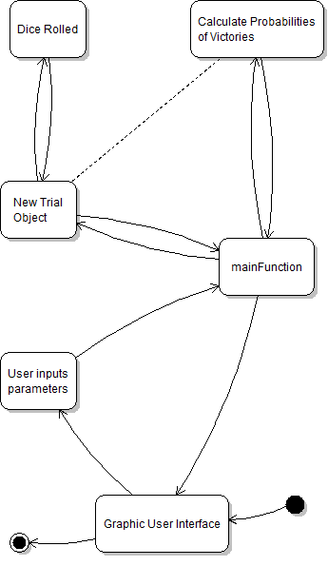

**Figure 3.** UML state diagrams for MATLAB RISK programs. Program design and functionality are explained in greater detail in the *Supplementary Information* section.

**Results and observations**

From a general Risk standpoint, I see it as two “forces” that control the ultimate outcome of a series of battles. The first is very obvious, the raw number of troops on both sides before a battle begins. The second, however, is less so – how each individual battle of the dice game is set-up (the number of dice each player rolls, i.e. 3v2, 2v2, 1v2 or 1v1). Each of these possible dice battles craft significantly different probabilities of what the outcome of the individual battle will be. All individual battles together decides the winner of the entire series of battles (the country is conquered or the country isn’t). While attackers do not always have to keep battling until a final conclusion is reached, the successful conquering of the defending country is the ultimate goal, and that is what I will be investigating. These probabilities have been heavily investigated by mathematicians and statisticians.

In order to calculate these winning probabilities, let’s start with a simple scenario. What is the probability of the attack winning the dice game in 1 dice versus another? This is pretty simple to calculate mathematically, so I’ll do it here:

|  |  |  |  |  |  |
| --- | --- | --- | --- | --- | --- |
| Dice Value | Chance of it appearing (P) | Chance of Defense Beating it (Q) | Chance of Defense Not Beating it (R) | Probability of Defense Winning:  (P X Q) | Probability of Attack Winning:  (P X R) |
| 1 | 1/6 | 1 | 0 | 1/6 | 0 |
| 2 | 1/6 | 5/6 | 1/6 | 5/36 | 1/36 |
| 3 | 1/6 | 2/3 | 1/3 | 1/9 | 1/18 |
| 4 | 1/6 | 1/2 | ½ | 1/12 | 1/12 |
| 5 | 1/6 | 1/3 | 2/3 | 1/18 | 1/9 |
| 6 | 1/6 | 1/6 | 5/6 | 1/36 | 5/36 |
|  |  |  | Sum: | **7/12** | **5/12** |

**Figure 4.** Probability of dice game outcome, 1 vs. 1.

As expected, the attack is more likely to lose because any and every tie counts as a victory for the defense. The difference between win and loss is one-sixth, which also makes sense because there are 6 instances in the 36 total possibilities from the rolling of two dice that the two dice are tied (1-1, 2-2, 3-3, … 6-6). My simulator shows nearly identical results.

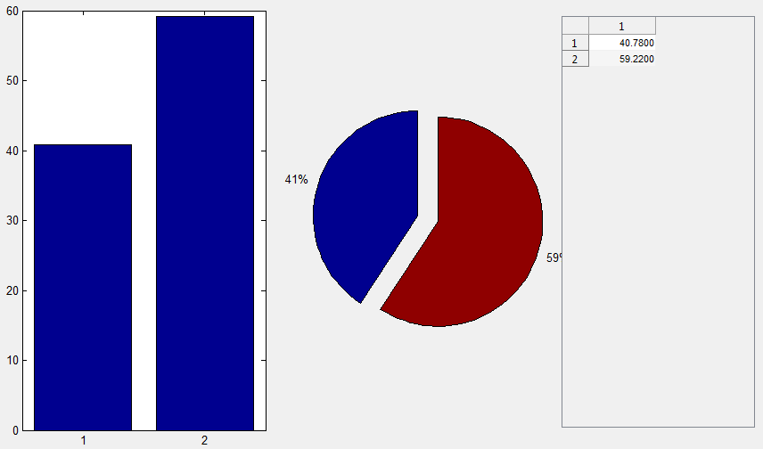

**Figure 5.** Simulated probability of dice game outcome, 1 vs. 1.

If we calculate this same probability for multiple dice, however, the math begins to get quite complicated. We must remember that for a certain dice value to be considered in battle, it has to be either the highest or second highest dice value, and it only has to appear once in all the dice that you roll. For example, if the attacker rolls a 3, 1, and a 5, the highest value of the three rolls is the 5 while the second highest is the 3. The 1 is removed from consideration because we only consider two dice. The 5 and the 3 only need appear once in the three rolls to be candidates for being considered. How complicated is this probability calculation? We start by calculating the probability of getting at least one of number X with two dice.

|  |  |  |
| --- | --- | --- |
| **Roll 1** | **Roll 2** | **Both Rolls** |
| 5/6 | 5/6 | 25/36 |

**Figure 6.** Probability of not rolling some number X in two rolls on a 6-sided die.

The chance of not rolling X on both rolls is 25/36, so the chance of rolling X on at least one roll is 1 minus that, or 11/36. Notice that 11/36 is significantly higher than what the chance was to roll X at least once with one dice, 1/6. The probability of rolling some number X at least once becomes much more likely with more dice.

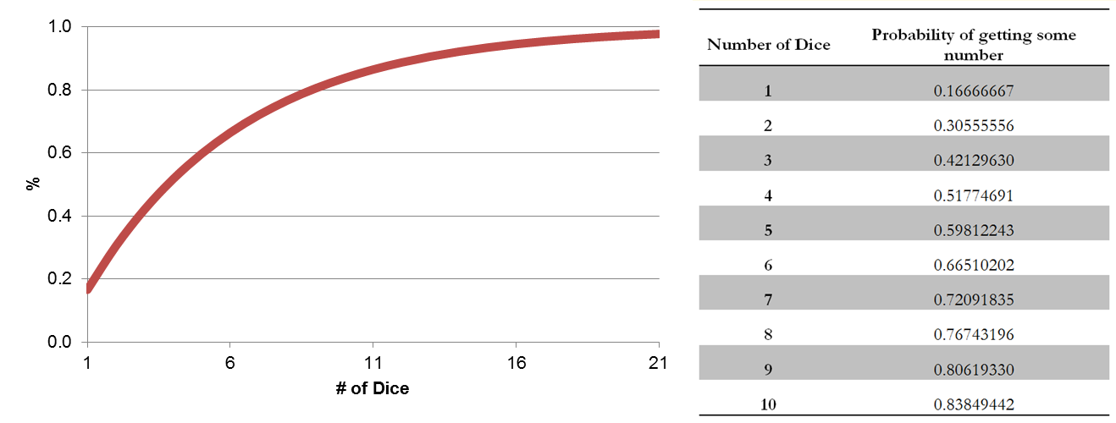

**Figure 7.** Probability of rolling some number X on a 6-sided die with an increasing number of dice.

We can generalize this probability of rolling X in ‘q’ rolls with an ‘n’-sided die.

In just 20 rolls or so, the chance of rolling some number X at least once is nearly 100%. This makes sense because the chance that you don’t see, say, a single ‘6’ in 20 rolls is very small.

Just because a dice value is rolled, however, doesn’t mean it is counted and included for battle. The chance that in my two dice that I roll a 1 is 11/36, but the chance that the 1 will actually be my highest dice value is actually just 1/36 because I only have a 1/6 chance that my second dice roll will not be higher than that first dice roll.

|  |  |  |  |  |  |  |  |
| --- | --- | --- | --- | --- | --- | --- | --- |
| # of Dice |  | 1 | 2 | 3 | 4 | 5 | 6 |
| 1 | 1st largest | 1/6 | 1/6 | 1/6 | 1/6 | 1/6 | 1/6 |
| 2 | 1st largest | 1/36 | 1/12 | 5/36 | 7/36 | ¼ | 11/36 |
|  | 2nd largest | 11/36 | 1/4 | 7/36 | 5/36 | 1/12 | 1/36 |
| 3 | 1st largest | 1/216 | 7/216 | 19/216 | 37/216 | 61/216 | 91/216 |
|  | 2nd largest | 2/27 | 5/27 | 13/54 | 13/54 | 5/27 | 2/27 |

**Figure 8.** The probability distributions of the maximum of one, two, three dice, and the second largest number of two and three dice.

**Review of literature**

From these fundamental calculations of the dice game probability distributions, mathematicians have created complicated generalized models to handle any combination of the dice game based on traditional RISK rules, popularly using a Markov chain.

A Markov chain is a mathematical model used to describe an experiment that is performed multiple times in the same way where the outcome of each trial of the experiment falls into one of several specified possible outcomes. The Markov chain can be used to create a state-space model, a sequence of probability vectors that describe the state of the system at a given time.

Osborne sets up his Markov chain like so: Let A be the total number of attacking armies and D be the total number of defending armies. The state of the system at the beginning of each battle is described in terms of A and D. Let Xn be the state of the system at the beginning of the nth turn in the battle where an is the number of attacking armies and dn is the number of defending armies:

With the initial state of the system . The probability that the system goes from one state at turn *n* to another state at turn *n*+1 given the history before turn *n* depends only on , so that forms a Markov chain:

States where both and are positive are transient while states where either or are absorbing. Transient states are ordered:

Absorbing states are ordered:

And using this order, the transition probability matrix takes on the form:

Where the matrix contains the probabilities of going from one transient state to another and the matrix contains the probabilities of going from a transient state into an absorbing state. This mathematical model considers the probability distributions of the maximum of one, two, and three dice and of the second largest number of two and three dice shown in Figure 9.

Originally proposed by Baris Tan, this mathematical model is argued by Osborne to have been used incorrectly initially because Tan made the mistake of assuming that dice events are independent, while in Risk, the dice values are ordered before comparison, and thus dependent. This minor mistake aside, however, both Tan’s and Osborne’s model uses this “transition probability matrix” to calculate not just the probability of certain dice values being rolled, but also the probability of winning a battle and what losses to expect.

**Simulation verification**

The first step of testing my simulator is to test it against the literature. If our probability results match-up, not only is it a good check for the theory in the literature, but it also validates my simulator. The “Simulated Probability” results are derived from the outcomes of 100,000 trials.

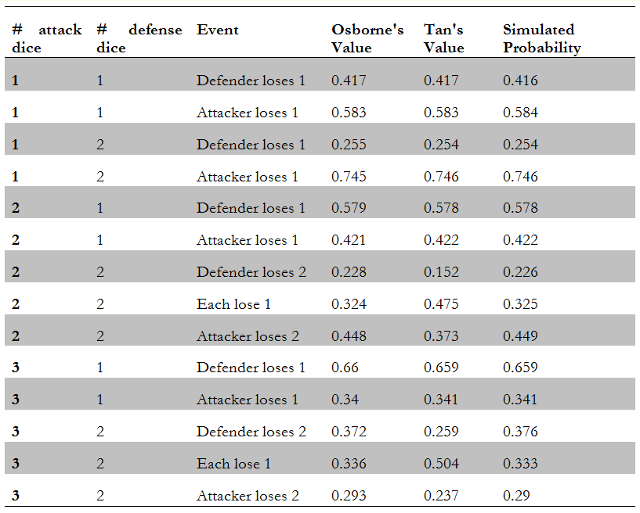

**Figure 9.** Probabilities making up the transition probability matrix.

My simulator immensely agrees with Osborne’s calculations, only ever differing by no more than 4 tenths of a percent. Tan was indeed wrong in assuming independent dice rolls.

Osborne investigates another result – the chance of conquering a country given a certain number of attacking and defending troops. His calculated table and my simulated table, again, all show extremely similar results, ever differing by no more than 3 tenths of a percent.

|  |  |  |  |  |  |  |  |  |  |  |
| --- | --- | --- | --- | --- | --- | --- | --- | --- | --- | --- |
|  | 1 | 2 | 3 | 4 | 5 | 6 | 7 | 8 | 9 | 10 |
| 1 | 0.417 | 0.106 | 0.027 | 0.007 | 0.002 | 0 | 0 | 0 | 0 | 0 |
| 2 | 0.754 | 0.363 | 0.206 | 0.091 | 0.049 | 0.021 | 0.011 | 0.005 | 0.003 | 0.001 |
| 3 | 0.916 | 0.656 | 0.47 | 0.315 | 0.206 | 0.134 | 0.084 | 0.054 | 0.033 | 0.021 |
| 4 | 0.972 | 0.785 | 0.642 | 0.477 | 0.359 | 0.253 | 0.181 | 0.123 | 0.086 | 0.057 |
| 5 | 0.99 | 0.89 | 0.769 | 0.638 | 0.506 | 0.397 | 0.297 | 0.224 | 0.162 | 0.118 |
| 6 | 0.997 | 0.934 | 0.857 | 0.745 | 0.638 | 0.521 | 0.423 | 0.329 | 0.258 | 0.193 |
| 7 | 0.999 | 0.967 | 0.91 | 0.834 | 0.736 | 0.64 | 0.536 | 0.446 | 0.357 | 0.287 |
| 8 | 1 | 0.98 | 0.947 | 0.888 | 0.818 | 0.73 | 0.643 | 0.547 | 0.464 | 0.38 |
| 9 | 1 | 0.99 | 0.967 | 0.93 | 0.873 | 0.808 | 0.726 | 0.646 | 0.558 | 0.48 |
| 10 | 1 | 0.994 | 0.981 | 0.954 | 0.916 | 0.861 | 0.8 | 0.724 | 0.65 | 0.568 |

**Figure 10.** Calculated probability that the attacker wins.

|  |  |  |  |  |  |  |  |  |  |  |
| --- | --- | --- | --- | --- | --- | --- | --- | --- | --- | --- |
|  | 1 | 2 | 3 | 4 | 5 | 6 | 7 | 8 | 9 | 10 |
| 1 | 0.418 | 0.107 | 0.027 | 0.007 | 0.002 | 0 | 0 | 0 | 0 | 0 |
| 2 | 0.755 | 0.365 | 0.205 | 0.092 | 0.05 | 0.022 | 0.011 | 0.005 | 0.002 | 0.001 |
| 3 | 0.916 | 0.659 | 0.472 | 0.315 | 0.206 | 0.133 | 0.083 | 0.053 | 0.033 | 0.021 |
| 4 | 0.971 | 0.787 | 0.641 | 0.475 | 0.362 | 0.253 | 0.18 | 0.124 | 0.087 | 0.057 |
| 5 | 0.99 | 0.889 | 0.769 | 0.638 | 0.507 | 0.395 | 0.296 | 0.223 | 0.162 | 0.118 |
| 6 | 0.997 | 0.934 | 0.857 | 0.745 | 0.64 | 0.521 | 0.422 | 0.327 | 0.26 | 0.194 |
| 7 | 0.999 | 0.967 | 0.91 | 0.834 | 0.737 | 0.642 | 0.539 | 0.444 | 0.355 | 0.287 |
| 8 | 1 | 0.98 | 0.946 | 0.887 | 0.819 | 0.731 | 0.643 | 0.546 | 0.465 | 0.379 |
| 9 | 1 | 0.99 | 0.968 | 0.93 | 0.874 | 0.808 | 0.728 | 0.648 | 0.558 | 0.481 |
| 10 | 1 | 0.994 | 0.98 | 0.955 | 0.916 | 0.861 | 0.8 | 0.723 | 0.649 | 0.568 |

**Figure 11.** Simulated probability that the attacker wins.

**The crafting of individual dice games – manipulating the outcome of a single battle**

An individual dice game in Risk is made up of certain parameters: The number of attacking dice, the number of defending dice, and the number considered. In Risk, there are only so many combinations and outcomes of the dice game (see Figure 9). But let’s take a closer look at these probabilities.

*The Simplest Scenario*

If the number we consider is just one troop, we see that the attack’s chances of losing significantly decrease with being able to roll more dice.

**Figure 12.** Probability of attack losing an X vs. 1 dice game.

*The Power of More Dice*

**Figure 13.** Probability of attack losing a dice game, considering 1 troop. The red line shows how many attack dice are rolled against 1 defense dice (X vs. 1) while the green line shows how many defense dice are rolled against 1 attack dice (1 vs. X). The blue line shows the probability of the defense rolling a six with increasing number of dice.

The attacker’s advantage in using more dice than the defense is limited – the chance for losing reaches no lower than 16%, even with 50 vs. 1. This is because even though the defense has just one dice, there is always a 1/6 chance (roughly 16%) that the defense will roll a six, which is unbeatable by anything the attack rolls, even if all 50 dice of the attack’s were sixes. The defense, on the other hand, is not limited in this way, trailing off at the perfect 100% for the attack to lose. The attack doesn’t have the benefit of winning a tie, so as the chance for the defense to roll at least 1 six increases with more dice (depicted by the green line), so does the chance that the attack will lose.

What if we change the number of dice so that the attack and the defense always get to roll the same number of dice?

**Figure 14.** Probability of attack winning a dice game, considering 1 troop.

We see that even though both sides increase the number of dice to roll, the power of the rule for defense winning all ties overwhelms that of being able to throw more and more dice.

*Considering More Troops*

When considering 1 troop, there are only two outcomes (A-1 or A-0). When considering 2 troops, however, there are three: the defense loses 2 troops (A-0), the attack loses two troops (A-2), or both sides lose 1 troop each (A-1). In Risk, there are only two instances of dice games in which two troops are considered: 3 vs. 2 and 2 vs. 2.

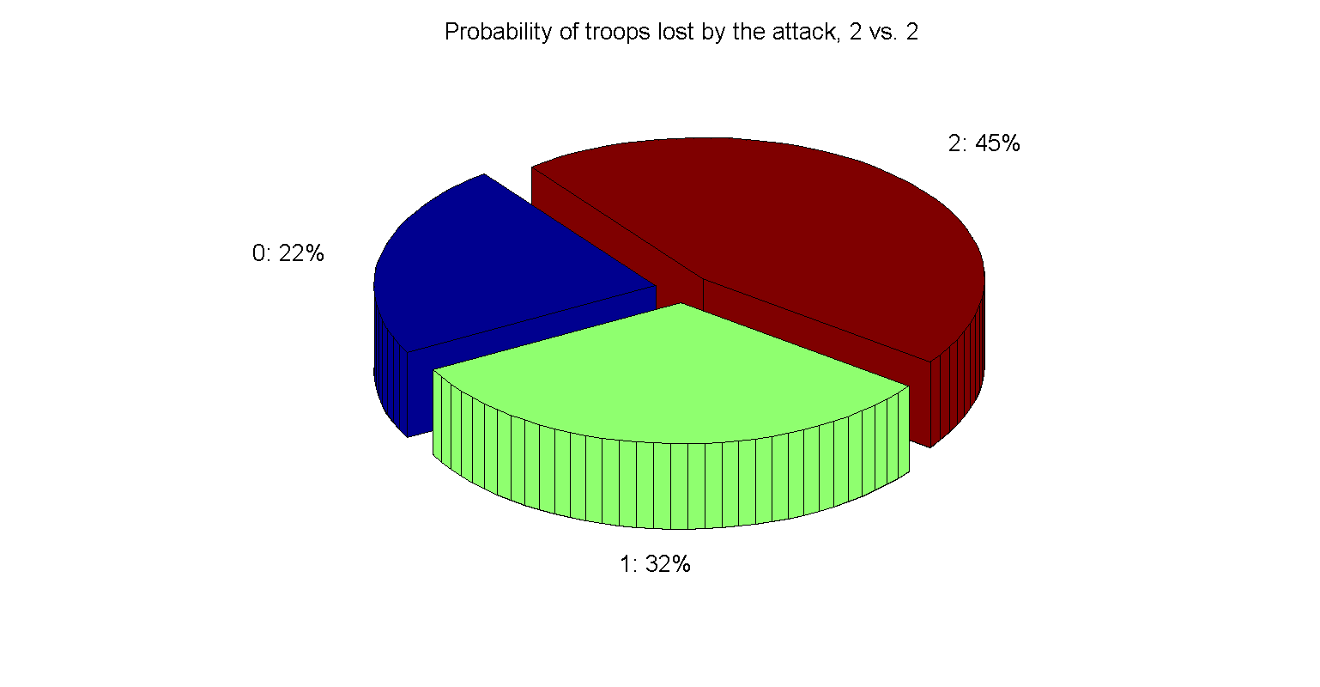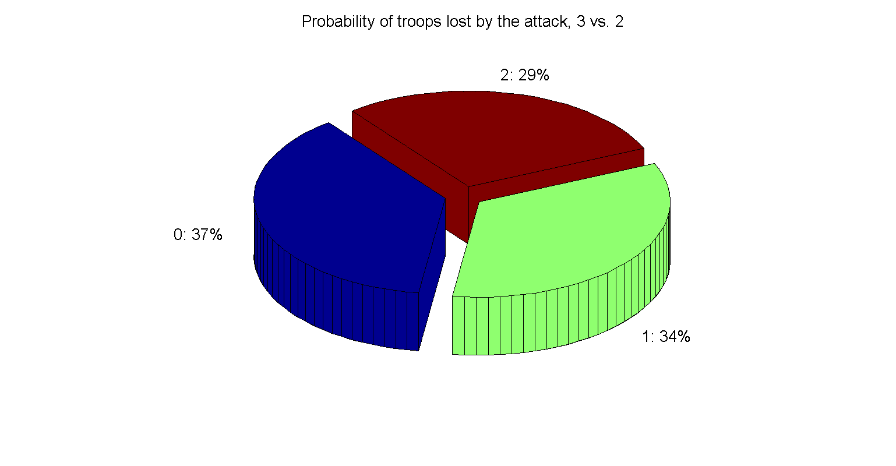

**Figure 15.** Pie charts of the simulated probabilities of different dice games, considering 2.

Figure 15 verifies two fundamental Risk strategies -- 1) the attacker should not expect to win when engaging in war when they are rolling the same number of dice as the defender and 2) the attacker should always roll as many dice as they can to boost their chances. Even though more troops are risked, the higher chance that the defender will lose troops makes it more than worth it. The 3 vs. 2 dice game seems like a relatively fair game, but, as we will see, the ~7% discrepancy in favor of the attacking side builds up an advantage for the attack over time.

*Larger Battles, More Considerations*

What happens if we change the number of troops that are considered for a battle? The number of dice? Take, for example, this trial:

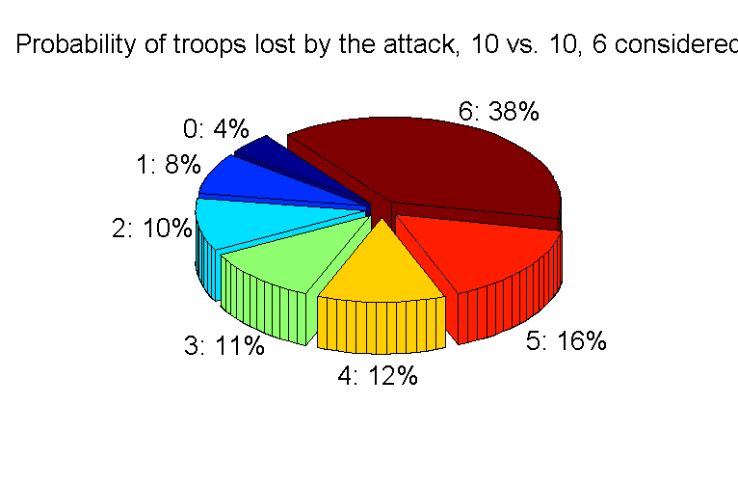

**Figure 16.** Number of attacking dice: 10, Number of defending dice: 10, Number considered: 6

Probabilities complicate – mathematical models at this point will become too large and complicated for any practical use.

*Manipulating the Attacking Advantage*

In a dice battle, there are possible battle outcomes (where n is the number considered parameter). In this instance, the attack could lose, in this single battle, 0, 1, 2, 3, 4, 5, or all 6 of the considered troops. The probability that the attack will lose less than the defense is ~22% (derived by summing up all the probabilities before the halfway mark). There is an 11% chance that the attack will lose the same number of troops as the defense, and a ~67% chance that the attack will lose more troops than the defense. I explore these probabilities with increased numbers of dice and number of troops considered.

|  |  |  |  |  |  |  |
| --- | --- | --- | --- | --- | --- | --- |
| Attack | Defense | Number Considered | Percent Chance of attack losing less | Percent Chance of both losing the same | Percent Chance of defense losing less | Difference |
| 3 | 2 | 2 | 37.47 | 37.47 | 28.71 | 8.76 |
| 6 | 4 | 4 | 48.38 | 20.97 | 30.65 | 17.73 |
| 9 | 6 | 6 | 54.31 | 15.06 | 30.63 | 23.68 |
| 12 | 8 | 8 | 59.44 | 11.61 | 28.95 | 30.49 |
| 15 | 10 | 10 | 62.74 | 9.72 | 27.54 | 35.2 |
| 18 | 12 | 12 | 63.89 | 8.67 | 27.44 | 36.45 |
| 21 | 14 | 14 | 67.71 | 7.6 | 24.69 | 43.02 |
| 24 | 16 | 16 | 68.9 | 6.5 | 24.6 | 44.3 |
| 27 | 18 | 18 | 71.33 | 5.5 | 23.17 | 48.16 |
| 30 | 20 | 20 | 72.62 | 4.92 | 22.46 | 50.16 |

**Figure 17.** Table of manipulating the attacking advantage. we keep constant the ratio of attack dice to defense dice (3:2). We always use as many number of troops considered as possible, which is the number of defending dice.

**Figure 18.** Attacking advantage over a 3:2 dice game ratio.

As we increase the number of troops that are considered, the attacker’s advantage becomes more distinct. I hypothesize, however, that this increasing advantage trend is only true for the side with more dice. If instead of a 3:2 attack dice to defense dice ratio, we used 2:3, our results would be reversed, but in favor of the defense instead. Because of the tie-breaker rule in favor of the defense, the defender only needs a smaller rolling dice ratio to obtain the same chance of winning as the attacker. Furthermore, as long as the defense rolls enough dice more than the number of troops considered to saturate all the considered with the highest dice values, sixes (the defense would be rolling 6 x the number considered dice), the attacker’s chance for winning will not increase until the number considered is greater than the number considered that the defense is able to saturate.

*More Dice Possibilities*

What happens if we increase or decrease the number of sides on each die? See how the probabilities change in 3 vs. 2 and 2 vs. 2 when we change the number of sides on the dice.

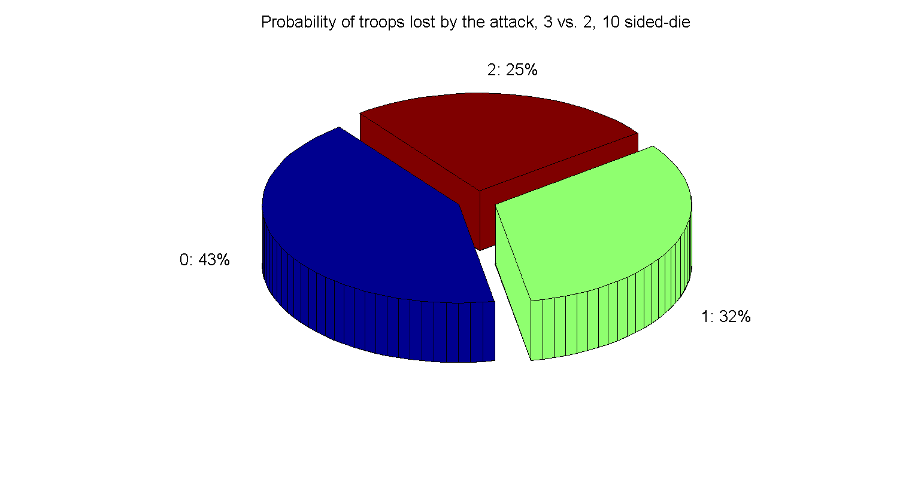

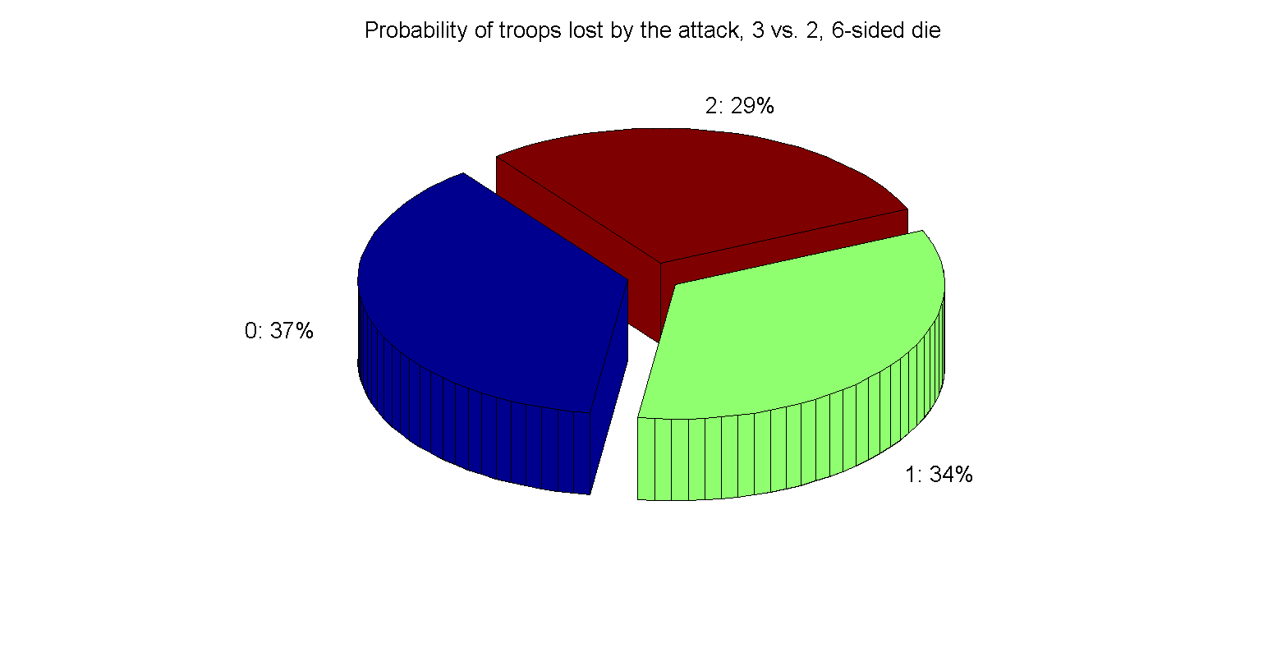

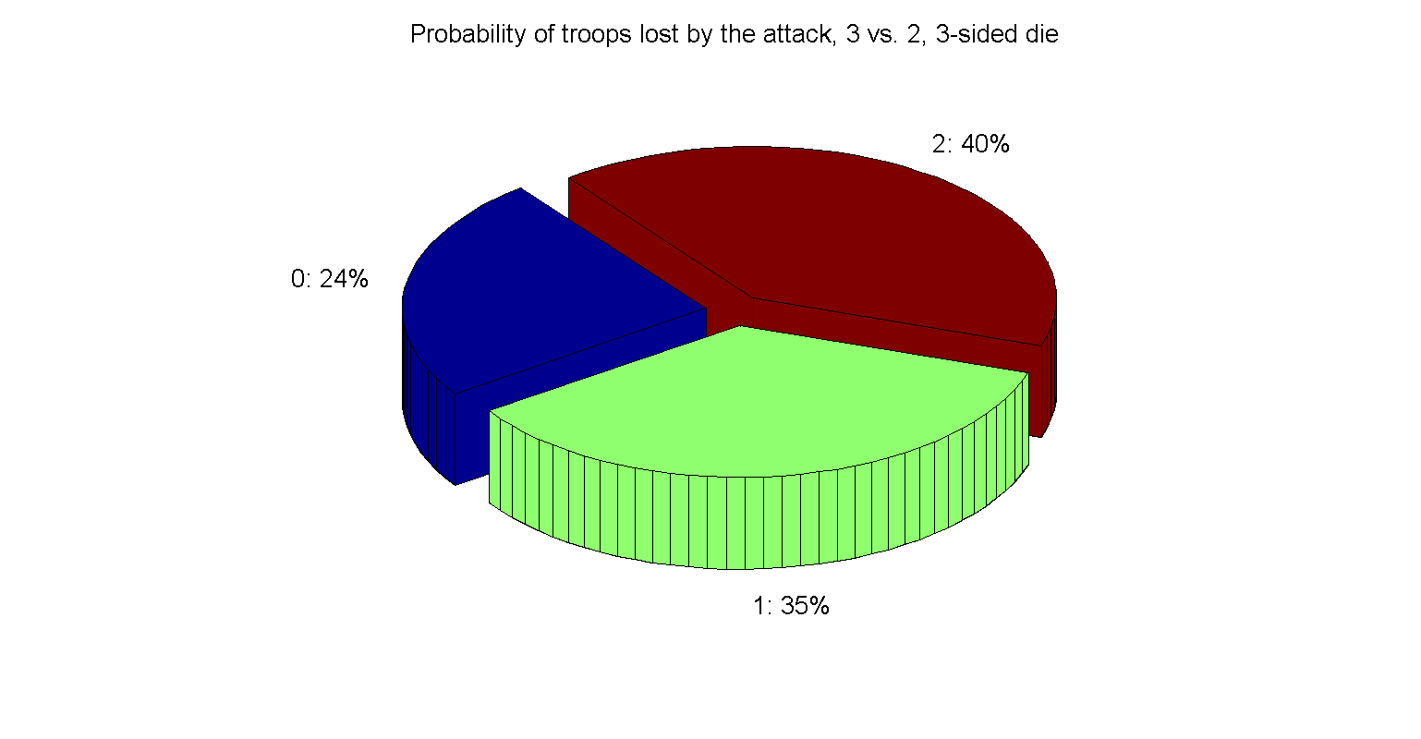

**Figure 19.** All these pie charts have 2 troops that are being considered. By increasing the number of sides on each die, we increase the number of possible outcomes and decrease the probability of a tie, thus diluting the power of Risk’s tie-breaker rule.

On the contrary, decreasing the number of possible outcomes boosts the probability of a tie occurring, so probabilities become worse for the attacker and better for the defender.

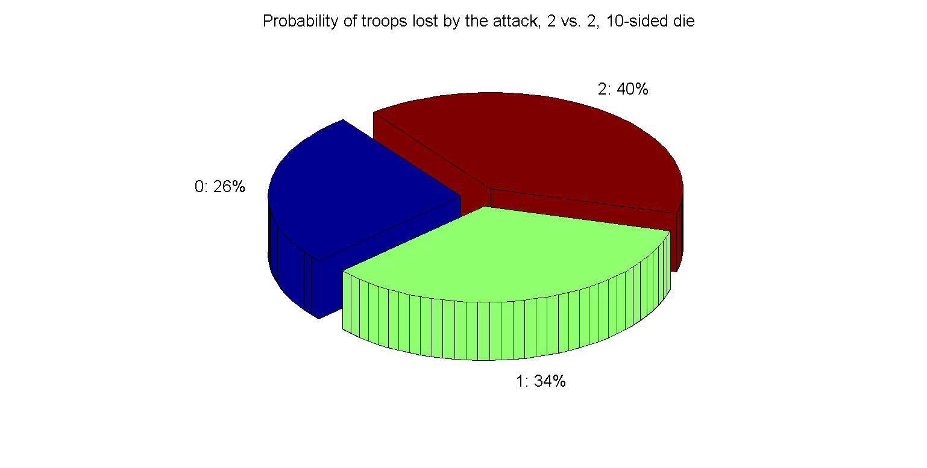

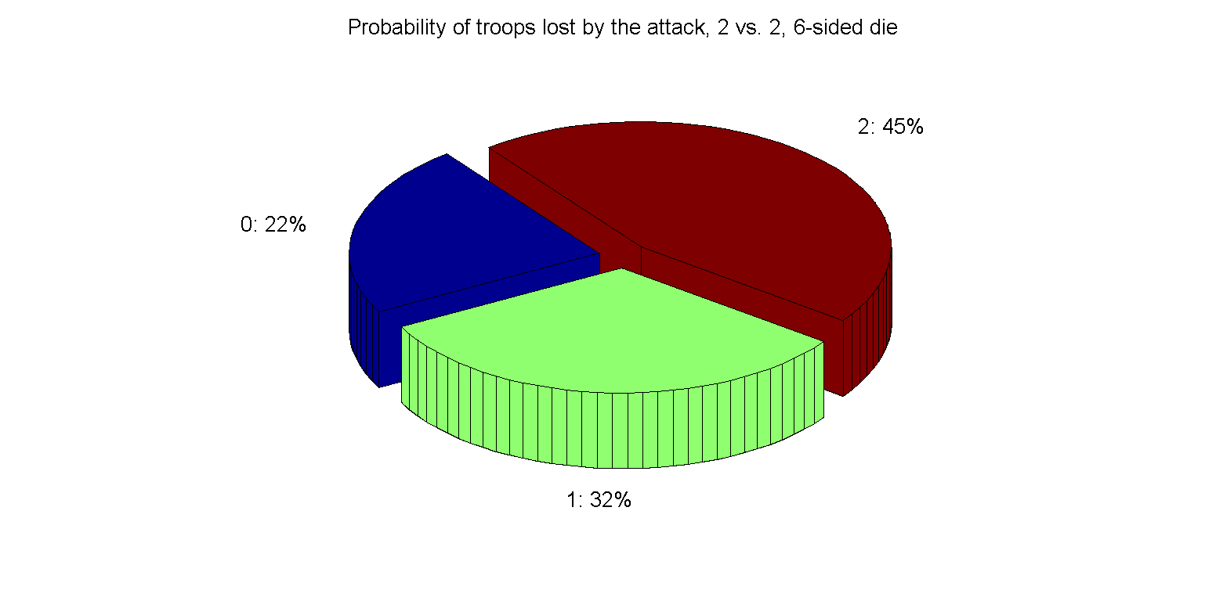

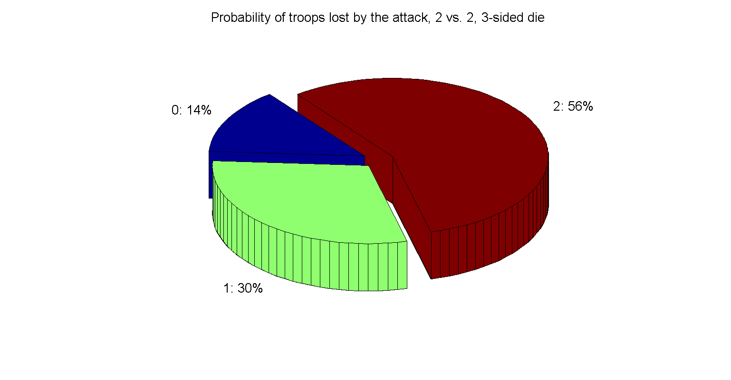

**Figure 20.** All these pie charts have 2 troops that are being considered. Trends are opposite of that of Figure 19.

**Manipulating the outcomes of a series of battles**

Osborne elaborates on a different kind of experiment in Risk. He expands the 10X10 table that he calculated (***in Figure*** ) to a 30 X 30 grid, then plotting the attacker’s probability of winning over the number of defending armies. I have reproduced his graph here.

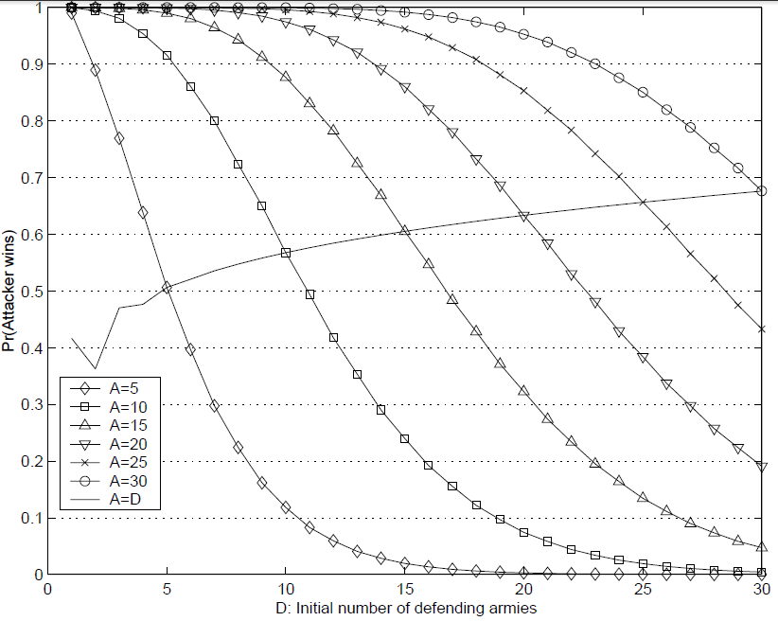

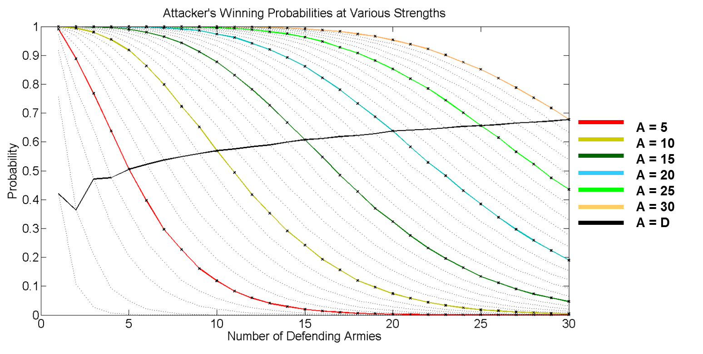

**Figure 21.** Reproduced graph of Osborne’s Markov-chain results illustrating the attacker’s winning probabilities at various strengths juxtaposed with the exact same graph of simulated probabilities.

Figure 21 shows us a number of interesting observations.

Observation 1: The higher the number of attacking troops, the more likely it is for the attack to take over another country.

The more troops you have the more chances you have to destroy more defending armies. The winning probability decays more slowly with more attacking troops, so not only does your chance of winning go up dramatically with the more troops you have, but the more troops you have the less each troop matters, probability-wise to defeat the other side.

Observation 2: The changing of dice battles early on explains the odd behavior in the beginning of the graphs.

At 1v1 (1 die vs. 1 die), things are in favor for the defense because they have the tie breaker rule. At 2v2 (2 dice vs. 2 dice), while both sides get an extra dice from 1v1, the strength of the tie-breaker rule for the defense overpowers that of the new attacking dice so that the probability is now even more in favor for the defense. At 3v3, however, the defense cannot roll more than 2 dice while the attack is able to still use another dice. The probability shoots up here for the attack and steadily increases at a smooth rate now that the 3 dice vs. 2 dice is stabilized.

Observation 3: The probability of the attack winning when A = D increases with larger and larger values of A.

This indicates that the 3 versus 2 dice game is slightly in favor of the attack. This result agrees with our first investigation (see Figure 15) where we found that in 3 vs. 2, the defense has about a 7% higher chance to lose two troops than the attack. Osborne, however, wrapped it up here, concluding that “the attacker has an advantage in the sense that expected losses are lower than for the defender, provided the initial number of attacking armies is not too small.”

*Expected Loss*

There’s something more to be known about this chart. While the attacker’s expected losses are lower than the defender’s with a proportionate increase of troops on both sides, a relatively easy conclusion given the fact that the probability of winning is shooting up, how do the expected losses for the attack change with different numbers of troops?

We can calculate expected loss using a weighted average.

Since and where is the number of attacking troops. This expected value gives us the number of troops that the attacker can expect to lose. In order to compare expected loss values across different numbers of attacking armies, we normalize all the expected values by dividing by the number of attacking troops.

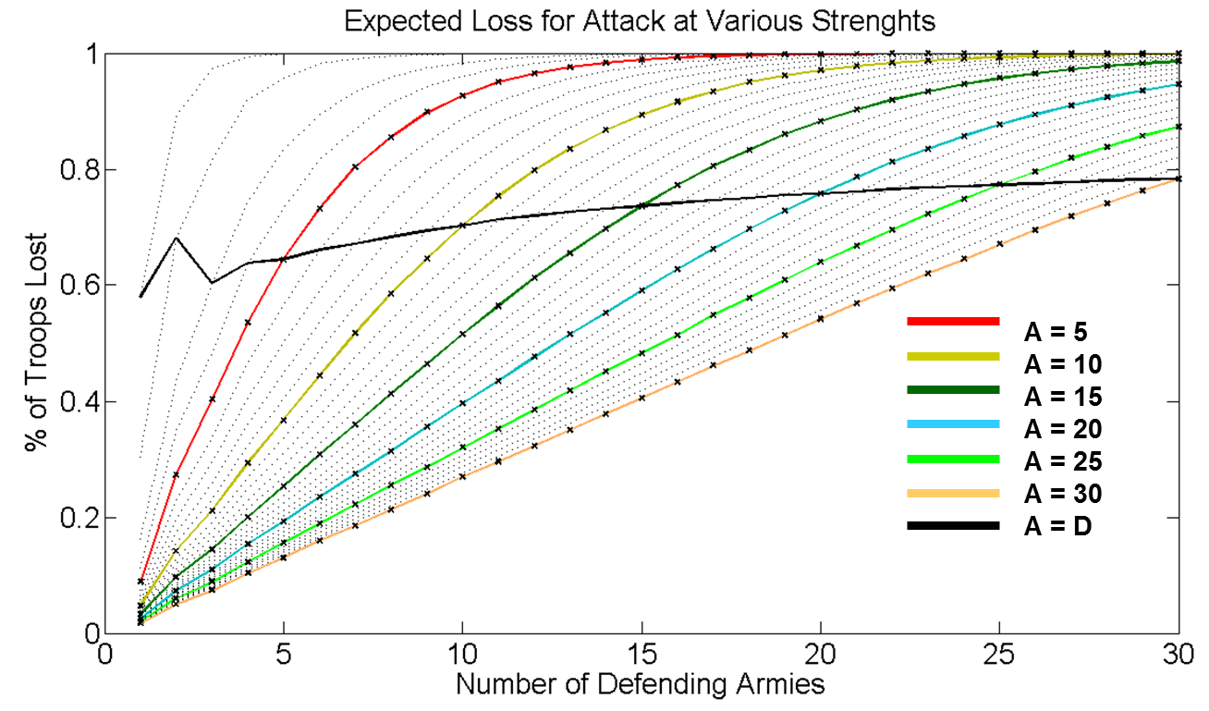

**Figure 22.** Expected Loss for attack at various strengths. While the expected loss gap between attack and defense increases, the proportion of the attacker’s expected loss to the number of attacking troops also increases.

As we have seen from above, the increasing chance of winning as the attacker and defender gain more troops powerfully indicates that the expected loss for the attacker is going to be increasingly smaller than that for the defender. From my results, however, we reach a more sophisticated conclusion. While the expected loss gap between attack and defense increases, the proportion of the attacker’s expected loss to the number of attacking troops also increases. As the attack and defense gain more troops, the chance for the attack to win increases, but at the cost of a more difficult series of battles, by proportion. For instance, while a 100 vs. 10 series of battles gives the attack a higher chance of conquering than a 50 vs. 5 series of battles, the 50 vs. 5 series of battles has a lower, by proportion, expected loss.

Attackers have a higher chance of winning with higher and higher troops, but it wouldn’t be smarter to let the defense grow at the same rate. Because the proportion of expected losses go up, it would be smarter for the attack to be more aggressive rather than less so. With higher numbers of troops, attackers should expect to lose a higher proportion of troops which would leave the attack weaker and more vulnerable to a counter-attack.

**Discussion**

The beauty of dice is that we can manipulate the probabilities of the dice game battle to be anything that we want. More advantage for attack? Use dice with more faces. More advantage for the defense? Consider fewer troops. Split the advantage right down the middle? Manipulate the number of dice that one can roll, the number of troops that are considered, or number of dice possibilities until you get there (4 vs. 3, considering 2, with 8 dice faces gets it pretty close)! We have discovered the trends and effects of changing each of the rules and parameters of the Risk dice game as well as what effect this has on overall battles with multiple troops.

*Why three dice versus two*

How did Hasbro came up with 3 vs. 2? There is, of course, the explanation that they might have hired a group of six people to play the game hundreds of times with various rules and took a survey to determine the optimal combination of rules that resulted in the most fair, fun game. As well as from a probability standpoint though, 3 vs. 2 has many beautiful qualities to it.

First off, 3 vs. 2 gives the attacker an advantage, but not so much of it. For Risk to be fun, the attack must be given more advantage than the defense because otherwise, the game would never end. If the defense had more of an advantage, then no one would dare attack unless they had an excessively significant surplus of troops which would take too many turns to accumulate resulting in a much less dramatic and exciting gameplay. At the same time, the attack’s advantage cannot be so overwhelming that the sequence of who goes first becomes too important. If it was that easy to take over other countries, then whoever goes last starts off with a huge disadvantage.

More importantly, however, is an economic argument. No one wants to own a board game where players have to frequently throw 30 dice. 6-sided dice are cube-shaped, easy to manufacture, and are standard for many games so they can be easily be replaced if they are lost. People don’t like thinking much about large or complicated numbers because numbers tend to slow down or interrupt the flow of gameplay. Risk’s simple rules is what makes it the popular and fun game that it is today.

**Conclusion**

As one of my favorite board games, Risk has given me many many hours of fun with my friends. It’s a game of politics, luck, probability, and world domination strategy – and it’s wonderful. This small summer project in mathematics and computer science has allowed me to take a more in-depth look at how we can craft and manipulate the dice game probabilities, shown me that simple game rules can have very complicated trends, and, most importantly, joy in my own creation.

**Future Work**

Networking probabilities of conquering across continents? Nah – I’ll stick to school work for now. ☺

**Acknowledgements**

MATLAB, summer, friends

**Remarks**

If you would like to download these MATLAB programs for your own purposes, email me at [justin.zhao71@gmail.com](mailto:justin.zhao71@gmail.com).

**References**

Osborne, J. (2003) “Markov chains for the RISK board game revisited,” Mathematics Magazine, 76(2):129-135.

Tan, B. (2012). Markov Chains and the RISK Board Game, *70*(5), 349–357.

Blatt, S., & Coles, A. C. (n.d.). RISKy Business : An In-Depth Look at the Game RISK Rules of the Game.

**Supplementary material**

*Program 1: Dice Game Simulator*

For the first program, the user specifies certain parameters:

* The number of attacking dice (default: 3)

This parameter is the number of dice that the attack is able to roll.

* The number of defending dice (default: 2)

This parameter is the number of dice that the defense is able to roll.

* The number of troops that are considered (default: 2)

This parameter is the number of troops that are able to be removed from battle. For example, in Risk, in the example of 3 vs. 2, 2 troops are considered that can be removed from battle – the attack can lose 2 troops, the defense can lose 2 troops, or each side can lose one. This parameter should not be greater than the number of dice that is being rolled by any one player.

* The maximum dice value (default: 6)

This parameter specifies the highest number from 1 to X that the dice can roll.

* The number of trials (default: 10,000)

How many trials that will be evaluated.

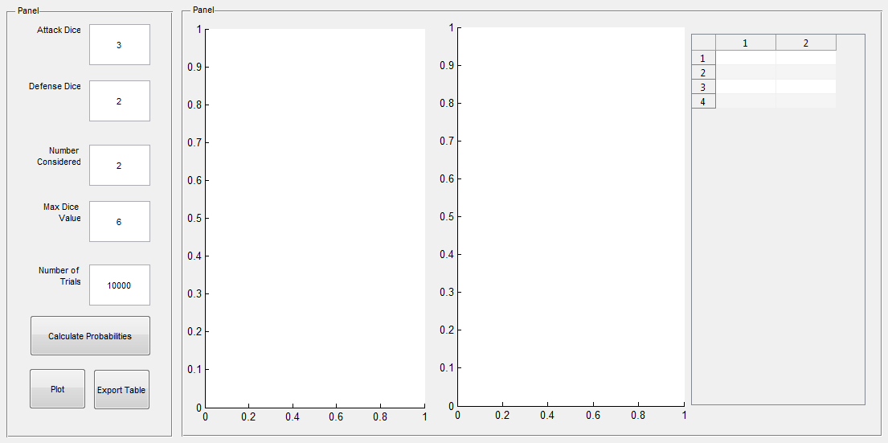

**Supplementary Figure 1.** Program 1 user interface (blank).

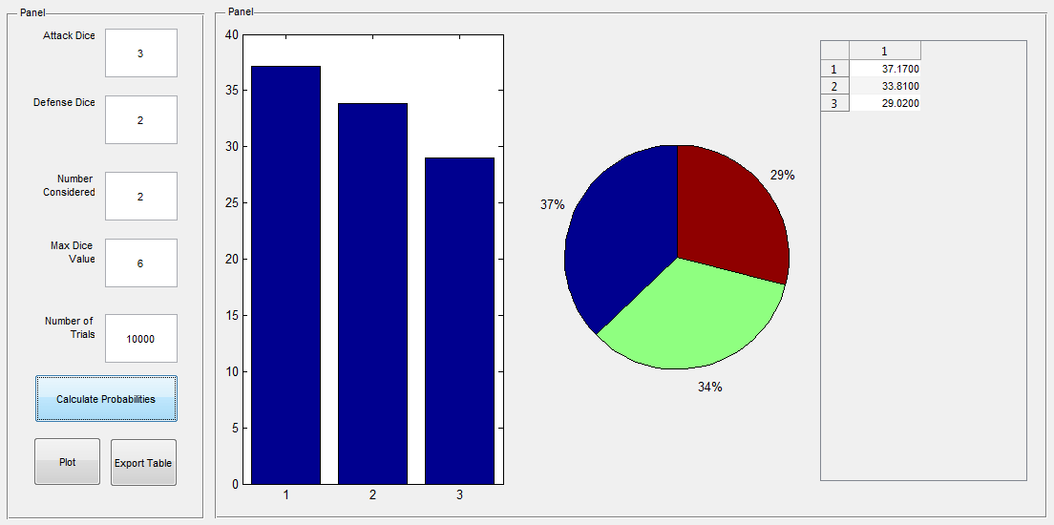

**Supplementary Figure 2.** Program 1 user interface with default results.

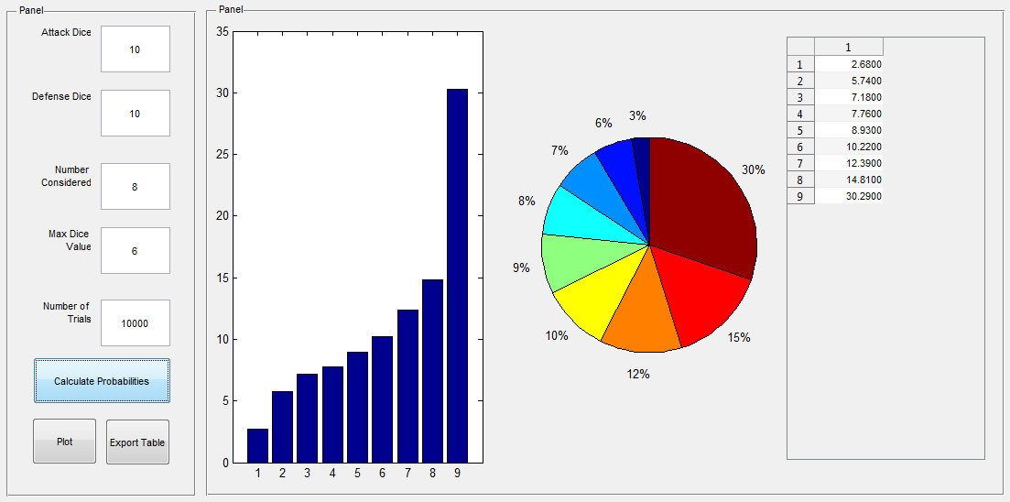

**Supplementary Figure 3.** Program 1 user interface with other results.

The numbers that are spit out by this first program are percentage values out of 100. Each time a result is attained, I count that result in an array. The array is indexed by the number of troops that the attack loses. When all the trials are finished, the program divides all the counts by the number of trials and multiplies it by 100 to get a percentage value.

Some functionality notes:

* Left panel - this is where the user specifies parameters
* Right panel – this is where the results of the simulation are reported. The first graph is a bar graph of the probabilities (%) over the number of troops that the attack lost while the second is a circle graph.
* “Calculate Probabilities” button – This begins the simulation
* “Plot” button – This exports the graphs to the MATLAB figure organizer, which has some additional functions (like labels and such), convenient for saving experiment results.
* “Export Table” button – Doesn’t do anything yet!

*Program 2: Territory Conquering Simulator*

The purpose of the second program was to try and figure out how many troops you would need to comfortably decide to take over another country. In addition to the parameters in the first program, the user also specifies the number of attacking troops and the number of defending troops.

In this program, we make a few extra assumptions:

1. Attack and defense always roll as many dice as they can, but bounded by the number of dice that is specified for both sides.

For instance, if I had run the program with an attacking dice limit of 3 and the attack had 10 troops, then the attack would be rolling 3 dice. If I had run the program with an attacking dice limit of 50 and the attack had 10 troops, then the attack would roll 9 dice because a side cannot roll more than the number of troops there are, which, for the attack is actually 1 less than the number of total troops remaining because that 1 troop must stay occupied on the attacking country. The greatest number of dice the defense could roll is just the number of defending troops itself.

1. We are always considering the greatest number of troops possible, bounded by the specified “number considered” parameter. This number of troops is the smallest of either the parameter itself, one less than the number of attack dice, or the number of defense dice.

For instance, if we have 3 vs. 2 dice game, then we consider 2 troops that are at risk to be lost from either side, comparing the highest 2 dice values of each side. If we have a 40 vs. 6 dice game, then we consider 6 troops that are at risk to be lost from either side. If we, however, ran the program with a number considered limit of 4 and had a 40 vs. 6 dice game, then the number considered for the 40 vs. 6 dice game would be 4.

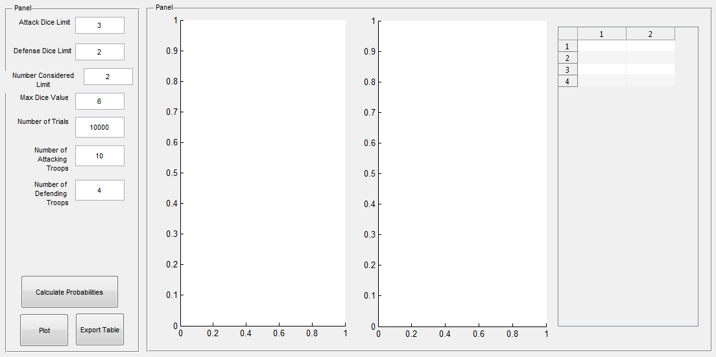

**Supplementary Figure 4.** Program 2 user interface (blank).

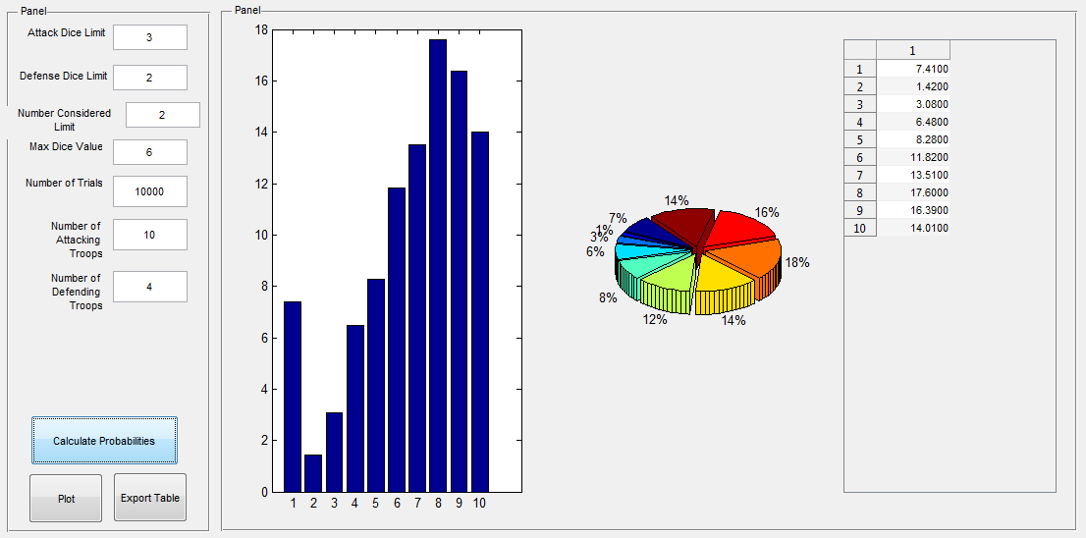

**Supplementary Figure 5.** Program 2 user interface with default results.

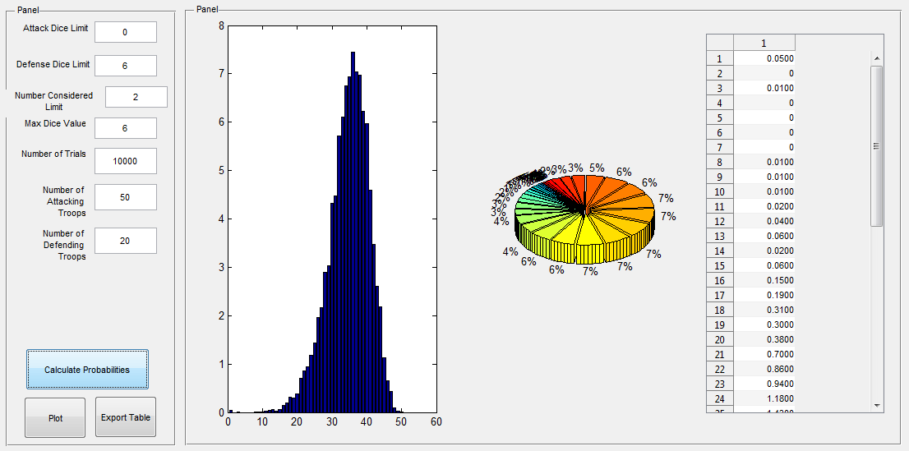

**Supplementary Figure 6.** Program 2 user interface with other results.

The principle of simulation and the positioning of the panels and whatnot are the same as the first program. The data that the program spits out now, however, are percentage values indexed by the number of remaining attacking troops after the all the battles are over. The battles are over when either the attack runs out of troops to keep attacking (1 troop remains), or when the defense has no troops left and is conquered. This program gives us simulated probabilities of the chance that X number of attacking troops will conquer Y number of defending troops with some number of troops remaining, i.e. anything in the first index of the array (1) means that X could not conquer Y).

In terms of the GUI functionality of the second program, it’s nearly identical to the first, so I won’t reiterate it here. I’ve designed and set-up these programs such that we can play with many different parameters that can be changed to lie outside of the traditional Risk dice game rules.