# CS 553 Scientific Visualization

# Project #7:

**Hyperbolic Geometry**

Yu Zhang

Zhangy6@onid.oregonstate.edu

Master Student in Computer Science

School of Electrical Engineering and Computer Science

Oregon State University

05/13/2015

1. **Images and relative comments of my project**
   1. Interface of my project (zoom out)

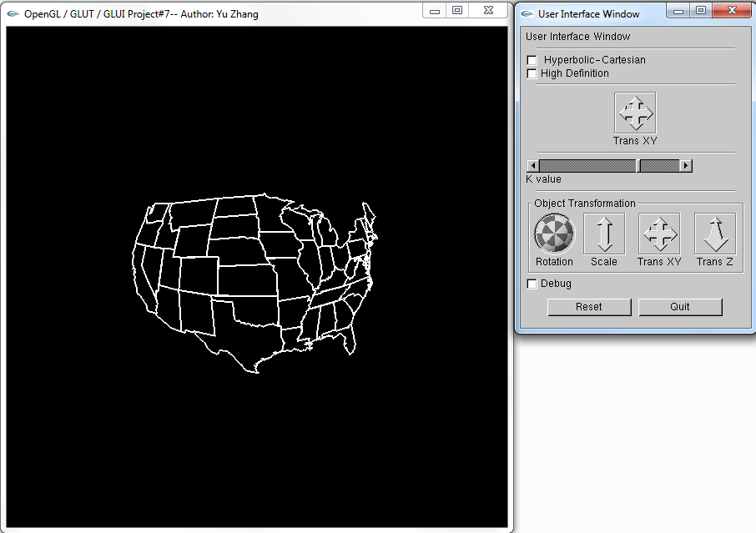

* 1. Interface of my project (zoom in)

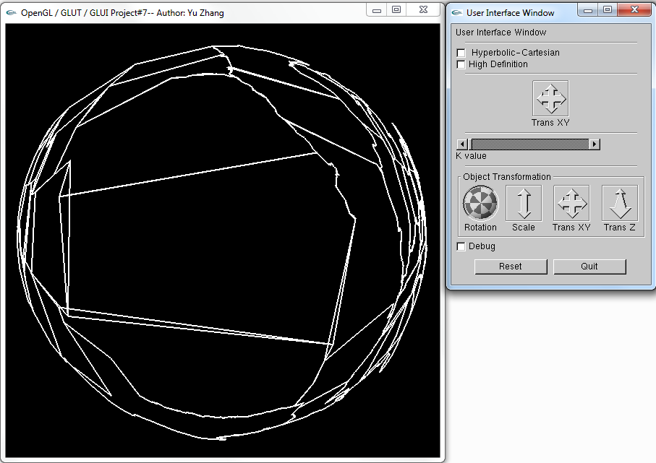

In this project, we are required to implement a U.S. national map. The data is given and we need to firstly import the data to our program. So in the function InitGraphics(), I used

FILE *fp = fopen( "proj07.dat", "r" );

And there are three main parts in this project: Hyperbolic-Cartesian, Hyperbolic-Polar and High definition for these two kinds of hyperbolic geometry.

* 1. Polar with low definition

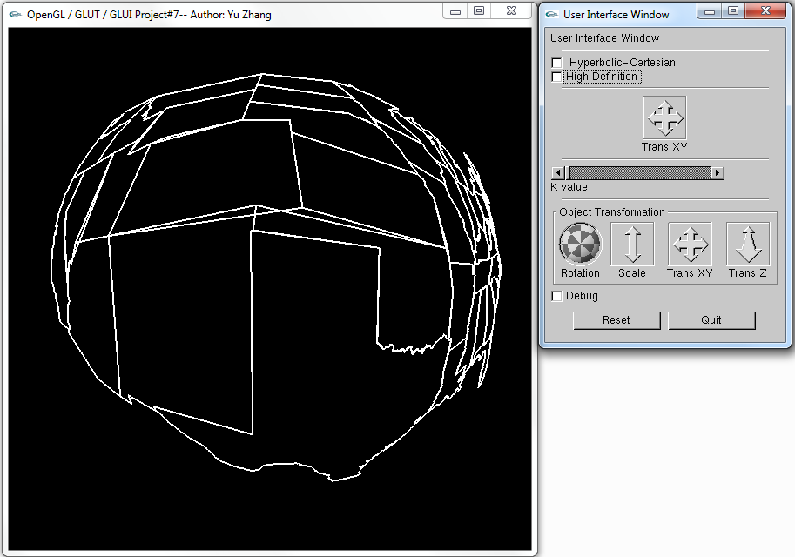

* 1. Polar with high definition

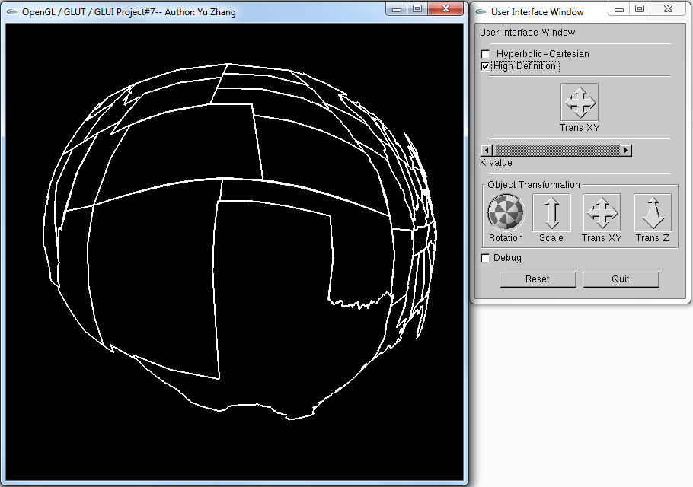

For implementing the polar part, I followed the instructions on the class website, the main algorithm is

x'' = r' * (x'/r) = x'/(r+K)

y'' = r' * (y'/r) = y'/(r+K)

For high definition part, I followed the algorithm showed in our slides, and I also created the function DrawHyperbolicLine()

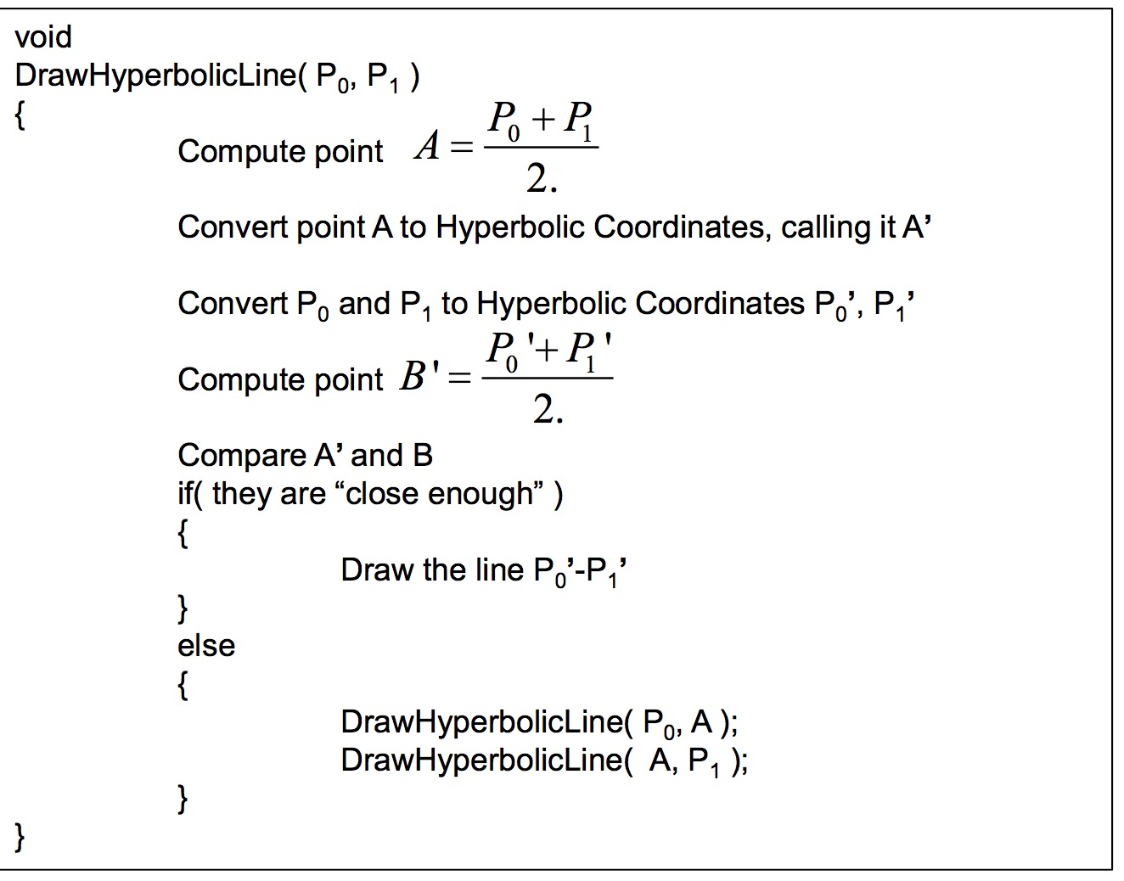

* 1. Cartesian with low definition

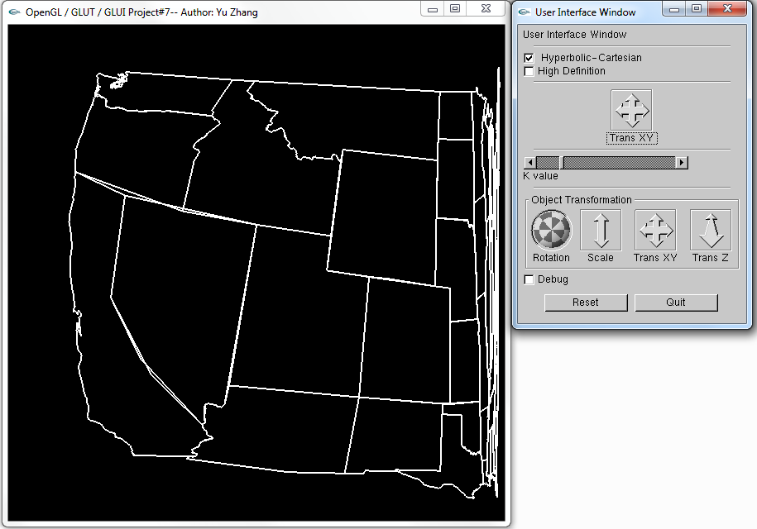

* 1. Cartesian with high definition

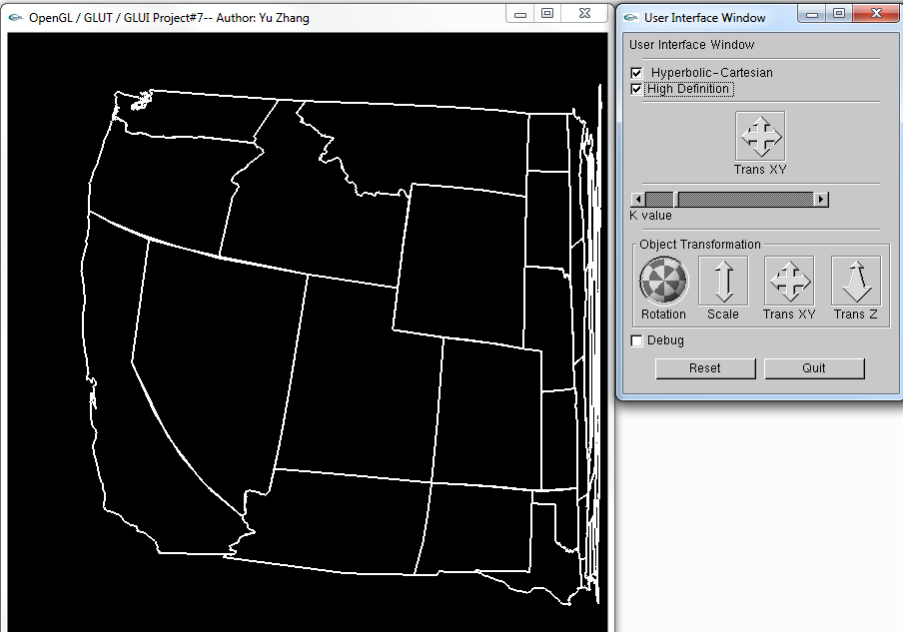

In this part, the main algorithm is

x'' = x' / sqrt( x'*x' + K*K )

y'' = y' / sqrt( y'*y' + K*K )

All in a word, this project is not very hard, I followed the algorithm showed in the class website and modified some codes, then it’ done successfully.