ROYAL BIRKDALE GOLF CLUB · 2026 OPEN CHAMPIONSHIP
2026 Open Championship: Statistical Favorites at Royal Birkdale
A statistical model predicting the winner of the 2026 Open Championship, built with SQL, Data Golf strokes-gained data, and Royal Birkdale course-history analysis
By Seymour Thomas · USC Marshall School of Business · July 2026
I. Executive Summary
The Open Championship returns to Royal Birkdale Golf Club July 16–19, 2026, for the first time since 2017. This analysis uses a custom-built SQLite relational database — populated with Data Golf skill rankings, 2026 season Strokes Gained data across the PGA Tour, DP World Tour, and LIV Golf, and actual Royal Birkdale results from the 2008 and 2017 Opens — to answer one question: who is statistically most likely to win?
The model combines three factors into a single composite score: a player’s skill rank (Data Golf’s own predictive rating), their current-season form (Strokes Gained: Total, Bayesian-shrunk to correct for small sample sizes), and a Royal Birkdale course-history bonus built from real finishing positions the last two times The Open visited this course.
The core finding is that only one player in the 156-man field checks all three boxes — elite skill rank, red-hot current form over a full season, and a proven result at Royal Birkdale. That player is Rory McIlroy. Behind him, Jon Rahm and Tyrrell Hatton round out the top three on current form alone, and one course-history specialist — Alex Noren — stands out as a longshot worth watching.
II. Royal Birkdale: What the Course Actually Rewards
Pulled from Data Golf’s Course Insights for the two most recent Opens held at Royal Birkdale — nine seasons apart, but telling a consistent story.

Metric | 2008 | 2017
Scoring average | 74.89 (+4.89) | 71.28 (+1.28)
Score std. deviation | 3.18 (high variance) | 2.90 (typical PGA Tour variance)
Skill separation (slope vs. 1.0 = normal tour) | 0.60 | 0.72
Player type favoured | Strongly favoured accurate drivers | Favoured accurate drivers

Key finding: Royal Birkdale rewards accuracy off the tee over raw distance, and skill separates less than usual here (slope 0.60–0.72 vs. 1.0) — meaning the best players in the world beat the field by less than they would elsewhere. This doesn’t override the skill/form model — it tempers it. A pure bomber with no Birkdale pedigree should be discounted slightly; a proven accurate ball-striker with course history should get a bump.
III. Adding Course History to the Model
Cross-referencing the 2008 and 2017 Open leaderboards against the current 156-player field turned up 10 players still competing who have real Royal Birkdale results on record.

Player | Best Birkdale Finish | Years
Padraig Harrington | Winner, 2008 | 2008
Henrik Stenson | T3 (2008), T11 (2017) | 2008, 2017
Alex Noren | T6 (2017), T19 (2008) | 2008, 2017
Rory McIlroy | T4 (2017) | 2017
Brooks Koepka | T6 (2017) | 2017
Matthew Southgate | T6 (2017) | 2017
Hideki Matsuyama | T14 (2017) | 2017
Xander Schauffele | T20 (2017) | 2017
Adam Scott | T16 (2008), T22 (2017) | 2008, 2017
Rickie Fowler | T22 (2017) | 2017

IV. The Model
Data was loaded into SQLite across five tables: the 156-player Open field (with each player’s Data Golf rank, OWGR, and tour rank), three Strokes Gained leaderboards (PGA Tour, DP World Tour, LIV Golf), and the Royal Birkdale course-history table above. Players were matched across tables by surname, with first-initial disambiguation for common names (Fitzpatrick, Kim, Hojgaard, Smith, Scott, Noren).
For each player, three factors were computed: a skill score derived from dg_rank (Data Golf’s own predictive rank, which already blends long-term skill with recent form), a form score — current-season Strokes Gained: Total, normalized per round — and a course-history score, points awarded for Royal Birkdale finish (Win = 10, top-3 = 8, top-6 = 6, top-15 = 2–4, top-25 = 1) summed across 2008 and 2017. Because a hot stretch over just 18 rounds is far noisier than one over 60+, Bayesian shrinkage was applied to the Strokes Gained figures so a short hot streak can’t outrank a full season of proven form.

-- simplified core of the ranking query
SELECT f.player_name, f.dg_rank, f.owgr_rank,
COALESCE(p.total/p.rnds, d.total/d.rnds, l.total/l.rnds) AS sg_per_round
FROM field f
LEFT JOIN pga_stats p ON f.last_name = p.surname
LEFT JOIN dpwt_stats d ON f.last_name = d.surname
LEFT JOIN liv_stats l ON f.last_name = l.surname
ORDER BY composite_score DESC;

Final composite: 70% skill rank + 30% shrunk current-season form, blended 88/12 with the Royal Birkdale course-history score. The 12% weight is deliberately modest — two tournaments is a small history sample, so it acts as a tiebreaker/booster rather than a dominant factor.
V. Top 15 Contenders (Course-History Adjusted)
The direct output of the composite-score ranking query, expanded with additional PGA Tour and DP World Tour stat coverage.

Rk | Player | DG Rk | Tour (SG/rd) | Birkdale Hist. | Note
1 | Rory McIlroy | 2 | PGA (+0.067) | T4, 2017 | Elite skill + hottest form + real Birkdale pedigree
2 | Jon Rahm | 5 | LIV (+0.067) | none | Matches McIlroy’s SG/rd over a full 36-round season
3 | Tyrrell Hatton | 23 | DPWT (+0.104) | none | Highest raw SG/rd — only 18 rounds of data
4 | Scottie Scheffler | 1 | PGA (+0.049) | none | #1 skill rank, but no Birkdale history
5 | Collin Morikawa | 8 | PGA (+0.043) | none
6 | Alex Fitzpatrick | 28 | PGA (+0.060) | none | Elite current form
7 | Matt Fitzpatrick | 3 | PGA (+0.033) | none
8 | Tommy Fleetwood | 4 | PGA (+0.033) | none | Home-soil pick, no Birkdale history on record
9 | Cameron Young | 9 | PGA (+0.035) | none
10 | Xander Schauffele | 15 | PGA (+0.029) | T20, 2017 | Moves up on Birkdale pedigree
11 | Sam Burns | 6 | PGA (+0.030) | none
12 | Russell Henley | 11 | PGA (+0.030) | none
13 | Ludvig Åberg | 13 | PGA (+0.029) | none
14 | Wyndham Clark | 7 | PGA (+0.026) | none
15 | Bryson DeChambeau | 24 | LIV (+0.039) | none

Full ranking (all 156 players) and raw SQL tables are available as a separate download alongside this memo.
VI. Three Most Likely Winners
Pick 1 — Rory McIlroy | Favorite
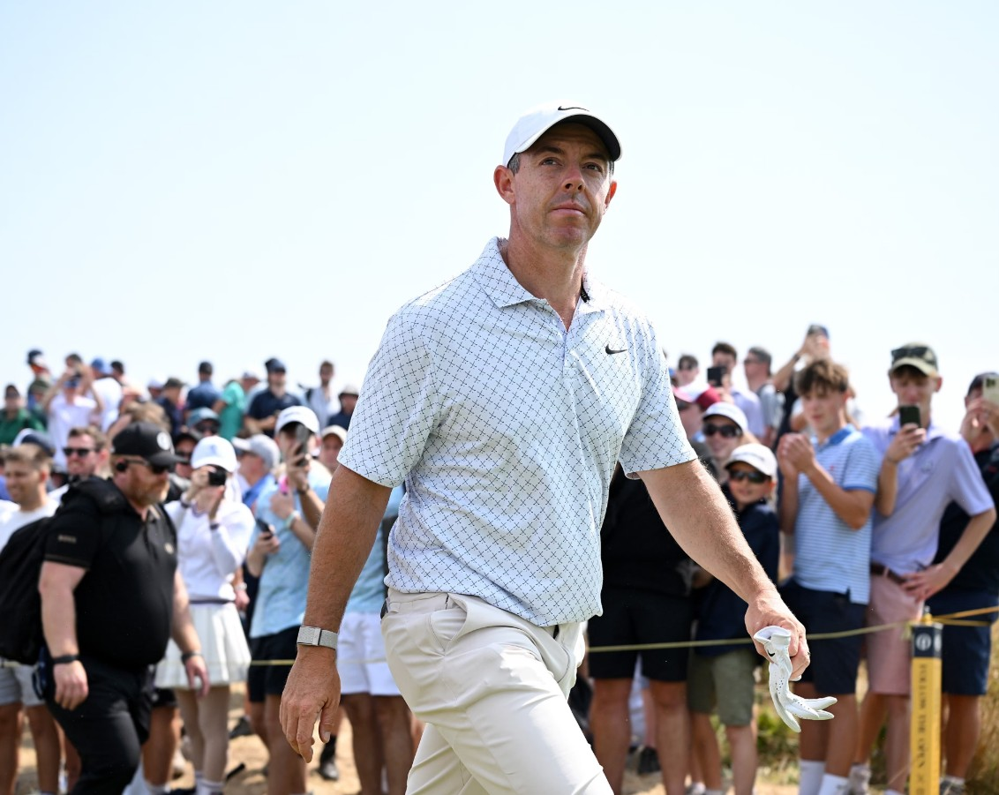
Rory McIlroy · Photograph: Charlie Crowhurst/R&A/Getty Images
Tops every layer of the model: elite skill rank (#2), the hottest full-season Strokes Gained pace in the field (38 rounds, not a hot streak), and real Royal Birkdale pedigree (T4 in 2017). No one else in the 156-player field checks all three boxes.
Pick 2 — Jon Rahm | Co-Favorite
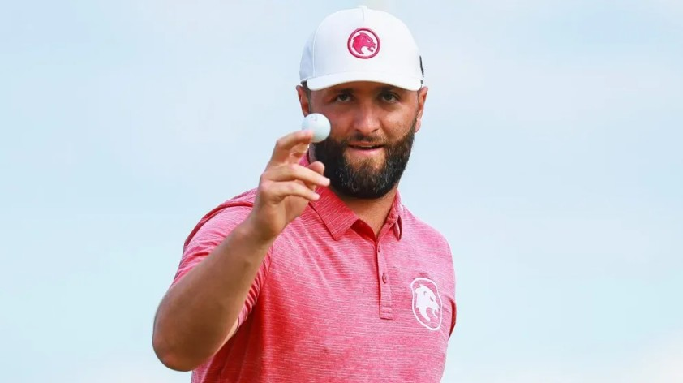
Jon Rahm · Photo by Manuel Velasquez/Getty Images
Statistically even with McIlroy on SG/round, sustained across a full 36-round LIV season — this isn’t a short-sample fluke. No recorded Birkdale history, so he’s leaning entirely on current form and skill rank (#5), and it’s enough to hold the #2 spot on its own.
Pick 3 — Tyrrell Hatton | Form Play
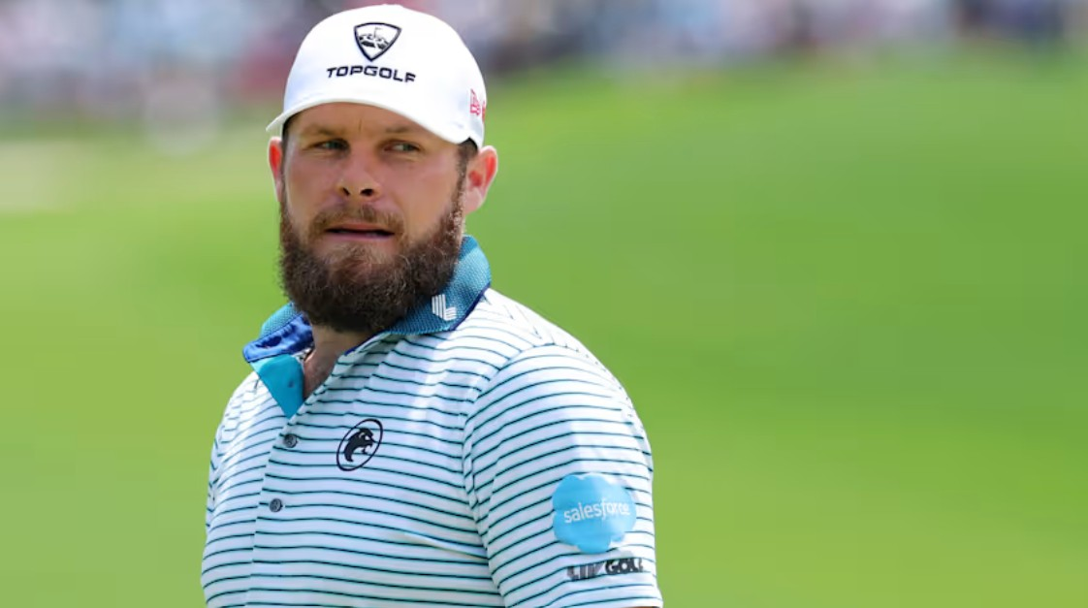
Tyrrell Hatton · Photo by Kevin C. Cox/Getty Images
The highest raw SG/round figure in the entire field. The honest caveat stands — it’s built on only 18 DP World Tour rounds, and Bayesian shrinkage pulled his score down accordingly — but even after that correction he’s still #3. Worth taking seriously, not just as a value bet.
VII. Surprise Pick
Alex Noren | The Course-History Longshot
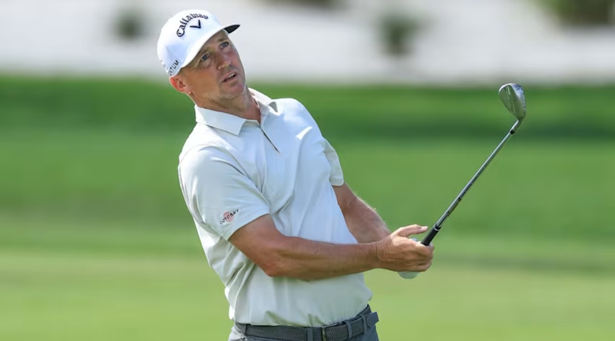
Alex Noren · (David Cannon/Getty Images)
Ranked 21st overall — well outside the “favorite” tier — but he’s the strongest Royal Birkdale course-history match of anyone in the field who isn’t already a top-3 pick: T6 in 2017 and T19 in 2008, the only player besides Stenson and Scott with a real result in both editions. His current Data Golf rank (45th) and season form are solid-but-unspectacular, which is exactly why the model buries him — but “accurate, experienced ball-striker with two good finishes at a course that specifically rewards accuracy” is precisely the profile Royal Birkdale has rewarded twice now.
Note on Scheffler: The world’s #1-ranked player sits 4th because he has no Royal Birkdale Open history in the data, and his 2026 SG pace — while strong across 58 rounds — hasn’t spiked the way McIlroy’s or Rahm’s has. Given the course’s history of favouring accurate drivers and compressing skill separation, this is a course where even an all-time great gets less of an automatic edge than usual.
VIII. Conclusion & Recommended Picks
Royal Birkdale’s history says this is not a course where the favorite dominates — it’s a course where accuracy, experience, and hot current form matter more than star power alone. Four names to watch:

1 | Rory McIlroy — Favorite | Only player combining elite skill rank, full-season hot form, and real Birkdale pedigree.
2 | Jon Rahm — Co-Favorite | Matches McIlroy’s SG/round pace over a full season, no course history needed.
3 | Tyrrell Hatton — Form Play | Highest raw SG/round in the field, even after correcting for small sample size.
4 | Alex Noren — Longshot | Best course-history profile outside the top 3; accuracy-first game fits Birkdale’s tendencies.

All four picks share a common thread: Royal Birkdale’s history rewards accuracy, current form, and proven course fit over star power alone — exactly the criteria this model was built to isolate.

Methodology: All rankings were produced by SQL queries joining the field, pga_stats, dpwt_stats, liv_stats, and birkdale_history tables in a custom-built SQLite database (open2026.db). Data sourced from Data Golf’s field rankings, season Strokes Gained tables, and Course Insights pages. Analysis conducted as part of a portfolio project at the University of Southern California Marshall School of Business.

