Creating an Op Art Style Drawing with HTML5 Canvas and JavaScript

# Table of Contents

Table of Contents 1

I. Introduction 2

II. Preparations 3

III. Drawing the Grid 3

IV. Conclusion 4

V. References 5

# I. Introduction

Op Art, short for Optical Art, is a style of visual art that creates illusions of movement, vibration, and depth using geometric shapes, patterns, and colors. It emerged in the 1960s and is characterized by its abstract and minimalist approach. In this assignment, the goal is to create an Op Art style drawing using HTML5 canvas and JavaScript. The canvas element will be used to draw a grid of vertical and horizontal lines, while JavaScript will be used to manipulate the spacing and position of the lines to create the illusion of movement and depth.

# II. Preparations

To create the Op Art style drawing, we will need to set up an HTML file with a canvas element and a JavaScript file to manipulate the canvas. The following are the requirements for the assignment:

1. Create an HTML file with a canvas element.
2. Set the width and height of the canvas to the desired size.
3. Link the JavaScript file to the HTML file.
4. Create a JavaScript file and select the canvas element using its ID.
5. Set the stroke style of the canvas to black.
6. Once the preparations are complete, we can begin drawing the grid using JavaScript.

# III. Drawing the Grid

To draw the grid, we can use JavaScript to create a loop that will draw the vertical and horizontal lines on the canvas. The following is the code to draw a grid of 28 vertical and 7 horizontal lines:

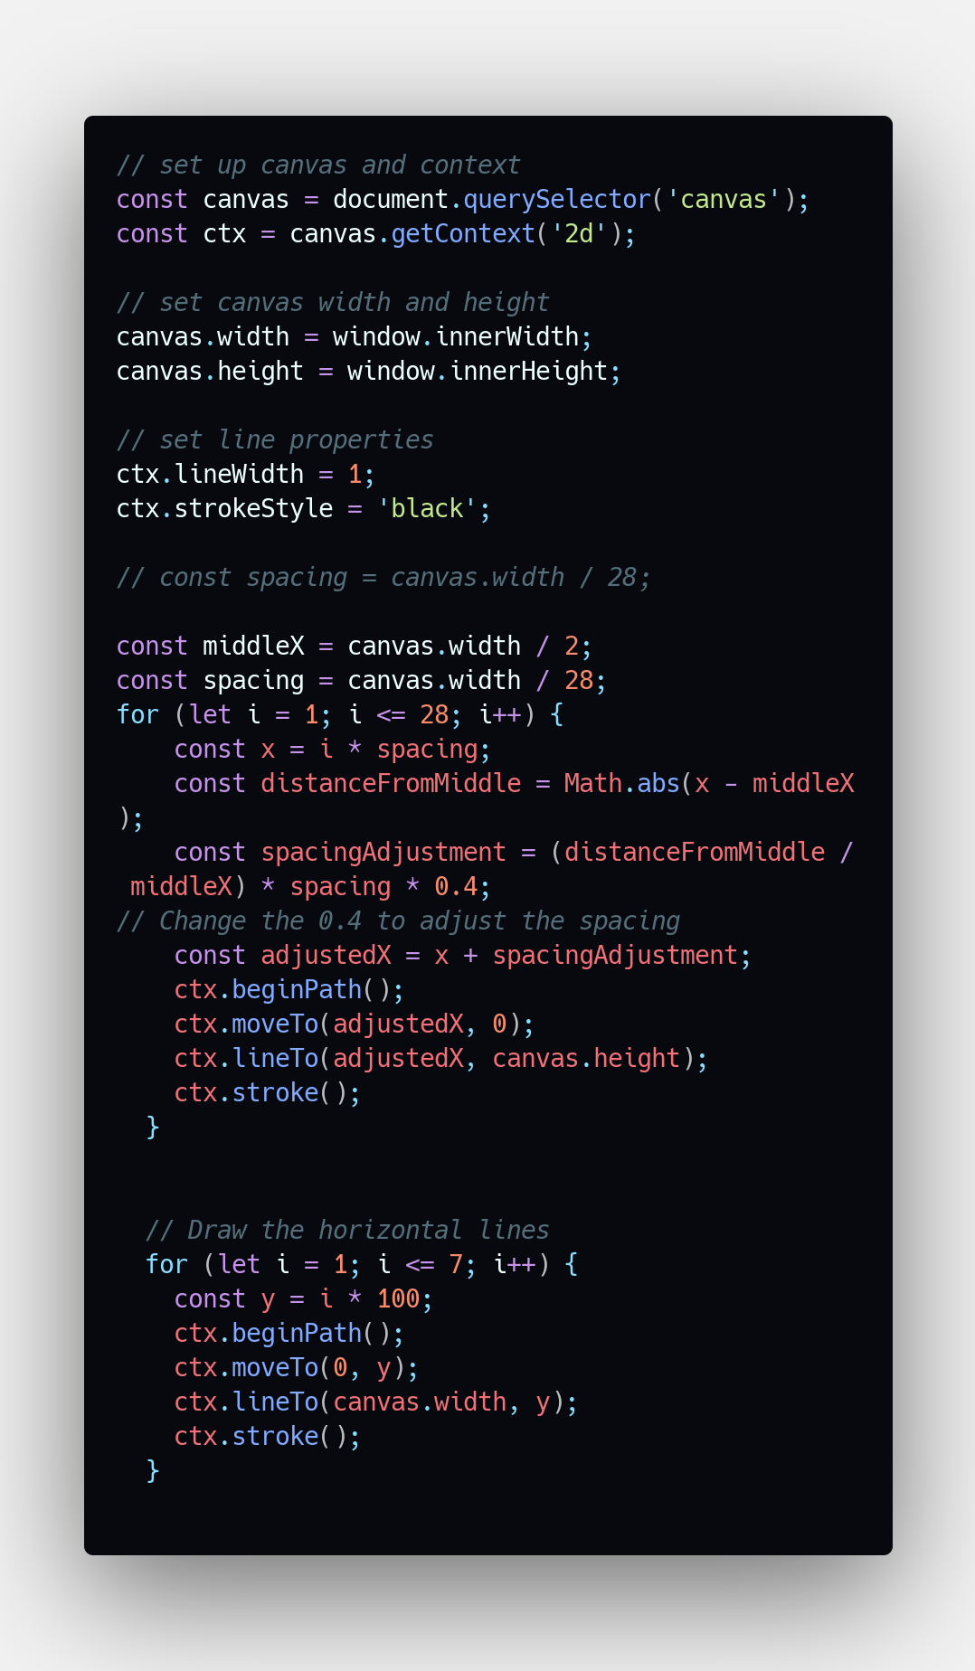

Fig 1. Code of the Canvas JavaScript file.

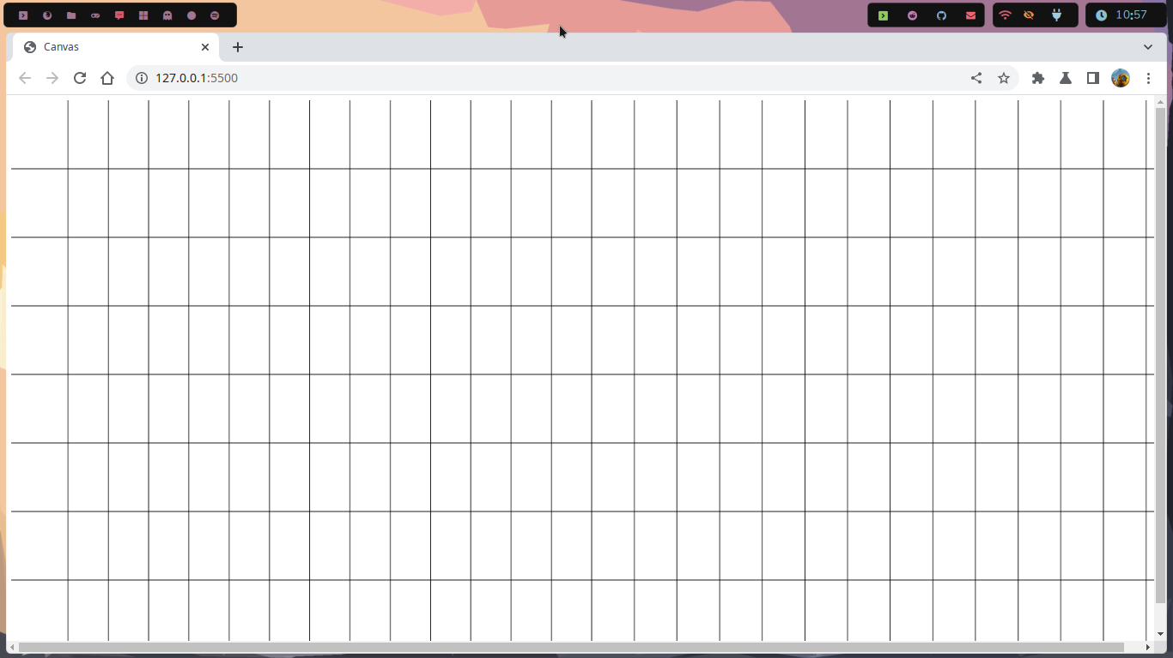

Fig 2. Layout in Chrome Web Browser

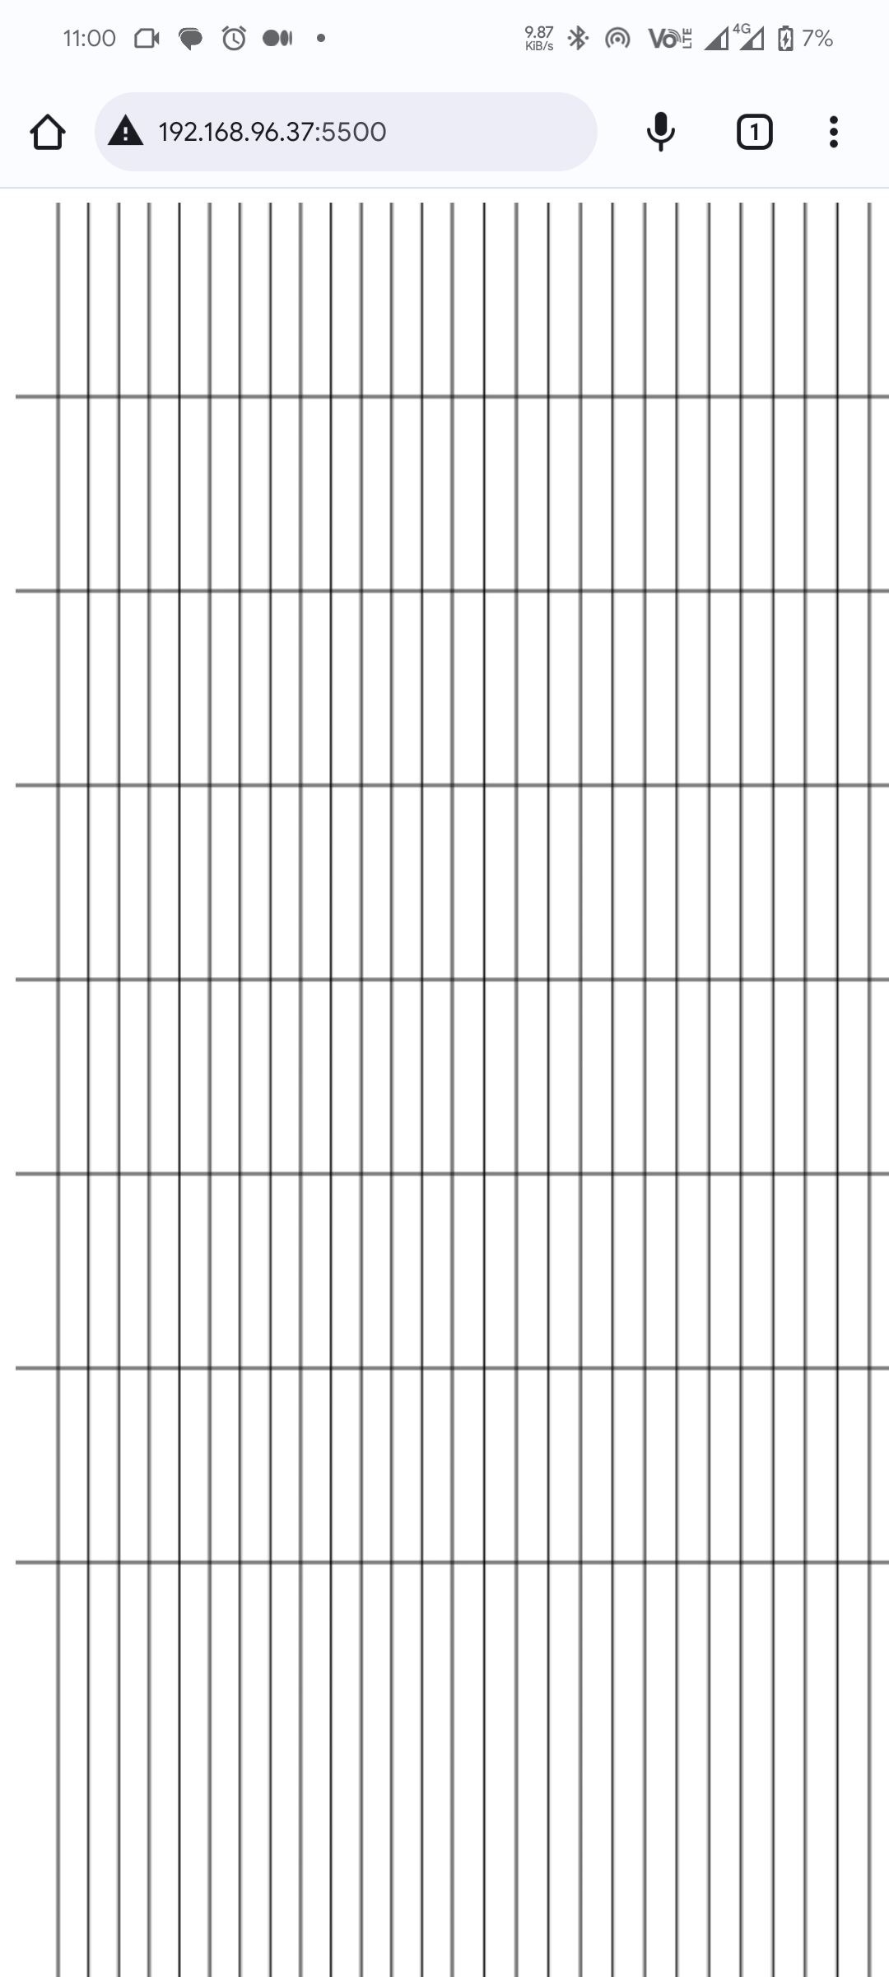

Fig 3. Layout in Chrome Mobile Browser

# IV. Conclusion

In conclusion, the Op Art style drawing created using HTML5 canvas and JavaScript is a prime example of how technology can be used to create visually stunning works of art. By manipulating the spacing and position of the lines, we were able to create an illusion of movement, depth, and vibration that is synonymous with Op Art.

The process of creating this drawing involved setting up an HTML file with a canvas element and a JavaScript file to manipulate the canvas. We then drew a grid of vertical and horizontal lines on the canvas using a for loop, adjusting the spacing and position of the lines to create the Op Art style illusion.

This assignment provided an excellent opportunity to explore the possibilities of using HTML5 canvas and JavaScript to create works of art. By experimenting with different line spacings and positions, it is possible to create an endless array of Op Art style illusions that are sure to captivate and inspire viewers.

# V. References

HTML5 Canvas API" - Mozilla Developer Network (<https://developer.mozilla.org/en-US/docs/Web/API/Canvas_API>)

"JavaScript Loops" - W3Schools (<https://www.w3schools.com/js/js_loop_for.asp>)

"Op Art" - Tate Modern (<https://www.tate.org.uk/art/art-terms/o/op-art>)\

"Op Art: A Movement in Art" - The Art Story (<https://www.theartstory.org/movement/op-art/>)

"Op Art History and Characteristics" - Art Encyclopedia (<https://www.visual-arts-cork.com/history-of-art/op-art.htm>)