# **Chapter I**

## **INTRODUCTION**

This chapter contains the problems that this project aims to solve, the purpose of creating the product, and how the proponents formulated the idea and came up with the project proposed. The objectives the proponents achieved as the proponents pursued the projects, the scope and limitation, and the importance of the completion of the project.

### **Project Context**

Electricity is one of the most important blessings that science has given to mankind. It has also become a part of modern life and one cannot think of a world without it. Electricity has many uses in our day to day life. It is used for lighting rooms, working fans and domestic appliances like using electric stoves, air-conditioning units and more. All these provide comfort to people.

It is undeniable that the benefits of Electricity are outstanding and become a necessity in living comfortably. A typical household life will hardly exist without the presence of electricity. With more and more devices requiring the use of internet in order to function, the proponents provide solutions to the ever-increasing need of monitoring the power consumption of each individual household, however a typical household can control the data provided resulted by monthly electricity bill and once an individual pays more attention with monitoring, it will be easy to control and save electrical consumption.

According to Yi-Tui Chen (2017), Electricity consumption may cause not only an improved living style but also aggravated impacts on the environment due to inappropriate use. Hence, relevant energy policies are required to induce efficient electricity consumption in the residential sector in many countries due to global warming effects and security of energy supply. As the electricity consumption in the residential sector accounts for about one third of the total electricity consumption in the world, this implies that the electricity consumption characteristics in households and residential sector should be focused.

According to the World Fact Book of the Central Intelligence Agency, as of 2016 the Philippines has an estimated consumption of 74.15 billion kWh which amounts more than 711 Billion Pesos in revenue using February 2017 Data Presented in the webpage of Meralco.

As the population increases, the demand for electricity also increases, according to Philippine Statistic Authority (2013). Electricity is the most common source of energy used by the household on the study that they released on the December 27, 2013 with about 87 percent of 21.0 million household use electricity from March to August 2011. Lighting to 92.1 percent of the 14.6 million households who reported to be users of electricity. Eighty percent of the electricity users used fluorescent lamps with an average annual consumption of 132 KWh; 53.4 percent used incandescent lamps, an average of 79 KWh; and 36.9 percent used compact fluorescent lamps, an average of 63 KWh. Sixteen percent of the households used other lamps such as Christmas lights, tiffany and neon lights, which consumed around 2.8 KWh per month or 34 KWh for the whole year. The second major use of electricity was for household recreation as reported by 85.4 percent of the total household electricity users. Among the electric appliances for household recreation, colored television recorded the biggest usage at 80.4 percent. Each household consumed about 210 KWh for colored TV; 92 KWh for black and white TV; and 55 KWh for VHS, betamax, laser disc, DVD or CD. Listening to music was enjoyed by almost one in every five households using the stereo, cassette or radio. On the average, each household consumed 243 KWh for stereo, 79 KWh for cassette and 80 KWh for radio. Likewise, karaoke or music mate was used more frequently on a longer period of time by 12.8 percent of the households as can be seen by a higher average consumption of 399 KWh. More than half of the households used electricity for space cooling (66.6%) and ironing (51.3%). For space cooling, 99.4 percent used electric fan consuming about 296 KWh per year, while 8.8 percent used air conditioner consuming about 3,914 KWh which is about 12 times as much as that of electric fan. Flat iron, on the other hand, consumed about 95 KWh during the year. Forty percent of the households claimed that they used electricity for refrigeration- either through the use of an ordinary or frost-free refrigerator which usually consumes around 1,000 KWh to 1,500 KWh annually, or through the use of a freezer which consumes around 2,400 KWh. About 27 percent used washing machine for laundry which, on the average, comprised 100 KWh of their total annual consumption. The use of electricity for cooking and food preparation was reported by 15.8 percent of the electricity users. The rice cooker was the most common cooking equipment registering an annual consumption of 223 KWh.

Currently there is no universal solution available in the market for the user to consume less energy. Therefore, the consumers decide to buy different energy efficient devices which we know the smarter the device the more expensive it is and the masses still choose to buy legacy devices. In addition to the lack of monitoring in our daily electric consumption and appliance, negligence may result to energy wastage and higher electricity bill.

The proponents aim to develop a system which can prevent, if not solve, problems with regards to disaster and risk reduction and also solve transparency of electricity consumption. By creating an Online Energy Monitoring and Power Sockets System, we aim to reduce the cause of fire hazards. The system also provides solution to over-consumption by giving out the information such as how the energy on the household is being divided into their appliances and which appliances consume the most power which is unavailable in previous energy monitoring devices which helps financially conscious consumers who are curious on how their monthly electricity bill will reduce. Appliances that are left unattended can be turned off remotely and the cause of fire due to electrical negligence is reduced and having this kind of monitoring methods and system in each household may prevent and be able to curb and detect the rampant unauthorized use of electricity.

### **Purpose and Description**

This section presents the features together with the significance of developing the system. The beneficiaries of the system were also discussed in the latter part of this section. Some of the features of the system includes: reading of the current usage of an appliance; denial of unwanted devices from accessing the electricity through the use of RFID; control and limit of appliances to help conserve and reduce unwanted risks and representation of accurate data into more understandable graphical representations. The following are the lists of who or what will benefit from the system:

**Electricity Consumer.** This will benefit those financially conscious consumers who are curious on how their monthly electricity bill will reduce. Having this kind of monitoring methods and system in each household may prevent and be able to curb and detect the rampant unauthorized use of electricity.

**Industries.** Which practices energy footprint reduction and efficiency.

**Electricity Providers.** Reduced electricity consumption may prolong their supply of energy and lessen the need for importation of energy to other country.

**Future Researchers.** For future researchers, this will serve as a stepping stone regarding on the findings found by the proponents on household energy monitoring and electricity consumptions.

### **General Objectives**

In this project, the proponents aim to develop a Mobile-Based Online Home Energy Monitoring and Power Socket Control System for household.

### **Specific Objectives**

1. To be able to integrate the following significant features in the developed system such as:
   1. RFID Appliance Registration;
   2. Appliance Plug-in Notifications;
   3. Appliance Consumption Monitoring;
   4. WiFi Connected Power Socket;
   5. Remote Power Socket Control; and
   6. Monthly Electricity Bill Estimation.
2. To be able to utilize the following software and hardware development tools:
   1. Linux Operating System (Raspbian);
   2. LAMP (Linux, Apache, MySQL, and PHP);
   3. HTML (Hypertext Markup Language);
   4. JavaScript;
   5. CSS (Cascading Style Sheets);
   6. ArduinoC;
   7. Notepad++ (Text Editor);
   8. Cordova;
   9. Arduino; and
   10. Raspberry Pi.
3. To be able to implement the AGILE SCRUM Software Development Life Cycle such as:
   1. Product Backlog Creation;
   2. Sprint Planning and Sprint Backlog Creation;
   3. Working on the Sprint. Scrum Meetings;
   4. Testing and Product Demonstration; and
   5. Retrospective and Next Sprint Planning.
4. To evaluate the system using the Software and Hardware Quality Evaluation criteria such as:
   1. Functionality;
   2. Reliability;
   3. Usability;
   4. Maintainability;
   5. Portability;
   6. Workability;
   7. Safety; and
   8. Training and Documentation;

### **Scope and Limitations**

The scope of the project are as follows, a notification will be sent to the mobile web application when an appliance is plugged in the power socket. The user can register it by tapping an RFID card/keychain. The system provides monitoring of the energy consumption of a certain household wherethe information is seen through the mobile application that is accessible via internet connection that allows monitoring and control even if the user is not at home.With real-time updates of the status defined as the response of the system per minute of the appliances and indicates if an appliance is on or just plugged in but not in use and allows the user to change the settings, plus the estimated average cost of the electric bill to be paid by the user per month.The power sockets are controlled by the user through the web mobile application where the user is able to turn off the appliances left running and unsupervised and can also stop the electrical current flowing to an appliance that is plugged in but not in use since an appliance still consumes energy even if the appliance is not running. The appliances to be considered for testing of energy consumption calculation were chosen by the proponents and the appliances that were used are those that are commonly used in a small-scale home.

The limitations of this project are as follows, the notifications of the proposed system are web-based only. The proposed system’s hardware prototype can only monitor one plugged in appliance at a time, so the use of extension cords with multiple power sockets is not advisable but it can be done. Since the proposed system rely on RFID card/tag to recognize an appliance, there should be one RFID card/tag per one appliance ratio. The proposed system cannot add the “System Loss Charge” of the Electricity Provider/s (Meralco) in the monthly consumption computation estimate because it varies monthly and the Electricity Provider/s (Meralco) does not provide an API for that. The prototype’s IR sensor cannot sense black colored plug because in nature, black color poorly reflects light which makes it hard or impossible for IR sensors to detect it. The reason why the proponents chose IR Sensor is to avoid obstruction between the appliance plug and the sensor because IR Sensors can detect objects that are near it unlike other that requires several centimeters to be able to sense objects. The power socket unit has a maximum power rating of five amperes (5A).

# **Chapter II**

## **REVIEW OF RELATED LITERATURE/SYSTEMS**

This chapter contains references and similar projects that proved to be helpful to the proponents when formulating the solution to their system. The proponents have gathered information from these sources whenever related to the problem that needed solving.

### **Related Literature**

#### **Real-time Power Monitoring. Home Automation and Sustainability**

According to Wisam Nader (2011), as the supply and demand of electrical energy is challenged within the context of environmental awareness and national security, the need to evaluate and advance each side is growing in importance. The electrical distribution system plays a critical role in the built environment as it is an enabling product, an intangible necessity used to power our systems. In order to manage our energy and prevent the consequences caused by energy wastage we need to develop tools for the built environment to become elastic with its consumption to respond to the national smart grid.

Understanding how energy is spent and knowing how to monitor and control it are key prerequisites for residential energy conservation. Research has shown that, in general, when presented with the appropriate information on energy usage, average homeowners will change their consumption behaviour to decrease their monthly electrical consumption and electricity bill. The magnitude of the savings depends on the type of feedback or information offered, cost of power, interface type and format, and other social and economic factors. The use of real-time feedback presents an opportunity to decrease energy consumption by 10%-20%. Several real-time monitors (RTM) created to provide real-time information to prompt consumers to curb their electricity use are available in the market. However, their effectiveness is limited due to their interface and mixed information, which range from partial and limited to overwhelming and impractical. It is also limited due to the user‘s knowledge of what action to take to curb the current wasted energy. Studies have demonstrated that it is the interface that fundamentally determines the behaviour. To create both energy and monetary impulse saving, we need to create a simple interface that empowers users to take control of their actions. Hence, current RTMs are not designed to take into account consumer behaviours in response to residential energy consumption and conservation.

Energy saved is, quite literally, energy found. A reduction of just 5% in global energy use would save the equivalent of more than 10 million barrels of oil a day and provide enough energy to power Australia, Mexico, and the United Kingdom. The residential sector, unlike the commercial and industrial sectors, is made up of multiple small energy users, such as houses, mobile homes, and apartments. Residential energy consumption accounts for 21% of the electricity used in the United States but research shows that almost 41% of that power is being wasted. While we are making improvements in energy efficiencies, we are offsetting it by increased consumption. The U.S. DOE‘s (Department of Energy) Energy Information Administration forecasts the trend in increased energy consumption to be in plug-in type loads. Furthermore, they have estimated through their Residential Energy Consumption Survey (RECS) research that miscellaneous plug loads – comprising DOE‘s ―miscellaneous‖ and ―electronics‖ end use categories – make up 15% of residential electricity consumption or about 1,600 kWh per year. Previous studies by Lawrence Berkeley National Laboratory (LBNL) estimated an average base load of approximately 77 to 87 watts for all loads in a household including hard-wired HVAC equipment and controls as well as white goods. Subtracting out the amount of power attributed to so called infrastructure, HVAC, and food/beverage end uses – largely white goods or hardwired products – from LBNL‘s findings, a base load of 64 to 74 watts is left. This is equivalent to 60W-75W light bulb running continuously in each house hold. With a 127 Million homes in the USA in 2007 that is approximately 7.7 GW of energy required to maintain loads in standby only. This energy, along with other loads remaining on 3 while not in use, such as lighting in rooms with no occupants, when reduced, will result in substantial resource savings.

A real-time monitoring of energy consumption is essential for energy conservation and sustainability. The project aims online real-time monitoring of energy consumption using ZPM system. The proponents of the project used the ZigBee protocol for mesh networks in home automation and Zero-Net Energy Test Home or ZNETH

#### **Wireless Monitoring of Household Electrical Power Meter Using Embedded RFID with Wireless Sensor Network Platform**

According to Wasana Boonsong and Widad Ismail (2014), tracking and monitoring system using radio frequency identification (RFID) have gained a lot of improvements especially for applications that need automation with reduction in human intervention and become more interesting nowadays with the increasing market demand for internet of things (IoT) technologies.

#### **Smart Home Automation: A Literature Review**

According to Vaishnavi Gunge (2016), home automation is becoming popular due to its numerous benefits. Home automation refers to the control of home appliances and domestic features by local networking or by remote control. Artificial Intelligence provides us the framework to go real-time decision and automation for Internet of Things (IoT).The work deals with discussion about different intelligent home automation systems and technologies from a various features standpoint. The work focuses on concept of home automation where the monitoring and control operations are facilitating through smart devices installed in residential buildings.

Smart home automation and the proposed system shares the same concept of controlling and monitoring appliances remotely. But the proposed system can go as far as controlling and monitoring an appliance even when the user was away from home by using the internet as a medium of communication.

#### **Social Electricity: When Awareness about Electricity Becomes Social**

According to Andreas Kamilaris, George Taliadoros and Andreas Pitsillides (2013), Although domestic smart metering has been introduced into our lives, it is still not easy for consumers to know how much electricity they are using. Consumers are unable to assess whether their consumption is low, average or high. “Social Electricity” is a Facebook application that aims to make individuals aware of their energy consumption by means of comparisons with the corresponding electrical consumption of their friends, as well as with the total consumption in the area where they live. Effective and realistic social comparisons could raise consumers’ awareness of their consumption behaviour, enabling them to take steps to reduce their electricity use and carbon footprint.

Energy conservation is a global issue with huge environmental, social and political implications. Smart metering has been introduced into homes to provide timely energy consumption feedback, helping consumers to more effectively manage their power use. Nevertheless, it is still difficult for people to quantitatively assimilate how much energy they consume. Consumers lack the required metrics to determine whether their total consumption is low, average or high. A promising way to understand the "semantics" of consumed energy is to compare it with the amount consumed by relatives, friends and neighbours. The increasing popularity of online social networking sites (eg Facebook, Twitter), allows the proliferation of social ICT applications targeting energy awareness.

Smart metering is not enough to suffice the lack of consumption awareness of electricity consumers, with that being said, the proposed system will individually monitor the electricity consumption of each registered appliance and the ability to monitor and control the consumption even when the consumer is away from home.

#### **Understanding the Importance of Conserving Electricity**

According to Beth Assaf (2014), the idea of conserving electricity means that you should only use it when necessary and avoid wasting it. This means doing simple things, such as turning off lights when you leave a room, as well as more involved processes, such as replacing standard light bulbs and appliances with those that use less electricity. While you may not notice much of an impact on your day-to-day life when you make these types of changes, the environmental impact of your actions will be much larger. One of the biggest motivators people have for conserving electricity in their homes is the accumulated savings in their energy bills at the end of the year.

### **Related Systems**

#### **Open Energy Monitor**

According to the developers of Open Energy Monitor (2016), it is project that helps a user monitor electric consumption. The project uses wireless nodes that send data to a web-connected Raspberry Pi. The nodes use microcontrollers that are compatible with the Arduino IDE. The Open Energy Monitor Supports Homes with a Solar Energy System and temperature monitoring.

User and sends data to a web application on the Raspberry Pi. The Open Energy Monitor and the proposed system similarly has the capability of monitoring energy consumption and usage of the Open Energy Monitor however, does not have a power socket controller part.

#### **Smart Air Socket**

According to the developers of Smart Socket Air (2016), the smart socket air is a plug-in device where the user can monitor the appliances or other electrical component connected to the socket. The system is manipulated through the use of wireless connection (Wi-Fi). First, register the device to a mini server in order to generate the serial number. If it is replaced by another, do the process again. Inside of the server, the user can see the list of hours, energy and consumption of the registered device.

#### **Smart Home Automation using Android**

According to Abhishek Xavier (2016), the prototype gives power to control appliances with the use of Bluetooth connection (Bluetooth dongle) that ranges 10-100 meter or wireless access point. The device has five sensors in order to monitor the temperature, electrical appliances such as fans, television, computer system, etc., leak of LPG, status of windows or doors and light intensity. The prototype used electromechanical relay that is connected in each device able to switch on/off the load and a microcontroller that serves as a main server. Researchers also made an android application to ease the user in controlling the device remotely. The project also implemented a monitoring system.

#### **AC Watt Meter**

According to Carl Jonathan Bergonia and Rober Ian Dones (2008) the watt meter is built to measures the voltage, current, apparent power, real power and power factor. The watt meter can easily adapt the other voltage, current and frequencies, but the meter is made for 230 V, max 2.54A and 50Hz. In measuring voltage and current the watt meter establish voltage measuring circuit and current measuring circuit to monitor and to have stable output.

#### **Apple HomeKit**

HomeKit lets people securely control connected accessories in their homes using Siri or the Home app on iPhone, iPad, and Apple Watch. In iOS, the Home app also lets users manage and configure accessories. Your iOS, tvOS, or watchOS app can also integrate with HomeKit to provide a custom or branded home automation experience.

This device is limited to ios device only it allows the user to make diy(do it yourself) smart home system and it supports homekit’s compatible products you choose to start with. This said more functional one you add apple tv or an ipad that doesn’t leave home. The product is focused on controlling ios/homekit’s compatible smart devices.

#### **Power Meter**

According to Jane Uymatiao (2011), the home automation for energy monitoring meant to scan the electricity bill every month and record all the electricity consumption of all the appliances. but a device just records the total consumption of all the appliances in a month. The Power meter of General Electrical (GE) measures the kilowatt-per-hour for electricity consumption. MERALCO Company, the biggest energy or power distributor in the Philippines uses the device. Meralco has latest digital power meter that can help the users and consumers in ability to read their and easier to maintain electricity bills.

### **Synthesis**

Based on all the compilation of related literatures and systems cited above, the proponents concluded that the proposed system is not obsolete but rather an innovative improvement of the existing concepts and systems because of the evident improvement of technology over the past years which is more capable of better output than before. With the information gathered through this, the proponents gained ideas and knowledge about the concept of the proposed system.

Smart metering is not enough to suffice the lack of consumption awareness of electricity consumers, with that being said, the proposed system will individually monitor the electricity consumption of each registered appliance and the ability to monitor and control the consumption even when the consumer is away from home.

As a consumer without prior knowledge on how much kilowatt they are consuming, it leads to overconsumption of electricity and wastage. Energy saved, is energy found. The home monitoring device and the proposed system both offer online real-time monitoring of energy. The components of the proposed system differ with the Real-time Power Monitoring, Home Automation and Sustainability project as the proposed system uses an Arduino-Compatible Microcontroller and the project uses the ZigBee Protocol. ZigBee uses Radio Frequency as a medium, while the proponents use Wi-Fi and HTTP as a protocol.

Just like the Open Energy Monitor, The project of the proponents allows the control of power socket and includes identification of the appliances. The proposed system also includes notifications regarding the power consumption of the user and tells the user when a maximum consumption the user set has been exceeded.

The existing Smart Air Socket device and the proposed system have the same function which is to monitor the power consumption of appliances plugged in the smart socket. The smart socket also has the feature of identifying devices and requires the device to be registered in order to be given power through the use of serial numbers. However, the smart socket can only identify one device and if it gets replaced, the user has to register the device again. The proposed system will also have the feature of registering the devices first before it can be given power, but the power socket will be able to identify multiple devices as long as it is registered in the database. The proponents may use Near Field Communication (NFC) technology or Radio Frequency Identification (RFID) for the identification of the device. Each electrical component is registered in the database and has own information listed to it. If the devices are not registered it will not be able to connect, but the user will be notified if there are unregistered devices plugged in, and the user will have the option to allow the device to get power for a limited time. The smart socket requires manually registering a certain component whenever it is replaced with another.

The proposed system and the Smart Home Automation both allow the user to control appliances and turn it on or off. The devices can also be controlled remotely. However, the proposed system is not capable of monitoring the temperature inside the home and the means of communication that will be used is through web. The proposed system will be web based so even the user is not at home, the devices can still be controlled. The smart home automation doesn’t have the function of filtering the devices that can consume power unlike the proposed system devices need to be registered in order to be given power. The proposed system has a main control panel that receives all the information regarding the devices and the energy consumption will be monitored. The power sockets will have a relay that will be used to cut the current being supplied in case the device that is plugged in is unregistered. The user will be notified if unregistered devices use the power socket and the user will have the option to allow the device to consume power.

The AC Watt Meter and the proposed system both measure voltage, current and power of the appliances and use a current sensor but the watt meter is only limited to measuring voltage and current. The proposed system will have the capability of monitoring the energy consumption real time and send the data to the web application. With the use of the power socket, the user will be able to control the devices that are plugged in.

# **Chapter III**

## **TECHNICAL BACKGROUND**

This chapter will further discuss in full description the development model that the proponents will use together with some of the requirements including software and hardware tools to be use in developing the system. In this chapter also discuss the process designs, flow charts and prototype user interface.

## **Methodology**

The software development life cycle (SDLC) is a framework defining tasks performed at each step in the software development process. SDLC is a structure followed by a development team within the software organization. It consists of a detailed plan describing how to develop, maintain and replace specific software. The life cycle defines a methodology for improving the quality of software and the overall development process.

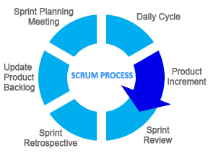

**Figure 1. Scrum Development Diagram (Jeff Sutherland, 1993)**

In order to manage the project, the proponents used Scrum as a project management methodology.Scrum framework allows you to implement Agile development methodology. Unlike the waterfall software development life cycle, the distinctive feature of Scrum is the iterative process of developing.

Development divides into several phases. Each of them results into a ready-to-use product. At the end of each step (called sprint in Scrum terminology) a ready product is delivered to a customer. Customer’s feedback helps reveal possible problems or change the initial plan, if needed. Planning the development period, the systems was on a timeline divided into sprints with the first sprints focusing on the most important parts of the functionality of the system. Since the proposed project was defined in the documentation, the proponents figured to do the system modularly by dividing the tasks into sprints and by doing so makes debugging faster and more efficient.

**Product Backlog Creation Phase**

Product backlog is a list that consists of features that should be implemented during the development process. It’s ordered by priority and its every item is called a User story. In this case, user will make use of the Gantt chart as basis of the backlogs to be created. Each entry in the Gantt chart will be converted into backlogs. After the product backlog creation is finished you can move to the next step – sprint planning.

The proponents used the project’s Gantt chart to create a backlog. Which will be later used as a basis in creating tasks for the entire development plan of the proposed system.

**Sprint Planning and Sprint Backlog Creation Phase**

The scrum team will select the most important user stories from the product backlog. Then the proponents will decide how they will solve this or that task. The Sprint backlog should be created next. It consists of user stories that will be completed during the current sprint. The amount of these stories depends on their duration in story points assigned to each story during evaluation stage. The team should be capable to finish all these stories on time.

The proponents will determine what the sprint’s duration will be. In this case the proponents will make use of the Gantt chart’s timeline as a guide. What’s more important at this phase is the cooperation of all the proponents and other important people especially expert advisers. The proponents decided to create to proposed system’s power socket first because it is the vital part of the system, without it, the proponents cannot put functions on the mobile web application.

**Working on the Sprint. Scrum Meetings Phase**

To track the current working process, a task board will be used. There are usually big cards with the names of particular user stories and a bundle of little sticky notes with a description of single tasks which are needed for implementation of this or that story.

These cards are arranged according to their importance. When work on a task has been started, the corresponding sticker is moved from the “To do” field to the “In progress” one. When work is completed, the sticker can be moved to the “Testing” field and after the task is successfully tested, the sticker goes to the “Done” field.

In this phase, the proponent’s team leader made a well-organized list of tasks that is needed to be done according to importance. The team leader created a table in a whiteboard namely “To do”, “In Progress”, “Testing”, and “Done” field to help in monitoring the accomplishment in the development of the proposed system.

**Testing and Product Demonstration Phase**

Since the ideal result of every sprint is a working product, the [full life-cycle testing](https://xbsoftware.com/qa-software-testing/full-qa-cycle/) process is very important. The result of every sprint is product demonstration. The Scrum team will create a review and demonstrate the results of their work. Afterwards, the proponents along with the adviser will take a decision about further project changes.

For ever task done, the proponents made a thorough testing of the finished task to detect bugs for later fixing and to improve some code logic in order to have the desired output of the proposed system.

**Retrospective and Next Sprint Planning Phase**

Retrospective’s main aim is to discuss the results and determine the ways how to improve the development process on the next step. The team should conclude what went well during the working process and what can be done better during the future iteration. When the ways of improvement are defined, the team can concentrate on the next sprint planning.

After discussing the results of the testing and product demonstration phase, the proponents discussed the next task’s plan while considering the good and bad points of the previous plan in order to improve the development cycle of the proposed system.

### **Conceptual Framework**

**Figure 2. Conceptual Framework**

The proposed system Online Home Energy Monitoring and Power Sockets Control System follows the process called Input-Process-Output (IPO). IPO Model is a widely used approach in system analysis and software engineering for describing the structure of and information processing program or other process as shown in figure 2.

The first frame is the input where all concepts and ideas are gathered to be processed later in the second frame. The second frame refers to the process in developing the proposed system. In this case, the proponents used the scrum development framework which consists of; daily cycle, product increment, sprint review, sprint retrospective, update product backlog, sprint planning meeting respectively. The last frame is the developed system.

### **Requirements Analysis**

Majority of homes uses electricity every day. The people living in it are mostly unaware of the electricity consumption of each of their appliances. Sometimes, they also tend to forgot to unplug an appliance leaving it unsupervised while wasting electricity. Unattended appliances may also be a cause of electricity induced fire incidents. Legacy power sockets doesn’t have the capability to be remotely controlled, monitored and be connected to the internet.

### **Requirements Documentation**

Online Home Energy Monitoring and Power Sockets Control System will help in the household electricity consumers. The proposed system will provide RFID integration for appliance registration, appliance consumption limiter and monitoring, unauthorized electricity usage notifications, power socket controls, and monthly electric bill estimation.

With all those features discussed, the consumers will be more aware of their consumption and may help promote energy conservation. It can also avoid electricity related fire incidents and electricity wastage because the proposed system can remotely turn off the power socket through its mobile web application.

#### **Software and Hardware Requirements**

**Table 1**

**Minimum Software Requirements**

|  |  |
| --- | --- |
| **Software** | **Version** |
| Google Chrome | 67.0.3396 and later |
| Mozilla Firefox | 52.0 and later |
| Operating System | Android Lollipop and later versions, iOS8 or later versions |

Table 1 shows all the minimum software requirements in order for the users to utilize the Proposed System. Google Chrome and Mozilla Firefox are used to access the website of the proposed system just in case they don’t have the mobile app installer. And the Operating System of the mobile phone should be running Android Lollipop or later and iOS 8 or later in order to utilize the proposed system.

**Table 2**

|  |  |
| --- | --- |
| **Hardware** | **Specification** |
| Desktop/Laptop | Intel Pentium 4 processor or later  2GB of RAM or higher |
| Mobile Phone | Android:  At least 1 GB of RAM  4GB internal Storage  iOS:  iPhone 4s and later |
| DD-WRT Router | Has wireless capability |
| Raspberry Pi | Version B+ or later |

**Minimum Hardware Requirements**

Table 2 shows the minimum hardware requirements of the proposed system for it to run properly. DD-WRT is a Linux-based firmware project developed to enhance the performance and features of wireless Internet routers. This open-source firmware upgrade is developed for specific router models and used as a replacement for the inconsistent stock firmware. Modifying a router to DD-WRT lifts restrictions built in to the default firmware, providing advanced capabilities to make your Internet and Home Network more controllable and versatile.

#### **Entity Relationship Diagram**

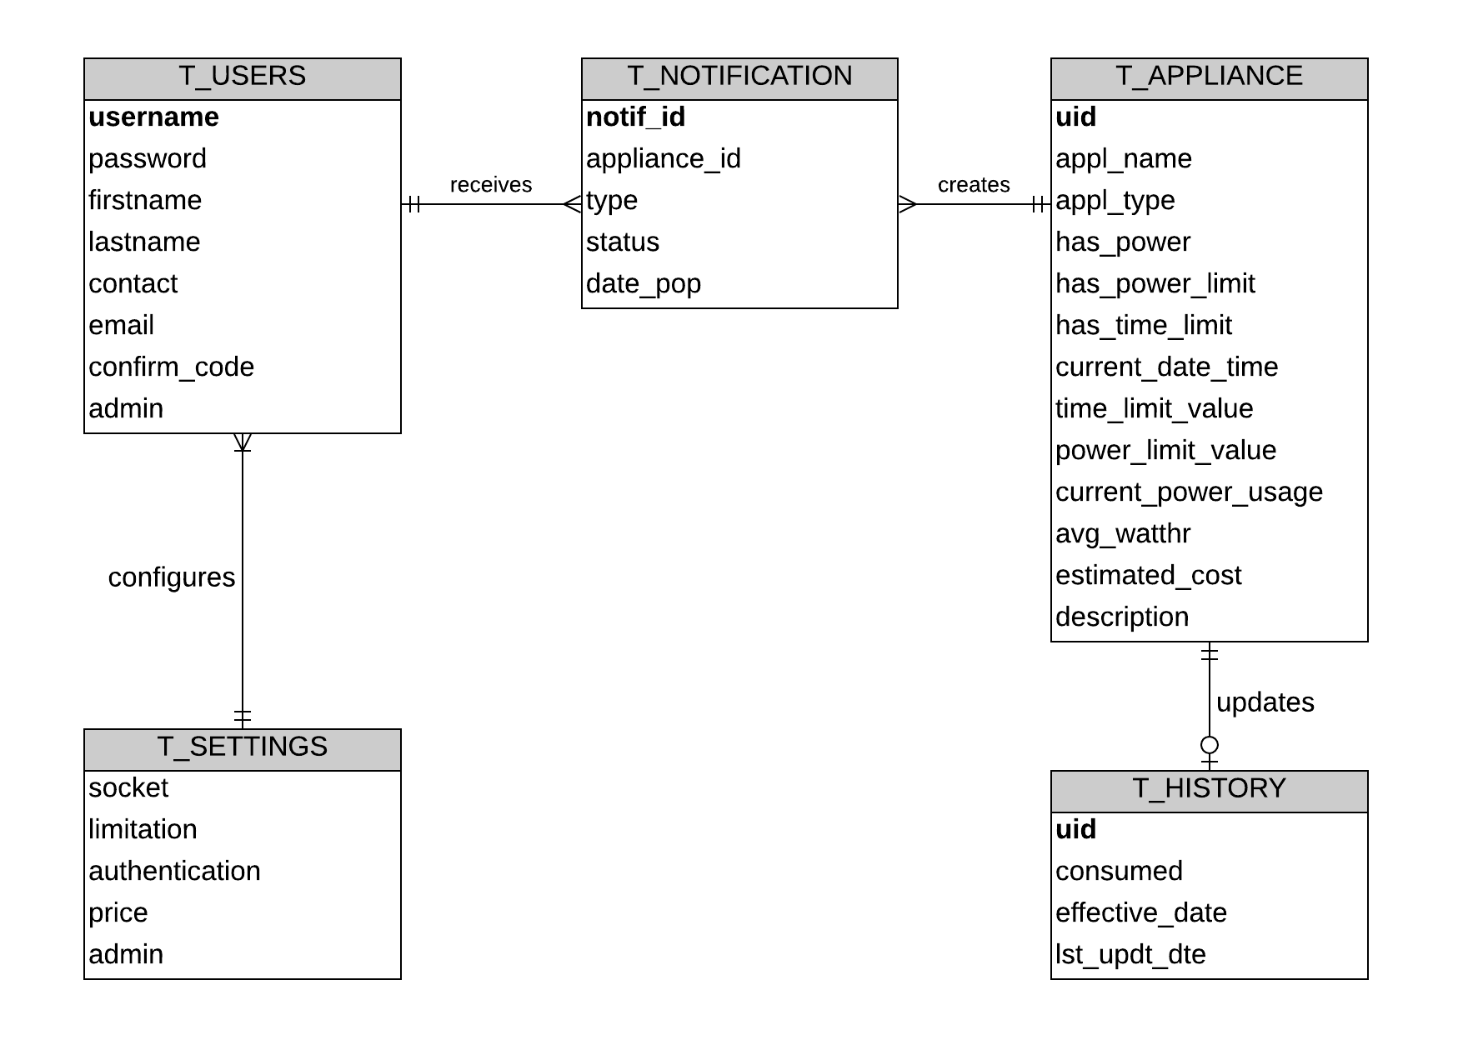

Figure 3. Entity Relationship Diagram

Figure 3 shows the relationship of each entities on the proposed system’s database. When and appliance is plugged in the power socket, the user will receive a notification. The user has a choice to register the appliance or not. The user can also configure the settings of the proposed system. The appliance updates its history real-time in the database to ensure updated data when monitoring it.

#### **Context Diagram**

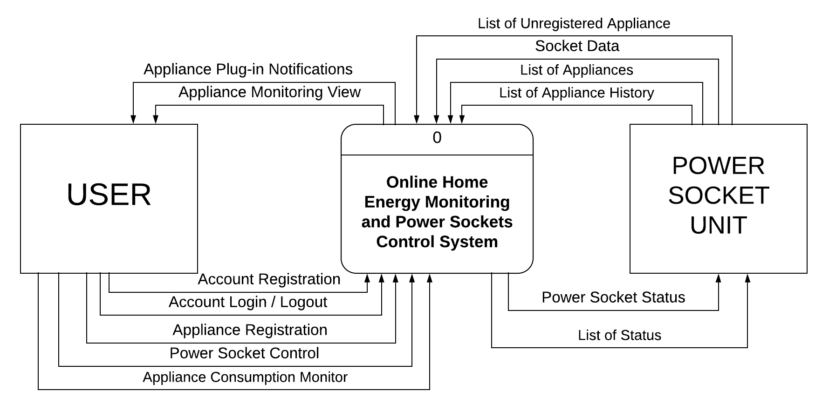

**Figure 4. Context Diagram**

Figure 4 shows the single process of Online Home Energy Monitoring and Power Sockets Control System. It shows all the user inputs in order to control the power socket and the results it gives back to the user.

#### **Data Flow Diagram**

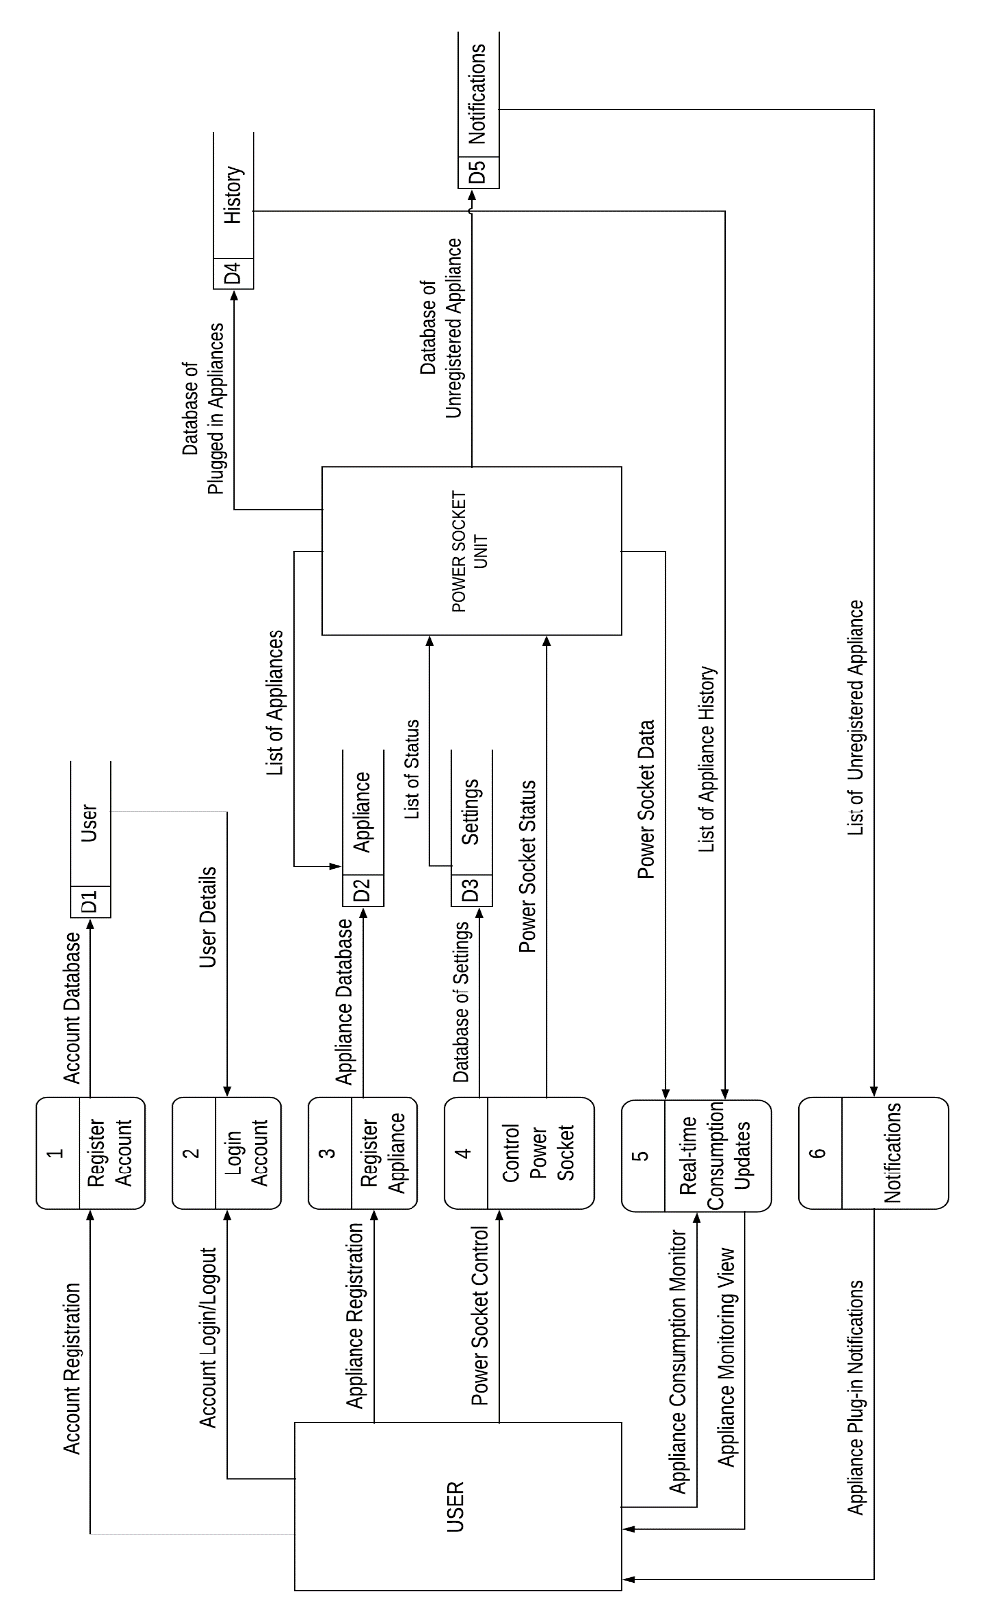

**Figure 5. Dataflow Diagram**

Figure 5 shows the multiple process of Online Home Energy Monitoring and Power Sockets Control.

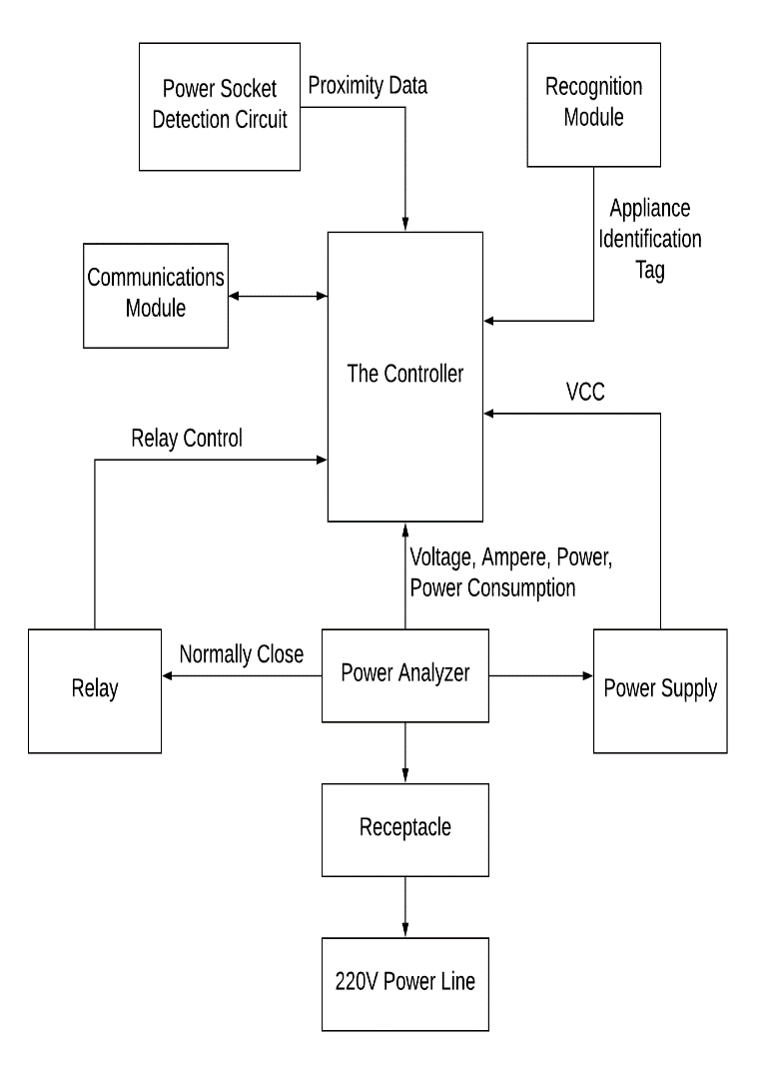The Power Socket

Figure 6. Block Diagram of the Power Socket

The Power Sockets, as seen on Figure 6 are the receptacles that are responsible for providing power to the appliances, The Power Socket contains identifiers and sensor circuits that determines or recognizes appliances to cross check to the database. The Power Socket also contains the sensor that measures the incoming current of the Power lines. The current measured is essential for the specific objectives of the proposed system, the detection of unauthorized connection as well measuring the total power consumption of the user.The Identification module is responsible for recognizing devices by an identification tag, if available. The relay module is responsible for switching the 220V power line on or off towards the receptacle of the Power Socket. Lastly, the Wi-Fi Module is responsible for transmitting and receiving data towards and from the Power Socket.

The Network Connection of the Components

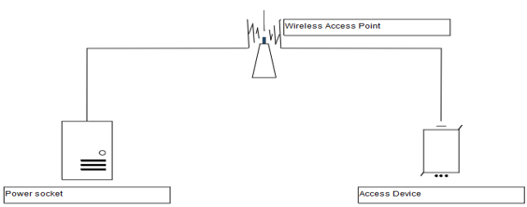

Figure 7. Representation of the Network Setup

The Security of the Wireless access point is out of the concern of the proponents as the security is dependent on the security policy, the router manufacturer and the firmware embedded in the wireless router.

The System requires an external common access point as shown in figure 7 in order to function. The access point is a wireless router that the Power Socket and the Access Device connects in order to communicate with each other.

The Wireless Access Point is required for the operation of the System. While the operation is possible by configuring the Controller of the Power Socket and Communications module as an Access Point, the proponents decided against. The reasoning behind the decision is that the user needs to change Access Points whenever the user wants to check the operation of the system and that the information available on the system is not easily available on the internet if configured as an access point. Making the System connect into an Internet connected wireless access point makes the information of the System available with fewer steps to be done by the user. Although, the proponents emphasize that Internet connectivity is not a requirement for the system to function and that the system is not optimized for security for doing so.

#### **The Overview Block Diagram of the System**

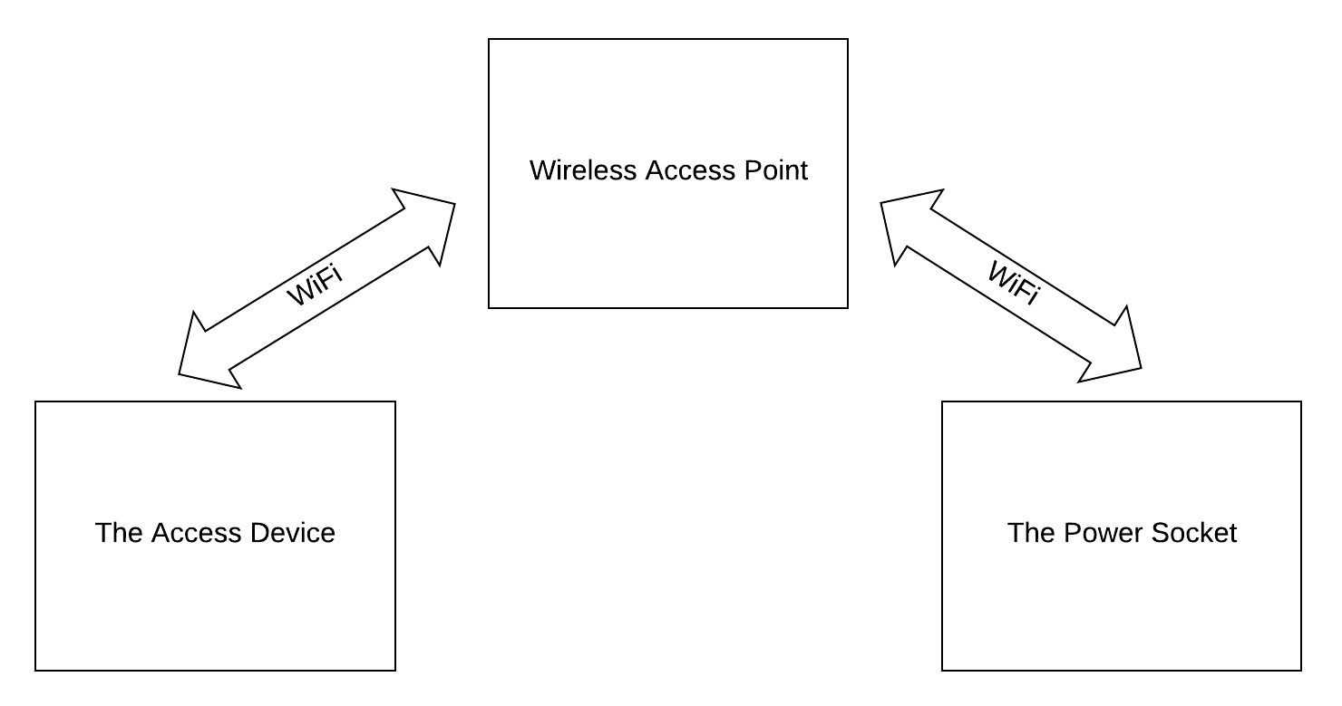

**Figure 8. Overview Block Diagram**

Figure 8 shows that the communication of the device to the power socket and control panel uses wireless communication, which in this case is Wi-Fi, and a wireless access point as the mediator between the two. The data will be sent to the server and in turn the wireless access point reads the server and communicates the message to the power socket.

#### **Flowchart Diagram****s**

##### **Power Socket Flowchart**

**Figure 9. Power Socket Flowchart (Part 1)**

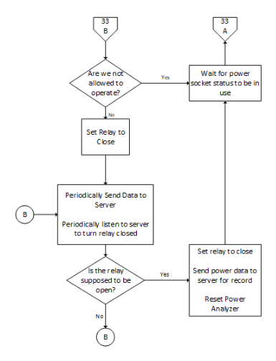

**Figure 10. Power Socket Flowchart (Part 2)**

The logic of the Power Socket is illustrated in Figure 9 and 10 shows the complete Systems Flowchart of the Power Socket System.

##### **Mobile Web Application Flowchart**

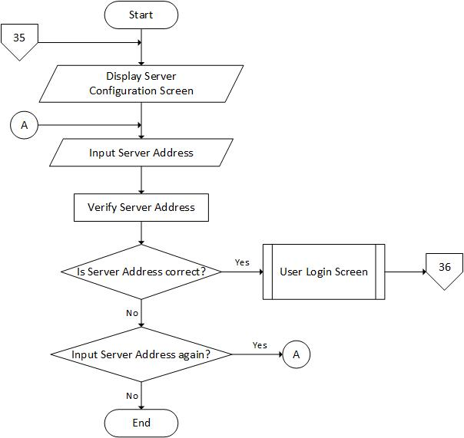

**Figure 11. Server Configuration View**

Figure 11 shows the flow of server configuration view. This screen is responsible for inputting the server address of the project.

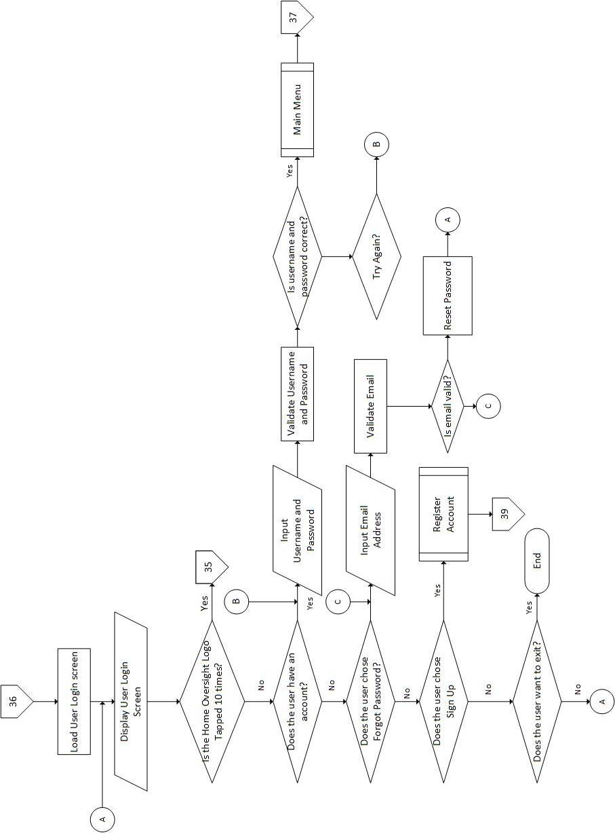

**Figure 12. Login View**

Figure 12 shows the flow of the login module. This module is responsible for account registration, account login, and forgot password.

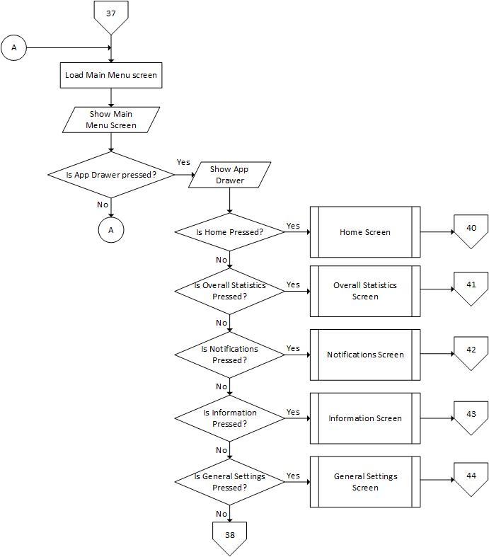

**Figure 13. Main Menu (Part 1)**

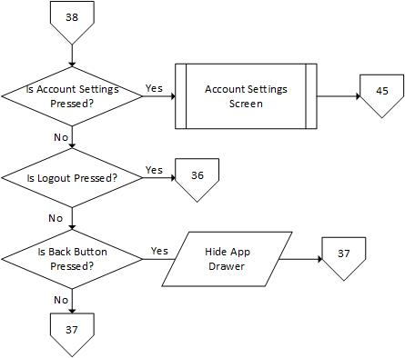

**Figure 14. Main Menu (Part 2)**

Figure 13 and 14 shows the main menu module flow. This is where the other functionalities of the mobile web application are listed.

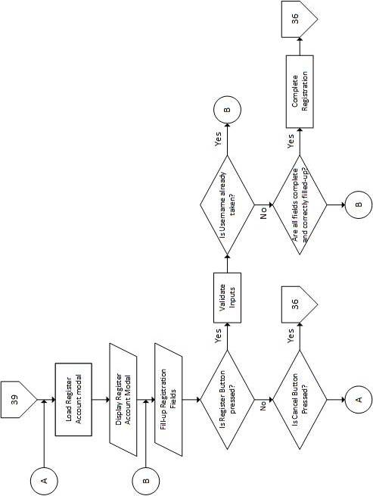

**Figure 15. Account Registration Modal**

Figure 15 shows theaccount registration modal flow whenever the user tries to register an account to access the system.

**Figure 16. Home View**

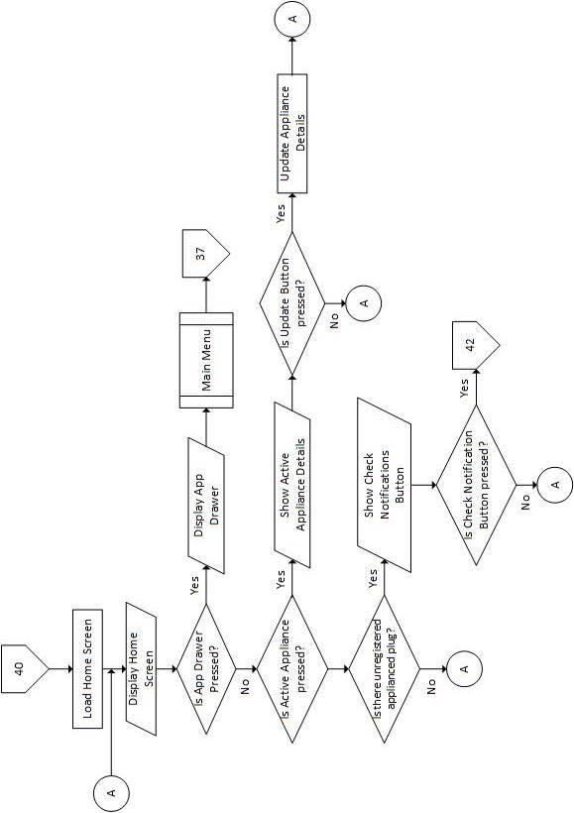

The detailed flow of the home view is described in figure 16. This shows the detailed explanation of the home view.

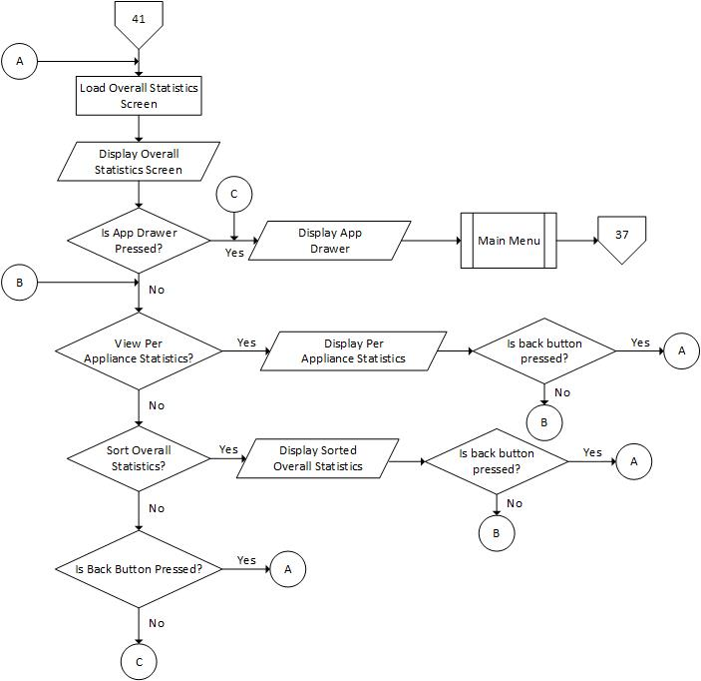

**Figure 17. Overall Statistics View**

The flow of the overall statistics view is shown in figure 17. It shows how statistical request are processed.

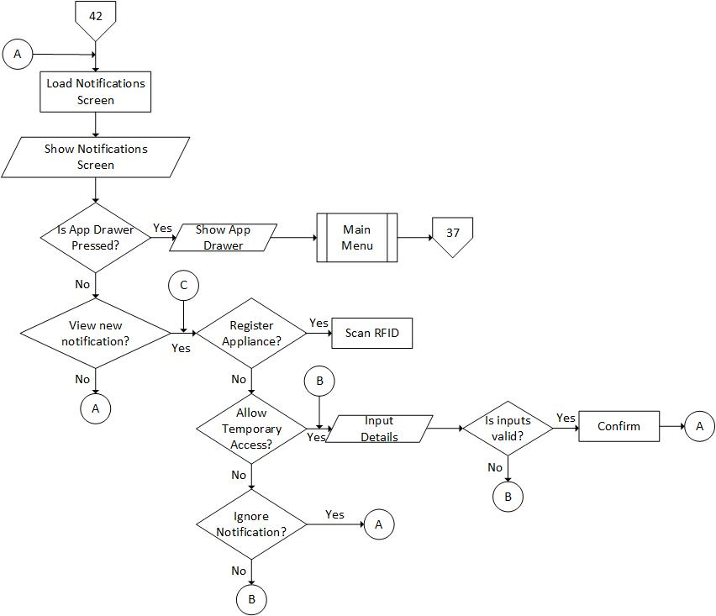

**Figure 18. Notifications Module**

The detailed flow of the notifications module is shown in figure 18. It shows all the new notifications and past notifications.

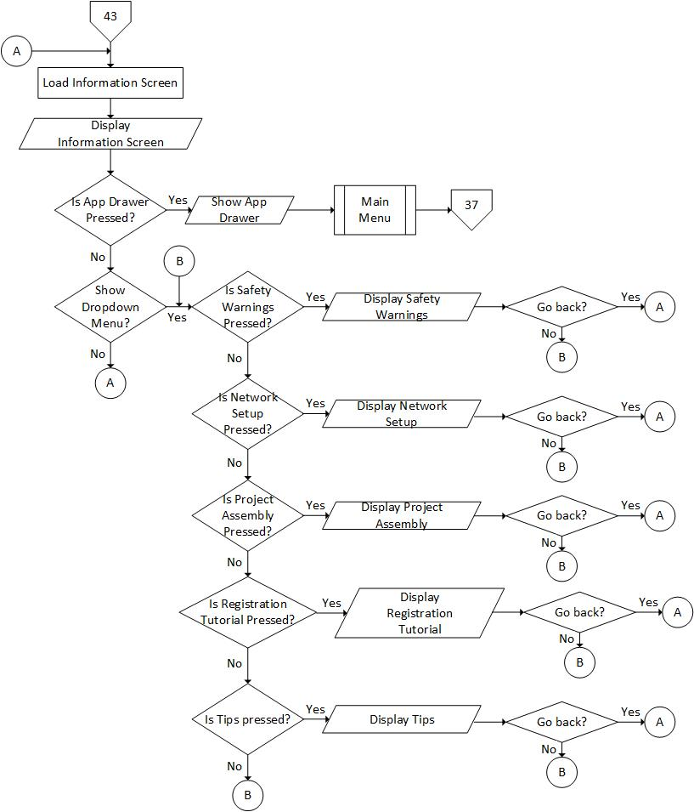

**Figure 19. Information Module**

The illustration of the information module flow is illustrated at figure 19. This figure shows the process on accessing the information contents.

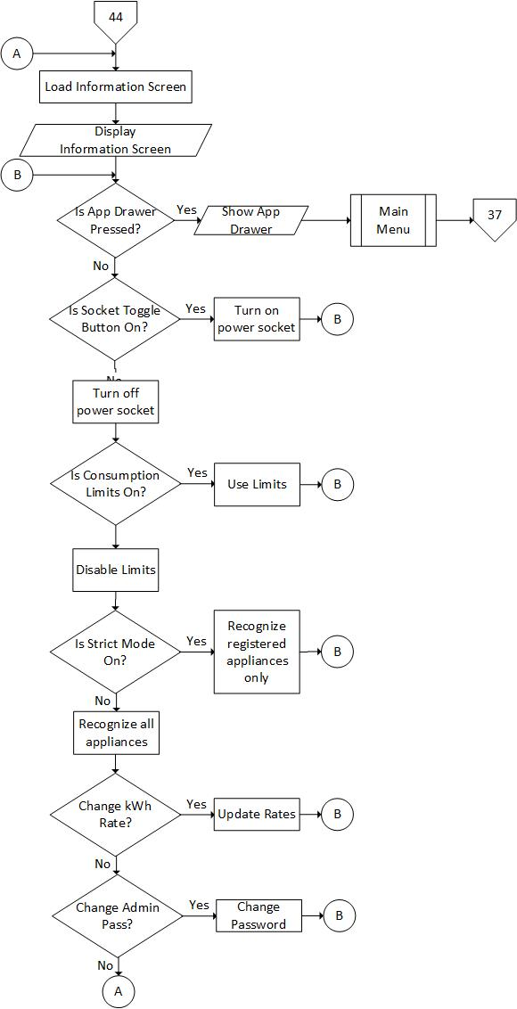

**Figure 20. General Settings Module**

The general settings flow is illustrated in figure 20. This figure shows the process of changing different settings on the power socket and the app itself.

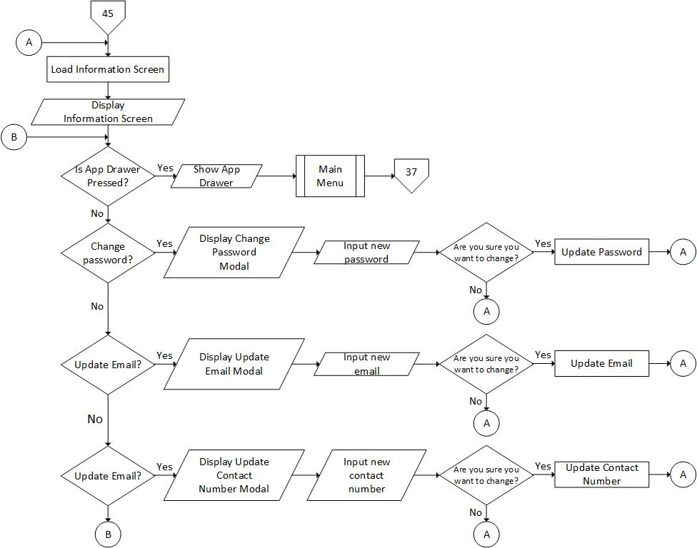

**Figure 21. Account Settings View**

The flow of the account settings view is illustrated in figure 21. It shows the process on how to change account password, email and contact number.

**Development and Testing**

In order to achieve the proponents’ idea of the project, testing the hardware and its accuracy is required. Tests have been devised in order to see the accuracy and reliability of the system. These tests challenge the different modules of the system to examine whether the project is coursing its way towards the product that the proponents have planned.

**Power socket status check.** This test is devised to check the whether the identification logic programmed in the Power Socket is functionally correct. The relay is expected to turn on when a Registered RFID Tag is scanned and should not turn on when an unregistered RFID Tag is scanned.

**Appliance Identification.** This test verifies the ability of the Power Socket to send UID data to the Main Control Panel Server and the Main Control Panel’s ability to cross check data in the database. The Information for the appliance should display in the PHP webpage. A pre-requisite for this test is that the appliance tags to be tested should be registered to the database of the server as well as the Main Control Panel and the Power Socket is linked locally by a Wireless Router.

**Power Analyzer Accuracy.** This test is devised to check the accuracy reading of the AC Power Analyzers employed to read the power of plugged in appliance. The proponents purchased a dedicated AC Digital Wattmeter for the testing and used it as a basis for the AC Power Analyzers of the Power Socket. A 90% minimum target accuracy is needed for the test to be deemed successful.

**Power Socket Usage Recognition**. This test takes note of the Power Socket Usage Circuit’s performance using different kinds of plugs available in the market. This test is essential for the proponents to determine the Voltage value of the proximity sensor that is needed for the Power Socket to determine whether there is a plugged-in appliance or not.

**Notification and Database Logic.** The objective of the test is to notify the user when an appliance has been plugged in and correspond with the appropriate status of the plugged-in appliance. The notification should pop-up when an appliance is plugged in.

**RFID Distance Test.** This test is devised to determine whether it is possible for the RFID to be positioned behind the power socket. Measuring the distance in centimeters will determine the maximum distance the RFID could successfully read the RFID tags.

**Proximity Sensor and Identification Test.** The function of the proximity sensor is to determine whether there is an appliance plugged in on the Power Socket. The power socket should scan for an RFID Tag when the voltage of the proximity sensor reaches an appropriate level. This test is devised to determine whether the proximity sensor is reading the status of the power socket and power plug correctly.

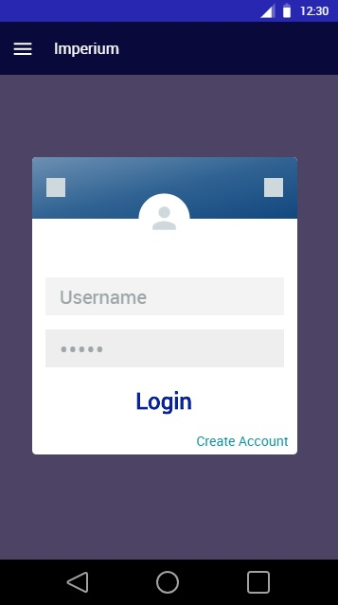**Description of the Prototype**

**Figure 22. Login Interface**

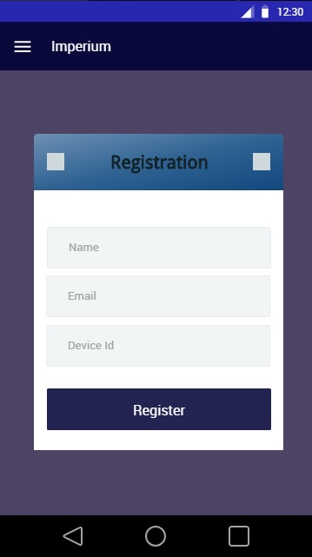As shown in Figure 22 the Login Interface presents the Login form where the user input their username and password to access the system.

**Figure 23. Registration Interface**

As shown in Figure 23 the Registration Interface allows the user to create an account to be use when logging into the application.

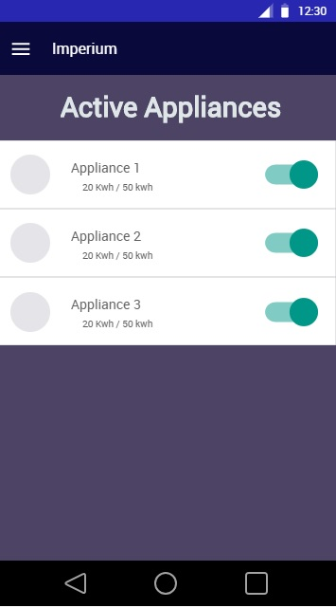**Figure 24. Dashboard/ Active Devices Interface**

As shown in Figure 24 is the Dashboard or Homepage of the Application where the user can view active/ plugged devices and turn them on and off.

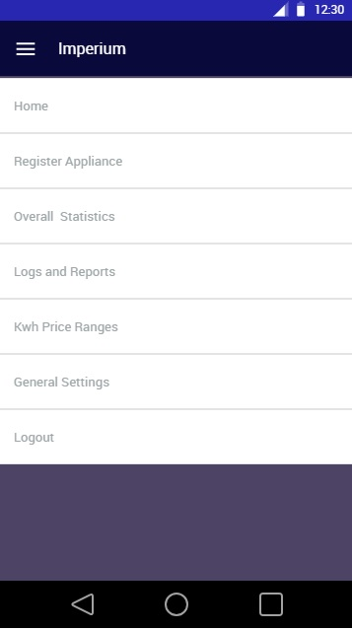**Figure 25. Main Menu**

As shown in Figure 25 the Main Menu allows the user to navigate through the different parts of the system after logging in.

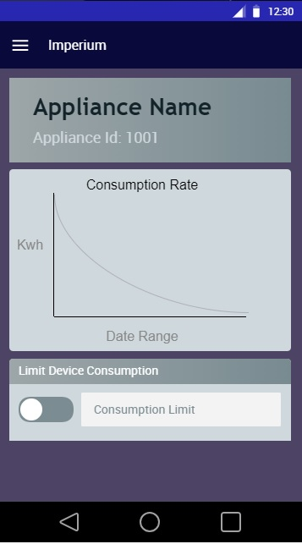**Figure 26. Appliance Description and Status**

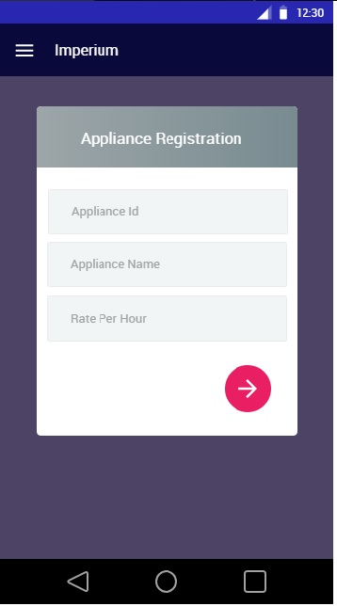As shown in Figure 26 the details of the selected appliance is presented including its consumption and limit.

**Figure 27. Appliance Registration Interface**

As shown in Figure 27 Appliance Registration Interface allows the logged user to add or register another appliance.

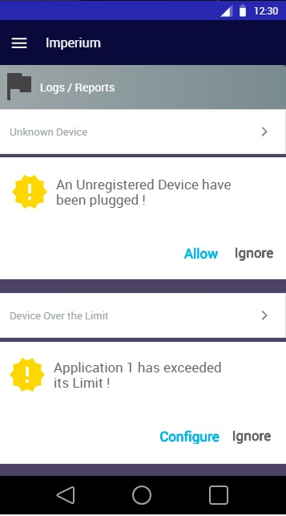**Figure 28. Logs and Reports Interface**

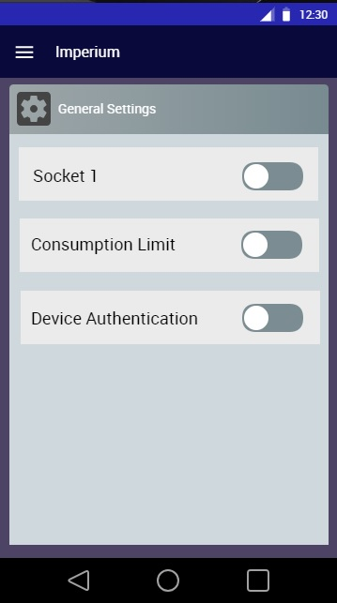As shown in Figure 28 the Logs and Reports Interface shows the user whenever an unauthorized device is plugged in. Also, user will be notified when a device exceed its power limit.

**Figure 29. General Settings Interface**

As shown in Figure 29, in the General Settings Interface you can turn on/off the sockets, consumption limit and device authentication.

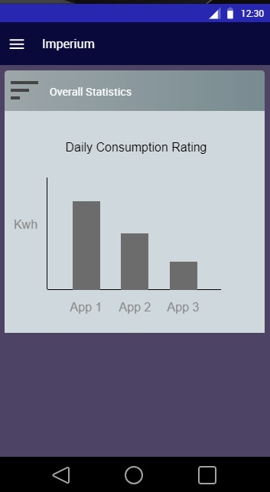**Figure 30. Overall Statistics Interface**

As shown in Figure 30 Check and Statistics Interface allows the user to check and compare the consumption on the past results.

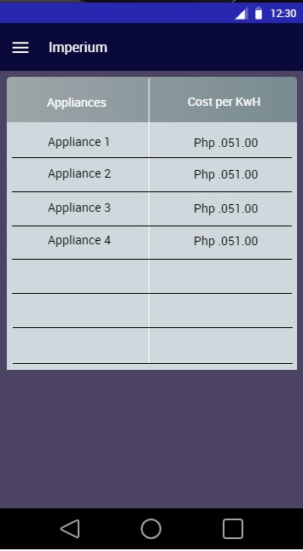**Figure 31. Kwh Price Ranges Table**

As shown in Figure 31 is the list of Price per KwH of each devices and applications.

**Chapter IV**

**RESULTS AND DISCUSSIONS**

This chapter puts the project in context and includes a discussion of the answer to specific objectives stated in the previous chapter.

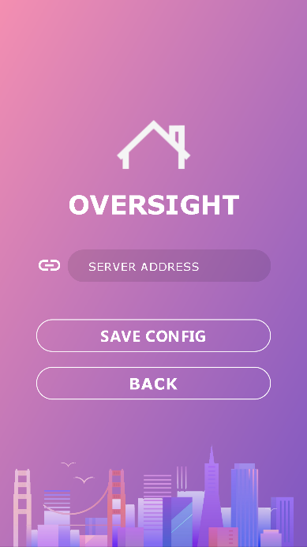**Features of the Developed Software**

**Figure 32. Server Address Configuration**

Figure 32 shows the Server Address Configuration Interface. This is where the user inputs the server address of the developed system.

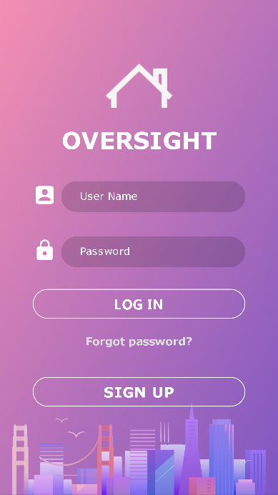**Figure 33. Login Interface**

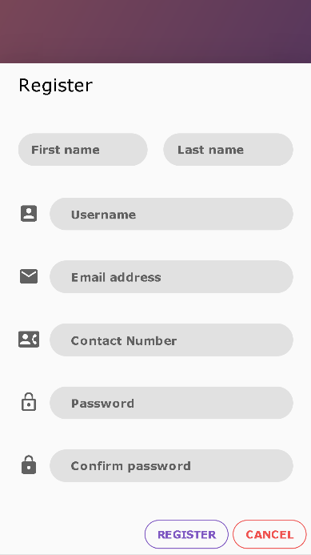As shown in figure 33, this is where the user login, register for an account or retrieve account in case the user forgets his/her login credentials.

**Figure 34. Account Registration Interface**

Figure 34 shows the Registration form for the Users.

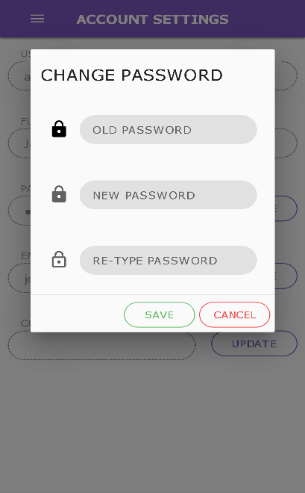

**Figure 35. Change Password Form**

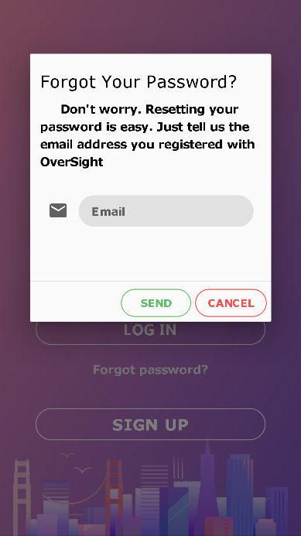Figure 35 Lets the User to change the password.

**Figure 36. Forgot Password Form**

Figure 36 User to input the email address to received reset password email

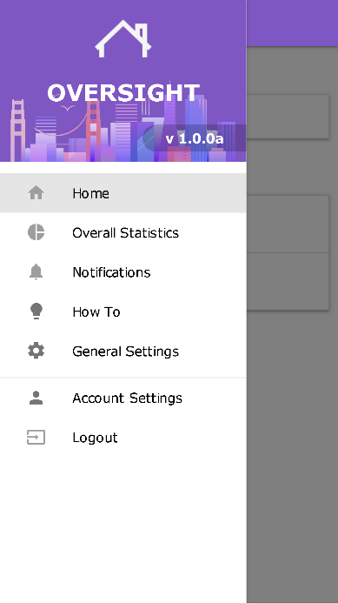**Figure 37. Main Menu**

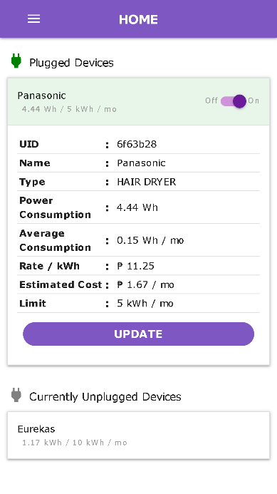Figure 37 shows all the features of the developed system

**Figure 38. Home Interface**

Figure 38 shows the Home Screen of the Developed System, it lets the user see the currently plugged appliance and the registered appliances that are not plugged in at the moment.

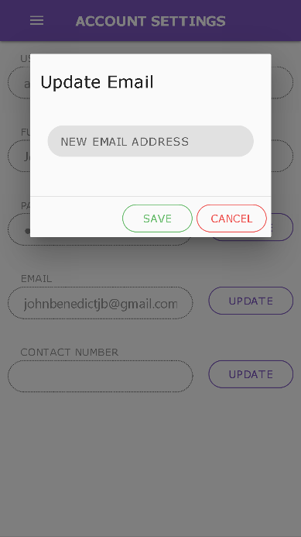

**Figure 39. Update Email Form**

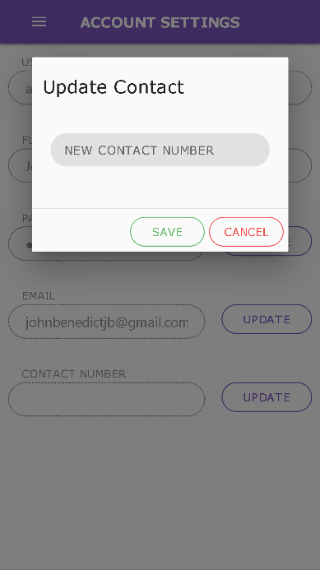Figure 39 asks the User to input new email address to be used.

**Figure 40. Update Contact Form**

Figure 40 asks the User to input new contact number.

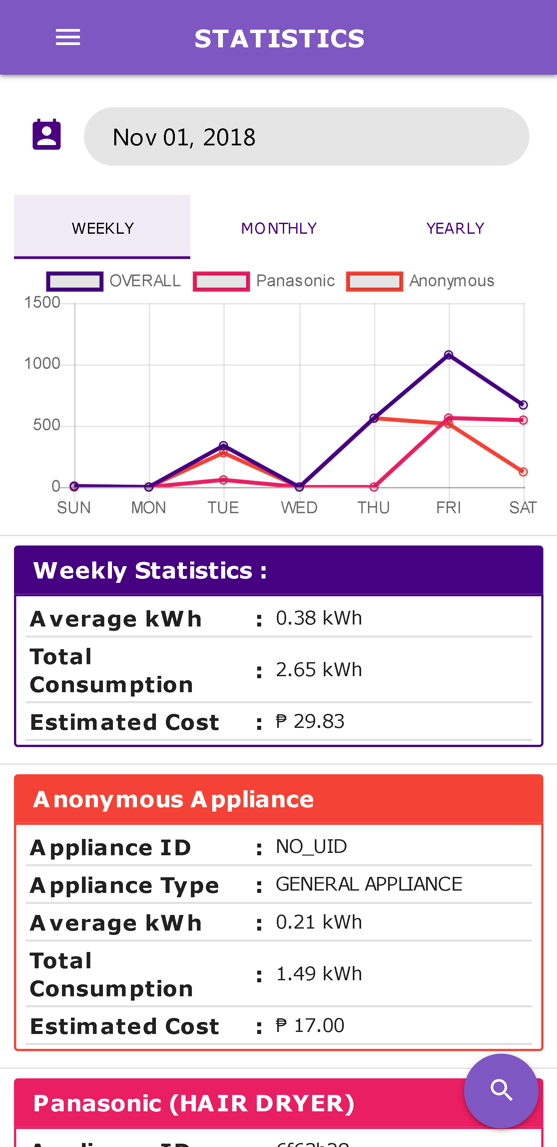

**Figure 41. Overall Statistics Interface (Part 1)**

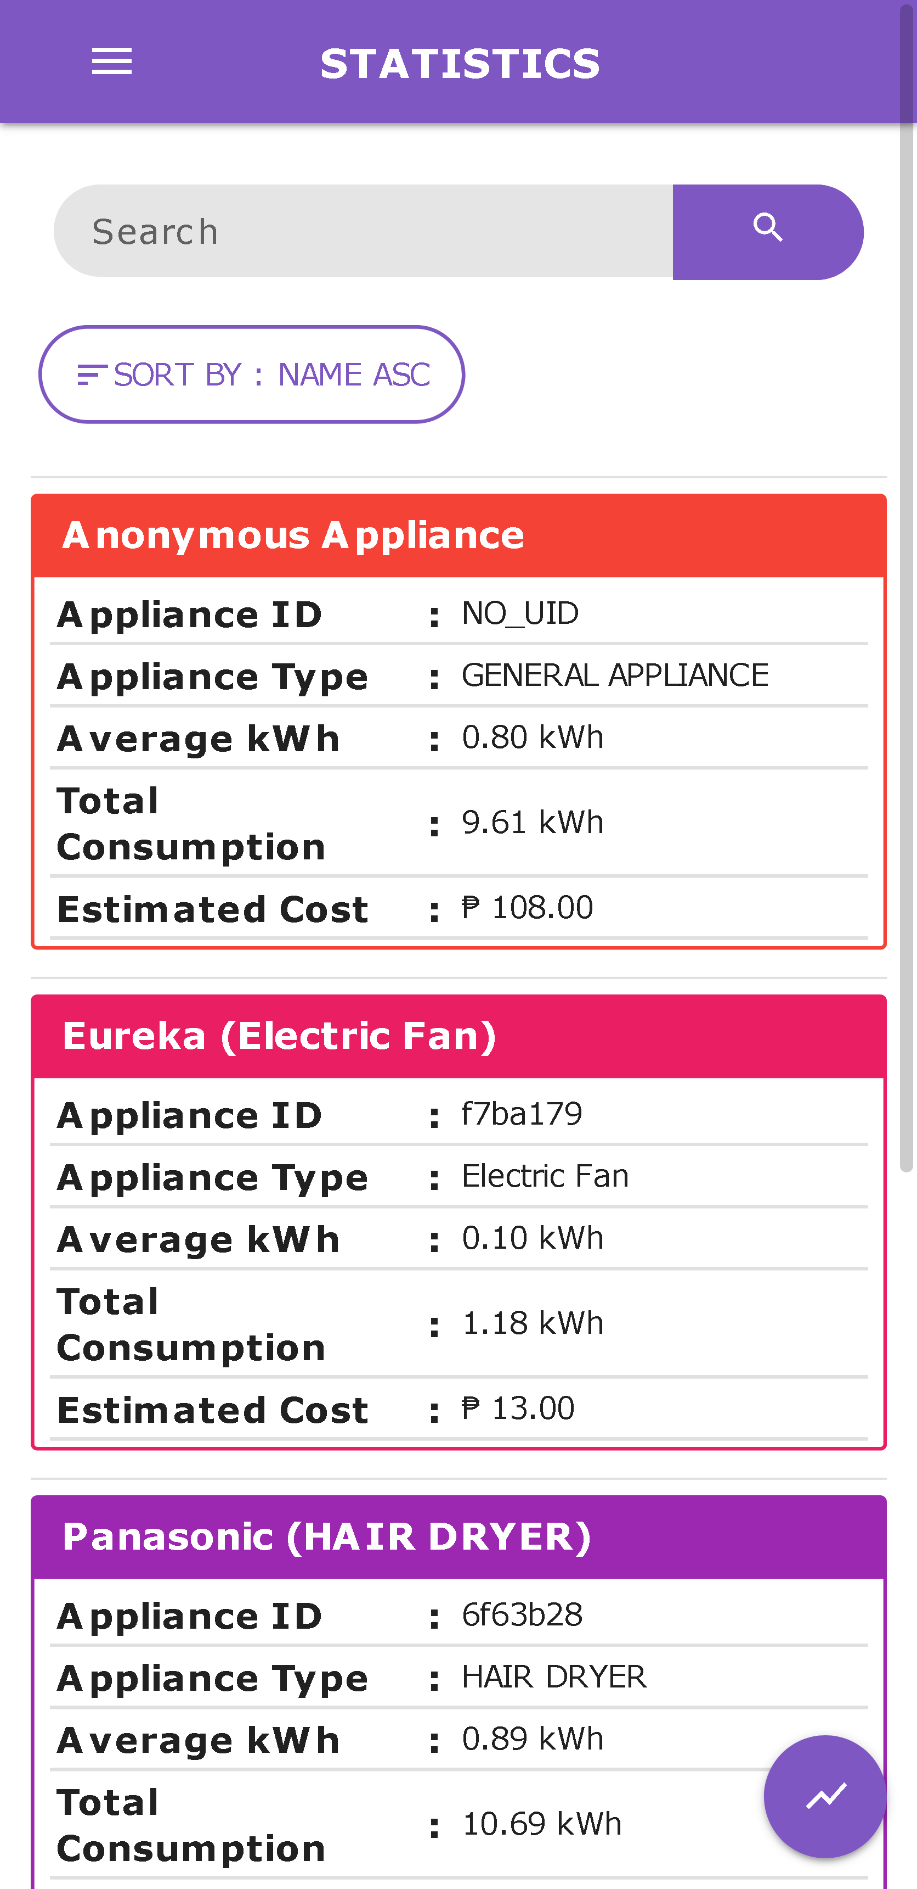

**Figure 42. Overall Statistics Interface (Part 2)**

Figure 41 and 42 shows the statistics interface of the mobile web application.

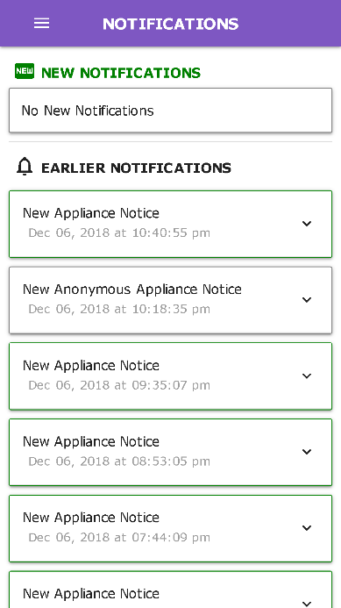**Figure 43. Notifications Interface**

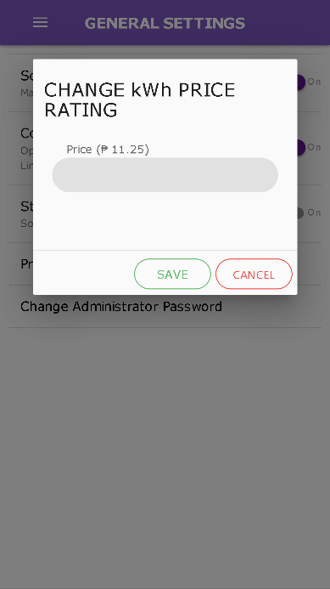Figure 43 shows the notification whenever an appliance is plugged-in.

**Figure 44. Change Rate Form**

Figure 44 Lets User to change the rate of the estimated cost of electric bill.

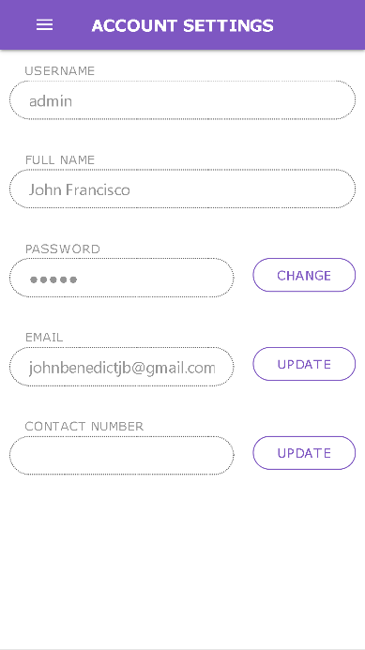**Figure 45. Account Settings Interface**

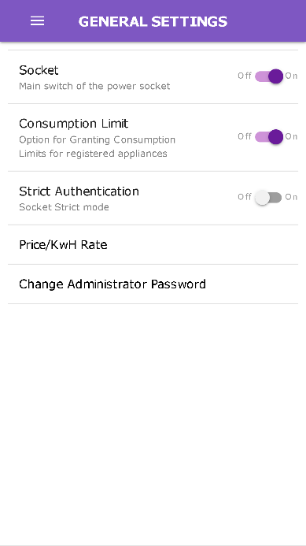 Figure 45 contains the user’s account credentials which can be edited or updated if the user wants it to be changed.

**Figure 46. General Settings Interface**

Figure 46 shows the general settings for the power socket unit and the price per Kilowatt Hour rate. The Socket toggle button lets the user to turn ON/OFF the main power socket unit switch which means that it will not supply electricity to the plugged in device if there is any. Consumption Limit toggle button is used if the user wants to enable or disable the consumption limit of the power socket unit. The Device Authentication toggle 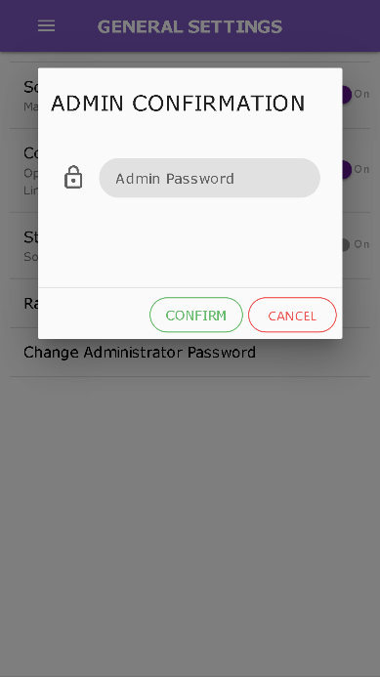button if enabled, it will only supply electricity to those appliance that are registered.

**Figure 47. Admin Confirmation Form**

Figure 47 Pops up when User is saving the new updated settings.

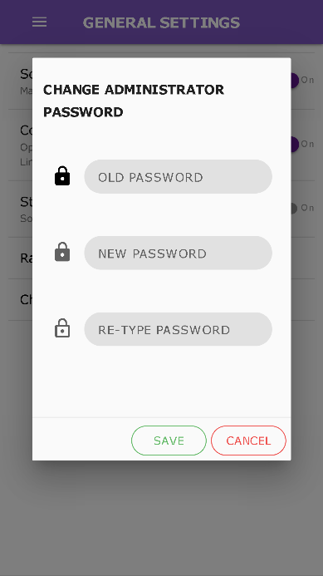**Figure 48. Change Administrator Password Form**

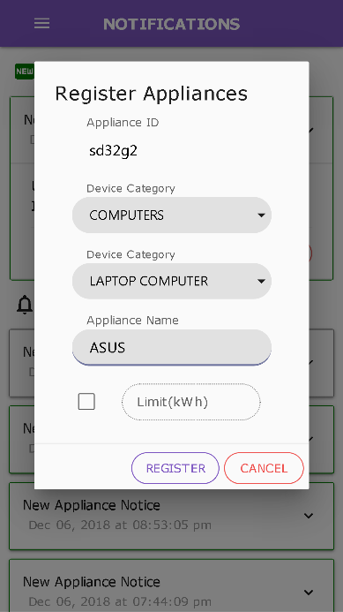Figure 48 Shows when Administrator wants to change old password into a new password.

**Figure 49. Register Appliances Form**

Figure 49 Used when User wants to add another or new appliance to be monitored by the developed system.

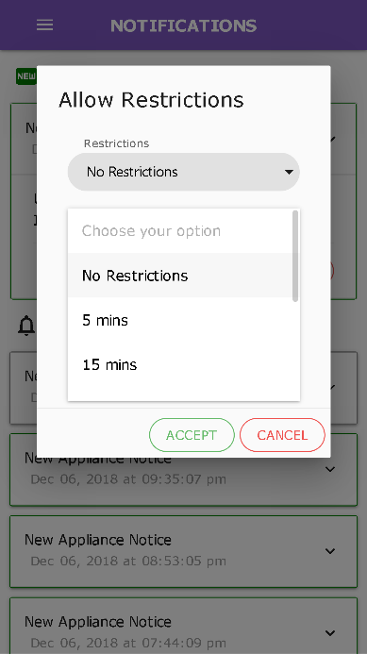**Figure 50. Allow Restriction Form**

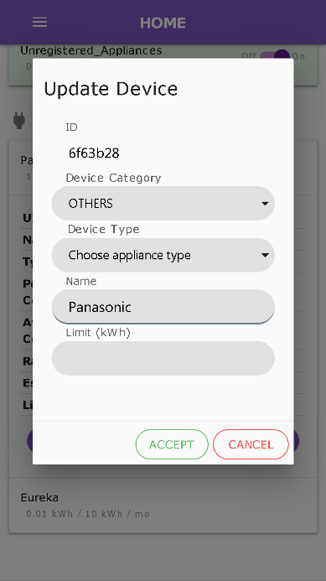 Figure 50 Pops up if you want to allow temporary electricity access to unregistered appliances.

**Figure 51. Update Device Form**

Figure 51 shows when user wants to update or edit the information of the specific device or appliance.

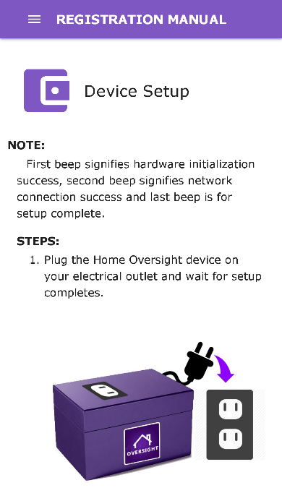

**Figure 52. Device Setup Instruction Interface**

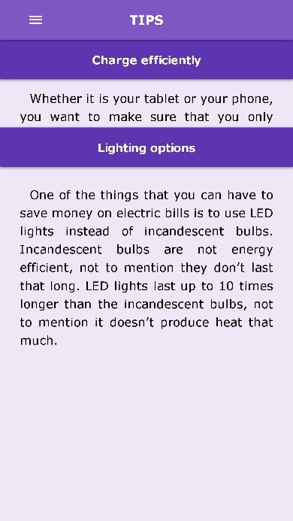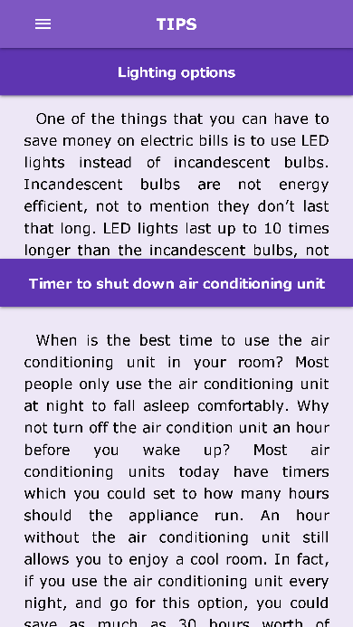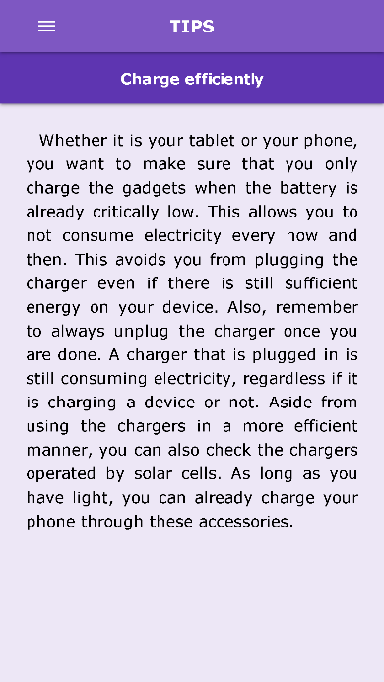Figure 52 shows the instruction on how to setup the power socket unit

**Figures 53. Electricity Conservation Tips Interface**

Figures 53 shows some tips on how to conserve electricity for the benefit of the consumers.

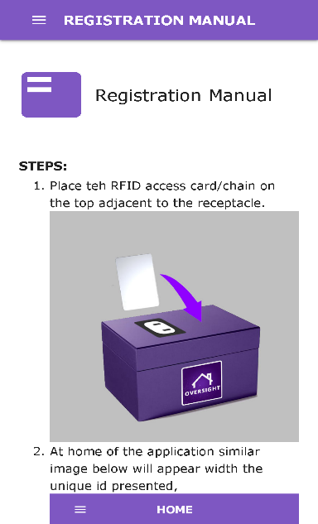**Figure 54. Appliance Registration Tutorial Interface**

Figure 54 shows the step-by-step tutorial on how to register an Appliance.

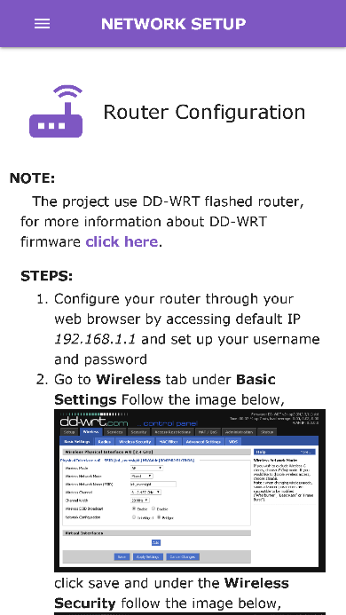

**Figure 55. Router Configuration**

Figure 55 show the step-by-step tutorial on how to configure router.

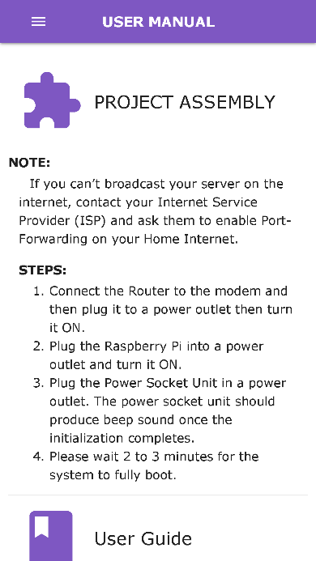**Figure 56. Project assembly**

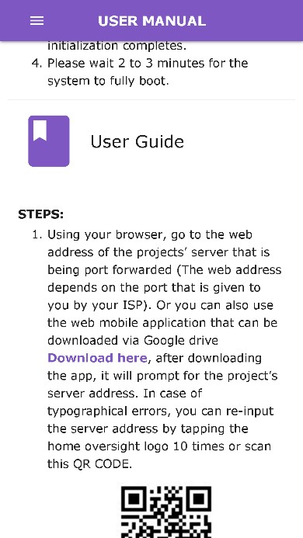Figure 56 show the step-by-step tutorial on how to assemble the project.

**Figure 57. User Manual**

Figure 57 show the step-by-step tutorial of user manual.

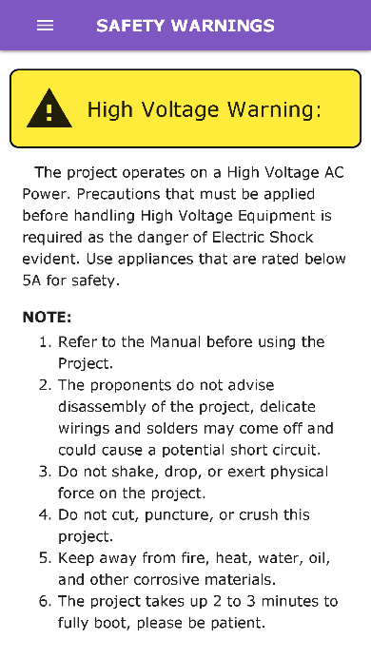

**Figure 58. Safety Warnings**

Figure 58 shows the number of safety warnings for the user.

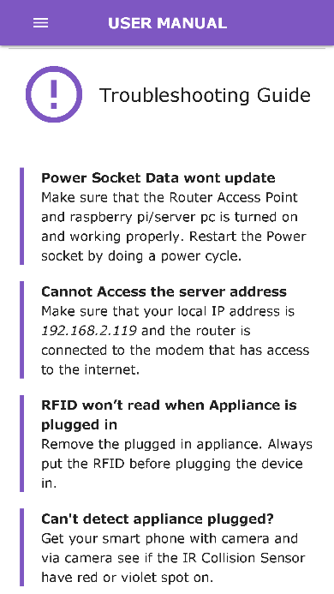

**Figure 59. Troubleshooting Guide**

Figure 59 shows the troubleshooting guide for the user.

## **Features of the Developed Hardware Prototype**

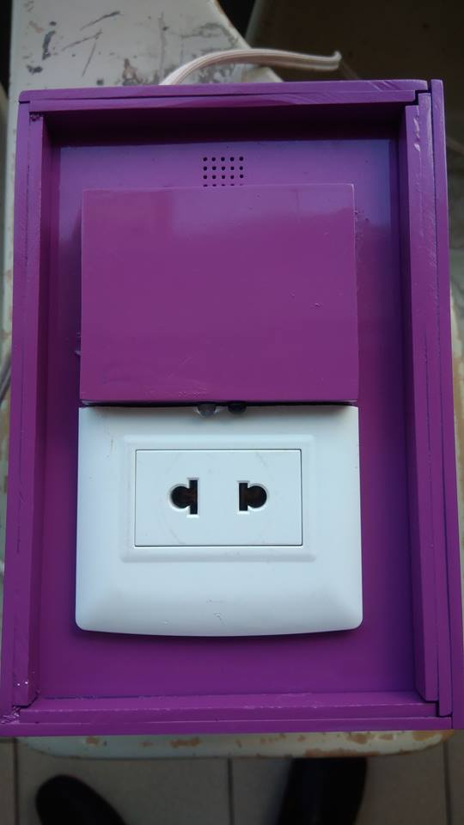

**Figure 60. RFID Recognition**

Figure 60 showcases the RFID Recognition Feature of the prototype. It works by placing the RFID card/tag above the surface encircled on the photo.



**Figure 61** Appliance Plugging Detection

Figure 61 show the location of the IR Sensor (encircled in red) that detects power plugs whenever they are plugged in the power socket unit



**Figure 62. Buzzer**

Figure 58 shows the location of the buzzer, it is used for alerts.

**Implementation of the Agile SCRUM Software Development Model**

|  |  |  |  |  |  |
| --- | --- | --- | --- | --- | --- |
| **Activities** | **Problem** | **Mitigation** | **Change Management Plan** | **Status** | **Date** |
| **Planning** |  |  |  |  | **62 days** |
| Develop Project Plan | --Communication | -Online meetings |  | Completed | 05/21/2018 – 06/10/2018 |
| Analyzing Project Cost |  |  |  | Completed | 05/21/2018 – 05/27/2018 |
| Create Project Scope |  |  |  | Completed | 05/21/2018 – 05/27/2018 |
| Contract Making |  |  |  | Completed | 05/27/2018 –  05/28/2018 |
| Expert Consultation |  |  |  | Completed | 05/28/2018 – 07/22/2018 |
| Milestone: Project Plan Approval |  |  |  | Completed | 05/28/2018 |

**Project Planning**

**Table 3. The Planning Phase**

Problem 1:

The Project Manager is responsible for ensuring that the team is doing their tasks. Difficulty in task updates are experienced due to the lack of meetings on the dates of 5/27/2018, 05/30/2018, and 06/02/2018 respectively.

Mitigation:

The Project Manager decided to schedule online meetings on the said dates. The Team used Facebook’s social media platform as a tool in order to perform online meetings.

**Project Execution**

**Table 4. The Project Execution Phase**

|  |  |  |  |  |  |
| --- | --- | --- | --- | --- | --- |
| **Activities** | **Problem** | **Mitigation** | **Change Management Plan** | **Status** | **Date** |
| **Execution** |  |  |  |  | **154 days** |
| Project Team Meeting | - |  |  | Completed | 06/04/18-  06/04/18 |
| Develop Project Schematic Design for Power Main Panel |  |  |  | Completed | 06/04/18-  06/10/18 |
| Develop Project Schematic Design for Power Socket |  |  |  | Completed | 06/11/18-  06/17/18 |
| Develop Mobile Application UI | UI Revision | Change UI into Material Theme |  | Completed | 06/18/18-  10/27/18 |
| Programming Stage | Bugs and Errors | Debugging |  | Completed | 06/11/18-  11/04/18 |
| Purchase of Hardware Parts |  |  |  | Completed | 07/04/18-  07/09/18 |
| Assembling of the Hardware Prototype | Power Analyzer exploded | Purchased new Power Analyzer |  | Completed | 07/16/18-  08/06/18 |

Problem 1:

The Thesis Adviser suggested to revise the Mobile Application User Interface as it does not meet the quality of a good user interface.

Mitigation:

The Team’s frontend developer came up with a new user interface based on “Material Theme”

Problem 2:

The Team’s backend developer had a hard time in the programming phase because of the bugs and errors that are encountered while coding the Developed System.

Mitigation:

The Project Manager decided to have a team’s overnight stay in order to brainstorm and come up a solution to the existing bugs and errors.

Problem 3:

The hardware prototype had a short circuit after connecting it to the Computer which caused the power analyzer of the prototype to break.

Mitigation:

Bought another brand new power analyzer as soon as possible to continue the programming on the hardware prototype.

**Project Monitoring**

|  |  |  |  |  |  |
| --- | --- | --- | --- | --- | --- |
| **Activities** | **Problem** | **Mitigation** | **Change Management Plan** | **Status** | **Date** |
| **Monitoring** |  |  |  |  | **62 days** |
| Maintenance of Hardware | - |  |  | Completed | 08/16/18-  11-18/18 |
| Review Project Changes |  |  |  | On-going | 11/19/18-  12-02/18 |
| Review Project Meeting |  |  |  | On-going | 12/03/18-  12/09/18 |

**Table 5. The Monitoring Phase**

Problem:

No problems were encountered during the monitoring phase.

Mitigation:

N/A

**Evaluation Results**

**Table 6**

**Respondents of the Evaluation**

|  |  |  |
| --- | --- | --- |
| **Respondents** | **Frequency** | **Percentage** |
| **IT Experts** | 5 | 12.5% |
| **Household Owners** | 15 | 37.5% |
| **IT Students** | 20 | 50% |
| **TOTAL** | **40** | **100%** |

Table 5.1 presents the respondents of the evaluation consisting of IT Experts (5), Household Owners (15) and IT Students (20). The interpretation and presentation of the tables discuss the overall mean distribution in each of the criteria. It also shows the interpretation that ranges from Poor, Fair, Good, Very Good and Excellent as the highest interpretation of the mean distributions. The researcher devised an evaluation instrument based on the Software and Hardware Quality Model following a five-point Likert scale:

**Table 7**

**Five Point Likert Type Attitude Scale**

|  |  |  |
| --- | --- | --- |
| **Scale** | **Range** | **Descriptive Rating** |
| 1 | 1.00 – 1.49 | Poor |
| 2 | 1.50 – 2.49 | Fair |
| 3 | 2.50 – 3.49 | Good |
| 4 | 3.50 – 4.49 | Very Good |
| 5 | 4.50 – 5.00 | Excellent |

Table 7 shows the rating from the respondent are treated statistically using a Likert Scale and was recorded based on the weighted mean or average. Their response to the Software Quality Evaluation Criteria such as: Functionality, Reliability, Usability, Maintainability, Portability and Training and Documentation and also their response to Hardware/Prototype Quality Evaluation Criteria such as: Functionality, Reliability, Usability, Maintainability, Portability, Workability, Safety, Training and Documentation.

There are three measurements of the central location widely used in descriptive statistics: the mean of which has its appropriate use in describing the sample or population being studied if three measurements; the weight mean, since it is more reliable in computing the data and considered to be the most stable measures of central location associated with the interval and/or ratio data provided that the distribution is normal.

The weight score are with descriptive rating of 5 = “Excellent”, 4 = “Very Good”, 3= “Good”, 2=”Fair” and 1=”Poor.” The rating of the respondent’s on the different criteria that will be computed using the mean formula.

Formula:

M=

Where:

M – Mean

- Sum of all ratings

N – Number of respondents

Expert’s Assessment on the Functionality of the developed Online Home Energy Monitoring and Power Sockets Control System. The expert’s assessments were sought using a five-point Likert Scale interpreted as follows: Excellent (5), Very Good (4), Good (3), Fair (2) and Poor (1).

**Evaluation for the Developed Web Application**

**Table 8**

**Mean Distribution of Expert Respondent Rating According to Functionality**

|  |  |  |
| --- | --- | --- |
| **INDICATORS** |  | **Response** |
| 1. **Functionality** | **Mean** | **Description** |
| 1. Suitability. Functions are appropriate to specifications. | 4.25 | Very Good |
| 1. Accurateness. Functions are correct. | 4.45 | Very Good |
| 1. Interoperability. Software can interact with other components or systems. | 4.5 | Excellent |
| 1. Compliance. Adherence to standards. | 4.15 | Very Good |
| 1. Security. Provision for security requirements. | 4.08 | Very Good |
| **General weighted mean** | **4.29** | Very Good |

4.50 – 5.00 Excellent; 3.50 – 4.49 Very Good; 2.50 – 3.49 Good; 1.50 – 2.49 Fair; 1.00 – 1.49 Poor

Table 8 shows that in functionality, the respondents graded the project as “Very Good” in terms of Suitability with a weighted mean of (4.25) which indicates that functions are appropriate to specifications. In terms of Accurateness, the respondents mark as “Very Good” with a mean performance of (4.45) which means functions are correct. In Interoperability, Software can interact with other components or systems. The respondents gave “Excellent” remark with a mean performance of (4.5). The Compliance of the project that define adherence to standards has a mean value of (4.15). Overall, the project weighted a mean value of (4.29) which means that the project is “Very Good” in terms of functionality.

**Table 9**

**Mean Distribution of Expert Respondent Rating According to Reliability**

|  |  |  |
| --- | --- | --- |
| **INDICATORS** |  | **Response** |
| 1. **Reliability** | **Mean** | **Description** |
| 1. Maturity. Absence of failures. | 4.38 | Very Good |
| 1. Fault tolerance. Ability to withstand and recover from component failure. | 4.45 | Very Good |
| 1. Recoverability. Ability to bring back a failed system to full operation, including data and network connections. | 4.55 | Excellent |
| 1. Correctness. Ability to produce correct computations, output or reports. | 4.3 | Very Good |
| **General weighted mean** | **4.42** | Very Good |

4.50 – 5.00 Excellent; 3.50 – 4.49 Very Good; 2.50 – 3.49 Good; 1.50 – 2.49 Fair; 1.00 – 1.49 Poor

What has stated in Table 9 shows that the Respondents rated the Reliability of the project as “Very good” with a General weighted mean of 4.42, very good. Absence of failures of the project was (4.38) very good and the Fault Tolerance (4.45) was Very Good. In Recoverability, the project was (4.55), Excellent. In terms of Correctness the respondents gave a “Very good” remark with a mean of (4.3). It may be safely concluded that the project has the capability to withstand user breakdown and hold independent running application.

**Table 10**

**Mean Distribution of Expert Respondent Rating According to Usability**

|  |  |  |
| --- | --- | --- |
| **INDICATORS** |  | **Response** |
| 1. **Usability** | **Mean** | **Description** |
| 1. Understandability. Ease of which the systems functions can be understood | 4.6 | Excellent |
| 1. Learnability. Learning effort for different users, i.e. novice, expert, casual etc. | 4.28 | Very Good |
| 1. Operability. Ability of the software to be easily operated by a given user in a given environment. | 4.5 | Excellent |
| 1. Provision for comfort and convenience. | 4.45 | Very Good |
| **General weighted mean** | **4.46** | Very Good |

4.50 – 5.00 Excellent; 3.50 – 4.49 Very Good; 2.50 – 3.49 Good; 1.50 – 2.49 Fair; 1.00 – 1.49 Poor

Table 10 shows that the Respondents rated the Usability of the project as “Very Good” which means, that. Among the four items presented in table 6.3 item (1) Ease of which the systems functions can be understood got a mean of 4.6 which is “Excellent” as perceived by the system evaluators. The Learnability criteria got 4.28, Very Good and Operability got a mean rating of 4.5, Excellent. It may be safely agreed that the project is visually appealing and at the same time easy to learn.

**Table 11**

**Mean Distribution of Expert Respondent Rating According to Maintainability**

|  |  |  |
| --- | --- | --- |
| **INDICATORS** |  | **Response** |
| 1. **Maintainability** | **Mean** | **Description** |
| 1. Analyzability. Ability to identify the root cause of a failure within the software. | 4.38 | Very Good |
| 1. Changeability. Software adjusts well to different screen dimensions, color depths, and font sizes. Different interfaces can be chosen to suit beginners and more advanced users. | 4.23 | Very Good |
| 1. Stability. Characterizes the sensitivity to change of a given system. | 4.3 | Very Good |
| **General weighted mean** | **4.3** | Very Good |

4.50 – 5.00 Excellent; 3.50 – 4.49 Very Good; 2.50 – 3.49 Good; 1.50 – 2.49 Fair; 1.00 – 1.49 Poor

In going over table 11 demonstrates that the Respondents rated the Maintainability of the project as “Very Good”. The ability to identify the root cause of failure within the software got a weighted mean of (4.38) Excellent. Software adjusts well to different screen dimensions, color depths, and font sizes. Different interfaces can be chosen to suit beginners and more advanced users got a weighted mean of (4.23) Very Good, and stability of the software got a mean of (4.3) Very Good. It may be safely concluded that the project is easy to maintain.

**Table 12**

**Mean Distribution of Expert Respondent Rating According to Portability**

|  |  |  |
| --- | --- | --- |
| **INDICATORS** |  | **Response** |
| 1. **Portability** | **Mean** | **Description** |
| 1. Adaptability. Ability of the system to change to new specifications or operating environments. | 4.25 | Very Good |
| 1. Installability. Are there different options available for installation? Is software easy to install? | 4.28 | Very Good |
| 1. Replaceability. Ease of exchanging a given software component within a specified environment and system coupling. | 4.3 | Very Good |
| 1. Software compatibility. Provision for portability of operating system used. | 4.3 | Very Good |
| 1. Build environment portability. Absence of other software requirement such as runtime system or standard database management engine. | 4.3 | Very Good |
| **General weighted mean** | **4.29** | Very Good |

4.50 – 5.00 Excellent; 3.50 – 4.49 Very Good; 2.50 – 3.49 Good; 1.50 – 2.49 Fair; 1.00 – 1.49 Poor

A gander of data in table 12 substantiate that Respondents rated the Portability of the project as “Very Good”; Adaptability (4.25) Very Good; Installability (4.28) Very Good; Replaceability, software compatibility and environment portability have the means of (4.3) Very Good. Overall, the portability of the project generated a weighted mean of (4.29) Very Good.

**Table 13**

**Mean Distribution of Expert Respondent Rating According to Training and Documentation**

|  |  |  |
| --- | --- | --- |
| **INDICATORS** |  | **Response** |
| 1. **Training and Documentation** | **Mean** | **Description** |
| 1. Availability of guides and printed documentation (technical or user’s manual). | 4.4 | Very Good |
| 1. Provision for trainings/tutorials or real interactive learning. | 4.25 | Very Good |
| 1. Provision for help component. Text should be clear and use language correctly, with appropriate headings and subheadings. Unfamiliar terms should be defined and explained. Organization should be logical. All information should be readily accessible for reference | 4.5 | Excellent |
| **General weighted mean** | **4.38** | Very Good |

4.50 – 5.00 Excellent; 3.50 – 4.49 Very Good; 2.50 – 3.49 Good; 1.50 – 2.49 Fair; 1.00 – 1.49 Poor

A read-through of data in table 13 confirms that Respondents rated Training and Documentation of the project as “Very Good.” Documentation content got a means of 4.4 Very Good, Provisions for training got a means of 4.25 Very Good and Provisions for help component 4.5 Excellent. It may be safely concluded that the project has proper training and documentation.

**Table 14**

**Summary of the Software Quality Evaluation Weighted Mean**

|  |  |  |
| --- | --- | --- |
| **Criteria** | **Mean** | **Description** |
| 1. Functionality | 4.29 | Very Good |
| 1. Reliability | 4.42 | Very Good |
| 1. Usability | 4.46 | Very Good |
| 1. Maintainability | 4.3 | Very Good |
| 1. Portability | 4.29 | Very Good |
| 1. Training and Documentation | 4.38 | Very Good |
| **Overall Weighed Mean 4.36 Very Good** | | |

Table 14 shows the overall weighted mean score of the software quality evaluation that is conducted in order to ensurethe software quality. Functionality gained a total mean of (4.29) which is very good. The reliability has a mean of (4.42) which is also very good. Usability scored a total mean of (4.46) which is very good.Maintainability garnered a weighted mean of (4.3) which is also very good. The portability criteria has a weighted mean of (4.29) with a description of very good. The training and documentation criteria has a weighted mean of (4.38) with a description of very good. All in all, the software evaluation has an overall weighted mean of (4.36) which makes it a very good software.

**Evaluation for the Developed Hardware/Prototype**

**Table 15**

**Mean Distribution of Expert Respondent Rating According to Functionality**

|  |  |  |
| --- | --- | --- |
| **INDICATORS** |  | **Response** |
| 1. **Functionality** | **Mean** | **Description** |
| 1. Suitability. Functions are appropriate to specifications. | 4.43 | Very Good |
| 1. Accurateness. Functions are correct. | 4.3 | Very Good |
| 1. Interoperability. Prototype can interact with other components or systems. | 4.18 | Very Good |
| 1. Compliance. Adherence to industry standards for similar hardware components. | 4.2 | Very Good |
| 1. Security. Provision for security requirements. | 4.43 | Very Good |
| **General weighted mean** | **4.31** | Very Good |

4.50 – 5.00 Excellent; 3.50 – 4.49 Very Good; 2.50 – 3.49 Good; 1.50 – 2.49 Fair; 1.00 – 1.49 Poor

Table 15 shows that in functionality, the experts graded the project as “Very Good” in terms of Suitability with a weighted mean of (4.43) which indicates that functions are appropriate to specifications. In terms of Accurateness, the respondents mark as “Very Good” with a mean performance of (4.3) which means functions are correct. In Interoperability, Software can interact with other components or systems. The respondents gave “Very Good” remark with a mean performance of (4.18). The Compliance of the project that define adherence to standards has a mean value of (4.2). The Security of the project that define adherence to standards has a mean value of (4.43). Overall, the project weighted a mean value of (4.43) which means that the project is “Very Good” in terms of functionality.

**Table 16**

**Mean Distribution of Expert Respondent Rating According to Reliability**

|  |  |  |
| --- | --- | --- |
| **INDICATORS** |  | **Response** |
| 1. **Reliability** | **Mean** | **Description** |
| 1. Maturity. Absence of failures. | 4.43 | Very Good |
| 1. Fault tolerance. Ability to withstand and recover from component failure. | 4.35 | Very Good |
| 1. Recoverability. Ability to bring back a failed system to full operation, including data and network connections. | 4.3 | Very Good |
| **General weighted mean** | **4.36** | Very Good |

4.50 – 5.00 Excellent; 3.50 – 4.49 Very Good; 2.50 – 3.49 Good; 1.50 – 2.49 Fair; 1.00 – 1.49 Poor

What has stated in table 16 shows that the Respondents rated the Reliability of the project as “Very good” with a General weighted mean of (4.36), very good. Absence of failures of the project was (4.43) very good and the Fault Tolerance (4.35) was Very Good. In Recoverability, the project was (4.3), Very Good.

It may be safely concluded that the project has the capability to withstand user breakdown and hold independent running application.

**Table 17**

**Mean Distribution of Expert Respondent Rating According to Usability**

|  |  |  |
| --- | --- | --- |
| **INDICATORS** |  | **Response** |
| 1. **Usability** | **Mean** | **Description** |
| 1. Understandability. Ease of which the systems functions can be understood. | 4.65 | Excellent |
| 1. Learnability. Learning effort for different users, i.e. novice, expert, casual etc. | 4.4 | Very Good |
| 1. Operability. Ability of the prototype to be easily operated by a given user in a given environment. | 4.05 | Very Good |
| 1. Provision for comfort and convenience. | 4.45 | Very Good |
| **General weighted mean** | **4.39** | Very Good |

4.50 – 5.00 Excellent; 3.50 – 4.49 Very Good; 2.50 – 3.49 Good; 1.50 – 2.49 Fair; 1.00 – 1.49 Poor

A perusal of data in table 17 shows that the Respondents rated the Usability of the project as “Very Good”. Among the four items presented in table 7.3 item (1) Ease of which the systems functions can be understood got a mean of 4.65 which is “Excellent” as perceived by the system evaluators. The Learnability criteria got 4.4, Very Good and Operability got a mean rating of 4.45, Very Good. It may be safely agreed that the project is visually appealing and at the same time easy to learn.

**Table 18**

**Mean Distribution of Expert Respondent Rating According to Maintainability**

|  |  |  |
| --- | --- | --- |
| **INDICATORS** |  | **Response** |
| 1. **Maintainability** | **Mean** | **Description** |
| 1. Analyzability. Ability to identify the root cause of a failure within the prototype. | 4.48 | Very Good |
| 1. Stability. Characterizes the sensitivity to change of a given system. | 4.3 | Very Good |
| 1. Testability. Characterizes the effort needed to verify (test) a system change. | 4.33 | Very Good |
| 1. Can hardware be serviced, maintained, and upgraded locally? | 4.28 | Very Good |
| **General weighted mean** | **4.35** | Very Good |

4.50 – 5.00 Excellent; 3.50 – 4.49 Very Good; 2.50 – 3.49 Good; 1.50 – 2.49 Fair; 1.00 – 1.49 Poor

In going over table 18 demonstrates that the Respondents rated the Maintainability of the project as (4.35) “Very Good”. The ability to identify the root cause of failure within the software got a weighted mean of (4.48) Very Good. Software adjusts well to different screen dimensions, color depths, and font sizes. Different interfaces can be chosen to suit beginners and more advanced users got a weighted mean of (4.3) Very Good, and ability of the software to be easily stability got a mean of (4.33) Very Good. It may be safely concluded that the project is easy to maintain.

**Table 19**

**Mean Distribution of Expert Respondent Rating According to Portability**

|  |  |  |
| --- | --- | --- |
| **INDICATORS** |  | **Response** |
| 1. **Portability** | **Mean** | **Description** |
| 1. Adaptability/Mobility. Ability of the system to change to new specifications or operating environments. | 4.15 | Very Good |
| 1. Installability. Are there different options available for installation? Can hardware be installed and maintained by local staff persons. | 4.05 | Very Good |
| 1. Replaceability. Ease of exchanging a given prototype component within a specified environment. | 4.23 | Very Good |
| 1. Appropriateness of size and weight suitability. | 4.23 | Very Good |
| **General weighted mean** | **4.17** | Very Good |

4.50 – 5.00 Excellent; 3.50 – 4.49 Very Good; 2.50 – 3.49 Good; 1.50 – 2.49 Fair; 1.00 – 1.49 Poor

A gander of data in table 19 substantiate that Respondents rated the Portability of the project as “Very Good”; Adaptability (4.15) Very Good; Instability (4.05) Very Good; Replaceability, software compatibility and environment portability have the means of (4.23) Very Good.

**Table 20**

**Mean Distribution of Expert Respondent Rating According to Workability**

|  |  |  |
| --- | --- | --- |
| **INDICATORS** |  | **Response** |
| 1. **Workability** | **Mean** | **Description** |
| 1. Availability of materials. Consideration must be given to whether a line of equipment is being discontinued; what implications does the discontinuance have on issues such as maintenance. | 4.33 | Very Good |
| 1. Availability of technical expertise. | 4.38 | Very Good |
| 1. Availability of tools and machines. Provision for diagnostic tools and procedures. | 4.35 | Very Good |
| **General weighted mean** | **4.35** | Very Good |

4.50 – 5.00 Excellent; 3.50 – 4.49 Very Good; 2.50 – 3.49 Good; 1.50 – 2.49 Fair; 1.00 – 1.49 Poor

In table 20, it shows that the Respondents rated the Workability of the project as “Very Good”. Availability of materials got the means of (4.33) “Very Good” which means that the implications of material discontinuation is highly considered. Availability of technical expertise got the means of (4.38) “Very Good” while the availability of tools and machines got a weighted mean of (4.35) “Very Good”.

It can now be safely concluded that the project is easy to work with when maintaining, troubleshooting or repairing it.

**Table 21**

**Mean Distribution of Expert Respondent Rating According to Safety**

|  |  |  |
| --- | --- | --- |
| **INDICATORS** |  | **Response** |
| 1. **Safety** | **Mean** | **Description** |
| 1. Absence of toxic or hazardous materials. | 4.43 | Very Good |
| 1. Absence of sharp edges. | 4.3 | Very Good |
| 1. Provision for protection against harmful or dangerous events/objects. | 4.38 | Very Good |
| **General weighted mean** | **4.37** | Very Good |

4.50 – 5.00 Excellent; 3.50 – 4.49 Very Good; 2.50 – 3.49 Good; 1.50 – 2.49 Fair; 1.00 – 1.49 Poor

In going over Table 21 demonstrates that the Respondents rated the Safety of the project as (4.37) “Very Good”. Absence of toxic or hazardous materials got a means of (4.43) “Very Good”, because the casing used in developing the power socket unit of the project is made up of acrylic sheets which does not contain hazardous chemicals that may endanger the lives of people. The absence of sharp edges generated a weighted mean of (4.3) “Very Good” and the provisions for protection against harmful or dangerous events or objects got a weighted mean of (4.38) “Very Good” because, as cited earlier, the casing is made up of acrylic sheets which does not conduct electricity.

It can now be safely concluded that the safety of the users are the number one priority in the development of the project. But precautionary measures should also be done to avoid untoward incidents resulting to injuries.

**Table 22**

**Mean Distribution of Expert Respondent Rating According to Training and Documentation**

|  |  |  |
| --- | --- | --- |
| **INDICATORS** |  | **Response** |
| 1. **Training and Documentation** | **Mean** | **Description** |
| 1. Availability of guides and printed documentation (technical or user’s manual). | 4.43 | Very Good |
| 1. Provision for trainings/tutorials or real interactive learning. | 4.5 | Excellent |
| 1. Provision for help component. Text should be clear and use language correctly, with appropriate headings and subheadings. Unfamiliar terms should be defined and explained. | 4.35 | Very Good |
| **General weighted mean** | **4.43** | Very Good |

4.50 – 5.00 Excellent; 3.50 – 4.49 Very Good; 2.50 – 3.49 Good; 1.50 – 2.49 Fair; 1.00 – 1.49 Poor

A read-through of data in Table 22 confirms that Respondents rated the Training and Documentation of the project as (4.43) “Very Good.” Availability of guides and printed documentation generated a weighted mean of (4.43) “Very Good”, Provisions for trainings/tutorials or real interactive learning got a weighted mean of (4.5) “Very Good” and Provisions for help component got a weighted mean of (4.35) “Very Good” because the text are clear and the language are used correctly. It has appropriate heading and subheadings.

**Table 23**

|  |  |  |
| --- | --- | --- |
| **Criteria** | **Mean** | **Description** |
| 1. Functionality | 4.31 | Very Good |
| 1. Reliability | 4.36 | Very Good |
| 1. Usability | 4.39 | Very Good |
| 1. Maintainability | 4.35 | Very Good |
| 1. Portability | 4.17 | Very Good |
| 1. Workability | 4.35 | Very Good |
| 1. Safety | 4.37 | Very Good |
| 1. Training and Documentation | 4.43 | Very Good |
| **Overall Weighted Mean 4.34** Very Good | | |

**Summary of the Hardware/Prototype Quality Evaluation Mean**

Table 23 shows the overall weighted mean score of the hardware/prototype. Functionality gained a total mean of (4.31) which is very good. The reliability has a mean of (4.36) which is also very good. Usability scored a total mean of (4.39) which is very good.Maintainability garnered a weighted mean of (4.35) which is also very good. The portability criteria has a weighted mean of (4.17) with a description of very good. The workability has a total mean of (4.35) with a description of very good. The safety criteria garnered a total mean of (4.37) with a description of very good. The training and documentation criteria has a weighted mean of (4.43) with a description of very good. All in all, the hardware/prototype evaluation has an overall weighted mean of (4.34) which makes it a very good hardware/prototype.

**Chapter V**

**SUMMARY AND RECOMMENDATIONS**

This final chapter is all about the summary of the entire project. It also provides the proponent’s recommendation for the future researchers that can help them gain ideas that can enhance the project.

**Summary**

The general objective of this project is to develop a Mobile Web Application: Online Home Energy Monitory and Power Sockets Control System for household appliances.

Electricity is one of the reason why people lives a convenient life, it provides power to everyday appliances. But the problems arises due to consumer’s negligence. Appliances that are left plugged in and unattended while consuming electricity costs unnecessary addition to consumer’s monthly electric bill and it can also cause serious electricity induced fire incidents. The consumers are unaware on how much electricity is consumed by each of their appliances every month leaving them no clue on which appliance consumes electricity the most. The consumers are also unaware if someone uses their electricity at home without their permission. Because of these problems, the proponents come up with a solution to those problems. By using the system, the consumers can control their power sockets through their smartphones even if they are far away from home.

The project has the features RFID recognition of appliances, appliance consumption limiter and monitoring, unauthorized electricity usage notifications, power socket control and monthly electric bill estimation.

This project aims to help not only the electricity consumers, but also the electricity providers because reduced electricity consumption may prolong their supply of energy, it will also be beneficial to the Industries that practices energy footprint reduction and efficiency. And lastly, this project can be of help to future researchers through the references they can gain in this project.

The scope of the project are as follows, the system provides monitoring of the energy consumption of a certain household wherethe information is seen through the mobile application that is accessible via internet connection that allows monitoring and control even if the user is not at home.With real-time updates of the status defined as the response of the system per minute of the appliances and indicates if an appliance is on or just plugged in but not in use and allows the user to change the settings, plus the estimated average cost of the electric bill to be paid by the user per month.The power sockets are controlled by the user through the web mobile application where the user is able to turn off the appliances left running and unsupervised and can also stop the Electrical Current flowing to an appliance that is plugged in but not in use since an appliance still consumes energy even if the appliance is not running.

The limitations of the project are as follows, the proposed system’s hardware can only monitor one plugged in appliance at a time, so the use of extension cords with multiple power sockets is not advisable. Since the proposed system rely on RFID card/tag to recognize an appliance, there should be one RFID card/tag per one appliance ratio. The proposed system cannot add the “System Loss Charge” of the Electricity Provider/s (Meralco) in the monthly consumption computation estimate because it varies monthly and the Electricity Provider/s (Meralco) does not provide an API for that. The power socket unit’s IR sensor cannot sense black colored plug because in nature, black color poorly reflects light which makes it hard or impossible for IR sensors to detect it. The power socket unit has a maximum power rating of five amperes (5A).

**Recommendations**

The proponents recommend some ideas that may help enhance the project. This project is also open for suggestion that can be used in the future. The future researchers who wants to continue this study may deploy the project on iOS smartphones since the web mobile application is developed using Cordova Framework which means that the project is cross-platform ready. the proponents suggests to find a better way of detecting plugged appliances instead of using IR sensors that poorly detect black colored objects. The power socket might also be enhanced by the future researchers by adding Jumper Detection feature. Making the form-factor of the power socket unit as compact as possible might also be done.

**BIBLIOGRAPHY**

**Internet Sources**

Electricity is the most common source of energy used by households | Philippine Statistics Authority. (2016). Psa.gov.ph. Retrieved from https://psa.gov.ph/content/electricity-most-common-source-energy-used- households

Home | OpenEnergyMonitor. (2016). Openenergymonitor.org. Retrieved from https://openenergymonitor.org/emon/

Smart Socket Air - Documentation | Loxone. (2016). Retrieved from http://www.loxone.com/enen/service/documentation/extensions/air-base/smart- socket-air.html

Xavier, A. (n.d.). Smart Home Automation using Android. Retrieved from http://www.instructables.com/id/DIY-Smart-Home-Automation/

Uymatiao, J. (2011). My Meralco electric meter is finally digital! Here's To Life! Retrieved from http://janeuymatiao.com/2011/12/13/my-meralco-electric-meter-is- finally- digital/

Kuryente › Electric Companies › MERALCO. (2016). Kuryente.org.ph. Retrieved from http://www.kuryente.org.ph/electric-company/rates/12

Boonsong, W., & Ismail, W. (2014). Wireless Monitoring of Household Electrical Power Meter Using Embedded RFID with Wireless Sensor Network Platform. Retrieved from https://journals.sagepub.com/doi/full/10.1155/2014/876914

Asaff, B. (2014). Understanding the Importance of Conserving Electricity. Retrieved from https://greenliving.lovetoknow.com/why-is-it-important-conserve-electricity

**PDFs**

Nader, W. (2011). Real-time Home Automation and Sustainability. Retrieved from http://digitalcommons.unl.edu/cgi/viewcontent.cgi?article=1008&context=archen gdiss

Chen, Y. (2017). The Factors Affecting Electricity Consumption and the Consumption Characteristics in the Residential Sector—A Case Example of Taiwan. Retrieved from https://www.mdpi.com/2071-1050/9/8/1484/pdf

**Online Newspaper Articles**

Kamilaris, A., Taliadoros, G., & Pitsillides A. (2013). Social Electricity: When Awareness About Electricity Becomes Social. Retrieved from https://ercim- news.ercim.eu/en93/ri/social-electricity-when-awareness-about-electricity- becomes-social

**Online Dessertations and Theses**

Bergonia, C., & Dones, R. (2008). Prepaid Power Meter. Retrieved from https://docplayer.net/40977582-Prepaid-power-meter-carl-jonathan-p-bergonia- robert-ian-o-dones.html