<country>
<language of test>
Computer Familiarity
qUESTIONNAIRE

School Name
Student ID
Student Name
Family Name
Given Name
Date of Birth
/ / 198
Day
Month
Year
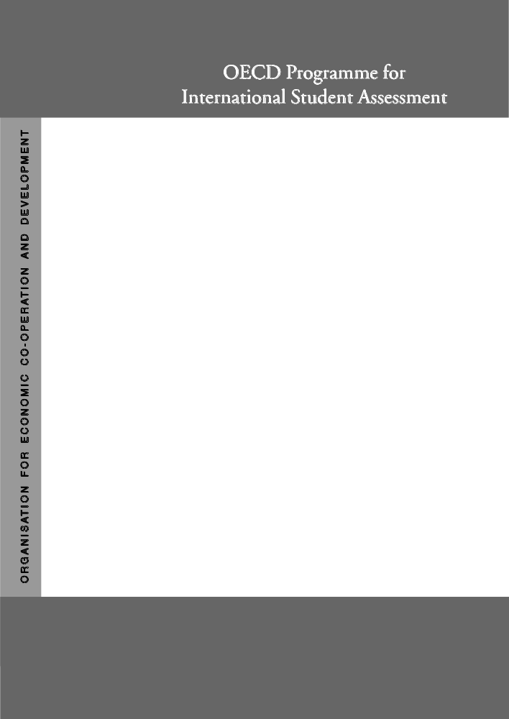

Project Consortium:
Australian Council for Educational Research (ACER)
Netherlands National Institute for Educational Measurement (CITO)

Educational Testing Service (ETS, USA)

National Institute for Educational Research (NIER, Japan)

Westat (USA)

IT01Q01  IT01Q02  IT01Q03  IT01Q04 | Q 1 How often is there a computer available to you to use at these places?  (<Tick> one box on each line.)  Between  A few once a  Almost times week Less than  every each and once once  day week a month a month Never  - At home n₁ n₂ n₃ n₄ n₅  - At school n₁ n₂ n₃ n₄ n₅  - In the library that you use n₁ n₂ n₃ n₄ n₅  - At another place n₁ n₂ n₃ n₄ n₅

IT02Q01  IT02Q01  IT02Q03 | Q 2 How comfortable:  (<Tick> one box on each line.)  Very Somewhat Not at all  comfortable Comfortable comfortable comfortable  - are you with using a computer? n₁ n₂ n₃ n₄  - are you with using a computer to write a paper? n₁ n₂ n₃ n₄  - would you be taking a test on a computer? n₁ n₂ n₃ n₄

IT03Q01 | Q 3 If you compare yourself with other 15-year-olds, how would you rate your ability to use a computer?  Excellent Good Fair Poor  n₁ n₂ n₃ n₄

IT04Q01  IT04Q02  IT04Q03  IT04Q04 | Q 4 How often do you use a computer:  (<Tick> one box on each line.)  Between  A few once a  Almost times week Less than  every each and once once  day week a month a month Never  - at home? n₁ n₂ n₃ n₄ n₅  - at school? n₁ n₂ n₃ n₄ n₅  - in the library that you use? n₁ n₂ n₃ n₄ n₅  - at another place? n₁ n₂ n₃ n₄ n₅

If you use a computer in any setting, please continue.

IF YOU DO NOT, PLEASE STOP HERE.

IT05Q01  IT05Q02  IT05Q01  IT05Q04 | Q 5 How often do you use:  (<Tick> one box on each line.)  Between Less  A few once a than  Almost times week once  every each and once a  day weeks a month month Never  - the Internet? n₁ n₂ n₃ n₄ n₅  - a computer for electronic  communication  (e.g. e-mail or “chat rooms”)? n₁ n₂ n₃ n₄ n₅  - the computer to help you learn  school material? n₁ n₂ n₃ n₄ n₅  - the computer for programming? n₁ n₂ n₃ n₄ n₅
IT06Q01  IT06Q02  IT06Q03  IT06Q04  IT06Q05 | Q 6 How often do you use each of the following kinds of computer software?  (<Tick> one box on each line.)  Between  A few once a  Almost times week Less than  every each and once once  day week a month a month Never  - Games n₁ n₂ n₃ n₄ n₅  - Word processing (e.g. Word ® or  Word Perfect®) n₁ n₂ n₃ n₄ n₅  - Spreadsheets (e.g., Lotus 1 2 3 ®  or Microsoft Excel®) n₁ n₂ n₃ n₄ n₅  - Drawing, painting or graphics n₁ n₂ n₃ n₄ n₅  - Educational software n₁ n₂ n₃ n₄ n₅
IT07Q01 | Q 7 It is very important to me to work with a computer.  Yes No  n₁ n₂
IT08Q01 | Q 8 To play or work with a computer is really fun.  Yes No  n₁ n₂
IT09Q01 | Q 9 I use a computer because I am very interested in this.  Yes No  n₁ n₂
IT10Q01 | Q10 I forget the time, when I am working with the computer.  Yes No  n₁ n₂

