<country>
<language of test>
school Questionnaire

School Name
School ID
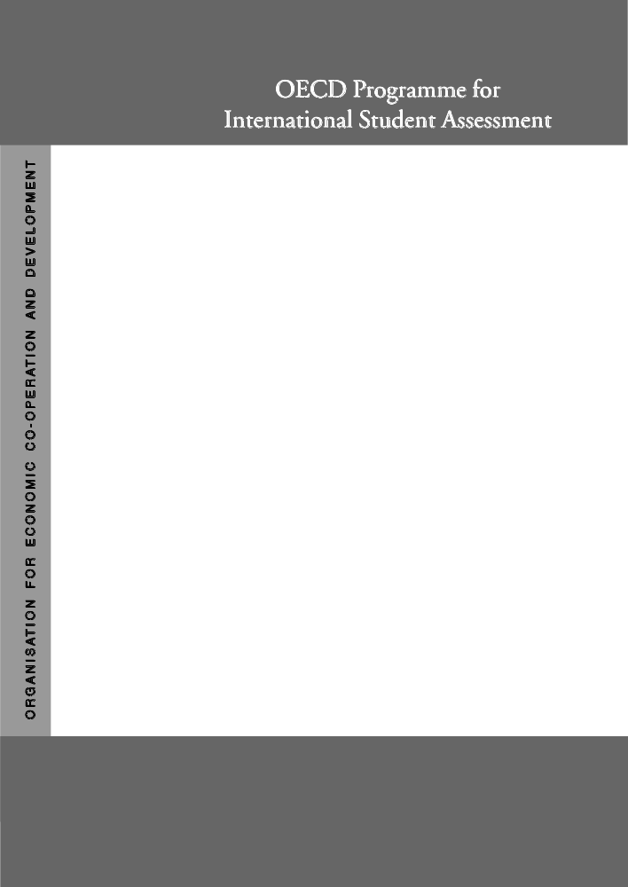

Project Consortium:
Australian Council for Educational Research (ACER)
Netherlands National Institute for Educational Measurement (CITO)
Educational Testing Service (ETS, USA)
National Institute for Educational Research (NIER, Japan)
Westat (USA)

This questionnaire asks for information about:
- The school’s resources;
- The number of teachers in the school and their qualifications;
- Characteristics of the students body;
- The relationship the school has with the students;
- Some of the administrative structures within the school;
- Some of the pedagogical practices of the school
The information may help to establish the impact of resource distribution on student achievements – both within and between countries.
The questionnaire should be completed by the principal or designate.
It should take about 30 minutes to complete.
If you do not know an answer precisely, your best estimation will be adequate for the purposes of the study.
Your answers will be kept confidential. Thank you.
Preliminary note:

Sometimes you will be asked about:
- the whole of your school; or
- 15-year-olds within your school; or,
- the <grade level> at which most 15-year-olds are studying.
Where it is all 15-year-old students we have underlined the text to emphasise that it is this whole group that we wish you to think about.

SC01Q01 | Q 1 Which of the following best describes the community in which your school is located?  (Please <tick> only one box.)  A <village, hamlet or rural area> (fewer than 3 000 people) ₁  A <small town> (3 000 to about 15 000 people) ₂  A <town> (15 000 to about 100 000 people) ₃  A <city> (100 000 to about 1 000 000 people) ₄  Close to the centre of a <city> with over 1 000 000 people ₅  Elsewhere in a <city> with over 1 000 000 people ₆

SC02Q01  SC02Q02 | Q 2 As at <March 31, 2000>, what was the total school enrolment (number of students)?  <reminder note>  (Please write in a number on each row. Write 0 (zero) if there is none.)  a) Number of boys: ______________  b) Number of girls: ______________

SC03Q01 | Q 3 Is your school a <public> or a <private> school?  (Please <tick> only one box.)  A <public> school ₁  (This is a school managed directly or indirectly by a public education authority, government agency, or governing board appointed by government or elected by public franchise.)  A <private> school ₂  (This is a school managed directly or indirectly by a non-government organisation; e.g., a church, trade union, businesses, other private institutions.)

SC04Q01  SC04Q02  SC04Q03  SC04Q04 | Q 4 About what percentage of your total funding for a typical school year comes from the following sources?  <reminder note>  (Please write in a number on each row. Write 0 (zero) if there is none.)  Percentage  - Government (includes departments, local, regional,  state and national) _________ %  - Student fees or school charges paid by parents _________ %  - Benefactors, donations, bequests, sponsorships,  parent fund raising _________ %  - Other _________ %  Total 100 %

SC05Q01  SC05Q02  SC05Q03  SC05Q04  SC05Q05  SC05Q06  SC05Q07  SC05Q08  SC05Q09  SC05Q10  SC05Q11  SC05Q12  SC05Q13  SC05Q14 | Q 5 Are the following <grade levels> found in your school?  (Please <tick> one box on each row.)  Yes No  a) <Grade 1> ₁ ₂  b) <Grade 2> ₁ ₂  c) <Grade 3> ₁ ₂  d) <Grade 4> ₁ ₂  e) <Grade 5> ₁ ₂  f) <Grade 6> ₁ ₂  g) <Grade 7> ₁ ₂  h) <Grade 8> ₁ ₂  i) <Grade 9> ₁ ₂  j) <Grade 10> ₁ ₂  k) <Grade 11> ₁ ₂  l) <Grade 12> ₁ ₂  m) <Grade 13> ₁ ₂  n) <Ungraded school> ₁ ₂

SC06Q01  SC06Q02  SC06Q03 | Q 6 The following question refers to different aspects of instructional time for 15-year-old students in your school.  <If 15-year-olds are in different programmes or <grades>, choose the one where most of the 15-year-olds are located.>  (Please write in a number on each row. Write 0 (zero) if there is none.)  a) How many instructional weeks are there in the school year? ______ weeks  b) How many <class periods > are there in the school week? ______ <class periods>  c) How many instructional minutes are there in the average  single <class period >? ______ minutes

SC07Q01  SC07Q02  SC07Q03  SC03Q04  SC07Q05  SC07Q06  SC07Q07 | Q 7 How often are the following factors considered when students are admitted to your school?  (Please <tick> one box on each row.)  Never Sometimes Always  a) Residence in a particular area ₁ ₂ ₃  b) Student’s record of academic performance  (including placement tests) ₁ ₂ ₃  c) Recommendation of feeder schools ₁ ₂ ₃  d) Parents’ endorsement of the instructional or religious  philosophy of the school ₁ ₂ ₃  e) Whether the student requires or is interested in  a special programme ₁ ₂ ₃  f) Preference given to family members of current  or former students ₁ ₂ ₃  g) Other ₁ ₂ ₃

SC08Q01  SC08Q02  SC08Q03  SC08Q04  SC08Q05  SC08Q06 | Q 8 In your school, what percentage of 15-year-old students is studying each programme?  <Reminder note>  (Please write in a number on each row. Write 0 (zero) if there is none.)  Percentage  a) <ISCED 2A> _________ %  b) <ISCED 2B> _________ %  c) <ISCED 2C> _________ %  d) <ISCED 3A> _________ %  e) <ISCED 3B> _________ %  f) <ISCED 3C> _________ %  Total 100 %

SC09Q01  SC09Q02  SC09Q03  SC09Q04  SC09Q05 | Q 9 In your school, how important is each of the following factors in determining the study programme of <15-year-old students>?  (Please <tick> one box on each row.)  Not Very  important Important important  a) Students’ choice ₁ ₂ ₃  b) Students’ previous academic record ₁ ₂ ₃  c) A placement examination ₁ ₂ ₃  d) Teachers’ recommendation ₁ ₂ ₃  e) Parents’ or guardians’ request ₁ ₂ ₃

SC10Q01  SC10Q02  SC10Q03  SC10Q04  SC10Q05  SC10Q06 | Q 10 In your school, how likely is it that a <15-year-old student> would be transferred to another school because of:  (Please <tick> one box on each row.)  If students are never transferred, go to Q 11.  Not Very  likely Likely likely  a) low academic achievement ₁ ₂ ₃  b) high academic achievement ₁ ₂ ₃  c) behavioural problems ₁ ₂ ₃  d) special learning needs ₁ ₂ ₃  e) parents’ or guardians’ request ₁ ₂ ₃  f) other ₁ ₂ ₃

SC11Q01  SC11Q02  SC11Q03  SC11Q04  SC11Q05  SC11Q06  SC11Q07  SC11Q08  SC11Q09 | Q 11 In your school, how much is the learning of <15-year-old students> hindered by:  (Please <tick> one box on each row.)  Not Very To some A  at all little extent lot  a) poor condition of buildings? ₁ ₂ ₃ ₄  b) poor heating, cooling and/or lighting systems? ₁ ₂ ₃ ₄  c) lack of instructional space (e.g., classrooms)? ₁ ₂ ₃ ₄  d) lack of instructional material (e.g., textbooks)? ₁ ₂ ₃ ₄  e) not enough computers for instruction? ₁ ₂ ₃ ₄  f) lack of instructional materials in the library? ₁ ₂ ₃ ₄  g) lack of multi-media resources for instruction? ₁ ₂ ₃ ₄  h) inadequate science laboratory equipment? ₁ ₂ ₃ ₄  i) inadequate facilities for the fine arts? ₁ ₂ ₃ ₄

SC12Q01  SC12Q02  SC12Q03  SC12Q04  SC12Q05 | Q 12 For <15-year-old students>, does your school provide the following resources?  (Please <tick> one box on each row.)  Yes No  a) Extra courses on academic subjects for gifted students ₁ ₂  b) Special training in <test language> for low achievers ₁ ₂  c) Special courses in study skills for low achievers ₁ ₂  d) Special tutoring by staff members ₁ ₂  - Room(s) where the students can do their homework with staff help ₁ ₂

SC13Q01  SC13Q02  SC13Q03  SC13Q04  SC13Q05  SC13Q06 | Q 13 In your school, about how many computers are:  <Reminder note>  (Please write in a number on each row. Write 0 (zero) if there is none.)  Number  a) in the school altogether? _______  b) available to 15-year-old students? _______  c) available only to teachers? _______  d) available only to administrative staff? _______  e) connected to the Internet/World Wide Web? _______  f) connected to a local area network (LAN, Intranet)? _______

SC14Q01  SC14Q02  SC14Q03  SC14Q04  SC14Q05  SC14Q06  SC14Q07  SC14Q08  SC14Q09  SC14Q10  SC14Q11  SC14Q12  SC14Q13  SC14Q14  SC14Q15  SC14Q16  SC14Q17  SC14Q18 | Q 14 In your school, how many full-time and part-time teachers:  A full-time teacher is employed at least 90% of the time as a classroom teacher. All other teachers should be considered part-time.  Note that categories b) to i) are not mutually exclusive, so the total item a) may be less than the sum of items b) to i).  <reminder note>  (Please write in a number in each space provided. Write 0 (zero) if there is none.)  Full-time Part-time  a) are there in TOTAL? _______ _______  b) have a <ISCED5A> qualification in <pedagogy>? _______ _______  c) are fully certified as teachers by <the appropriate authority>? _______ _______  d) are <test language> teachers? _______ _______  e) have a <ISCED5A> qualification <with a major>  in <test language>? _______ _______  f) are <mathematics> teachers? _______ _______  g) have a <ISCED5A> qualification <with a major>  in <mathematics>? _______ _______  h) are <science> teachers? _______ _______  i) have a <ISCED5A> qualification <with a major>  in <science>? _______ _______

SC15Q01 | Q 15 During the last three months, what percentage of teaching staff in your school have attended a programme of professional development?  <reminder note>  Professional development is a formal programme designed to enhance teaching skills or pedagogical practices. It may or may not lead to a recognised qualification. The total length of the programme must last for at least one day and have a focus on teaching and education.  _______________ %

SC16Q01  SC16Q02  SC16Q03  SC16Q04  SC16Q05 | Q 16 Generally, in your school how often are <15-year-old students> assessed using:  (Please <tick> one box in each row.)  4 or more  2 times 3 times times  Never Yearly a year a year a year  a) Standardised tests? ₁ ₂ ₃ ₄ ₅  b) Teacher-developed tests? ₁ ₂ ₃ ₄ ₅  c) Teachers’ judgmental ratings? ₁ ₂ ₃ ₄ ₅  d) Student <portfolios>? ₁ ₂ ₃ ₄ ₅  e) Student assignments/projects/homework? ₁ ₂ ₃ ₄ ₅

SC17Q01  SC17Q02  SC17Q03 | Q 17 In your school, about how often is information on the performance of <15-year-old students> formally communicated to:  (Please <tick> one box on each row.)  4 or more  2 times 3 times times  Never Yearly a year a year a year  a) parents? ₁ ₂ ₃ ₄ ₅  b) school <principal>? ₁ ₂ ₃ ₄ ₅  c) <district/government administrators>? ₁ ₂ ₃ ₄ ₅

SC18Q01  SC18Q02  SC18Q03  SC18Q04  SC18Q05  SC18Q06 | Q 18 In your school, are assessments of <15-year-old students> used to:  (Please <tick> one box on each row.)  Yes No  a) inform parents about their child’s progress? ₁ ₂  b) make decisions about retention or promotion? ₁ ₂  c) group students for instructional purposes? ₁ ₂  d) compare the school to <district or national> performance? ₁ ₂  e) monitor the school’s progress from year to year? ₁ ₂  f) make judgments about teachers’ effectiveness? ₁ ₂

SC19Q01  SC19Q02  SC19Q03  SC19Q04  SC19Q05  SC19Q06  SC19Q07  SC19Q08  SC19Q09  SC19Q10  SC19Q11  SC19Q12  SC19Q13  SC19Q14  SC19Q15  SC19Q16  SC19Q17 | Q 19 In your school, is the learning of <15-year-old students> hindered by:  (Please <tick> one box on each row.)  Not Very To some A  at all little extend lot  a) low expectations of teachers? ₁ ₂ ₃ ₄  b) student absenteeism? ₁ ₂ ₃ ₄  c) poor student-teacher relations? ₁ ₂ ₃ ₄  d) teacher turnover? ₁ ₂ ₃ ₄  e) lack of parental support for student  learning at home? ₁ ₂ ₃ ₄  f) disruption of classes by students? ₁ ₂ ₃ ₄  g) teachers not meeting individual students’ needs? ₁ ₂ ₃ ₄  h) teacher absenteeism? ₁ ₂ ₃ ₄  i) students skipping classes? ₁ ₂ ₃ ₄  j) students lacking respect for teachers? ₁ ₂ ₃ ₄  k) staff resisting change? ₁ ₂ ₃ ₄  l) not enough instructional time? ₁ ₂ ₃ ₄  m) the use of alcohol or illegal drugs? ₁ ₂ ₃ ₄  n) teachers being too strict with students? ₁ ₂ ₃ ₄  o) students intimidating or bullying other students? ₁ ₂ ₃ ₄  p) students not being encouraged to achieve their  full potential? ₁ ₂ ₃ ₄  q) students coming from poor home  environments? ₁ ₂ ₃ ₄

SC20Q01  SC20Q02  SC20Q03  SC20Q04 | Q 20 Think about the teachers in your school. How much do you agree or disagree with the following statements?  (Please <tick> one box on each row.)  Strongly Strongly  disagree Disagree Agree agree  a) The morale of teachers in this school is high. ₁ ₂ ₃ ₄  b) Teachers work with enthusiasm. ₁ ₂ ₃ ₄  c) Teachers take pride in this school. ₁ ₂ ₃ ₄  d) Teachers value academic achievement. ₁ ₂ ₃ ₄

SC21Q01  SC21Q02  SC21Q03  SC21Q04  SC21Q05 | Q 21 In your school, is the learning of <15-year-old students> hindered by:  (Please <tick> one box on each row.)  Not at all A little Somewhat A lot  a) a shortage/inadequacy of teachers? ₁ ₂ ₃ ₄  b) a shortage/inadequacy of <test language> teachers? ₁ ₂ ₃ ₄  c) a shortage/inadequacy of <mathematics>  teachers? ₁ ₂ ₃ ₄  d) a shortage/inadequacy of <science> teachers? ₁ ₂ ₃ ₄  - a shortage/inadequacy of support personnel  for classroom teachers? ₁ ₂ ₃ ₄

SC22Q01  SC22Q02  SC22Q03  SC22Q04  SC22Q05  SC22Q06  SC22Q07  SC22Q08  SC22Q09  SC22Q10  SC22Q11  SC22Q12 | Q 22 In your school, who has the main responsibility for:  (Please <tick> as many boxes as appropriate on each row.)  Not a school Appointed or Department  responsibility elected board Principal head Teachers  a) hiring teachers? ₁ ₁ ₁ ₁ ₁  b) firing teachers? ₁ ₁ ₁ ₁ ₁  c) establishing teachers’ starting salaries? ₁ ₁ ₁ ₁ ₁  d) determining teachers’ salary increases? ₁ ₁ ₁ ₁ ₁  e) formulating the school budget? ₁ ₁ ₁ ₁ ₁  f) deciding on budget allocations  within the school? ₁ ₁ ₁ ₁ ₁  g) establishing student disciplinary  policies? ₁ ₁ ₁ ₁ ₁  - establishing student assessment  policies? ₁ ₁ ₁ ₁ ₁  i) approving students for admittance  to school? ₁ ₁ ₁ ₁ ₁  j) choosing which textbooks are used? ₁ ₁ ₁ ₁ ₁  k) determining course content? ₁ ₁ ₁ ₁ ₁  l) deciding which courses are offered? ₁ ₁ ₁ ₁ ₁

