INTERNSHIP PROJECT REPORT ON
LAB REPORT OCR SYSTEM USING YOLOV8 AND MULTI-ENGINE OCR
Submitted in partial fulfillment of the requirements for the award of Internship Credit
Intern Name: Devesh
Project Guide: Supervisor Name
Date: July 1, 2026

1. Introduction & Project Background
Digitization of paper-based laboratory reports is vital for streamlining EHR datasets. This report details the research, development, training, and execution of the Lab Report OCR System during my software development internship.

1.1 Company Profile
The internship was hosted in a software development environment focusing on applied machine learning, computer vision, and document layout analysis tools for healthcare data extraction pipelines.

2. Project Methodology
The technical approach utilizes transfer learning with YOLOv8 on clinical scan datasets, bounding box parsing using a custom geometric reading order algorithm, image preprocessing (sharpening, thresholding), text parsing (Tesseract and EasyOCR), and output serialization.
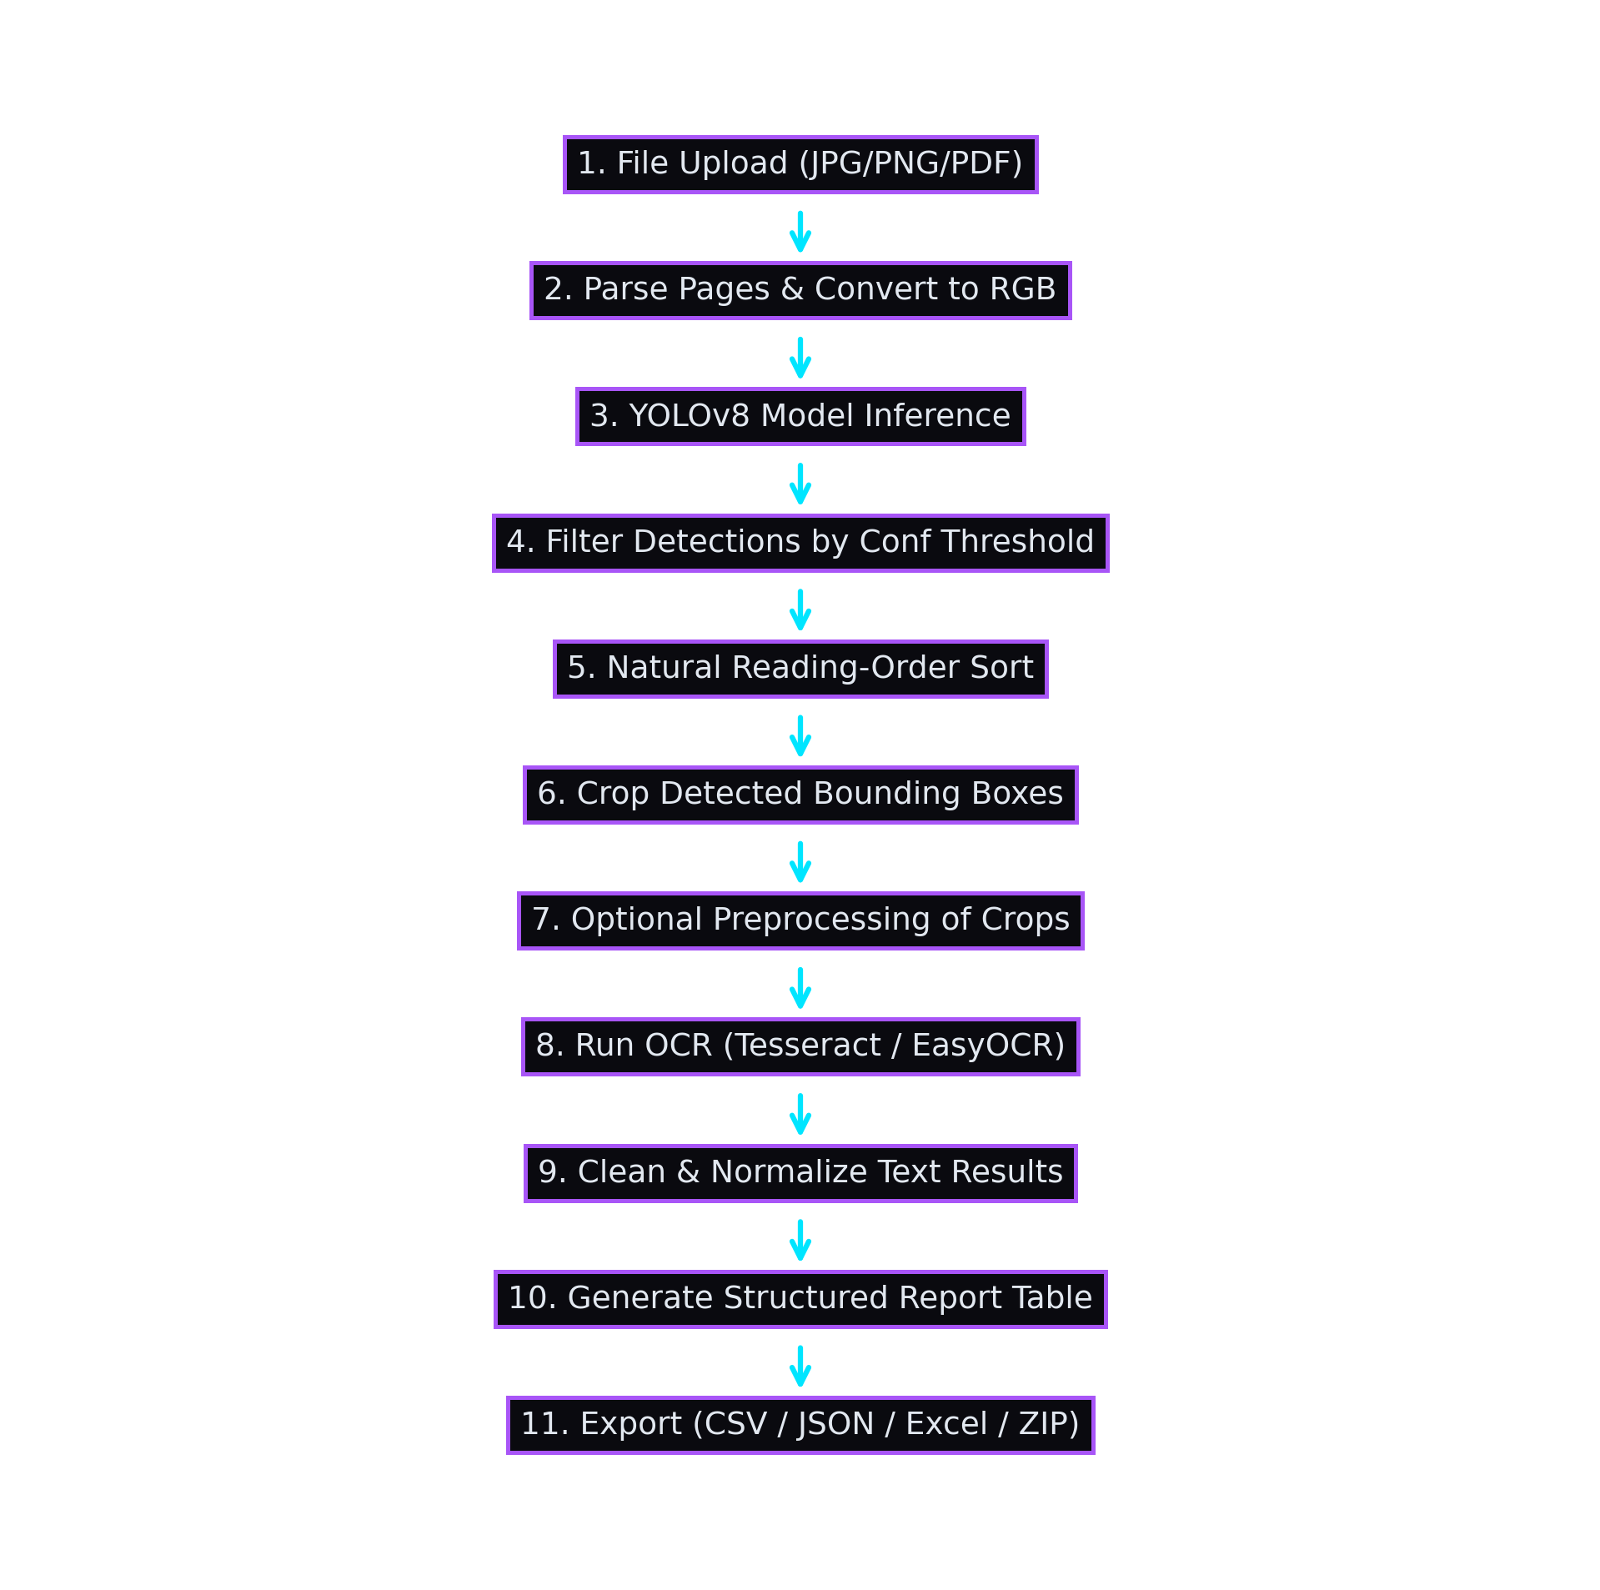
Figure 2.1: Complete Pipeline Methodology Flowchart.

3. Development & Training
YOLOv8 Nano was fine-tuned for 50 epochs on annotated Roboflow dataset files. Final precision scored 96.8% and mAP@50 reached 98.7%, allowing for robust field segment localization on complex clinical scans.

4. Internship Learning Outcomes
During this internship, I developed skills in convolutional neural network fine-tuning, image processing pipelines, deep-learning based OCR engines, reactive web design with Streamlit, and structured data export management.

