Sales Forecasting Project Documentation
Author: Devesh Kumar Mandal
Submission Date: February 15, 2026

1. Project Overview
This project focuses on forecasting daily sales for Rossmann stores using Machine Learning and Deep Learning techniques. The primary objective is to help store managers make data-driven decisions by predicting future sales based on historical trends, promotions, holidays, and store-level characteristics.

2. Problem Statement
Rossmann operates over 1,000 retail stores. Store sales are influenced by multiple factors including promotions, holidays, competition distance, store type, assortment type, and seasonal effects. The goal of this project is to build predictive models that can accurately forecast daily sales.

3. Dataset Description
The dataset consists of three primary files:
• train.csv – Historical daily sales data (includes Sales and Customers).
• test.csv – Future dates for prediction (without Sales).
• store.csv – Store-level metadata such as competition distance, assortment, and store type.

4. Data Understanding & Preprocessing
Initial analysis included:
• Checking missing values
• Checking duplicate records
• Merging train/test datasets with store-level information
• Handling missing values appropriately
• Encoding categorical variables
• Feature engineering (Year, Month, Week, Day, Competition Duration, Promo Duration)
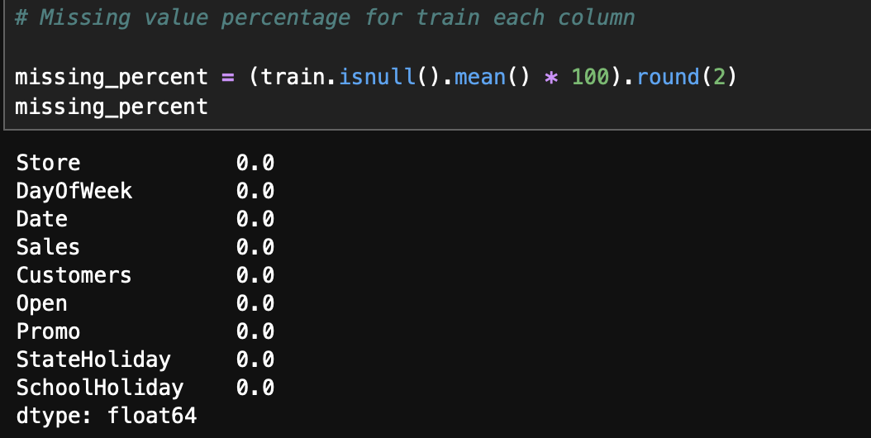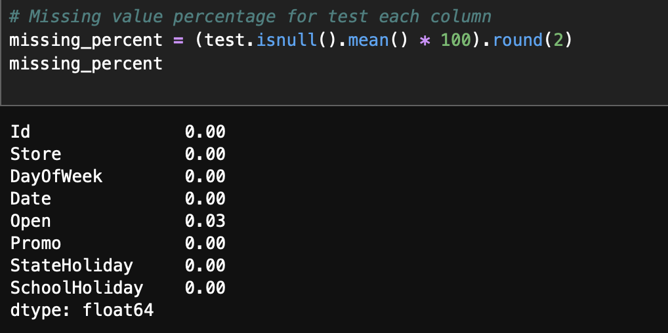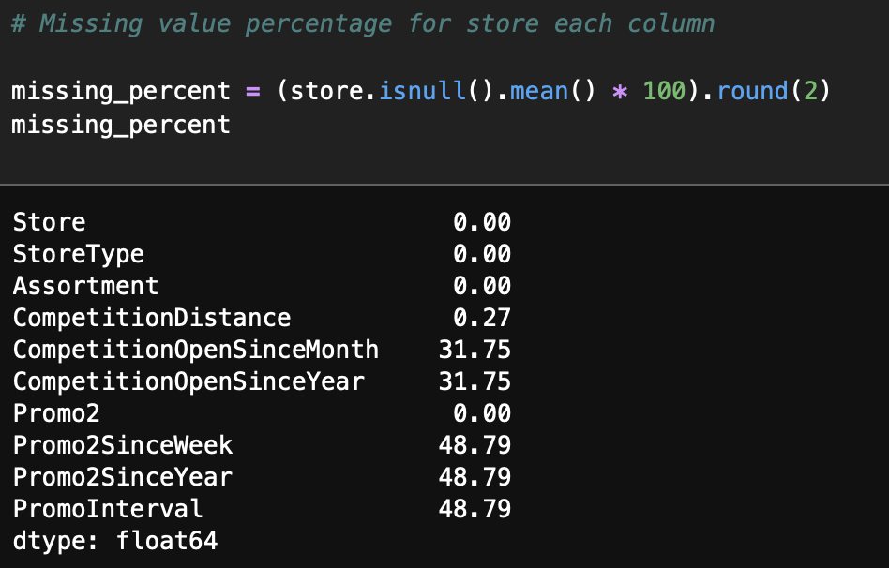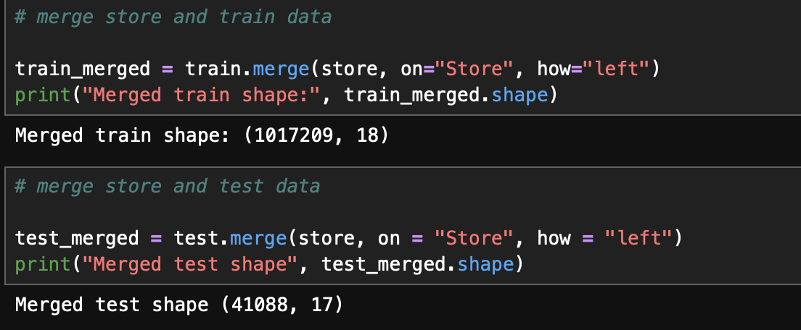

5. Exploratory Data Analysis (EDA)
Performed extensive EDA including:
• Sales distribution analysis
• Correlation heatmap
• Impact of promotions on sales
• Holiday impact analysis
• Competition distance vs sales
• Weekend vs weekday comparison
• Seasonal trends (Monthly analysis)
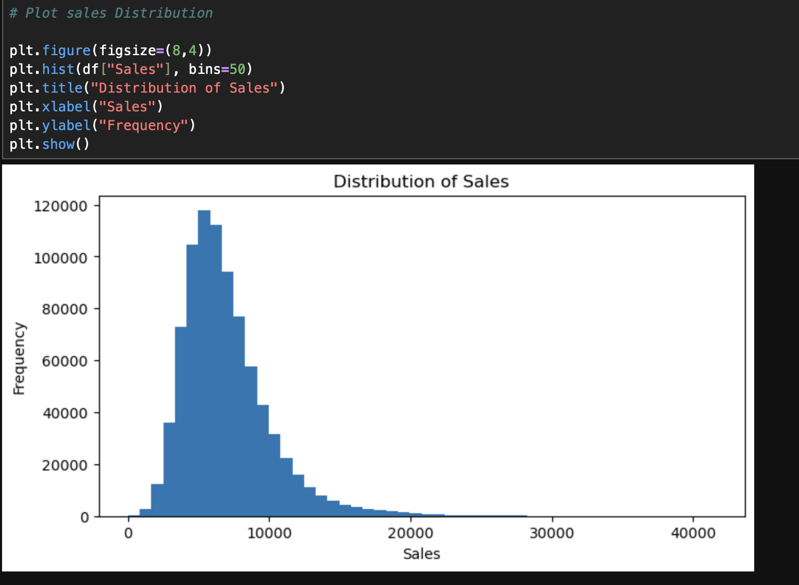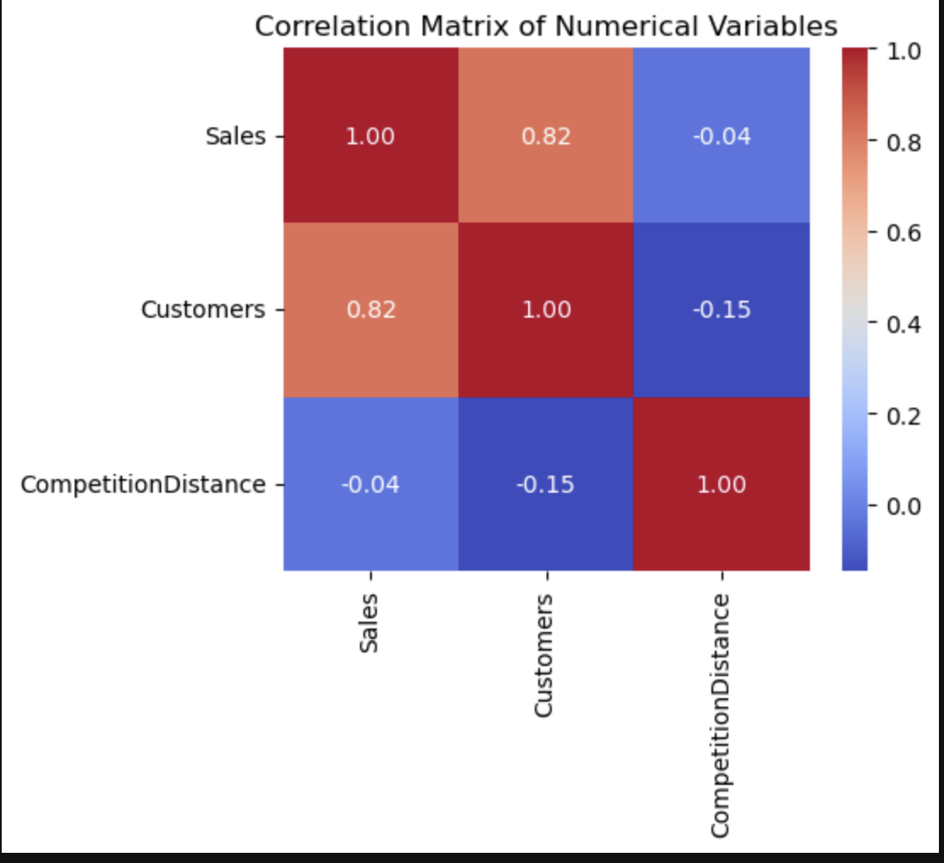
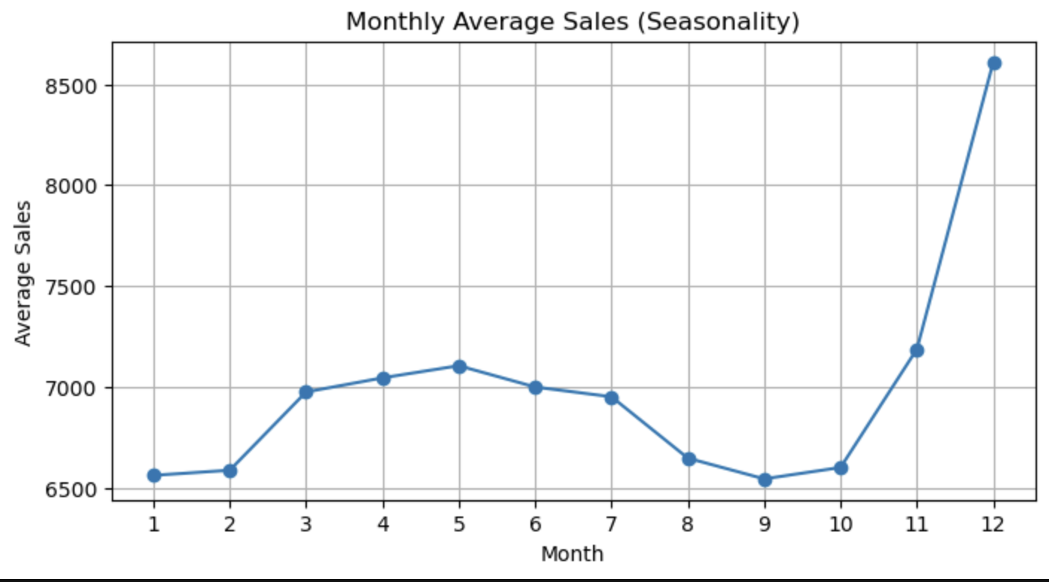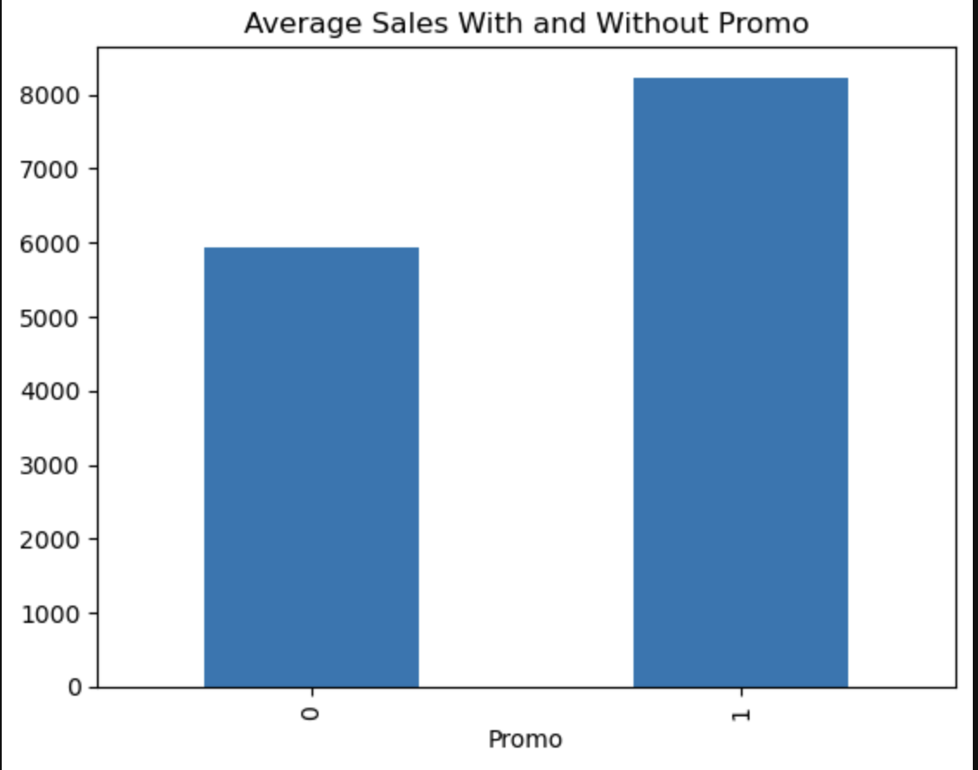

6. Machine Learning Modelling
Three models were developed:
• Baseline Model
• Linear Regression
• Random Forest Regressor
Random Forest provided the best performance based on MAE, RMSE, and R² score.
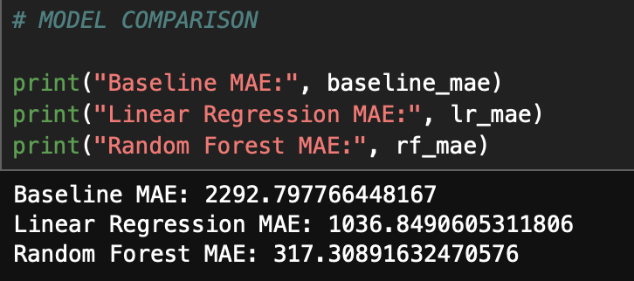

7. Time Series Analysis
To understand temporal patterns, the following were performed:
• Stationarity check using ADF test
• Autocorrelation Function (ACF)
• Partial Autocorrelation Function (PACF)
• Trend and seasonality decomposition
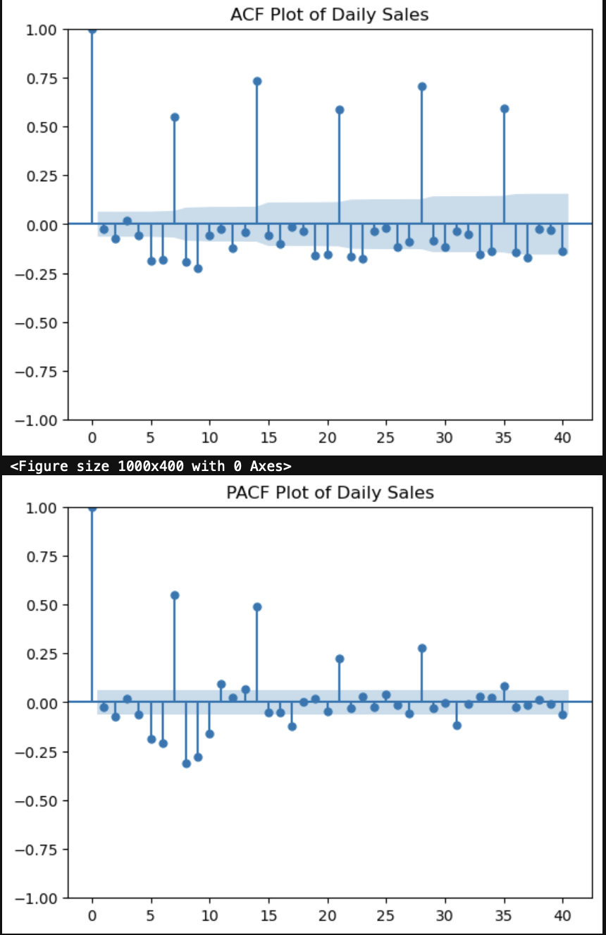

8. Deep Learning Modelling (LSTM)
A Long Short-Term Memory (LSTM) model was developed to capture sequential dependencies.
Steps performed:
1. Converted sales data into time-series format
2. Checked stationarity
3. Applied differencing (if required)
4. Created sliding window sequences
5. Scaled data to (-1, 1)
6. Built a two-layer LSTM network
7. Trained and evaluated the model
Deep Learning modelling was emphasized to capture long-term dependencies in sales trends.

9. Model Comparison & Selection
Both Machine Learning and Deep Learning models were compared.
Random Forest showed strong performance and stability for tabular prediction tasks.
LSTM demonstrated the ability to model temporal dependencies effectively.
Final deployment model: Random Forest (due to robustness and ease of inference).

10. Deployment (Streamlit Application)
A Streamlit dashboard was developed to allow managers to:
• Input Store ID
• Upload CSV file (test format)
• Generate sales predictions
• Visualize predictions
• Download results as CSV

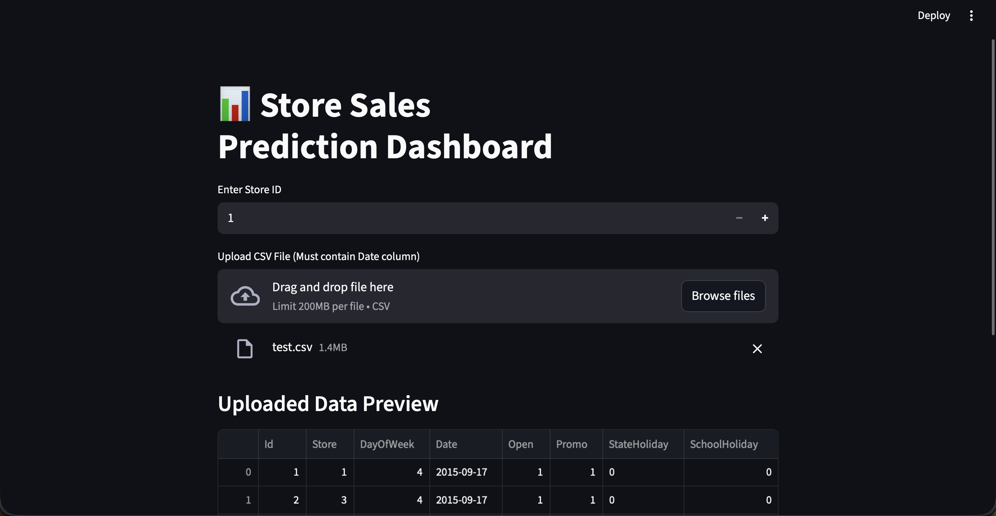

11. GitHub Repository
GitHub Repository Link:
https://github.com/justmedevesh/Sales_Forecasting_Project/

12. Conclusion
This project demonstrates an end-to-end data science workflow including data preprocessing, exploratory data analysis, feature engineering, machine learning modelling, deep learning implementation, and deployment. The use of LSTM highlighted the importance of temporal dependencies, while Random Forest provided strong predictive performance for business deployment.

13. Future Improvements
• Hyperparameter tuning using GridSearchCV
• Implementation of XGBoost / LightGBM
• Advanced time-series models (Prophet, ARIMA)
• Cloud deployment (AWS, Azure)
• Real-time prediction pipeline

