**1B程式語言第一次上機考 2018-10-11**

Note:

1. 嚴禁作弊，有違犯者，考試0分，另扣總分20分，嚴重者送校處理。
2. 在每一題結束前，請輸出 “Coding by your_ID_name”
3. (20%) 輸入兩個整數n1, n2，請列出n1, n2之相關運算，如下輸出。不需要寫迴圈。

檔名：p1_ID.cpp // 用你的學號取代 ID

評分： 比較運算 (10%)，奇偶數判斷 (10%)

螢幕輸出：

第1次執行：

Enter two integers: 25 10

25 > 10

25 is odd; 10 is even.

Coding by your_ID_name

第2次執行：

Enter two integers: 10 25

10 < 25

10 is even; 25 is odd.

Coding by your_ID_name

第3次執行：

Enter two integers: 10 10

10 = 10

10 is even.

Coding by your_ID_name

1. (20%) 寫一個迴圈，輸入身高及體重，請判斷其分級，並提供建議，該增重

或減重幾公斤才能達到正常BMI水準。

BMI 公式 = 體重(公斤) / 身高2 (公尺)

檔名：p2_ID.cpp // 用你的學號取代 ID

評分： 分級判斷 (15%)，建議增重或減重 (5%)

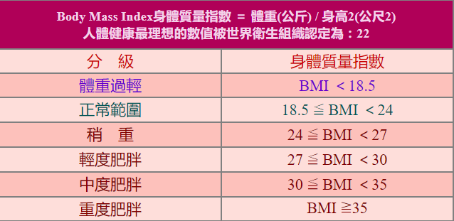

螢幕輸出：

Enter height and weight (-1 to exit): 175 55

Your BMI = 18.0 (體重過輕).

The normal BMI (18.5) = 56.7. You need to gain 1.7 kg to normal.

Enter height and weight (-1 to exit): 175 70

Your BMI = 22.9 (正常範圍).

Enter height and weight (-1 to exit): 175 80

Your BMI = 26.1 (稍重).

The normal BMI (24) = 73.5. You need to reduce 6.5 kg to normal.

Enter height and weight (-1 to exit): 175 90

Your BMI = 29.4 (輕度肥胖).

The normal BMI (24) = 73.5. You need to reduce 16.5 kg to normal.

Enter height and weight (-1 to exit): 175 100

Your BMI = 32.7 (中度肥胖).

The normal BMI (24) = 73.5. You need to reduce 26.5 kg to normal.

Enter height and weight (-1 to exit): 175 110

Your BMI = 35.9 (重度肥胖).

The normal BMI (24) = 73.5. You need to reduce 36.5 kg to normal.

Enter height and weight (-1 to exit): -1 -1

Coding by your_ID_name

1. (20%) 輸⼊高度，畫出如下的兩個直角三⾓形，要用迴圈，高度輸⼊-1則結束。

檔名: p3_ID.cpp // 用你的學號取代 ID  
評分:畫出左三⾓角形，得10分，畫出右三⾓角形，得10分。

void prchar(char c, int n){

for(int i=1;i<=n;i++) printf("%c", c);

}

螢幕輸出：

Enter height (-1 to exit): 5

***** *

**** **

*** ***

** ****

* *****

Enter height (-1 to exit): 7

******* *

****** **

***** ***

**** ****

*** *****

** ******

* *******

Enter height (-1 to exit): -1

Coding by your_ID_name

4. (40%) 寫一個選單，共有4個選項，其中(1)~(3)選項每個選項10%，要呼叫函式，如果沒有用函式寫，得一半5%分數。選單可以運作得10%。

(1) f2C(F) // 輸入華氏溫度(實數)，回傳攝氏溫度(實數)。(F=C*9/5+32)，不需迴圈

(2) daysPassed(y1,y2)，輸入y1,y2兩年(y1<=y2)，回傳y1至y2之天數，不需迴圈

(3) drawDiamond(h) // 輸入高度(奇數)，畫出實心菱形，不需迴圈

(4) Exit

檔名: p4_ID.cpp // 用你的學號取代 ID  
評分: 選單(10%)，(1)~(3)每個選項10%。 (1)~(3)如果沒有用函式，得5%

螢幕輸出

1. f2c(f)

2. daysPassed(y1,y2)

3. drawDiamond(h)

4. Exit

=> 1

Enter temperature in F: 90.5

90.5 F = 32.5 C // by calling f2c(f), no loop

1. f2c(f)

2. daysPassed(y1,y2)

3. drawDiamond(h)

4. Exit

=> 1

Enter temperature in F: 70

70.0 F = 21.1 C // by calling f2c(f), no loop

1. f2c(f)

2. daysPassed(y1,y2)

3. drawDiamond(h)

4. Exit

=> 2

Enter year1 and year2: 2018 2018

days(2018,2018) = 365 // by calling daysPassed(y1,y2)

1. f2c(f)

2. daysPassed(y1,y2)

3. drawDiamond(h)

4. Exit

=> 2

Enter year1 and year2: 2018 2020

days(2018,2020) = 1096

1. f2c(f)

2. daysPassed(y1,y2)

3. drawDiamond(h)

4. Exit

=> 2

Enter year1 and year2: 2000 2100

days(2000,2100) = 36890

1. f2c(f)

2. daysPassed(y1,y2)

3. drawDiamond(h)

4. Exit

=> 3

Enter height (-1 to exit): 9 // height is odd (奇數)

*

***

*****

*******

*********

*******

*****

***

*

1. f2c(f)

2. daysPassed(y1,y2)

3. drawDiamond(h)

4. Exit

=> 4

Coding by yourID