EE 616 Preliminary Evidence

Initial Toy Simulation Results for Vision Only Leader Follower Coordination
Kinematic baseline for faculty review before ROS 2 and Gazebo implementation
STATUS  Toy baseline completed | OWNER  Neeraj Kumar Kanchani | LAST UPDATED  September 16, 2026

Field | Details
Faculty reviewer | Professor Masudul Imtiaz
Course | EE 616-57, section 9189, four credits
Experiment type | Deterministic two-dimensional kinematic simulation
Trial set | 32 trials; four scenarios; eight recorded random seeds
Decision requested | Approve the measurement-only Gazebo baseline as the next implementation gate

1 Result and Interpretation
The toy baseline completed all 32 deterministic trials without a collision sample. Median camera-geometry error was 0.011 m for range and 0.104 degrees for bearing. Median formation error was 0.009 m, and the forced occlusion case reacquired a measurement after 0.030 s. These values show that the experiment harness, estimator, controller, and logging contract operate together under simplified assumptions. They are not evidence of ROS 2, Gazebo, learned detection, or physical robot performance.
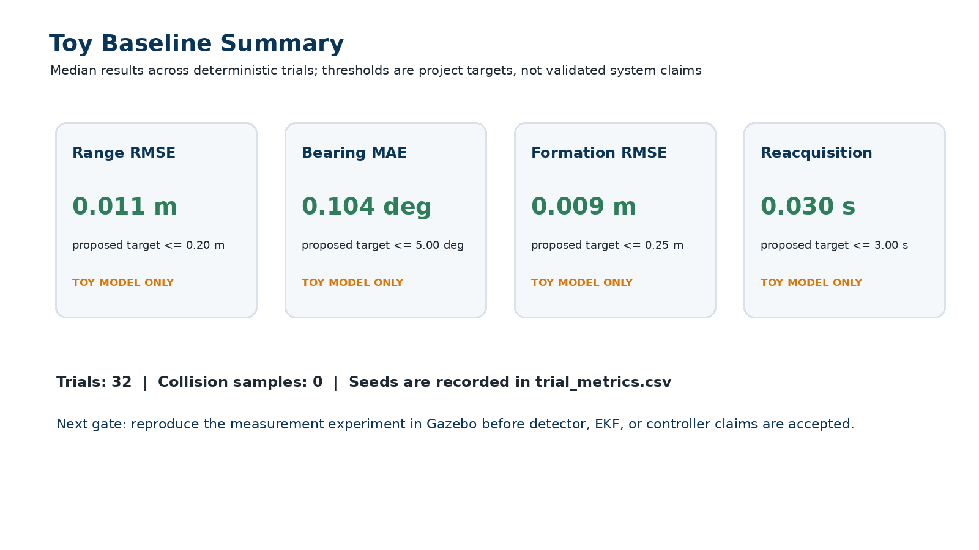
Figure 1 Aggregate toy baseline results with proposed project thresholds shown only as references

2 Experiment Design
Element | Toy baseline implementation
Scenarios | Straight motion, S-curve motion, constant-radius turn, and a forced visual occlusion
Perception | Synthetic bounding-box height and center with pixel noise at a nominal 15 Hz camera rate
Estimation | World-frame constant-velocity Kalman filter using follower pose and camera-derived range and bearing
Control | Bounded unicycle range-and-bearing controller at 50 Hz with TRACK, PREDICT, and SAFE_STOP states
Evidence | Per-trial metrics, representative time series, fixed configuration, recorded seeds, and four figures

3 Representative Behavior
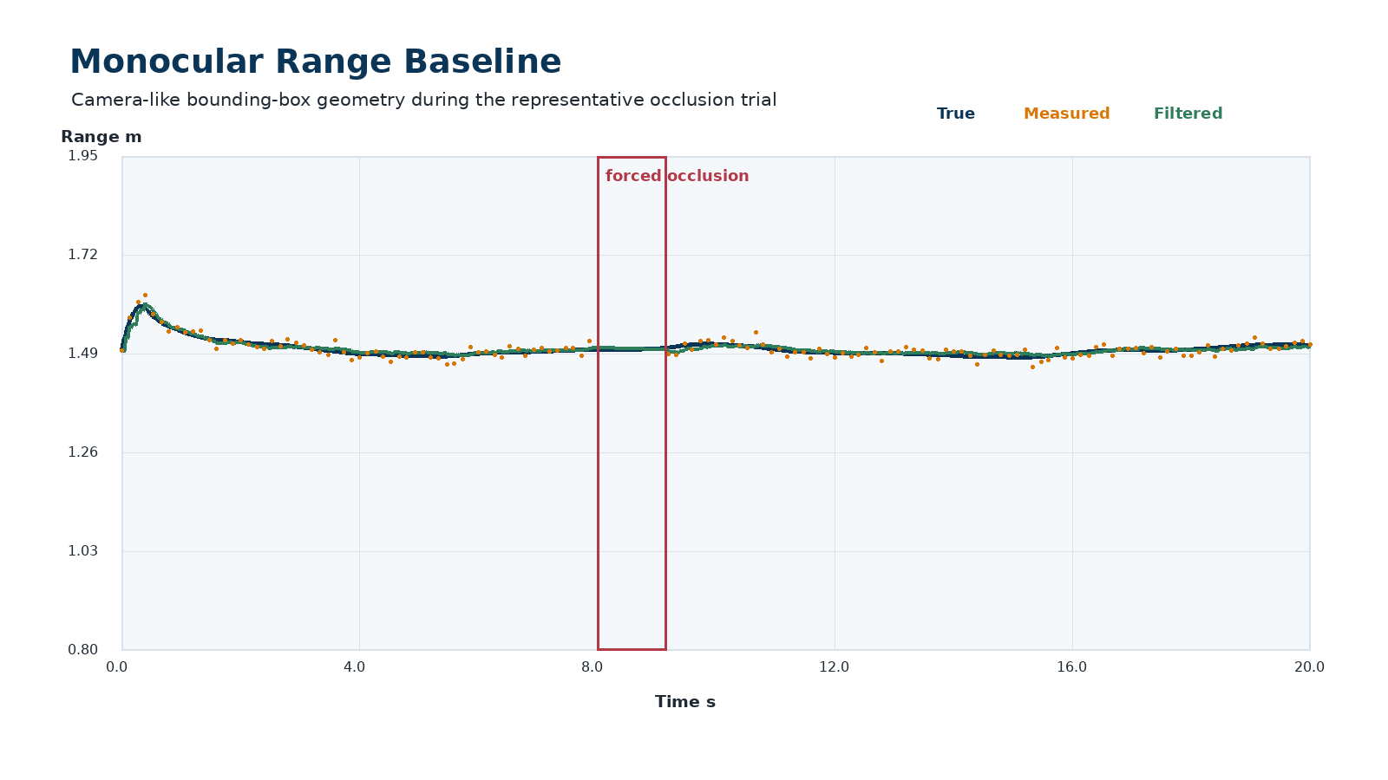
Figure 2 True measured and filtered leader range during the representative forced-occlusion trial
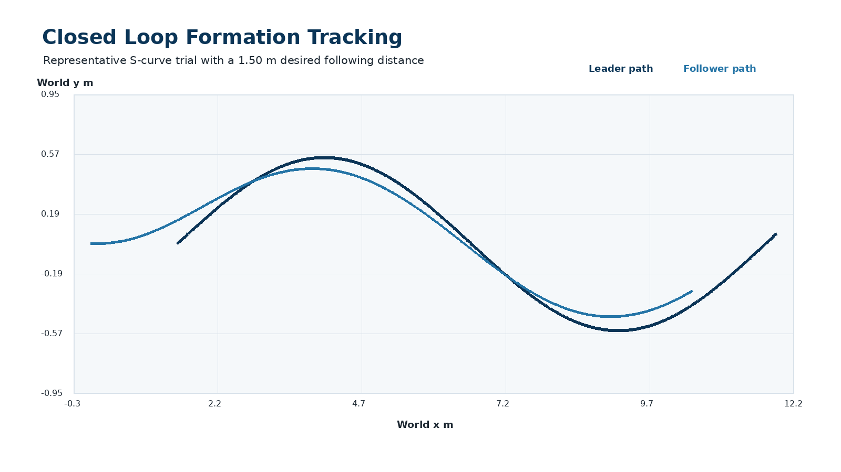
Figure 3 Leader and follower world paths during the representative S-curve trial

4 Occlusion Handling and Limitations
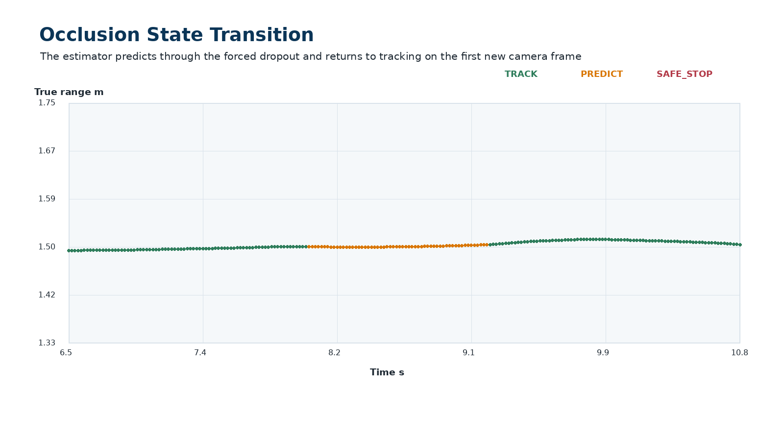
Figure 4 Controller state through the forced visual occlusion

Limits of This Evidence
The follower pose is available without an odometry error model, the leader has a known marker height, and the camera model generates bounding-box geometry directly. The simulation does not include detector misses outside the declared occlusion, image artifacts, variable inference latency, wheel slip, actuator dynamics, message delay, or GPU contention. The low errors are therefore expected and should not be compared with real deployment performance.

Recommended Next Gate
I recommend reproducing only the calibrated range-and-bearing experiment in Gazebo next. That gate should compare camera-derived measurements against Gazebo ground truth across range, heading, lighting, and off-axis placement. I will not treat the detector, filter, or controller as validated until that evidence is reviewed.

Approval Requested
Please confirm whether this toy baseline and experiment structure are sufficient to begin the measurement-only Gazebo implementation. I will preserve the same seeds, configuration manifest, CSV schema, figures, and acceptance criteria so the next result can be compared directly with this baseline.

Use footnotes for definitions, assumptions, or terms that need precision without interrupting the main narrative.

