Постановка задачи

**Анализ продуктов питания.**

Лаборатория производит анализ продуктов, которые обрабатываются при определенной температуре X1 (t, °С), и в которые добавляются для увеличения срока годности определенные консерванты Х2 (мг). В готовом продукте может содержаться некоторое количество нежелательных веществ Y (в долях к общей массе). Х1 и Х2 даны в относительных единицах (абсолютные значения t ∈ [60; 80]; консервант Х2∈ [0,5; 1]), Y - в абсолютных.

Необходимо определить зависимость Y = f(Х1,Х2) и установить значения Х1 и Х2, которые обеспечивают номинал Yном. =0,009; 0,010; 0,011; 0,01 г. Определить ошибку ε, которая соответствует установленному номиналу Yном.

|  |  |  |  |
| --- | --- | --- | --- |
| № | X1i | Х2i | Yi |
| 1. | 3 | 6 | 0,016 |
| 2. | 3 | 6 | 0,015 |
| 3. | 3 | 6 | 0,014 |
| 4. | 6 | 4 | 0,014 |
| 5. | 4 | 7 | 0,013 |
| 6. | 4 | 7 | 0,013 |
| 7. | 9 | 1 | 0,011 |
| 8. | 9 | 1 | 0,012 |
| 9. | 1 | 10 | 0,012 |
| 10. | 1 | 10 | 0,017 |
| 11. | 1 | 10 | 0,015 |
| 12. | 9 | 2 | 0,009 |
| 13. | 9 | 2 | 0,010 |
| 14. | 2 | 9 | 0,014 |
| 15. | 2 | 9 | 0,018 |
| 16. | 2 | 9 | 0,016 |
| 17. | 8 | 1 | 0,009 |
| 18. | 5 | 5 | 0,013 |
| 19. | 5 | 5 | 0,011 |
| 20. | 5 | 5 | 0,014 |
| 21. | 3 | 7 | 0,016 |
| 22. | 4 | 6 | 0,012 |
| 23. | 4 | 6 | 0,011 |
| 24. | 7 | 3 | 0,013 |
| 25. | 7 | 3 | 0,012 |
| 26. | 2 | 8 | 0,011 |
| 27. | 10 | 2 | 0,010 |
| 28. | 10 | 2 | 0,009 |
| 29. | 7 | 4 | 0,010 |
| 30. | 7 | 4 | 0,011 |

Текст программы

|  |  |  |  |  |  |  |  |  |  |  |  |  |  |  |  |  |  |  |  |  |  |  |  |  |  |  |  |  |  |  |  |  |  |  |  |  |  |  |  |  |  |  |  |  |  |  |  |  |  |  |  |  |  |  |  |  |  |  |  |  |  |  |  |  |  |  |  |  |  |  |  |  |  |  |  |  |  |  |  |  |  |  |  |  |  |  |  |  |  |  |  |  |  |  |  |  |  |  |  |  |  |  |  |  |  |  |  |  |  |  |  |  |  |  |  |  |  |  |  |  |  |  |  |  |  |  |  |  |  |  |  |  |  |  |  |  |  |  |  |  |  |  |  |  |  |  |  |  |  |  |  |  |  |  |  |  |  |  |  |  |  |  |  |  |  |  |  |  |  |  |  |  |  |  |  |  |  |  |  |  |  |  |  |  |  |  |  |  |  |  |  |  |  |  |  |  |  |  |  |  |  |  |  |  |  |  |  |  |  |  |  |  |  |  |  |  |  |  |  |  |  |  |  |  |  |
| --- | --- | --- | --- | --- | --- | --- | --- | --- | --- | --- | --- | --- | --- | --- | --- | --- | --- | --- | --- | --- | --- | --- | --- | --- | --- | --- | --- | --- | --- | --- | --- | --- | --- | --- | --- | --- | --- | --- | --- | --- | --- | --- | --- | --- | --- | --- | --- | --- | --- | --- | --- | --- | --- | --- | --- | --- | --- | --- | --- | --- | --- | --- | --- | --- | --- | --- | --- | --- | --- | --- | --- | --- | --- | --- | --- | --- | --- | --- | --- | --- | --- | --- | --- | --- | --- | --- | --- | --- | --- | --- | --- | --- | --- | --- | --- | --- | --- | --- | --- | --- | --- | --- | --- | --- | --- | --- | --- | --- | --- | --- | --- | --- | --- | --- | --- | --- | --- | --- | --- | --- | --- | --- | --- | --- | --- | --- | --- | --- | --- | --- | --- | --- | --- | --- | --- | --- | --- | --- | --- | --- | --- | --- | --- | --- | --- | --- | --- | --- | --- | --- | --- | --- | --- | --- | --- | --- | --- | --- | --- | --- | --- | --- | --- | --- | --- | --- | --- | --- | --- | --- | --- | --- | --- | --- | --- | --- | --- | --- | --- | --- | --- | --- | --- | --- | --- | --- | --- | --- | --- | --- | --- | --- | --- | --- | --- | --- | --- | --- | --- | --- | --- | --- | --- | --- | --- | --- | --- | --- | --- | --- | --- | --- | --- | --- | --- | --- | --- | --- | --- | --- | --- | --- | --- | --- | --- |
| |  |  |  |  |  |  |  |  |  |  |  |  |  |  |  |  |  |  |  |  |  |  |  |  |  |  |  |  |  |  |  |  |  |  |  |  |  |  |  |  |  |  |  |  |  |  |  |  |  |  |  |  |  |  |  |  |  |  |  |  |  |  |  |  |  |  |  |  |  |  |  |  |  |  |  |  |  |  |  |  |  |  |  |  |  |  |  |  |  |  |  |  |  |  |  |  |  |  |  |  |  |  |  |  |  |  |  |  |  |  |  |  |  |  |  |  |  |  |  |  |  |  |  |  |  |  |  |  |  |  |  |  |  |  |  |  |  |  |  |  |  |  |  |  |  |  |  |  |  |  |  |  |  |  |  |  |  |  |  |  |  |  |  |  |  |  |  |  |  |  |  |  |  |  |  |  |  |  |  |  |  |  |  |  |  |  |  |  |  |  |  |  |  |  |  |  |  |  |  |  |  |  |  |  |  |  |  |  |  |  |  |  |  |  |  |  |  |  |  |  |  |  |  |  | | --- | --- | --- | --- | --- | --- | --- | --- | --- | --- | --- | --- | --- | --- | --- | --- | --- | --- | --- | --- | --- | --- | --- | --- | --- | --- | --- | --- | --- | --- | --- | --- | --- | --- | --- | --- | --- | --- | --- | --- | --- | --- | --- | --- | --- | --- | --- | --- | --- | --- | --- | --- | --- | --- | --- | --- | --- | --- | --- | --- | --- | --- | --- | --- | --- | --- | --- | --- | --- | --- | --- | --- | --- | --- | --- | --- | --- | --- | --- | --- | --- | --- | --- | --- | --- | --- | --- | --- | --- | --- | --- | --- | --- | --- | --- | --- | --- | --- | --- | --- | --- | --- | --- | --- | --- | --- | --- | --- | --- | --- | --- | --- | --- | --- | --- | --- | --- | --- | --- | --- | --- | --- | --- | --- | --- | --- | --- | --- | --- | --- | --- | --- | --- | --- | --- | --- | --- | --- | --- | --- | --- | --- | --- | --- | --- | --- | --- | --- | --- | --- | --- | --- | --- | --- | --- | --- | --- | --- | --- | --- | --- | --- | --- | --- | --- | --- | --- | --- | --- | --- | --- | --- | --- | --- | --- | --- | --- | --- | --- | --- | --- | --- | --- | --- | --- | --- | --- | --- | --- | --- | --- | --- | --- | --- | --- | --- | --- | --- | --- | --- | --- | --- | --- | --- | --- | --- | --- | --- | --- | --- | --- | --- | --- | --- | --- | --- | --- | --- | --- | --- | --- | --- | --- | --- | | |  |  | | --- | --- | | 1 | clc; | | 2 | clear; | | 3 | n = 2; | | 4 | X1 = [3 3 3 6 4 4 9 9 1 1 1 9 9 2 2 2 8 5 5 5 3 4 4 7 7 2 10 10 7 7]; | | 5 | X2 = [6 6 6 4 7 7 1 1 10 10 10 2 2 9 9 9 1 5 5 5 7 6 6 3 3 8 2 2 4 4]; | | 6 | Y  = [0.016 0.015 0.014 0.014 0.013 0.013 0.011 0.012 0.012 0.017 0.015 0.009 0.010 0.014 0.018 0.016 0.009 0.013 0.011 0.014 0.016 0.012 0.011 0.013 0.012 0.011 0.010 0.009 0.010 0.011 ]; | | 7 | Ynominal = [0.009 0.01 0.011 0.01]; | | 8 | absX1 = [60 80]; | | 9 | absX2 = [0.5 1]; | | 10 |  | | 11 | fun1 = @(x)(absX1(2)-absX1(1))*x/100.0 + absX1(1); | | 12 | fun2 = @(x)(absX2(2)-absX2(1))*x/100.0 + absX2(1); | | 13 |  | | 14 | X1 = fun1(X1); | | 15 | X2 = fun2(X2); | | 16 |  | | 17 | X = [X1; X2]; | | 18 |  | | 19 | Y_X1 = Y.*X1; | | 20 | Y_X2 = Y.*X2; | | 21 |  | | 22 | B = [sum(Y) sum(Y_X1) sum(Y_X2)]'; | | 23 |  | | 24 | X = [ones(1, length(X1)); X]'; | | 25 | XT = X'; | | 26 | A = XT*X; | | 27 |  | | 28 | A(1,1) = length(X1); | | 29 |  | | 30 | b = mldivide(A, B); | | 31 | fun = @(x1, x2)b(1)+b(2)*x1+b(3)*x2; | | 32 | Y2 = fun(X1, X2); | | 33 |  | | 34 |  | | 35 |  | | 36 |  | | 37 | syms x1 x2 f; | | 38 | f = collect([1 x1 x2]*b); | | 39 |  | | 40 | fprintf('-- System regression:\n'); | | 41 | fprintf('f(x1, x2) = '); | | 42 | pretty(vpa(collect(f), 3)) | | 43 |  | | 44 | x = linspace(min(X1), max(X1)); | | 45 | y = linspace(min(X2), max(X2)); | | 46 | z = fun(x, y); | | 47 | plot3(x,y,z, X1, X2, Y, 'o'); | | 48 | grid on; | | 49 |  | | 50 | index = cell(1, length(X1)+2); | | 51 | ind = 1:(length(X1)); | | 52 | for i=1:length(X1) | | 53 | index(i) = {ind(i)}; | | 54 | end | | 55 | index(length(X1)+1) = {' SUM '}; | | 56 | index(length(X1)+2) = {' AVG '}; | | 57 | X1sqr = X1.^2; | | 58 | X2sqr = X2.^2; | | 59 | YX1 = Y_X1; | | 60 | YX2 = Y_X2; | | 61 | X1X2 = X1.*X2; | | 62 | Ysqr  = Y .^2; | | 63 | Y_Y2 = Y-Y2; | | 64 | Y_Y2sqr = Y_Y2.^2; | | 65 | A = abs(Y_Y2./Y).*100; | | 66 |  | | 67 | X1 = [X1 sum(X1) mean(X1)]; | | 68 | X2 = [X2 sum(X2) mean(X2)]; | | 69 | Y = [Y sum(Y) mean(Y)]; | | 70 | Y2 = [Y2 sum(Y2) mean(Y2)]; | | 71 | X1sqr = [X1sqr sum(X1sqr) mean(X1sqr)]; | | 72 | X2sqr = [X2sqr sum(X2sqr) mean(X2sqr)]; | | 73 | YX1 = [YX1 sum(YX1) mean(YX1)]; | | 74 | YX2 = [YX2 sum(YX2) mean(YX2)]; | | 75 | X1X2 = [X1X2 sum(X1X2) mean(X1X2)]; | | 76 | Ysqr  = [Ysqr sum(Ysqr) mean(Ysqr)]; | | 77 | Y_Y2 = [Y_Y2 sum(Y_Y2) mean(Y_Y2)]; | | 78 | Y_Y2sqr = [Y_Y2sqr sum(Y_Y2sqr) mean(Y_Y2sqr)]; | | 79 | A = [A sum(A) mean(A)]; | | 80 |  | | 81 | index = index'; | | 82 | X1 = X1'; | | 83 | X2 = X2'; | | 84 | Y = Y'; | | 85 | X1sqr = X1sqr'; | | 86 | X2sqr = X2sqr'; | | 87 | YX1 = YX1'; | | 88 | YX2 = YX2'; | | 89 | X1X2 = X1X2'; | | 90 | Ysqr = Ysqr'; | | 91 | Y2 = Y2'; | | 92 | Y_Y2 = Y_Y2'; | | 93 | Y_Y2sqr = Y_Y2sqr'; | | 94 | A = A'; | | 95 |  | | 96 | MainTable = table(index, X1, X2, Y, X1sqr, X2sqr, YX1, YX2, X1X2, Ysqr, Y2, Y_Y2, Y_Y2sqr, A); | | 97 | disp(MainTable); | | 98 |  | | 99 | f1 = solve(f-Ynominal(1)); | | 100 | f2 = solve(f-Ynominal(2)); | | 101 | f3 = solve(f-Ynominal(3)); | | 102 | f4 = solve(f-Ynominal(4)); | | 103 | F = [f1; f2; f3; f4]; | | 104 | F = subs(F, x2, absX2(1)); | | 105 |  | | 106 | Ynom = Ynominal'; | | 107 | X1 = *double*(F); | | 108 | X2 = *double*(F); | | 109 | X2(:) = absX2(1); | | 110 | SearchYnominal = table(Ynom, X1, X2); | | 111 | disp(SearchYnominal); | |  | |  |

Выполнение

На рисунке 1 показан график уравнения регрессии системы, полученный при помощь программы. Точки обозначают экспериментальные данные, которые были даны при постановки задачи.

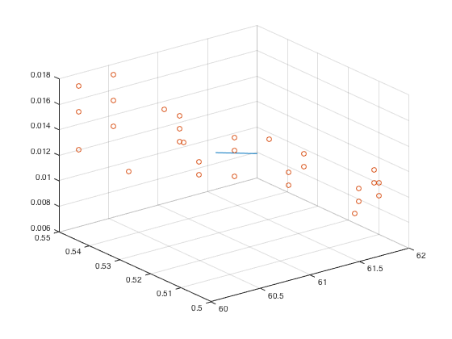

Рисунок 1 – График уравнения регрессии системы

На рисунке 2 показано полученное уравнение регрессии системы, вспомогательная таблица регрессионного анализа, значения параметров обеспечивающие номинал заданный в постанове задачи.

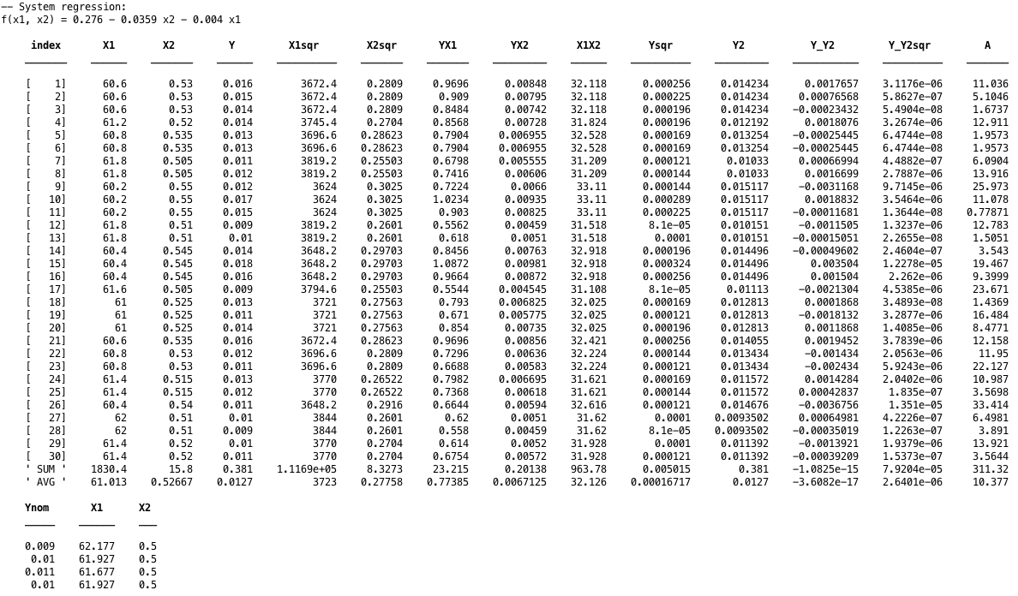

Рисунок 2 – Основная часть регрессионного анализа

Вывод

Качество уравнения регрессии оценивается с помощью средней ошибки аппроксимации, которая в данном случае равна 𝐴 = 10.377%. Значит, фактические значения нежелательных веществ в готовом продукте и расчетные по уравнению регрессии в среднем различаются на 10.377 %. Качество уравнения регрессии считается хорошим, если ошибка аппроксимации не превышает 8-10%. Полученное уравнение регрессии можно оценить как недостаточно хорошее.