Pizza Runner – SQL EDA & Power BI Dashboard Project Documentation

Project Overview
This project demonstrates an end‑to‑end data analytics workflow using a synthetic food delivery dataset. The objective was to clean operational data using SQL, perform exploratory data analysis (EDA), and build an interactive dashboard in Power BI. The dataset imitates real‑world food delivery operations, including customer orders, runners, pizzas, recipes and delivery activity.

Tools & Technologies
- PostgreSQL database
- pgAdmin for database management
- SQL for data cleaning and analysis
- Microsoft Power BI for data modelling and dashboard development
- Gamma AI for presentation generation

Data Source
The data used in this project is synthetic and was created for learning and portfolio purposes. However, it closely reflects real‑life food delivery business processes such as order placement, cancellations, delivery durations, distance travelled, and order customisation (extras and exclusions).

Data Import into Power BI
1. The PostgreSQL database was accessed through pgAdmin.
2. In Power BI, the PostgreSQL connector was used to connect directly to the database server.
3. The relevant schema and tables were selected.
4. Data was loaded into Power BI for modelling and reporting.
5. Relationships between tables were verified inside the Power BI data model.

Data Cleaning Process (SQL)
Several data quality issues were resolved before analysis:

- Inconsistent null values such as empty strings and the text 'null' were standardised to proper NULL values.
- Extra spaces and inconsistent comma formatting in the exclusions and extras columns were corrected.
- Distance and duration fields were cleaned by removing non‑numeric characters using regular expressions.
- Pickup time values were converted into proper timestamp data types.
- Recipe topping values were standardised by removing unnecessary spaces.

These steps ensured accurate aggregation, filtering and calculations during analysis.

Exploratory Data Analysis (EDA)
The following key analytical questions were answered using SQL:

- Total number of pizzas ordered - 64
- Total number of unique customer orders - 56
- Number of successful deliveries per runner –
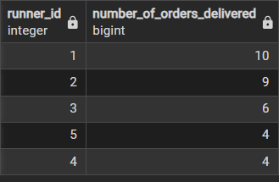
- Number of each pizza type delivered
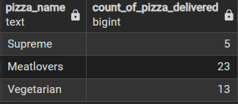
- Pizza preferences by customer
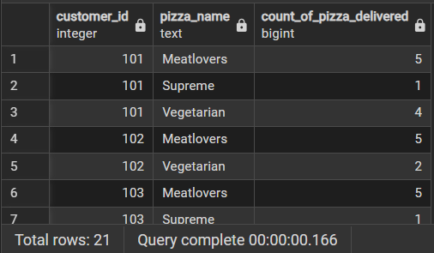
- Maximum pizzas delivered in a single order
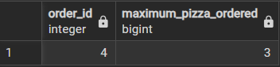
- Orders with changes (extras or exclusions)
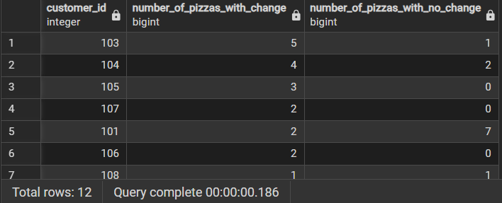
- Orders with both exclusions and extras
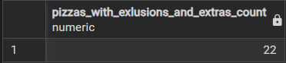
- Order volume by hour of day
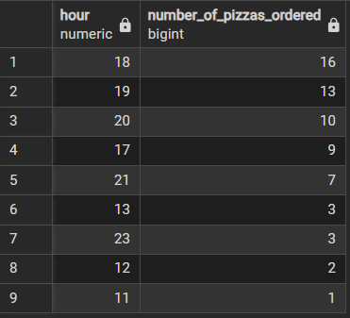
- Order and pizza volume by day of the week
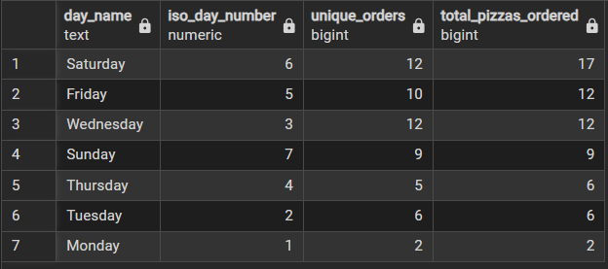

Key Dashboard KPIs
- Total Orders
- Total Pizzas Ordered
- Accepted (Delivered) Orders Percentage
- Average Delivery Duration
- Orders Delivered per Runner
- Percentage of Orders with Customisations

Visuals Created in Power BI
- Line chart showing average delivery time by day of the week
- Bar chart showing number of orders per runner
- Bar chart showing pizza types delivered
- Time‑based analysis of orders by hour and day
- KPI cards summarising key operational metrics

Outcome and Value
This project demonstrates strong SQL data preparation skills, real‑world data modelling concepts, and the ability to translate business questions into actionable Power BI dashboards. The workflow mirrors typical analytics processes used in logistics and food delivery companies.

