CAREER PORTFOLIO
Cybersecurity Portfolio
Submission
A concise record of my public security portfolio and LinkedIn placement.
Candidate | Justus Njogu Nderitu
Date | August 2026
Portfolio focus | Threat detection, vulnerability management, network defense, and incident response

Public links
Live site https://justo340.github.io/Security-Portfolio/
GitHub repository https://github.com/justo340/Security-Portfolio
LinkedIn profile https://www.linkedin.com/in/justus-njogu/

What this portfolio demonstrates
The linked homepage presents a recruiter-friendly summary of my security focus areas and a body of evidence that grows as I complete labs and projects. Each project is structured around an objective, method, tooling, outcome, and key learning.
- Hands-on work in security monitoring and investigation
- Risk-based vulnerability review and remediation planning
- Network reconnaissance, traffic analysis, and defense fundamentals

LinkedIn proof
Before submitting: replace the three placeholders above with live URLs and insert a screenshot below showing the live site added in your LinkedIn Featured section.
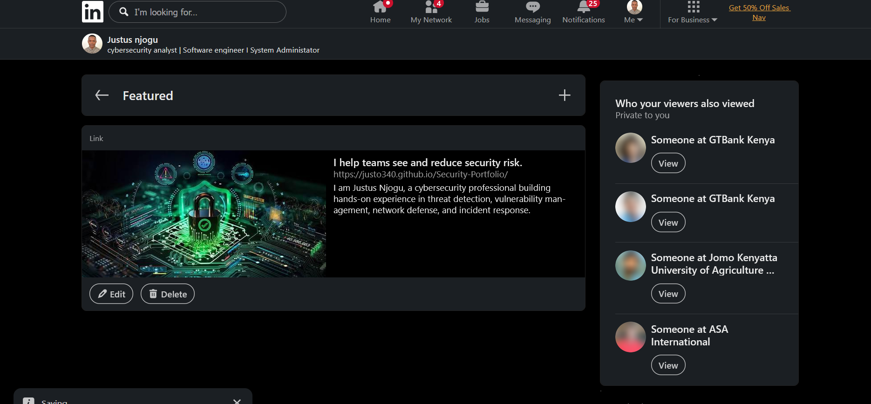INSERT LINKEDIN FEATURED SCREENSHOT HERE
Show the live portfolio card or URL on your profile.
Final check: open each link from the exported document, confirm the site is public, and make sure the screenshot includes your name and/or profile context.

