In this project, we PKU students add the algorithms of obfuscation, as shown below:

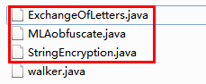

The ExchangeOfLetters.java is a new algorithm. It changes the letters order of the variable name. For an example, the name "abcd" after obfuscation would become "_dbca". And I added some comments in the file, in English of course~

The MLAobfuscation.java includes the Minimum Lexical Algorithm. And we have introduced this algorithm for lots of times. I made some changes in the original basis.

The String Encryption.java includes the String Encryption Algorithm.

In walker.java, I used Exchange Of Letters Algorithm and Minimum Lexical Algorithm to obfuscate the variable names. If you want to use the Minimum Lexical Algorithm, then you need to write data directory which named obfuscated_names in walker.java. The code is as shown below:

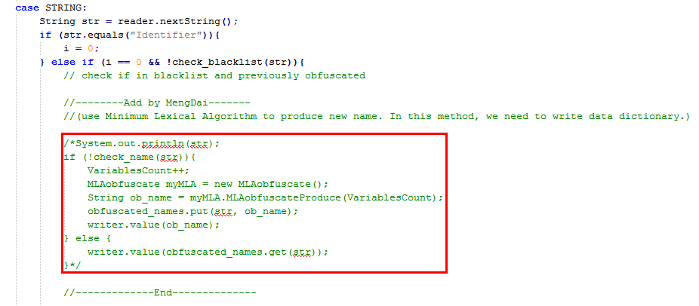

But if you use the Exchange Of Letters Algorithm, you don’t to write data directory, because all the names is obfuscated by the same rule. The code is as shown below:

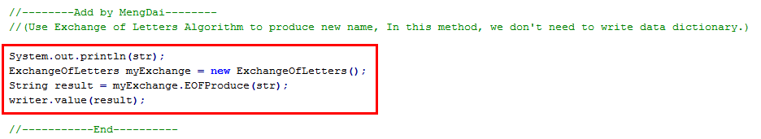

I didn’t use the String Encryption Algorithm, because I can’t get the content of strings. And I found it is not suitable to obfuscate strings. If we obfuscate strings, some structures will be affected, such as the table structure in Lua.

If you have any questions, just contact me! O(∩_∩)O~