How Memory Functions

title

How Memory Functions

author

Waleed Ahmad

description

This chapter covers the various processess and systems of memory

keywords

memory, types of memory, memory models, process of memory.

Learning Objectives

By the end of this section, you will be able to:

* Discuss the three basic functions of memory
* Describe the three stages of memory storage
* Describe and distinguish between procedural and declarative memory and semantic and episodic memory

...

One of the major elements that separate humans from animals is our ability to store, recall, and use complex information: memory. Memory refers to the formation, retention, and retrieval of learned associations, stored information, and skills.

# Models of memory

Several models of memory have been proposed to describe the various systems, processes and subtypes of memory.

**Broadbent's Model** (1958) describes three memory storing systems, S-system for sensory memory, P-system for short-term memories and and a long-term store.

**Atkinson and Shriffen's Model** 1968, also known as multi-store model or modal model of memory, also describes such three systems respectively termed, sensory memory, short-term memory and long-term memory stores; the model also described an executive control process that controlled the flow of information between these stores.

These two models deal largely with **memory storage systems** classifed based on the duration they can store information and their maximum storage capacity but do not describe the processing of information, such as how information is encoded, manipulated, elaborated or retrived from these stores.

The processing of memory is broadly described by the **information processing model**. Information processing models involve an **input** system to receive information, a **central processing system** that receives information from the input system, processess it and passess the final product to on to an **output** system, such as our longterm memory system, which stores this information for later recall.

The **levels of processing theory** and **Baddely's model** are information processing models, as is the generally accepted memory processing model.

**Tulving's Model** of memory describes describes different types of memories based on their nature. Episodic memories are memories for events, while procedural memories involve motor skills.

Beginning with an introduction to memory processing, we will describe all these models in detail in this section.

# Process of Memory

The process of memory is best seen as an analog process of how a computer stores memory. A computer receives information via an input device, such as a keyboard, which it processes through its central processing unit, after which it can save it to its solid-state drive for long-term storage. The computer can then access and retrieve this information from the drive when needed.

Human memory processes work similarly; to encode, store, and retrieve information over different periods.

See (Fig. %s) <cnx_psych_08_01_memory> for elaboration.

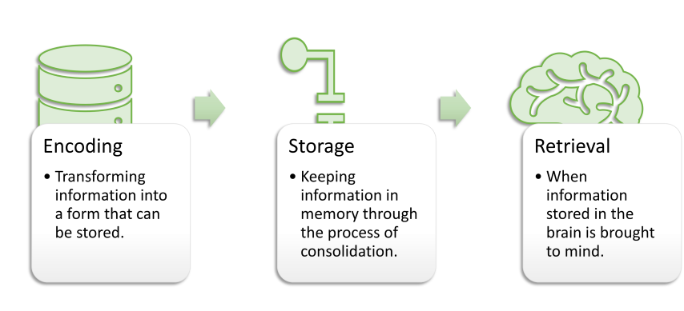

Watch [this video](https://www.youtube.com/watch?v=sI_ceF5-OiQ) for more information on some unexpected facts about memory.

# ENCODING

We get information into our brains through a process called encoding , which is the input of information into the memory system. We receive sensory data from the environment in raw form; until it is processed, this data is meaningless. Inside the brain, the data undergoes extensive processing and integration, that makes the data meaningful. With encoding, the brain forms memory codes for the perceived information. We can then organize the information with other similar information and connect new concepts to existing concepts. Encoding information occurs through **automatic processing** and **effortful processing**.

If someone asks you what you ate for lunch today, more than likely you could recall this information quite easily. This is known as automatic processing, or the encoding of details like time, space, frequency, and the meaning of words. Automatic processing is usually done without any conscious awareness. Recalling the last time you studied for a test is another example of automatic processing. But what about the actual test material you studied? It probably required a lot of work and attention on your part in order to encode that information. This is known as effortful processing ([link]).

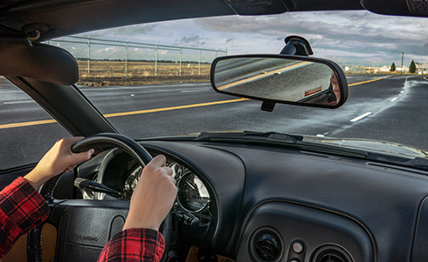

A photograph shows a person driving a car.

## Enriching encoding

**What are the most effective ways to ensure that important memories are well encoded?** See (Fig. %s) <enriching_encoding>

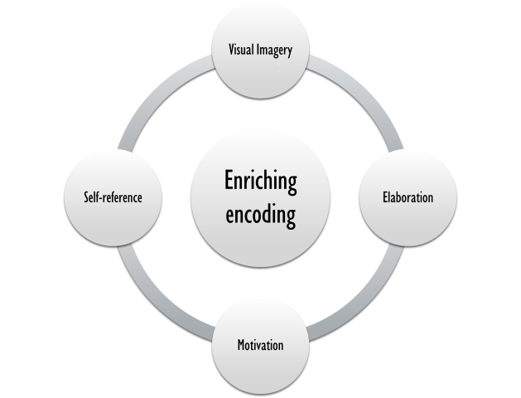

An illustration that shows how encoding can be enriched: visual imagery, elaboration, making the information self-relevant, and finally increasing motivation to remember.

Even a simple sentence is easier to recall when it is **meaningful** (Anderson, 1984) :footciteandersonRoleReaderSchema2018

Read the following sentences (Bransford & McCarrell, 1974), then look away and count backward from 30 by threes to zero, and then try to write down the sentences (no peeking back at this page!).

1. The notes were sour because the seams split.
2. The voyage wasn't delayed because the bottle shattered.
3. The haystack was important because the cloth ripped.

How well did you do? By themselves, the statements that you wrote down were most likely confusing and difficult for you to recall. Now, try writing them again, using the following prompts: bagpipe, ship christening, and parachutist. Next count backward from 40 by fours, then check yourself to see how well you recalled the sentences this time. You can see that the sentences are now much more memorable because each of the sentences was placed in context. Material is far better encoded when you make it meaningful.

Elaborative Rehearsal

Material is well-encoded when it is well-integrated with your current knowledge and concepts. For instance, think about the prevalence of schizophrenia, 0.7% in the general population. Now, we can make it more elaborate by rounding it off to 1 percent or one out of every hundred. If you know the prevalence of OCD is about 2%, you can make it even more meaningful; OCD is twice as common as schizophrenia, in other words, schizophrenia is almost as prevalent. While schizophrenia is equally frequent in both genders, OCD is two times more frequent in women, however, ie, men account only for 1/3rd of the cases of OCD. Thus, in men, OCD may not be more prevalent than schizophrenia. This is called elaborative rehearsal in terms of levels of processing approach (see below).

## Semantic, Phonemic, and Visual Encoding

There are three types of encoding. The encoding of words and their meaning is known as semantic encoding. It was first demonstrated by William Bousfield (1935) :footcitebousfieldOccurrenceClusteringRecall1953 in an experiment in which he asked people to memorize words. The 60 words were divided into 4 categories of meaning, although the participants did not know this because the words were randomly presented. When they were asked to remember the words, they tended to recall them in categories, showing that they paid attention to the meanings of the words as they learned them.

Visual or structural encoding is the encoding of images, and acoustic encoding is the encoding of sounds, words in particular. To see how **visual encoding** works, read over this list of words: *car, level, dog, truth, book, value*. If you were asked later to recall the words from this list, which ones do you think you’d most likely remember? You would probably have an easier time recalling the words *car, dog,* and *book*, and a more difficult time recalling the words *level, truth,* and *value*. Why is this? Because you can recall images (mental pictures) more easily than words alone. When you read the words *car, dog,* and *book* you created images of these things in your mind. These are concrete, high-imagery words. On the other hand, abstract words like *level, truth,* and *value* are low-imagery words. High-imagery words are encoded both visually and semantically (Paivio,1986) :footcitepaivioMentalRepresentationsDual, thus building a stronger memory.

Tip

Encoding may be enhanced with visual imagery. Encoding of hypothetical concepts, like anger, high intelligence, and strong memory etc, for example, may be enriched by thinking about someone with these traits one knows about.

Some people, especially children have an especially strong capacity for visual encoding due to their ability to experience **eidetic imagery**. Eidetic imagery refers to the persistence of mental images with photographic quality. For example, if you show them a picture in which a cat is sitting over the branch of a tree while a girl is standing, wearing a colorful dress, and pointing at the sky, they may be able to mentally count the number of stripes on the tail of the cat after the photo has been removed from their sight. This ability has been estimated to occur in up to 5% of children.

Now let’s turn our attention to **acoustic or phonemic encoding**. You are driving in your car and a song comes on the radio that you haven’t heard in at least 10 years, but you sing along, recalling every word. In the United States, children often learn the alphabet through song, and they learn the number of days in each month through rhyme:

“Thirty days hath September, April, June, and November; All the rest have thirty-one, Save February, with twenty-eight days clear, And twenty-nine each leap year.”

These lessons are easy to remember because of acoustic encoding. We encode the sounds the words make. This is one of the reasons why much of what we teach young children is done through song, rhyme, and rhythm.

Tip

Acoustic encoding may be enriched with the help of rhymes.

## Levels of Information Processing Approach

Which of the three types of encoding do you think would give you the best memory of verbal information? Some years ago, psychologists Fergus Craik and Endel Tulving (1975) :footcitecraikDepthProcessingRetention1975 conducted a series of experiments to find out.

Participants were given words along with questions about them. The questions required the participants to process the words at one of the three levels. The visual processing questions included such things as asking the participants about the font of the letters. The acoustic processing questions asked the participants about the sound or rhyming of the words, and the semantic processing questions asked the participants about the meaning of the words. After participants were presented with the words and questions, they were given an unexpected recall or recognition task.

Words that had been encoded semantically were better remembered than those encoded visually or acoustically.

Based on experiments like these, Craik and Tulving proposed that deeper processing of verbal information enhances their retention, a proposal called the level of information processing approach. The depth of information processing was based on the meaningfulness of the information. Visual encoding or structural encoding is the least meaningful and regarded as the shallowest level, whilst semantic encoding is the deepest.

Semantic encoding involves a deeper level of processing than the shallower visual or acoustic encoding. Craik and Tulving concluded that we process verbal information best through semantic encoding, especially if we apply what is called the **self-reference effect**. The self-reference effect is the tendency for an individual to have better memory for information that relates to oneself in comparison to material that has less personal relevance :footciterogersSelfreferenceEncodingPersonal1977.

# STORAGE

Once the information has been encoded, we have to somehow retain it. Our brains take the encoded information and place it in storage. Storage is the creation of a permanent record of information.

In order for a memory to go into storage (i.e., long-term memory), it has to pass through three distinct stages: Sensory Memory, Short-Term Memory, and finally Long-Term Memory. These stages were first proposed by Richard Atkinson and Richard Shiffrin (1968). Their model of human memory ([Figure]), called **Atkinson-Shiffrin (A-S)**, is based on the belief that we process memories in the same way that a computer processes information.

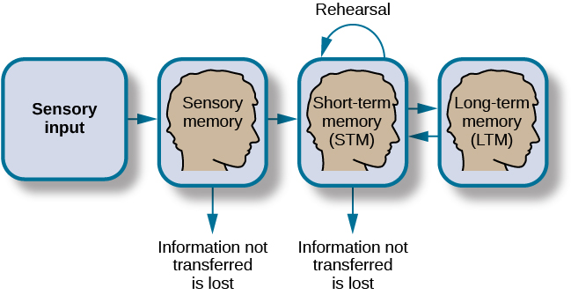

A flow diagram consists of four boxes with connecting arrows.

The first box is labeled “sensory input.” An arrow leads to the second box, which is labeled “sensory memory.” An arrow leads to the third box which is labeled **short-term memory (STM).** An arrow points to the fourth box, labeled **long-term memory (LTM)**, and an arrow points in the reverse direction from the fourth to the third box. Above the short-term memory box, an arrow leaves the top-right of the box and curves around to point back to the top-left of the box; this arrow is labeled “rehearsal.” Both the “sensory memory” and “short-term memory” boxes have an arrow beneath them pointing to the text “information not transferred is lost.”

### Sensory Memory

In the Atkinson-Shiffrin model, stimuli from the environment first reach sensory memory a storage system for sensory events, such as sights, sounds, and tastes. It holds the information for a brief duration of up to a fraction of seconds, without processing it. Thus, it helps filter the irrelevant information we are constantly bombarded with. Without this filter, we would not be able make process and make sense of the world around. What was your professor wearing the last class period? Unless someone is particularly attentive to people's dressing, chances are, it wont be remembered. This system discards sensory information about sights, sounds, smells, and even textures unlesss there is selective focus of attention to it. When we selectively attend to a certain information, it will move into our short-term memory system. For example, while reading this passage, your selective attention is likely focused on the information in this passage, and you are likely to encode it into your working (short-term) memory, where it can be processed for further comprehension. Most of what else you have heard, felt on your skin, or seen, is discraded by your brain.

Stroop Effect

One study of sensory memory researched the significance of valuable information on short-term memory storage. J. R. Stroop discovered a memory phenomenon in the 1930s: you will name a color more easily if it appears printed in that color, which is called the Stroop effect. In other words, the word “red” will be named more quickly, regardless of the color, the word appears in, than any word that is colored red.

**Stroop Colour Word Test**, a popular neuropsychological tool designed to assess a subject's ability to control cognitive interference is based on stroop effect.

Try an experiment: name the colours of the words you are given in (fig. %s) <cnx_psych_08_01_stroop>. Do not read the words, but say the color the word is printed in. For example, upon seeing the word “yellow” in green print, you should say “green,” not “yellow.” This experiment is fun, but it’s not as easy as it seems.

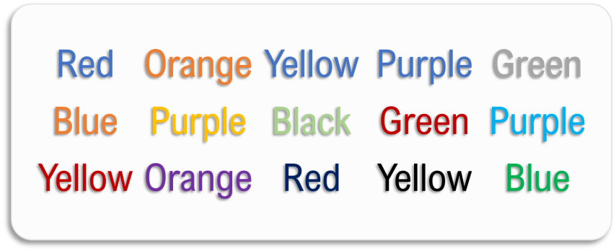

Several names of colors appear in a font color that is different from the name of the color. For example, the word “red” is colored blue.

Sensory memory can occur in any sensory modality; **iconic** memory, which corresponds to vision and **echoic** memory, which corresponds to audition, are the two most studied subtypes of sensory memory. Iconic memory lasts upto 1 second while echoic memory may be retained for 3-4 seconds.

### Short-Term Memory

Short-term memory (STM) is a temporary storage system that processes incoming sensory memory; sometimes, it is called **working memory** or **attention-span**. Short-term memory takes information from sensory memory and sometimes connects that memory to something already in long-term memory. Short-term memory storage lasts about {bdg-info}20 seconds. George Miller (1956) :footcitemillerMagicalNumberSeven1956, in his research on the capacity of memory, found that most people can retain {bdg-info}about 7 items in STM. Some remember 5, some 9, so he called the capacity of STM 7 plus or minus 2. However, new research has shown that the capacity may be greater.

One way to improve the capacity of working memory, or attention span is by **chunking** information. Information can be grouped in a way that the number of chunks is reduced for your brain thus allowing it to be processed by your brain, comprehended or stored in your longterm memory. Example: which one is easier to commit to brain among 3459148231 or 345 9148 231?

Attention, Short-term and Working memory.

The concept of "short-term memory" in Atkinson and Shiffrin's model roughly equates to our attention span or working memory. It is the capacity of an individual to hold information actively in mind for mental manipulation. However, when we use the term working memory, as in Baddeley's model, we also include its central executive system. Thus, working memory is our capacity to hold information actively in mind and our ability to mentally manipulate this information. Short-term memory testing, as performed during mental state examination, however, is a test of new learning (see below).

### Dual memory theory

The dual memory theory views short-term memory as the information in a computer's RAM (random access memory) —a document, a spreadsheet, or a web page. Information here will either be saved onto a memory drive or discarded. Likewise, the information in short-term memory goes to long-term memory (by rehearsal) or is discarded (by displacement). The step of rehearsal, the conscious repetition of information to be remembered, to move STM into long-term memory, is called memory consolidation.

In terms of levels of processing approach, this concept is termed **maintenance rehearsal.** But it also describes another type of reherasal that can better enhance memory retention: **elaborative rehearsal**. In elaborative rehearsal, information is linked with the information already in mind.

Error

Rehearsal of information in mind helps transform short-term memories into long-term. However, unlike as described in Atkinson's model, it is not the only mechanism.

#### Baddeley's model

**Baddeley and Hitch** (1974),:footcitebaddeleyWorkingMemory1974 have proposed a model where short-term memory has different forms. In this model, storing memories in short-term memory is like opening different files on a computer and adding information. The type of short-term memory (or computer file) depends on the type of information received. There are memories in visual-spatial form, as well as memories of spoken or written material, and they are stored in three short-term systems: a **visuospatial sketchpad**, an **episodic buffer**, and a **phonological loop**. The phonological loop stores acoustic information, while the visuospatial sketchpad holds spatial and visual information. These two systems are shown to be controlled by different brain areas; more specifically, the visuospatial information is controlled by the right hemisphere and the acoustic information by the left hemisphere. The episodic buffer helps with the integration of visual and auditory information in the working memory and; the retrieval and storing of information between the working memory and long-term memory stores. According to Baddeley and Hitch, a **central executive** part of memory supervises or controls the flow of information to and from the three short-term systems.

Real-world Application: Making Most of Working Memory Capacity

Due to its limited capacity, new information entering the working memory store replaces the existing chunks of information. Thus, working memory function is impaired by unhelpful environmental stimuli and intrusive thoughts. To help enhance the processing of information by the working memory, a task that requires comprehension or memorization should be performed in an environment with least distractions; anxiety, depression or other situations that worsen or cause intrusive thoughts should be identified and managed accordingly.

Also note how visual and verbal information has different systems in the working memory model proposed by Baddely. This is how visual imagery aids verbal information, for instance while watching or presenting a slideshow. The audience would find it much more easier to process and comprehend a slideshow with figures, graphs, images etc than one with pure text.

Clinical-correlate: Digit Span Test

To explore the capacity and duration of short-term memory (working memory or attention span), read the strings of random numbers ([link]) out loud to the subject, beginning each string by saying, “Ready?” and ending each by saying, “Recall,” at which point the subject should try to write down the string of numbers from memory.

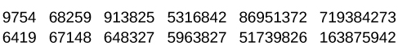

A series of numbers includes two rows, with six numbers in each row.

From left to right, the numbers increase from four digits to five, six, seven, eight, and nine digits. The first row includes “9754,” “68259,” “913825,” “5316842,” “86951372,” and “719384273,” and the second row includes “6419,” “67148,” “648327,” “5963827,” “51739826,” and “163875942.” Note the longest string at which they got the series correct. For most people, this will be close to 7, Miller’s famous 7 plus or minus 2.

Recall is somewhat better for random numbers than for random letters (Jacobs, 1887), and also often slightly better for the information we hear (acoustic encoding) rather than see (visual encoding) (Anderson, 1969).

While attention span or working memory concerns our capacity to hold and actively manipulate information in mind, the ability to sustain attention over time is **concentration**. Concentration is clinically tested by serial 7s. In this test, we ask a patient to start with 100 and keep subtracting 7s from the remainder. They are allowed to continue five times. The number of correct answers is noted and scored. For example, 2 correct answers are scored as 2/5.

Impairment of attention is characteristic of attention deficit hyperactivity disorder. Children with ADHD are often very distractible and can not sustain their attention for long especially on boring activties with higher cognitive load (reading and comprehension). Attention and concentration is also often impaired in patients with anxiety and depression; patients with these disorders are often preoccupied with characteristic negative thoughts which they can hardly help control. These thoughts make it very difficult for them to sustain their attention for long.

Impairment of attention is also characteristic of delirium and Lewy body dementia.

### Long-term Memory

Long-term memory (LTM) is the persistent storage of information. Unlike short-term memory, the storage capacity of LTM has no limits. It encompasses all the things you can remember that happened more than just a few minutes ago to all of the things that you can remember that happened days, weeks, and years ago. In keeping with the computer analogy, the information in your LTM would be like the information you have saved on the hard drive. It isn’t there on your desktop (your short-term memory), but you can pull up this information when you want it, at least most of the time. Not all long-term memories are strong memories. Some memories can only be recalled through **prompts**. For example, you might easily recall a fact— “What is the capital of the United States?”—or a procedure—“How do you ride a bike?”—but you might struggle to recall the name of the restaurant you had dinner when you were on vacation in France last summer. A prompt, such as that the restaurant was named after its owner, who spoke to you about your shared interest in soccer, may help you recall the name of the restaurant.

Clinical-correlate: Testing Long-term Memory.

Long-term memory is tested clinically in three steps. Recall at approximately 5 minutes is tested first. The patient is given a list of 3 unrelated words (so they may not use chunking), for example, book, sky, and knife to repeat them after the examiner and is told that he has to recall them after five minutes. For the next five minutes, the patient is kept engaged, to avoid rehearsal, and then asked to recall the three names. The number of items they can successfully recall (eg 2/3) is noted to be the value of short-term memory (not to be confused with the short-term memory concept as in Atkinson and Shiffrin Model of Memory). Recent memories are checked by enquiring about the recent events, such the number of days they have stayed in hospital, an important event from yesterday, how they came to hospital etc. Remote longterm memories are tested by enquiring about important events from their past popular global or national events etc.

Long-term memory is divided into two types: **explicit** and **implicit** ([link]). Understanding the different types is important because a person’s age or particular types of brain trauma or disorders can leave certain types of LTM intact while having disastrous consequences for other types.

Explicit memories are those we consciously try to remember and recall.

For example, if you are studying for your chemistry exam, the material you are learning will be part of your explicit memory. This type of memory is impaired in people with amnesia.

Implicit memories are memories that are not part of our consciousness. They are memories formed from behaviours. Implicit memories are unimpaired in patients with amnesia.

Note

Sometimes, but not always, the terms explicit memory and declarative memory are used interchangeably. Likewise, implicit memory is also called non-declarative memory.

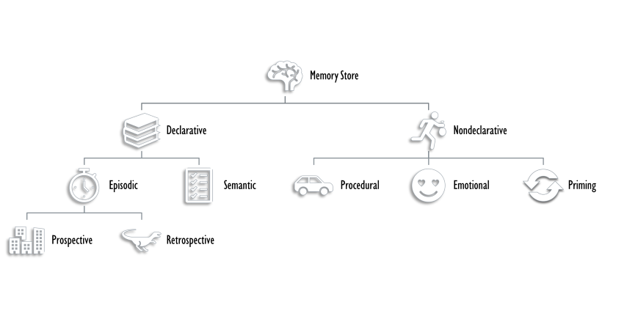

A diagram consists of three rows of boxes.

The box in the top row is labeled “long-term memory”; a line from the box separates into two lines leading to two boxes on the second row, labeled “explicit (declarative)” and “implicit (non-declarative).” From each of the second-row boxes, lines split and lead to two additional boxes. From the “explicit” box are two boxes labeled “episodic (experienced events)” and “semantic (knowledge and concepts).” From the “implicit” box are two boxes labeled “procedural (skills and actions)” and “emotional conditioning.

Procedural memory is a type of implicit memory: it stores information about how to do things. It is the memory for skilled actions, such as how to brush your teeth, how to drive a car, and how to swim the crawl (freestyle) stroke. If you are learning how to swim freestyle, you practice the stroke: how to move your arms, how to turn your head to alternate breathing from side to side, and how to kick your legs. You would practice this many times until you become good at it. Once you learn how to swim freestyle and your body knows how to move through the water, you will never forget how to swim freestyle, even if you do not swim for a couple of decades. Similarly, if you present an accomplished guitarist with a guitar, even if he has not played in a long time, he will still be able to play quite well. These memories are least affected in early dementia and retained until later stages.

Priming and emotional memories are also non-declarative memories. **Priming** occurs when past experience with certain stimuli increases the speed or accuracy of identifying and naming those stimuli. **Emotional memories** involve the emotional aspects of things and events. This occurs through conditioning, especially classical conditioning. For example, if an event or a thing is repeatedly experienced in the presence of another pleasant or unpleasant stimuli, it will automatically arouse those feelings in the future even.

Caution

**Subliminal messages** are used in manipulative tactics to influence later decision-making. For example, if you are exposed to the number 79 repeatedly, you are likely to choose this number from a list of random numbers, without consciously being aware of how you were primed to choose this.

Declarative memory has to do with the storage of facts and events we experienced. Explicit (declarative) memory has two parts: semantic memory and episodic memory.

Semantic memories relate to language and knowledge about language. An example would be the question “what does *argumentative* mean?” Stored in our semantic memory is knowledge about words, concepts, and language-based knowledge and facts. For example, the following questions test semantic memory:

* Who was the first President of the United States?
* What is democracy?
* What is the longest river in the world?

Semantic memories may be tested clinically by asking patients to name an object (shown to them) such as a pencil, asking about the function of an object (what do we use a pencil for?)

**Semantic dementia** is a subtype of frontotemporal dementia characterized by a progressive cognitive and language decline, mainly involving comprehension of words and semantic processing. Despite the loss of word meaning, their fluency, phonology, and syntax remain intact.

Semantic memory deficits may also occur in patients with Alzheimer's disease evident as word-finding difficulties and naming deficits.

Episodic memory is information about events we have personally experienced. The concept of episodic memory was first proposed about 40 years ago (Tulving, 1972). :footcitetulvingEpisodicSemanticMemory1972 Since then, Tulving and others have looked at the scientific evidence and reformulated the theory. Currently, scientists believe that episodic memory is memory about happenings in particular places at particular times, the what, where, and when of an event (Tulving, 2002). :footcitetulvingEpisodicMemoryMind2002 It involves the recollection of visual imagery as well as the feeling of familiarity (Hassabis & Maguire, 1) :footcitehassabisDeconstructingEpisodicMemory2007.

Episodic memories are of two types, **retrospective** (memory of past events) and **prospective** (memory of events coming in future)

Clinical-correlate: Hyperthymesia

**Can You Remember Everything You Ever Did or Said?**

Episodic memories are also called autobiographical memories. Let’s quickly test your autobiographical memory. What were you wearing exactly five years ago today? What did you eat for lunch on April 10, 2009? You probably find it difficult, if not impossible, to answer these questions. Can you remember every event you have experienced over the course of your life—meals, conversations, clothing choices, weather conditions, and so on? Most likely none of us could even come close to answering these questions; however, American actress Marilu Henner, best known for the television show *Taxi,* can remember. She has an amazing and highly superior autobiographical memory ([Fig. %s]).



A photograph shows Marilu Henner.

Very few people can recall events in this way; right now, only 12 known individuals have this ability, and only a few have been studied :footciteparkerCaseUnusualAutobiographical2006 . And although hyperthymesia normally appears in adolescence, two children in the United States appear to have memories from well before their tenth birthdays.

...

Watch these [Part 1](https://www.youtube.com/watch?v=u-SBTRLoPuo) and [Part 2](https://www.youtube.com/watch?v=I4V6aoYuDcg) video clips on superior autobiographical memory from the television news show *60 Minutes*.

# RETRIEVAL

So you have worked hard to encode (via effortful processing) and store some important information for your upcoming final exam. How do you get that information back out of storage when you need it? The act of getting information out of memory storage and back into conscious awareness is known as retrieval. This would be similar to finding and opening a paper you had previously saved on your computer’s hard drive. Now it’s back on your desktop, and you can work with it again. Our ability to retrieve information from long-term memory is vital to our everyday functioning. You must be able to retrieve information from memory in order to do everything from knowing how to brush your hair and teeth, to driving to work, to knowing how to perform your job once you get there.

There are three ways you can retrieve information out of your long-term memory storage system: recall, recognition, and relearning.

## Recall

Recall is what we most often think about when we talk about memory retrieval: it means you can access information without cues. For example, you would use recall for an essay test.

## Recognition

Recognition happens when you identify information that you have previously learned after encountering it again. It involves a process of comparison. When you take a multiple-choice test, you are relying on recognition to help you choose the correct answer. Here is another example. Let’s say you graduated from high school 10 years ago, and you have returned to your hometown for your 10-year reunion. You may not be able to recall all of your classmates, but you recognize many of them based on their yearbook photos.

Transfer-appropriate processing (TAP) is a type of state-dependent memory specifically showing that memory performance is not only determined by the depth of processing, but by the relationship between how information is initially encoded and how it is later retrieved. For example, if you study an MCQ exam, you will perform poorly on a test of recall, eg a short-answer questions and vice versa.

## Relearning

The third form of retrieval is relearning, and it’s just what it sounds like. It involves learning information that you previously learned. Whitney took Spanish in high school, but after high school she did not have the opportunity to speak Spanish. Whitney is now 31, and her company has offered her an opportunity to work in their Mexico City office. In order to prepare herself, she enrolls in a Spanish course at the local community center. She’s surprised at how quickly she’s able to pick up the language after not speaking it for 13 years; this is an example of relearning.

# Summary

Memory is a system or process that stores what we learn for future use.

Our memory has three basic functions: encoding, storing, and retrieving information. Encoding is the act of getting information into our memory system through automatic or effortful processing. Storage is retention of the information, and retrieval is the act of getting information out of storage and into conscious awareness through recall, recognition, and relearning. The idea that information is processed through three memory systems is called the Atkinson-Shiffrin (A-S) model of memory. First, environmental stimuli enter our sensory memory for a period of less than a second to a few seconds. Those stimuli that we notice and pay attention to then move into short-term memory (also called working memory). According to the A-S model, if we rehearse this information, then it moves into long-term memory for permanent storage. Other models like that of Baddeley and Hitch suggest there is more of a feedback loop between short-term memory and long-term memory. Long-term memory has a practically limitless storage capacity and is divided into implicit and explicit memory. Finally, retrieval is the act of getting memories out of storage and back into conscious awareness. This is done through recall, recognition, and relearning.

### Review Questions

1

Question 1

Another name for short-term memory:

1. sensory memory
2. episodic memory
3. working memory
4. implicit memory

Check Answer

C

Question 2

The storage capacity of long-term memory is ________.

1. one or two bits of information
2. seven bits, plus or minus two
3. limited
4. essentially limitless

Check Answer

D

Question 3

The three functions of memory are ________.

1. automatic processing, effortful processing, and storage
2. encoding, processing, and storage
3. automatic processing, effortful processing, and retrieval
4. encoding, storage, and retrieval

Check Answer

D

## Critical Thinking Questions

1. Compare and contrast implicit and explicit memory.

* Both are types of long-term memory. Explicit memories are memories we consciously try to remember and recall. Explicit memory is also called declarative memory and is subdivided into episodic memory (life events) and semantic memory (words, ideas, and concepts). Implicit memories are memories that are not part of our consciousness; they are memories formed from behaviors. Implicit memory is also called non-declarative memory and includes procedural memory as well as things learned through classical conditioning.

1. According to the Atkinson-Shiffrin model, name and describe the three stages of memory.

* According to the Atkinson-Shiffrin model, memory is processed in three stages. The first is sensory memory; this is very brief: 1–2 seconds. Anything not attended to is ignored. The stimuli we pay attention to then move into our short-term memory. Short-term memory can hold approximately 7 bits of information for around 20 seconds. Information here is either forgotten, or it is encoded into long-term memory through the process of rehearsal. Long-term memory is the permanent storage of information—its capacity is basically unlimited.

1. Compare and contrast the two ways in which we encode information.

* Information is encoded through automatic or effortful processing. Automatic processing refers to all information that enters long-term memory without conscious effort. This includes things such as time, space, and frequency—for example, your ability to remember what you ate for breakfast today or the fact that you remember that you ran into your best friend in the supermarket twice this week. Effortful processing refers to encoding information through conscious attention and effort. Material that you study for a test requires effortful processing.

## Personal Application Questions

1. How do we get information into our brain?
2. What is the difference between automatic and effortful encoding?
3. What are some examples of each?
4. What are the three distinct types we use to encode information?
5. What are the three distinct stages that memory has to go through to become long term memory?
6. How are short term and working memory similar and different?
7. How can we move information from short term memory into long term memory?
8. What are the different types of long-term memory? Give an example of each
9. How does retrieval work?
10. What are the different ways in which we retrieve information?
11. Describe something you have learned that is now in your procedural memory. Discuss how you learned this information.
12. Describe something you learned in high school that is now in your semantic memory.

acoustic encoding

input of sounds, words, and music ^

Atkinson-Shiffrin model (A-S)

memory model that states we process information through three systems: sensory memory, short-term memory, and long-term memory ^

automatic processing

encoding of informational details like time, space, frequency, and the meaning of words ^

declarative memory

type of long-term memory of facts and events we personally experience ^

effortful processing

encoding of information that takes effort and attention ^

encoding

input of information into the memory system ^

episodic memory

type of declarative memory that contains information about events we have personally experienced, also known as autobiographical memory ^

explicit memory

memories we consciously try to remember and recall ^

implicit memory

memories that are not part of our consciousness ^

long-term memory (LTM)

continuous storage of information ^

memory

system or process that stores what we learn for future use ^

memory consolidation

active rehearsal to move information from short-term memory into long-term memory ^

procedural memory

type of long-term memory for making skilled actions, such as how to brush your teeth, how to drive a car, and how to swim ^

recall

accessing information without cues ^

recognition

identifying previously learned information after encountering it again, usually in response to a cue ^

rehearsal

conscious repetition of information to be remembered ^

relearning

learning information that was previously learned ^

retrieval

act of getting information out of long-term memory storage and back into conscious awareness ^

self-reference effect

tendency for an individual to have better memory for information that relates to oneself in comparison to material that has less personal relevance ^

semantic encoding

input of words and their meaning ^

semantic memory

type of declarative memory about words, concepts, and language-based knowledge and facts ^

sensory memory

storage of brief sensory events, such as sights, sounds, and tastes ^

short-term memory (STM)

(also, working memory) holds about seven bits of information before it is forgotten or stored, as well as information that has been retrieved and is being used ^

storage

creation of a permanent record of information ^

visual encoding

input of images

### References