□ AGITATED DEPRESSION



**AYESHA RAZZAQ**

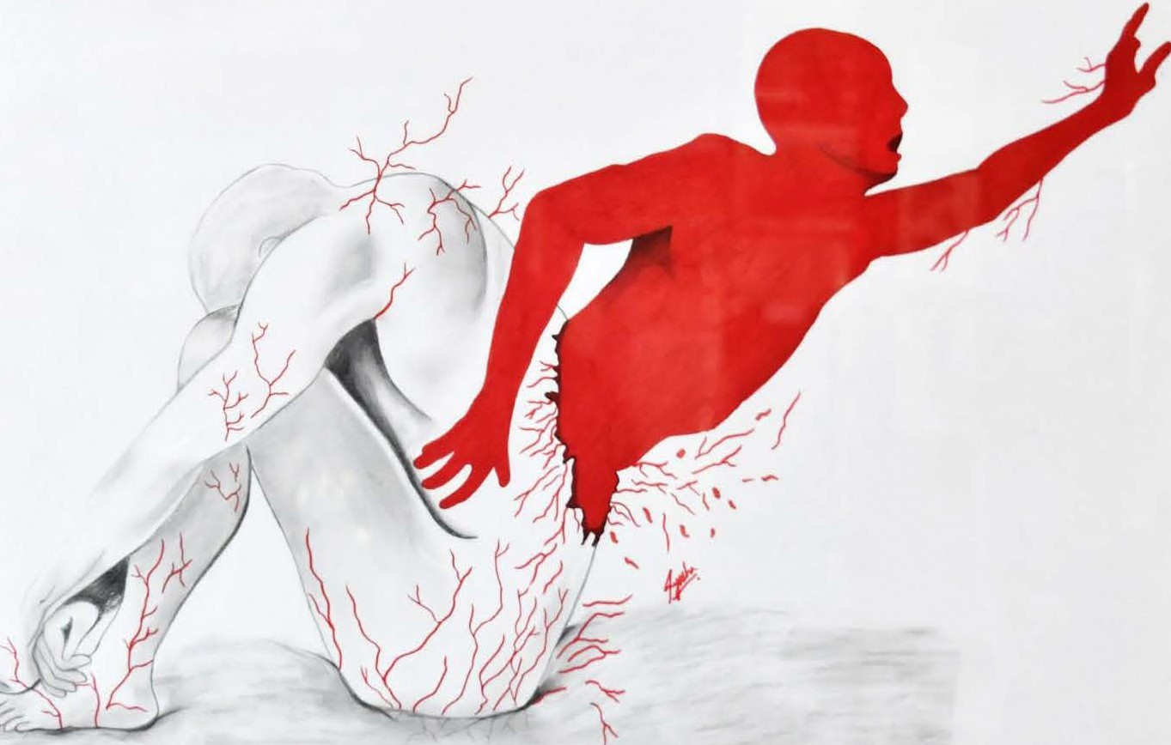

*PAGE 36 OCTOBER* - *DECEMBER 2017* I *VOLUME 14 NUMBER 4*