**ORIGINAL ARTICLE**

**BURNOUT AMONG MEDICAL DOCTORS: EXAMINING THE ROLE OF OPTIMISM AND PESSIMISM**

### UME LAILA', RUBINAHANIF', TASNIM REHNA'

u PhD scholar, National institute of psychology Quaid-e-Azam University Islamabad Pakistan, 'Assistant Professor, National institute of psychology Quaid-e-Azam University Islamabad Pakistan

Submitted: September 29, 2016

Accepted: February 08, 2017

**CORRESPONDENCE: UME LAILA,** E-mail: [umme_l@nip.edu.pk](mailto:umme_l@nip.edu.pk)

### ABSTRACT



**OBJECTIVE**

To find out level of job burnout among medical doctors with reference to their job demands and provided job resources and estimation of mediating role of optimism and pessimism attribution between this relationship.

### STUDY DESIGN

Cross Sectional

### PLACE AND DURATION OF STUDY

The study was carried out in ajailofLahore city.

### SUBJECTS AND METHODS

A convenient sample of N= 256 physicians working in public and private hospitals of Islamabad and Rawalpindi were selected. Both male and female physicians were included in present study with minimum work experience of one year, doing full time job at public or private hospital. Maslach burnout inventory and occupational attribution style questionnaire were used to collect measure of the variables under study.

### RESULTS

Job demands of medical doctors have significant positive relationship with job burnout whereas available job resources have significant negative relationship with burnout. Study also confirmed partial mediation between job demand, resources and burnout with optimistic and pessimistic attributions.

### CONCLUSION

Most of the physicians at Pakistan, as per study sample are at risk of burnout, task level demands are found to be major contributor for burnout whereas work group level support found to be safe guard against unhealthy work related out comes. Role of attributions are not foundto behighly influential.

### KEYWORDS

Physician burnout, Indigenous Job demand/ resources, Optimism/pessimism

### INTRODUCTION

A big number of researches on emotional disturbance, substance addiction, stress, depression and anxiety has been reported which presents that physicians have been focused for above complaints in and around Pakistan. Physicians are vulnerable to stress, depression, burnout and other unhealthy work related outcomes, due to heavy work load,emotional job demands, long working shifts, short rest periods, high frequency of traumatic situations, evening clinics and unforeseen emergency situations. A report based on overview of 15 studies elaborates that physicians are at higher risk of suicide in comparison to other professionals. Another finding of numbered researches revealed that medical doctors have been diagnosed with neuroticism, self-criticism, anxiety, depression and burnout. These emotional disturbances lead to poor performance at work place, jumbled with physical health issues, tendencies to turn over intensions and ultimately job switchover or fly away from country.

First time Freudenberger had enlightened the construct of burnout which was more tinted by Maslach & Jackson those brought it to give acknowledgement as syndrome, It is defined a construct consisted upon emotional exhaustion, depersonalization and sense of reduced accomplishment but it is not limited only to individual but also cause many annoyance at part of organization.

Task leveljob demands inclusive;timepressure, longshifts,number of cases to be dealt on daily basis and job resources in terms of support from colleagues, supervisors, incentive, feedback and facilitations at part of hospital are directly related to job performances. Along with these direct indicators, some of indirect indicators are also at work to contribute about performance out comes these are some of personality resources like personality types, traits, characters and attributions, those have been acknowledged having their impact among these direct relationship.

Physician at Pakistan are facing tough requirement of their susceptible profession, which is not propped up by ample resources at hospital like advance technology, justified duration of shift hours, supportive supervisors, transparent evaluation, encouraging incentive system and patient feedback.These all factors contribute towards their work related outcomes healthy or unhealthy but some of their distinctive personality attributes alsotake part in a vital position between interplay of job demands and resources and performance outcomes. It seems deeply significant to identify major contributors and facilitators that may safe guard physicians at Pakistan against job related negative outcome likeburnout.

Based upon above discussed scenario at Pakistan, following may be justification to find out with help of an empirical study, the extend, level and direction of associationsbetween doctors' causalattribution, work stressors, supports and personal resources that lead or resist burnout among physicians.

##### Figure 1

- --

##### Table 2

Zero-order correlations between all the variables included the study

Job Demands

Qualities work loads:;:::==-:., Qualities work load,

feedback and roll conflict

2 Burnout .56**

Job Resources -.31** -.18**

4 Optimistic -.01 -.36**

-.04

Health Snap Shot

Pessimistic .10** .47

.03

-.12**

Supervisor support, **=:::::::::::-:.I**

peer support &

Family support

**Proposed Model**

**SUBJECTS AND METHODS**

## Participants

A cross-sectional survey design was used, with convenient samples (N= 256) taken of hospitals from Islamabad and Rawalpindi. Inclusion criteria for doctors aremaleor female, married or unmarried,working at public or private hospital with working experience of at least one year from any of medical specialty. As per informed consent research respondents were approached and briefed about research object and guidelines to fill thesurvey forms were given, only those forms are included for analysis purpose, which answered 97% of the questions in the forms.

## Instruments

Four scales were used for present research; two of the subscales, task level job demands of 10 item with *a* = 0.83 and work group level support, 7 item scale with *a* = 0.87 were selected from Job

Demands and resources indigenous scale. Moreover for the measurement of burnout Maslach Burnout Inventory having 23

Items with *a* = 0.83 and to assess optimism and pessimism, The

Organizational Attribution Style (Martinko) Questionnaire (OASQ) was used which isbased on Seven work Related scenarios.

#### RESULTS

Matching the inclusion criteria of present study, 300 doctors from different specialtieswere approached but 256 research surveys were finalized for study analysis, based on judgment of missing responses percentage (not more than 3%). Descriptive statistsshowed normal distribution of data, with highly satisfactory alpha reliabilities which ensuredthevalidityofresults(see table 1for details).

##### Table 1

Descriptive statistics and scale reliabilities (N=142)

••. Correlation is significant at the .01 level (2-tailed).

* . Correlation is significant at the .05 level (2-tailed).

Correlation tables shows the association among study variables, job demands have strong positive relationship with job burnout whereas job resources have negative and significant relationship with job demandsand burnout. But significant correlation cannot be observed among attribution between burnout and optimism although direction of the relationship is negative. Pessimism has positive and significant correlation with job demands. literature is supporting it and burnout while job resources have positive significant correlation with optimism, past findings are also proving it.

##### Figure 2

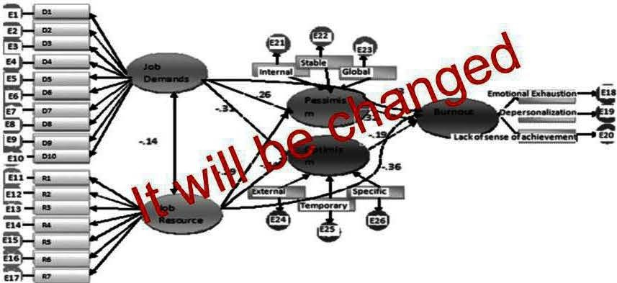With reference to under study sample, emotional exhaustion is high among doctors (68%), it is confirming other studies about burnout and physicians, reduced sense of accomplishment issecond highest indentified facets of burnout (51%) whereas physician reported lowly at depersonalization (45%) although many of past research work is not witness of such findingbut someareconfirming it.

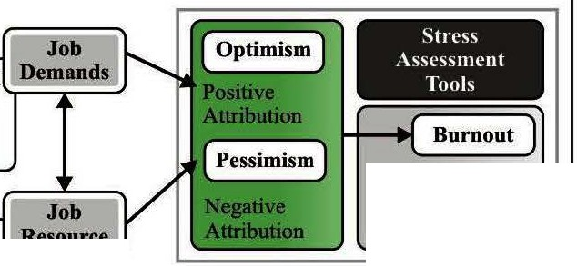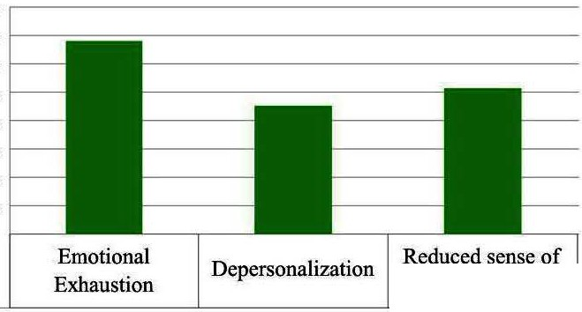

**Level of Burnout among study sample**

..

**.**.**:a**.

<

80%

70%

60%

50%

40%

30%

20% IO% 0%

* Study

Results

68%

45%

accomplishment

51%



|  |  |  |  |  |  |  |
| --- | --- | --- | --- | --- | --- | --- |
|  | Job Demands | 17.16 | 6.12 | .80 | IO | 1-4 |
| 2 | Job Resources | 14.22 | 5.91 | .74 |  | 1-4 |
| 3 | Burnout | 12.21 | 6.47 | .78 | 23 | 0-6 |
| 9 | Optimistic OASQ | 129.50 | 16.62 | .87 | 40 | 1-6 |
| IO | Pessimistic OASQ | 110.50 | 16.62 | .87 | 40 | 1-6 |

# Journal of Pakistan Psychiatric Society

and relief rate of patients, unavailability of these support or lessthan required level persuade physician for unhealthy adjustment patterns which is most evident as depersonalization; a mechanistic attitude towards work andclients.Thethirdstate isactually outcome of above two phases which is an overall perception and developed sense of reduced accomplishment where doctors concluded about themselves and about system that system cannot be improved and internally convicted that we are not justifying with our job.

|  |  |  |  |  |  |  |  |  |  |
| --- | --- | --- | --- | --- | --- | --- | --- | --- | --- |
| **Measurement** | 766.98 | 266 | 2.88 | .92 | .90 | .90 | .86 | .89 | .051  (.047-.056; p<.05) |
| Hypothetical | 708.23 | 263 | 2.70 | .92 | .91 | .92 | .87 | .90 | .049  (.045-.053; p<.01) |
| **Direct** | 316.56 | 72 | 4.40 | .94 | .91 | .91 | .88 | .88 | .069  (.061-.077; p<.00) |
| **Indirect** | 620.61 | 259 | 2.40 | .93 | .93 | .93 | .89 | .92 | .044  (.040-.049; p<.00) |
| **Final** | 623.61 | 261 | 2.39 | .93 | .93 | .93 | .89 | .92 | .044  (.040-.049; p<.00) |

#### CONCLUSION

Task level demands are major contributor of physician job burnout. On the other side, work group level support has been recognized as major resource which may diminish job burnout. Individual factors as

attributions styles, optimistic or pessimistic may partially contribute

Model testing was carried out with help of Amos 21, direct, indirect and final model fit indices showed that although all of these models are within acceptable ranges but inclusive model of direct and indirect paths gave a better fit in comparison to other comparative models.

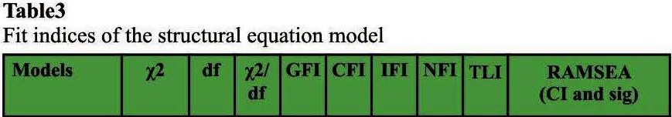

#### DISCUSSION

The study brought about the findings, that task level demands are high contributors of job burnout of physician at Pakistan, which includes long working shifts, short or less *off* days, sensitive nature of work, emotional demand of the work and unsatisfactory evaluation system at their work place.These findings are aligned with literature. It is also revealed with study findings that work group level support protect against negative or unhealthy work related outcomes. It is also confirming recent results. In other words, study depicted that physicians at Pakistan arefacing various resource constraints in terms of lack of time, lack of physical facilities in hospital, outdated machinery and equipments, inefficient supporting staff. Misbalancing situation between demands and resources are susceptible for doctors and enhancing their prostrate rate towards burnout. Pessimism has positive and significant correlation with job demands literature is supporting it" andburnout while job resources have positive significant correlation with optimism, past findings are also proving it". Indirect relationship of attribution styles as per selected for present study; optimism and pessimism is also found as contributor for physicians susceptibilitytowards burnout as revealed that optimism attributions and facilitated by resources but are not major resistance between demands and burnout, on the other side pessimistic attribution increases the receptiveness towards burnout jumbling up with high demands but could not be provided_ as obstruction between job resources and job burnout. These finding are confirming past researches'.

Emotional exhaustion is high among doctors as other studies about burnout and physicians" already found, reduced sense of accomplishment is second highest indentified facets of burnout whereas physician reported depersonalization although many of past research work is not witness of such finding but some are confirming itl 9. As per leittre, At first stage doctors tried to put forth their energies and resources to combat with high work related demands asaforementioned,failing to sustain their capabilities upto maximal level leads them towards emotional exhaustion. This state demands support from external resources like working environment, peer support, supervisor support, work related clarity, family support

to productive or inverse resultsbut cannot be soleresponsible for job related positive or negative outcomes.

#### REFERENCES

1. Nisar K, Khan KH, Shah m. anxiety and depression in doctors undergoing postgraduate training courses at armed forces postgraduate medical institute rawalpindi. J Ayub Med Coll Abbottabad. 2012;24:3-4
2. Lindeman S, Laara E, Hakko H, Lonnqvist J. A systematic review on gender-specific suicide mortality in medical doctors. The British Journal of Psychiatry. 1996;168(3):274-9.
3. Firth-Cozens J. Emotional distress in junior house officers. Br MedJ (Clin Res Ed).1987;295(6597):533-6.
4. Zhang Y, Feng X. The relationship between job satisfaction,

burnout, and turnover intention among physicians from urban state-owned medical institutions in Hubei, China: a cross­ sectional study.BMChealth servicesresearch.2011;11(1):1.

1. Kumar D. Compensation factors and coping styles: Cross country study on faculty members. African Journal of Business Management. 2012;6(8):3082.
2. Freudenberger D, Freudenberger CD. Good Relationships:

Ethical and Ecological Perspectivesof Rangeland Management. The Rangeland Journal. 1994;16(2):321-32.

1. Maslach C, Jackson SE, Leiter MP. Maslach Burnout Inventory: MBI:Consulting PsychologistsPress; 1981.
2. Ghazali SSA, Shah IA, Zaidi SAA, Tahir M. Job satisfaction among doctors working at teaching hospital of Bahawalpur, Pakistan. J AyubMed Coll Abbottabad. 2007;19(3):81-3.
3. Wessells Jr D,Kutscher A, Seeland IB, Seider FE, Cherico DJ,Clark EJ. Professional burnout in medicine and the helping professions: Routledge; 2013.

1O. Khuwaja AK, Qureshi R, Andrades M, Fatmi Z, Khuwaja NK.

Comparison of job satisfaction and stress among male and female doctors in teaching hospitalsof Karachi. Journal of Ayub Medical College, Abbottabad:JAMC.2003;16(1):23-7.

1. Naveed S, Rana NS. Job Burnout Process and its Implications in HRM Practices: A Case Study ofTrainee Doctors in Public Health Organization. Asian Journal of Business Management. 2013;5(1):113-23.
2. Kent RL, Martinko MJ. The measurement of attributions in. Attribution theory: Anorganizationalperspective. 1995;17.
3. Bakker AB, Demerouti E, Euwema MC. Job resources buffer the impact of job demands on burnout. Journal of occupational

healthpsychology. 2005;10(2):170.



1. Bruce S, Conaglen H, Conaglen J. Burnout in physicians: a case for peer - support.Internal medicinejournal. 2005;35(5):272-8.
2. Xanthopoulou D, Bakker AB, Demerouti E, Schaufeli WB. Reciprocal relationships between job resources, personal resources, and work engagement. Journal of Vocational behavior. 2009;74(3):235-44.
3. Segerstrom SC. Optimism and resources: Effects on each other and on health over 10 years. Journal of Research in Personality. 2007;41(4):772-86.
4. Riolli L, Savicki V. Optimism and coping as moderators of the relationship between chronic stress and burnout. Psychological reports. 2003;92(3c):1215-26.
5. Embriaco N, Papazian L, Kentish-BarnesN, Pochard F, Azoulay E. Burnout syndrome among critical care healthcare workers. Current opinion incritical care.2007;13(5):482-8.
6. Chopra SS, Sotile WM, Sotile MO. Physician burnout. Jama.

2004;291(5):633-.

1. Leiter MP. Burnout as a developmental process: Consideration. Professional burnout: Recent developments in theory and research. 1993:237-49.

|  |  |  |  |  |
| --- | --- | --- | --- | --- |
| **Sr.#** | **Author Name** | **Affiliation of Author** | **Contribution** | **Signature** |
| 1 | **Ume Lalla** | Ph.D. Scholar  NIP, QAU,Islamabad | Conception, Conduction **Analysis, andreportingof the research** |  |
| **2** | **Dr. Ratiq Ratique** | **Assistant Professor**  NIP, QAU,Islamabad | **Review, Feedback, Recommendation,** and Approval |  |
| **3** | **Raiha AHab** | Ph.D. Scholar  NIP, QAU,Islamabad | Data Collectionand #  **analysis** |  |