□ SCHIZOPHRENIA

**CREATIVE CORNER**

**AN ANONYMOUS STUDENT OF PMC**



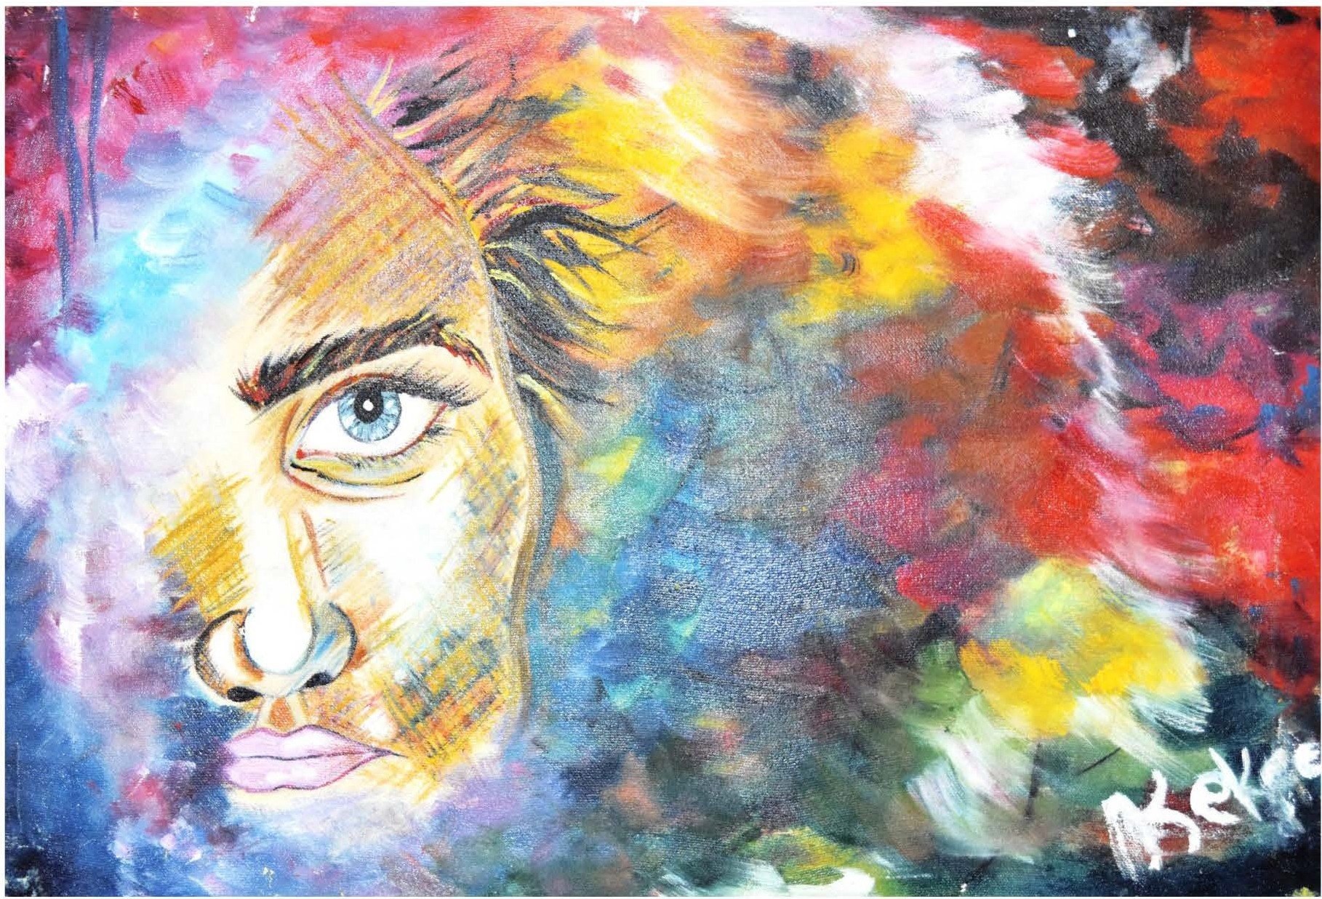

The illustration depicts the one of the most well known disorders in Psychiatry. Image istranslating the feel of a patient who hasschizophrenia onto the canvas.It signifies the split and smash of thoughtsthat are hard to contain within boundary and hence not distinguishable from one an other.

*PAGE 38 JANUARY-MARCH 2019* I *VOLUME 16 NUMBER 1*