

PSYCHEDELIC STATE

**QURAT UL AIN**

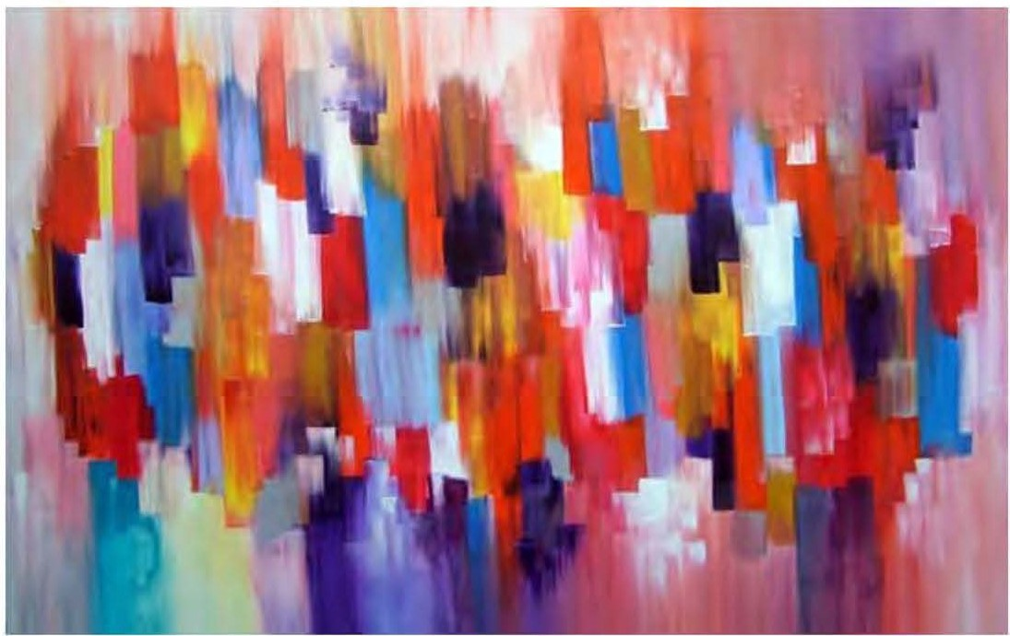

*APRIL -JUNE 2015* J *VOLUME 12 NUMBER 2 PAGE 56*