CREATIVE CORNER

NEW HORIZONS

The depiction illustrated new hopes bundled in the title of an end; when you reach the last edge you are exposed to new horizons, new possibilities and new meaning. In fact every end has a new

beginning in it. This hope for new horizon is very meaningful in post pandemic world.

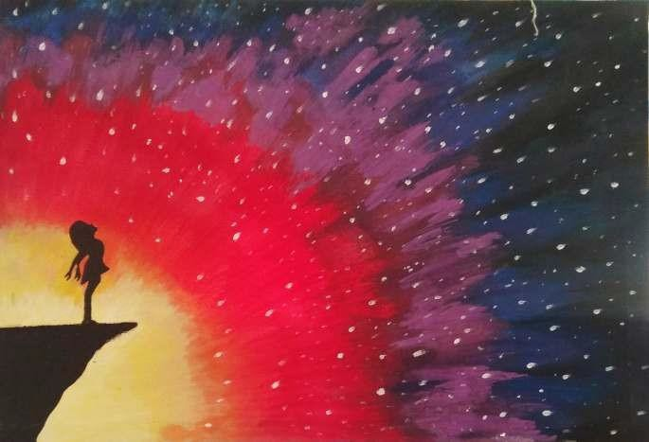

*PAGE 32 OCTOBER - DECEMBER 2020 VOLUME 17 NUMBER 4*

*OCTOBER - DECEMBER 2020 VOLUME 17 NUMBER 4 PAGE 33*