

**CREATIVE CORNER**

**A PERCEPTION THAT IS NOT A PERCEPTION**

**EDITOR'S NOTE**

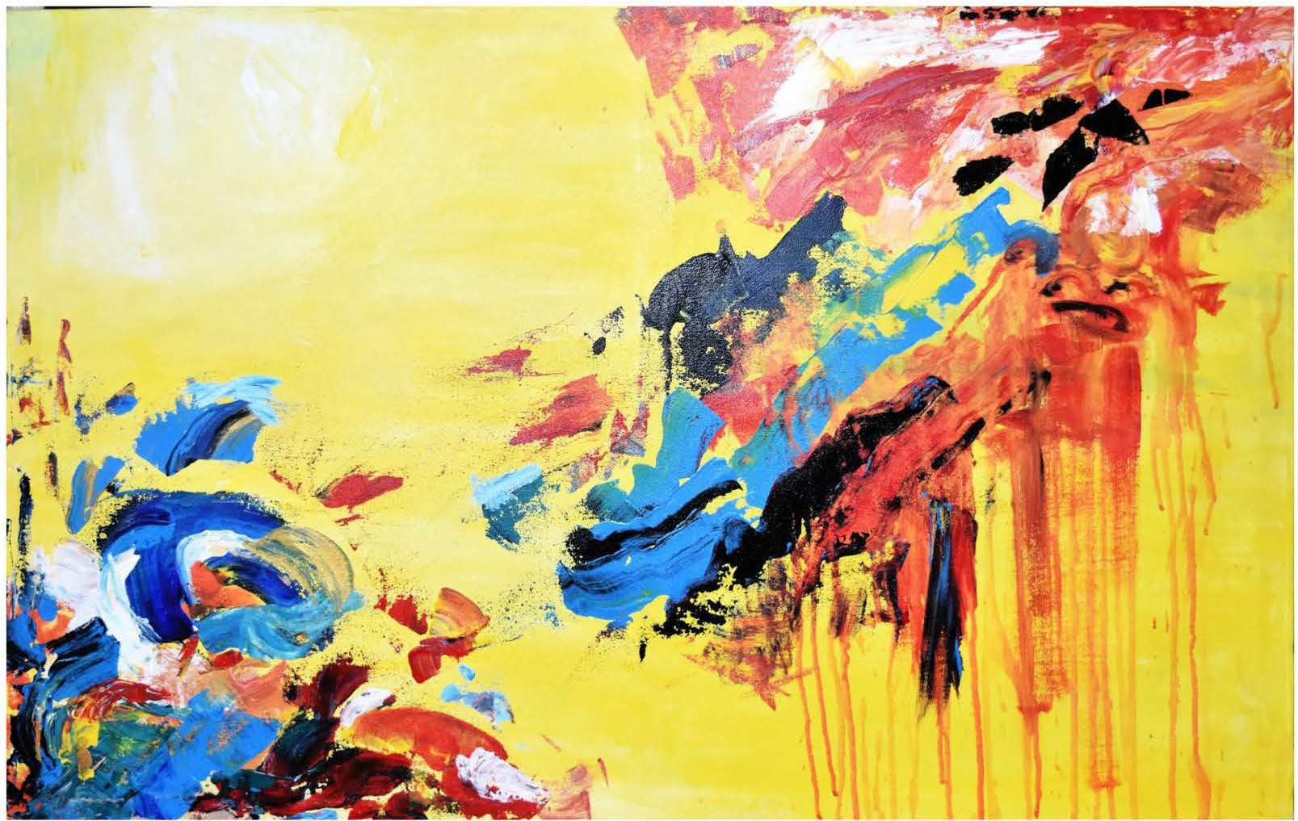

The art piece is courtesy to Rang Fest 17, 5th annual art and painting exhibition of Punjab Medical College, Faisalabad. The depiction haunts the beholders in the wilderness of meaning.I couldsumit up as a perception that isnot a perception.

*APRIL-JUNE 2018* I *VOLUME 15 NUMBER* 2 *PAGE 43*