**CREATIVE CORNER**

**CHASHM-E-TAMASHA**

**BAZALA**

•

• •

.. - · **t'** ..

.... ..... ***t***

* ·.· ..

..

. - '.

* + *::·*

.....,

·•·

,._../.\,··.·.

-

.

.. - . .. .

*-*·*:*,-

.

*..*

.\ \

'

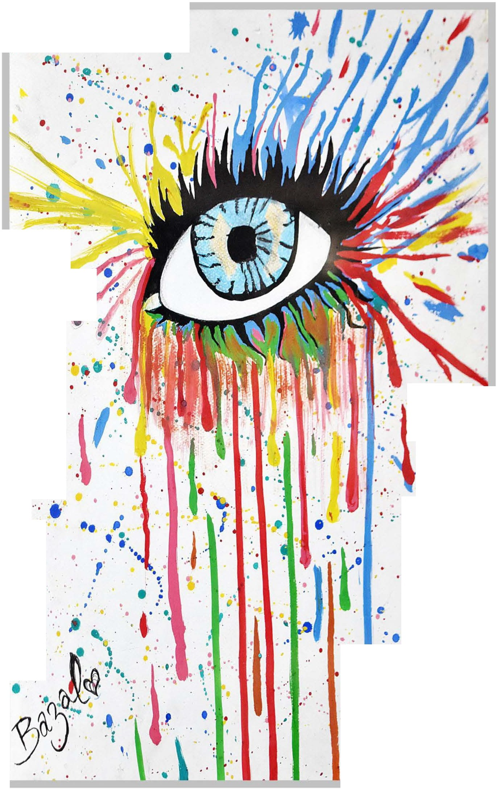

The depiction represents the inside eye of a mental health professional to pick the comprehensive range of cues elicited or intrigued by the patients. This eye acts as the hand of an ancient seasoned hakeem on the pulse of the patient to mark the pathology. An eye that misses nothing; manifest or latent.

*JANUARY-MARCH 2017* I *VOLUME 14 NUMBER 1 PAGE43*