CREATIVE CORNER

SUBLIMATION

**SHANZA AKRAM**

The eye has shed all colours that it had dreamt of. But the draining dreams are converted into vibrant realities constructing artefacts in the external world. The depiction illustrated one of the healthiest mechanisms of ego defense known as sublimation wherein energy

of important unmet need, impulse or desire is diverted from immediate goal to a moral or aesthetic purpose which is socially desirable.

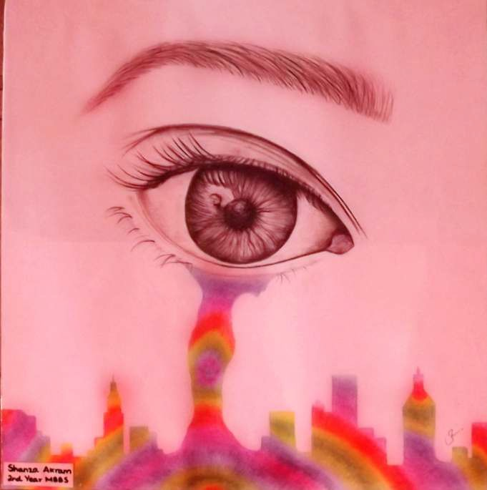

*JANUARY - MARCH 2021*

*VOLUME 18 NUMBER 1*

*PAGE 39*