□ CREATIVE CORNER

NARCISSISTIC PERSONALITY DISORDER

**KOMAL RAZA**

Punjab Medieol College Faisalabad.

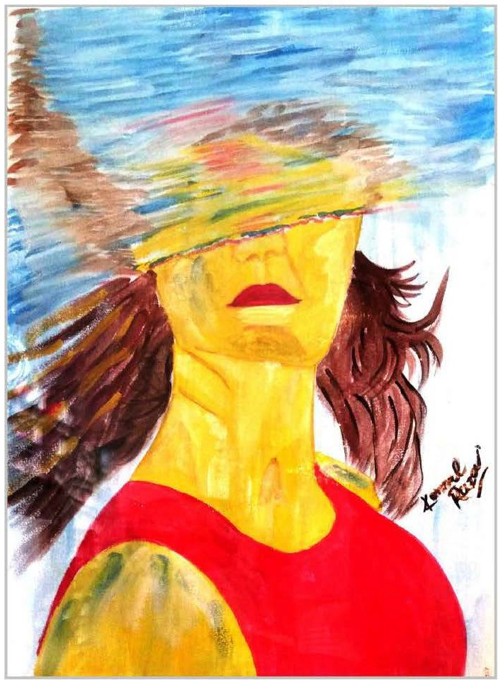

The imagecorrespondsto the perfect depictionofoneofthemost talkedabout condition relatedto personality, narcissistic personality disorder, wherein the physical health, appearance and self worth is all intact but ability to appreciate differences along with process of recognition of other's respect and ways to relating to others decline. The condition literally leaves the suffering person void of objective view and keeps the person imprisonedin selfreflection.

*PAGE 36 JULY-SEPTEM8ER 2019* I *VOLUME 16 NUMBER 3*