

CREATIVF CORNER



**PSYCHOLOGICAL FIRST AID**

**COURTESY:**

ARTS & PAINTING EXHIBITION 2016 ORGANIZED BY NETIZENS, PUNJAB MEDICAL COLLEGE, FAISALABAD

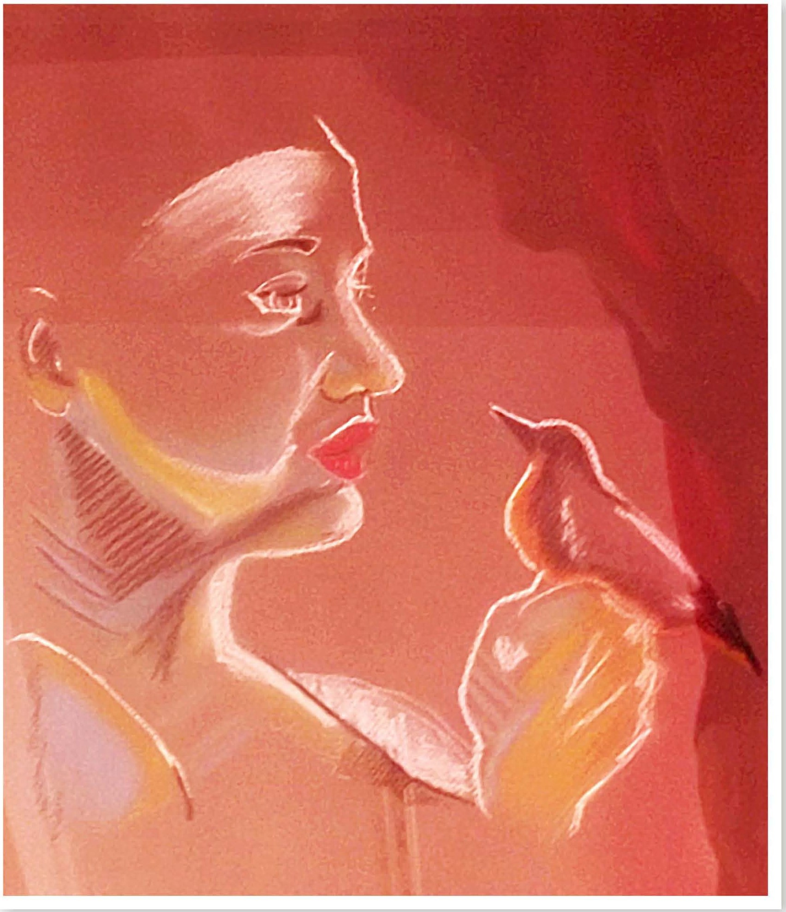

The image depicts psychological first aid and emphasizes upon the elements it includes.The sparrow stands for psychological first aid; it shows qualities of psychological first aid like non professional helper contacting the affected, engaging them, providing comfort & compassion, active listening without pressure, and it also stresses upon the essential elements of psychological first aid like safety,calmness, connectedness and hope.

*PAGE 38 JULY-SEPTEMBER 2016* I *VOLUME 13 NUMBER 3*