

**CREATIVE CORNER**

GOOD BYE TO THE PAST

**PMC PAINTING AND ART EXHIBITION 2017**

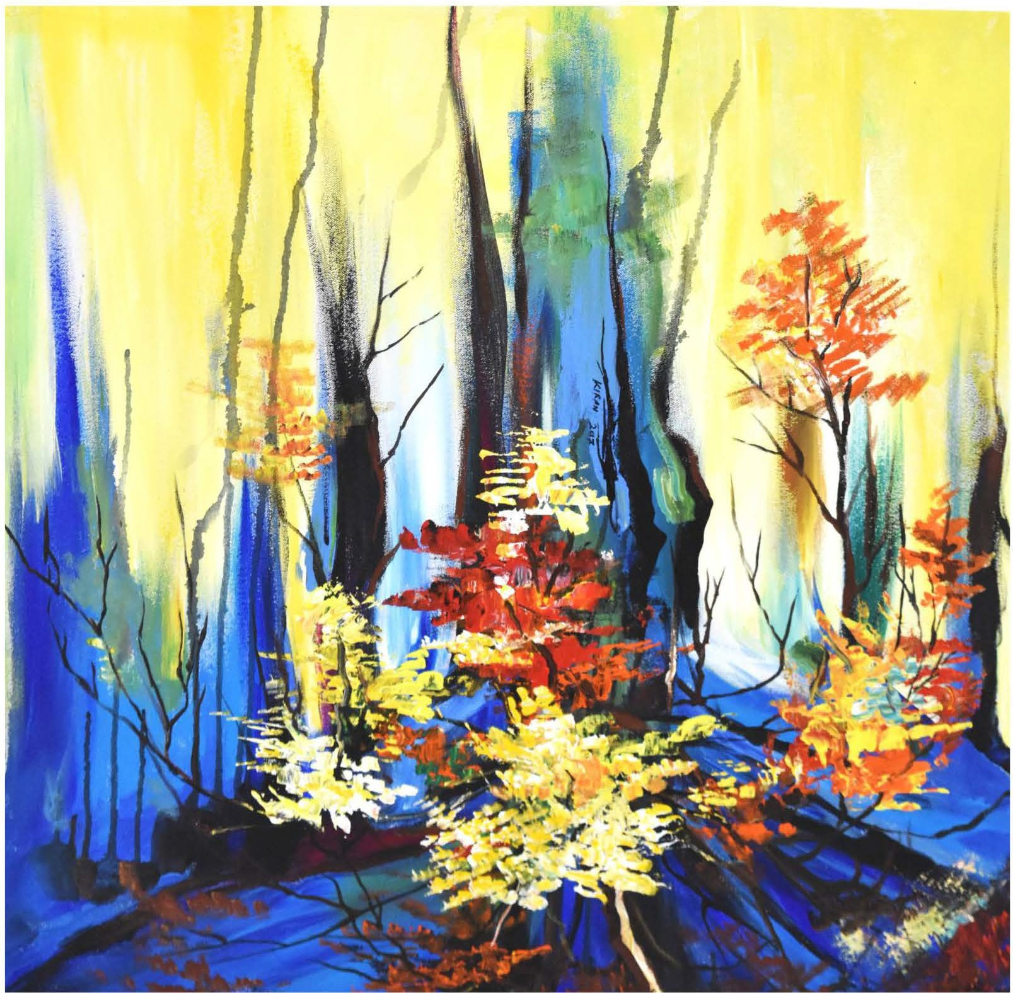

This is an illustration of retrograde amnesia where patient happens to wave a good bye to his or her past. The image depicts how retrograde amnesia appears before the sufferer; beholder can see that past represented by back drop isvague and difficult to comprehend as the memories in retrograde amnesia are not retrievable, whereas the developing memory is intact represented by blooming flowers.

*OCTOBER- DECEMBER 2018* I *VOLUME 15 NUMBER 4 PAGE 39*