**ORIGINAL ARTICLE**

**DEVELOPMENT AND VALIDATION OF RESILIENCE SCALE**

**SUMMAYA ANWAR', IFFAT BATOOL', YA. SAKINA', SHAHRUKH TARIQ4**

'·'·' Department of Psychology, GC. University, Lahore. 'National Agriculture Research Department (NARC).

Submitted: October 01, 2016

Accepted: March 04, 2017

**CORRESPONDENCE: ALIA ASMAT,** E-mail: [aliarandhawa@gmail.com](mailto:aliarandhawa@gmail.com)

## ABSTRACT OBJECTIVE



To develop and validate an indigenous scale of Resilience.

## STUDY DESIGN

Mixed method

## PLACE AND DURATION OF STUDY

The study was conducted in different schools and academies of Lahore and Gujranwala during 2014- 2015.

## SUBJECTS AND METHODS

A sample of 40 adolescents whose age ranged M (SD) = 17.55(2.17) for was selected for pilot study, and 540 adolescents (272 boys & 268 girls) were taken for validation study. Additionally, a sample of 145, Psychologists (15), Adolescents (100) and 30 Graduate students were taken to enlist the adverse situations of resilience. Purposive convenient sampling was used.

## RESULTS

Exploratory factor analysis yielded four factors ( emotional regulation (a=.71), adventurousness *(a=.66),* determination (a=.62) & self-reliant (a=.59) that **encountered for 46.2% of the item variance. It also showed**

significant Cronbach's alpha reliability *(a=.84)* and item­ total correlations (ranged from .44 to .62 at p<.001). Confirmatory Factor Analysis resulted in good model fit with acceptable values on indices and parameter estimates supporting the construct validity of the instrument (CF! = .88, GFI = .91, RMSEA =.05andx2(2) = 237.93, p < .01).

## CONCLUSION

Resilience Scale(RS) developed in this research was found to be a reliable and valid measure to evaluate level of resilience in adolescents and youngsters.

## KEYWORDS

Resilience,EFNCFA, Adolescents.

## INTRODUCTION

Resilience is defined as a dynamic process of exhibiting positive behavioral adaptation when encounter significant adversity or trauma'. Resilience refers to emotional stamina and has been used to describe persons who display courage and adaptability in the wake oflife's misfortunes'.

Adolescence is a time of transition, strange enough because of different problems an adolescent isfacing like identity crisis, emotional changes, physical changes, death or separation of some loved one,and etc., but the major dilemma is that he is unable to express his feelings and emotions as it is. Whenever, adolescents face some misfortune, adversity, hardship, or difficulty,they try to react likeadults and staycalm; but still they have something hidden inside them. It consists of thoughts, behaviors and actions that can be developed and learned. There are various factors that determine and contribute to successful dealing of an individual with the adversities and hardships of life like an individual's way of viewing, analyzing and engaging with the world, quality and accessibility of social resources and particular coping strategies'.

Resilience refers to resourcefully adapting to changes in circumstances and contingencies in environment, careful analysis of goodness of fit along with consideration of demands and possibilities in a situation, and selection of the appropriate problem solving strategy is called as resilience. In the beginning, resilience was thought to be an ability present in exceptional people who possess good mental and emotional-health. Recently, empirical research has identified resilience is not a rare but a common outcome which can be observed frequently in the required circumstances'·'. Maintenance of relatively stable and healthy psychological level and physical strength in a normal person in exposure to isolation or highly stressful event (death of aloved one or alife threatening or violent situation) iscalled asresilience'.

Study of resilience has evolved in the four waves of research and has emerged a new framework for resilience theory, practice, and research. Among the four waves, the first wave of resilience"·'·"·" explored the actual phenomena of resilience while focusing on individual along with its different concepts and methods; the second wave"·"·"·"·"·"·,. "·20•21 adopted a developmental system approach to research and theory while focusing on the interaction among individuals and systems; the third wave"· "· "· "· "· "· *21* changed the developmental pathways by focusing on interventions; and the recent fourth wave"·"·"·"·"·"·32 focused on integrating and understanding the phenomenon of resilience with a focus on neurobiological processes, epigenetic, and brain development. There are three types of resilience: Psychological,ecological andcultural resilience33. Atheoretical model of resilience is considered as meta-model of stress, emotions and performance34.There are at least two different approaches that are helpful in studying resilience that have been classified as person focused approach andvariable-focusedapproach'·".



Present study aims to develop a scale to measure resilience in the local adolescent andyoungster population.

# SUBJECTS AND METHODS

#### *Phase I: Item Generation for the Development of the* Resilience Scale (RS)

For the generation of item pool for Resilience Scale, the definition of resilience connotes emotional stamina and has been used to describe persons who display courage and adaptability in the wake of life's misfortunes was usedl. Phase I was consisted offive steps: in step I, item pool was generated by taking a sample of 15 psychologists, 100 graduate studentsand 30 pot graduate students. In step11, a lists of 57 adverse situations and 101 items were extracted from raw data. In step Ill, expert review was conducted in which judges analyzed the situations and statements to evaluate their content validity, comprehensibilityand comprehensiveness. At Step IV,36items finalized after judges opinion were arranged on a random order along a Likert type 5 point rating scale ranged from Agree to Disagree. In order to reduce the biasness, 7 items out of 36 were negatively worded.

# PILOT STUDY

After that a pilot study was conducted on a sample of 40adolescents, selected with convenient purposive sampling, to check the practicality of the scale developed. It was to ensure the understandability and psychometric cleansing of the items. It was conducted in order to eliminate the items which were unclear or ambiguous.

#### *Phase* II: *Factor analysis and Internal Consistency of the* Resilience Scale (RS)

Main purpose of thisphase wasto finalize items for original scale and identification of factors present in resilient adolescents of Pakistan. For this purpose, data collection was done by using Resilience Scale (RS) and exploratory factor analysis was administered to the data. Cronbach's alpha, item total correlation and sub scale correlations were computed for obtaining internal consistency of the scale and sub-scales.

# PARTICIPANTS

For exploratory factor analysis (EFA), Data was collected from 540 adolescents and youngsters. There were 272 boys (50.4%) and 268 girls (49.6%) in the sample. Age of the participants included in the study ranged from 13 to 23 years(M = 17, SD= 1.73). In the sample, 35.2% participants were belonging to joint family system, while rest of 64.8% participantswasfrom nuclear family system.

# PROCEDURE

Primarily developed Resilience Scale (RS) was administered on sample in their class rooms. The scale was consisted of 36 items, arranged on Likert type 5-point rating scale. Students were instructed to read out the instructionscarefully and answer all of the items and demographic questions. Names, addresses, institutes' name or any other personal information wasnot required in the form and they were ensured about theconfidentiality of the datacollected

from them. They were asked to rate the items according to their personal experience andjudgment about their own self.

Varimax rotation and principal component analysis were carried out for determining the factorial structure of the scale. Psychometric properties of Resilience Scale were determined by computing Cronbach's alpha, item total correlation, and sub-scale correlations.

#### *Phase Ill: Discriminant Validity of the Resilience Scale* (RS)

The degree to which the measuresof different constructsaredistinct from each other is called as discriminant validity36. There is a significant negative correlation among resilience and depression. Siddiqui Shah Depression Scale (SSDS) was used to determine discriminant validity of the RS. This is an indigenous scale of measuring depression.

# METHOD PARTICIPANTS

A sample of 30 adolescents was taken to collect data for the determination of discriminant validity. Their age ranged from 14-19 years. All of them were taken from an academy of Lahore.They were approached in their class rooms, questionnaires were distributed to them, after giving required instructions they were asked to respond thequestionnaires.

# INSTRUMENTS

#### *Resilience Scale (RS): The Resilience Scale (RS) was used* for the measurement of Resilience.

***Siddiqui Shah Depression Scale (SSDS):*** Siddiqui Shah Depression Scale (SSDS) was developed in Urdu language to measure the level of depression37. The scale consists of 36 items. Each item is rated on 4-point Likert typerating scale ranging from 0-3 (0= Never, 1 = Sometimes, 2 = Often and 3 = All the time).The sum of score on individual itemsisthe total score.The scoresranged from 0-

108. Low scores show lower levels of depression while high scores show higher levelsof depression.

# PROCEDURE

The questionnaires were distributed to the students in their class room, only to the studentswho voluntarily agreed to take part in this activity. They were asked to read the instructionsand statements of the scalescarefully and answer them according to their own feelings about themselves. They were also instructed not to skip any statement and stay honest while answering them.

# RESULTS

The basic purpose of the study was to ensure the practicality of the scale. Reliability analysis was applied to the data as a pre-check analysis".Seven items(7, 26, 28,31,32,33 and 35) were given reverse scoring as they were negatively worded. All of the items of a reliable scale must be correlating with the total scale. Items having poor

correlation should be excluded". suitable for factor analysis.

Reliability analysis of 36 items showed highCronbach'salpha (r= .83). Some items showed negative as well as poor correlation. Asthe scale wasnot of a large length,no itemwas deleted at thisstage,andallof the items were retained for main study data collection.

The objective of the pilot study was to check the practicality of the scale. Feedback was taken from the participants of pilot study in order to make sure that all of the statements are comprehensible and clearly understandable for the adolescent population. Satisfactory comments were received from the participants.

### Exploratory Factor Analysis (EFA)

After subjecting the data to various statistical analyses following results wereobtained.

### 3.9.1 Factorial Structure

To detect the items with any potential problem, the score of each item was correlated with the total score. Item with item-total correlation lessthan.30 would be considered weak39.On the base of this criterion,9 items(6, 7,12,26, 28,31, 32,33 and 36) were excluded to develop a scale comprising of reliable items.

Communality wasanother criterion to determinethe reliability of the items for the final scale. Value of communality greater than .5 is considered good38. On the basis of this criteria, 8 more items (1, 15, 16, 21, 23, 24, 27 and 34) were excluded and 19 items remained

**Table** I

Factor Loadings of Exploratory Factor Analysis for Resilience Scale (N= 540)



Resilience Scale having 19 itemswas administered on the sample of 540 adolescents. Factor analysis was computed on the data for the generation of factors. Varimax rotation and principal component analysis were used. Four factors were generated as a result of principal component analysis. These factors were having eigen values greater than 1.0. All of these factors were retained for meeting the criteria40 as these factors showed theoretically relevance and significant amount of variance (46.2%).

Table 1 shows the exploratory factor analysis (EFA) to identify the underlying latent variables for the Resilience Scale (RS). The Oblique rotation with variamax method was used. The Kaiser Meyer Olkin (KMO) measure of sample adequacy value was .89 which was excellent for structure detection. Bartlett's test ofsphericitywas significant x2(561, n = 540) = 2006.93, p< .001.The factor loadings were greater than .40 in each sub-scales. Total 46.2% variation was explained by the four factors. The four factors were labeled as emotional regulation, grit, determination and self-reliance respectively.

**Table 2**

Showing Final Factors, Factor Labels and Items of Resilience Scale (RS)

Table 2 shows final factor loadings for all four factors.





**Emotional Regulation**

2 **Adventurousness Determination**

4 Self-Reliance

5, 36, 29, 13, 4, 20

19, 30, 25, 14, 9

3, 2, II, 22

8, 18, 17, IO

|  |  |  |  |  |  |  |
| --- | --- | --- | --- | --- | --- | --- |
|  | | | | | | **Table 3** |
| **rsa5** | .66 | .05 | .29 | -.05 |  | Item-Total Score Correlations for the 19-items Resilience Scale (RS) (N=540) |
| rsa36 | .66 | .22 | .12 | .IO |  |  |
| **rsa29** | .63 | .04 | .13 | .25 |  |  |
| **rsal3** | .52 | .14 | .06 | .42 |  |  |
| **rsa4** | .50 | -.01 | .39 | .02 |  |  |
| **rsa20** | .46 | .33 | .04 | .24 |  |  |
| **rsal9** | -.00 | .70 | .26 | -.12 |  |  |
| rsa30 | .37 | .62 | -.04 | .09 |  |  |
| **rsa25** | .IO | .59 | .12 | .21 |  |  |
| **rsal4** | .IO | .59 | -.06 | .24 |  |  |
| **rsa9** | .03 | .52 | .36 | .II |  |  |
| **rsa3** | .22 | .03 | .69 | .01 |  |  |
| rsa2 | .IO | .18 | .59 | .19 |  |  |
| rsall | .22 | .16 | .52 | .II |  |  |
| **rsa22** | .15 | .36 | .43 | .36 |  |  |
| **rsa8** | .05 | .06 | .28 | .66 |  |  |
| rsal8 | .15 | .21 | .17 | .64 |  |  |
| **rsal7** | .17 | .16 | -.10 | .60 |  |  |
| **rsalO** | .07 | -.01 | .43 | .48 |  |  |
| Eigen | 4.99 | 1.41 | 1.21 | 1.16 |  |  |
| **%Var** | 26.24 | 7.40 | 6.35 | 6.12 |  |  |

*Note: Solution was obtained by Orthogonal with Varimax rotation. Note: **p<U.01*

|  |  |  |
| --- | --- | --- |
|  | | **.49\*\*** |
|  | 36 | **.56\*\*** |
|  | 29 | **.52\*\*** |
|  | 13 | **.57\*\*** |
|  | 4 | **.46\*\*** |
|  | 20 | ***.ss••*** |
|  | 19 | **.45\*\*** |
|  | 30 | ***.55\*\**** |
|  | 25 | **.51\*\*** |
|  | 14 | **.46\*\*** |
|  | 9 | **.52\*\*** |
|  |  | **.44\*\*** |
|  | 2 | **.49\*\*** |
|  | II | **.50\*\*** |
|  | 22 | **.62\*\*** |
|  |  | **.49\*\*** |
|  | 18 | **.57\*\*** |
|  | 17 | **.44\*\*** |
|  | IO | **.47\*\*** |



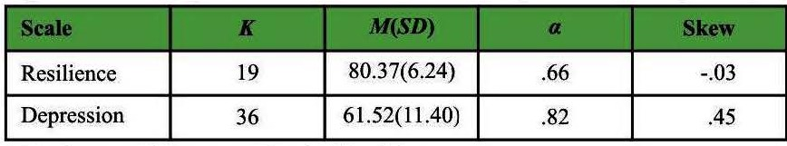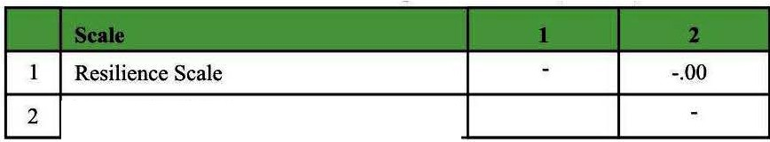

The item-total correlation analysis was administered on 19 items. In this analysis, the proportion of correlation of each item with total score was determined. The proportion of correlation of each item with the total score of the scale was determined. Table 4 shows that there is significant positive correlation (r ranging from .44 to .62, p

<.001) among items of Resilience Scale and total score. Results revealed that all of the items finalized for the original scale are valid and reliable indicators ofresilience as measured by RS.

##### Table 4

Psychometric Properties of the Resilience Scales (N= 540)

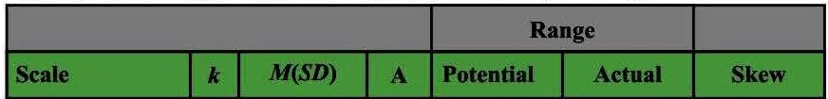

|  |  |  |  |  |  |  |
| --- | --- | --- | --- | --- | --- | --- |
|  | | | | | |  |
| **Resilience** | 19 | 76.46(10.3) | .84 | 1-5 | 2.0-5.0 | -.60 |
| **Emotional**  Regulation | 6 | 24.14(4.15) | .71 | 1-5 | 1.0-5.0 | -1.0 |
| **Adventurousness** | *5* | 19.12(3.80) | .66 | 1-5 | 1.0-5.0 | -.64 |
| **Detennination** | 4 | 16.72(2.51) | .62 | 1-5 | 1.5-5.0 | -.93 |
| Self-Reliance | 4 | 16.47(2.87) | .59 | 1-5 | 1.3-5.0 | -I.I |

*Note. k* = *no. of items. a* = *Cronbach's alpha.*

Table 4 shows mean, standard deviation, Cronbach's alpha value, range and skewness values. Allsub-scales have acceptable reliability.

##### Tables

Inter-correlation between Resilience Total and Its Sub-Scale (N= 540)



|  |  |  |  |  |  |
| --- | --- | --- | --- | --- | --- |
|  | | | | |  |
| **Resilience** |  | **.82\*\*** | **.77\*\*** | **.75\*\*** | **.73\*\*** |
| 2 **Emotional**  **Regulation** |  |  | **.44\*\*** | **.52\*\*** | **.47\*\*** |
| **Adventurousness** |  |  |  | **.45\*\*** | **.40\*\*** |
| 4 **Detennination** |  |  |  |  | **.47\*\*** |
| Self-Reliance |  |  |  |  |  |

*Note. **p<* .001.

In table 5, Pearson product moment correlation was carried out to find the relationship between the overall resilience scores and its sub-scales. Results indicated significant correlation between overall resilience and emotional regulation (r = .82, p< .001), adventurousness (r = .77, p< .001), determination **(r** = .75, p< .001), and self-reliance (r= .73, p< .001).It was also found that all sub-scales of resilience scale positively and significantly correlated with each other.

##### Table 6

Mean Inter-item and Item Total Correlations for Resilience Scale (N= 540)



|  |  |  |
| --- | --- | --- |
| **Emotional regulation** | .30** | **.45\*\*** |
| 2 **Adventurousness** | **.28\*\*** | **.41\*\*** |
| **Determination** | **.29\*\*** | **.41\*\*** |
| 4 Self-Reliance | **.27\*\*** | .37** |
| **Resilience total** | .22** | **.43\*\*** |

***Note.**p<0.01.***

Mean inter-item correlation is a direct method to determine internal consistency. It is computed as mean of inter-item correlations. For newly developed scales, acceptable range of mean inter-item

correlation is.15 to .5.Resultsgivenin Table 6 showed that computed values of mean inter-item correlations and mean item-total correlations fall in acceptable range.

##### CONFIRMATORY FACTOR ANALYSIS (N = 250)

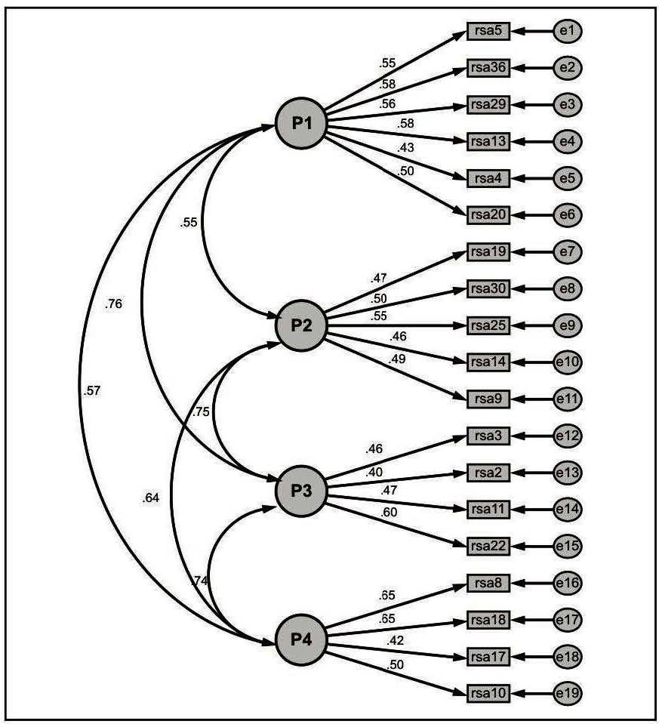

Figure 1.Standardized solution of CFA for Resilience Scale (N= 250)

Results indicated that CF!= .88, GFI = .91, RMSEA = .05 and x2 (2) = 237.93, p< .01 for the standardized model was acceptable. It was found that the structure in exploratory factor analysisisvalid.

##### DISCRIMINANT VALIDITY OF RESILIENCE SCALE

**Table** 7

Psychometric Properties of the Resilience and Depression Scale (N= 30)

***Note. k* = *no. of items. a* = *Cronbach's alpha***

Table 7 shows mean, standard deviation, Cronbach's alpha and skew values.Resilience and depression scaleshave acceptable reliability.

##### Table 8

Correlation between Resilience and Depression Scale (N = 30)

**Depression Scale**

***Note.p-ns.***

Pearson product moment correlation was carried out to find the discriminant validity for the resilience scale.It was found that there is no significant correlation between the overall resilience and depression scores (r= -.001, p = .ns).

## DISCUSSION



Resilience connotes emotional stamina and has been used to describe persons who display courage and adaptability in the wake of life's misfortunes!. Present study was conducted to develop a reliable and valid scale of resilience in Urdu language for adolescent and youngster population of Pakistan. Factor analysis has been considered as an imperative feature in development of scale as usually high alpha leads to diverse number of factors in a scale. Subject-to-item ratio of 10:1 is vital for an appropriate factor construction.Data for the recent study also meet the criteria of communality of every item is more than .5.In order to determine the empirical suitability of data, KMO and Bartlett's test ofSphericitywere also used. The Kaiser Meyer Olkin (KMO) value for the current data was .89 was excellent for structure detection. Hence, it was indicated that the patterns of correlation are condense and analysis would yielddistinctive and reliable factors38. Bartlett's test of Sphericity also revealed significant results (p < .001), that indicates the suitability of factor analysis for current data.Principle Component Analysis (PCA) companied by varimax rotation were applied to 36 items of Resilience Scale (RS) in order to generate a factor structure for the construct of resilience. Four factors were generated by factor analysis, which had eigenvalues exceeded'. Four factors yielded by factor analysis were selected on the basis of theoretical significance andeigenvaluesexceed value 1".

All four factors were identified by suitable number of items. The first factor seemed to associate with the dimension of "Emotional regulation", which explained 26.24% variance, whereas, second factor accounted for by 7.40% variance and the items indicated the dimension of"Advantageousnature".Third dimension was named as "Determination", showed a variance of 6.35%. The items loaded on the fourth factor were found to be associated with the dimension of "Self-Reliance", which explained 6.12% of total variance. These four factors of Resilience Scale (RS) collectively explained 46.2%of total variance.

The inter-correlation among all four subscales and the total score of Resilience Scale (RS) was also analyzed in order to ensure the suitability of factor structure of the scale. It had been indicated by results that all the four factors and the total score of Resilience Scale (RS) are significantly correlated (r range from .73 to .82, p< .001). Furthermore, there was also significant correlation between all four subscales. The results also indicated that correlation between the four factors of the Resilience Scale (RS) was relatively moderate {r range from .40 to .52, p< .001) in comparison with the high values of correlation coefficients which was indicated among the total score of the scale and its four factors. The results demonstrated that all four factorsarediverse and distinct aspectsof the construct of resilience.

Mean inter-item correlation is a method that measures internal consistency directly. Recently developed construct's cut off score for the interpretation for the mean inter-item correlation would be.15 to *S".* The mean inter-item correlation ranged from.22 to .30, p<.001. It was proposed by the results that the mean inter-item and the total correlationswere reasonable. Moreover remarkably, Resilience Scale (RS) is a significantly consistent and homogenous measure of resilience, as the value of Cronbach's alpha for recent scale was .84. The results of current study also indicated that mean score of RSwas

76.46 and the value of standard deviation was 10.29. Furthermore,

results of confirmatory factor analysis added to the acceptability of Resilience Scale as avalid measure of resilience.

By summarizing the results of the current study, it can be said that Resilience Scale {RS) is a multi-dimensional and internally reliable measure of Resilience of adolescents andyoungsters.

## LIMITATIONS AND SUGGESTIONS

Tough the resultsof current study show that Resilience Scaleisavalid and reliable scale to measure resilience, however, it was impossible to develop ascalewithout limitations.

As the objective of the study was to develop a scale of resilience for adolescent and youngster population, sample taken for the process of item generation was comprised of majority of the adolescents. However, it would be an encouraged step to test the psychometric properties of the same scale using diverse population. The convergent validity of the scale has not been determined. Computation of discriminate validity would be a beneficial step. It is also suggested to establish norms of Resilience Scale for further research.Resilience Scale can be used by other researchers in the future who want to develop another indigenous measure of resilience for assessing convergent anddiscriminant validity.

## CONCLUSION

The Resilience Scale is a useful measure for researchers who need an indigenous scale of resilience with adequate reliability and validity of the construct. Acceptable overall fit of model and good internal consistency suggest that overall RS isa soundand valuable measure.

## REFERENCES

1. Luthar 55, Cicchetti D. The construct of resilience: Implications for interventions and social policies. Development and Psychopathology.2000;(12):857-885.
2. Wagnild G, Young HM. Resilience among older women. Image: Journal of Nursing Scholarship. 1990; 22:252-255.
3. American Psychological Association. The road to resilience. 2004. APA press.
4. BlockJH, BlockJ.The roleof egocontrol andego-resiliency in the origination of behaviour" in W.A. Collings (ed.) The Minnesota Symposia on Child Psychology, Vol. 13 (Erlbaum, Hillsdale, NJ), 1980;pp.39-101.
5. Masten AS. Ordinary magic: Resilience processes in development.American Psychologists.2001;56:227-238.
6. Bonnano G. Loss, Trauma, and Human resilience. American Psychologist. 2004;59(1):20-28.
7. Masten AS, Best KM, Gramezy N. Resilience and development: Contributions from the study of children who overcome adversity. Development and Psychopathology. 1990; 2: 425- 444.
8. Rutter M. Psychosocial resilience and protective mechanisms.

American Journal ofOrthopsychiatry.1987;57:316-331.

1. Werner E, Smith R. Vulnerable but Invincible: A Longitudinal Study of Resilient Children and Youth. New York: Adams, Bannister, andCox.1982.
2. Werner EE, Smith RS. Overcoming the odds: High risk children from birth to adulthood. NewYork: Cornell University Press.



1992.

1. Luthar SS.Cushing G.Measurement issues in the empirical study of resilience: An overview. In M. D. Glantz., J. L. Johnson. Resilience and development: Positive life adaptations. Plenum; New York:1999. pp. 129-160.
2. Cicchetti D. Resilience under conditions of extreme stress: A multilevel perspective. World Psychiatry. 201O;9(3): 145-154.
3. Egeland B, Carlson E, Sroufe LA. Resilience as process.

Development and Psychopathology.1993;5(4):517-528.

1. Masten AS. Risk and resilience in development. In P. D. Zelazo (Ed.), Oxford handbook of developmental psychology. New York,NY:OxfordUniversity Press(in press). 2012.
2. Masten AS. Resilience in children threatened by extreme adversity: Frameworks for research, practice, and translational synergy. Development and Psychopathology. 2011; 23: 493-506.
3. Masten AS. Resilience in developing systems: Progress and promise as the fourth wave rises. Development and Psychopathology.2007;19:921-930.
4. Feder A, Nestler EJ, Charney DS. Psychobiology and molecular genetics of resilience. Nature Reviews Neuroscience. 2009; 10: 446-457.
5. Wyman PA. Emerging perspectives on context specificity of children's adaptation and resilience: Evidence from a decade of research with urban children in adversity. In S. S. Luthar (Ed.), Resilience and vulnerability: Adaptation in the context of childhood adversities (pp. 293-317). New York, NY: Cambridge University Press.2003.
6. Sroufe LA, Rutter M. The domain of developmental psychopathology.Child Development. 1984;55:17-29.
7. Charney D. Psychobiological mechanisms of resilience and vulnerability: implications for successful adaptation to extreme stress. American Journal of Psychiatry.2004; 161: 195-216.
8. Cicchetti D, Curtis WJ.The developing brain ad neural plasticity: Implications for normality, psychopathology, and resilience. In D.Cicchetti& D. Cohen (Eds.), Developmental psychopathology (Developmental neuroscience 2nd ed., Vol. 2, pp. 1-64). Hoboken, NJ:Wiley. 2006.
9. Cicchetti D. Resilience under conditions of extreme stress: A multilevel perspective. World Psychiatry. 201O;9(3):145-154.
10. Coie JD, Watt NF, West SG, HawkinsJD, Asarnow JR,Markman HJ, Ramey SL, Shure MB, Long B. The science of prevention: A conceptual framework and some directions for a national research program. American Psychologist. 1993;48:1013-1022.
11. Cowen EL, Durlak JA. Social policy and prevention in mental health. Development and Psychopathology.2000; 12:815-834.
12. Masten AS, Coatsworth JD.The development of competence in favorable and unfavorable environments: Lessons from successful children. American Psychologist. 1998;53:205-220.
13. Weissberg RP, Kumpfer KL. Special Issue: Prevention that works for children and youth. American Psychologist. 2003; 58: 425-490.
14. Yoshikawa H. Prevention as cumulative protection: Effects of early family support and education on chronic delinquency and itsrisks. Psychological Bulletin.1994;115: 28-54.
15. Gottlieb G. Probabilistic epigenetics. Developmental Science. 2007;10:1-11.
16. Charney D. Psychobiological mechanisms of resilience and vulnerability: implications for successful adaptation to extreme

stress. American Journal of Psychiatry.2004; 161:195-216.

1. Cicchetti D, Curtis WJ.The developing brain ad neural plasticity: Implications for normality, psychopathology, and resilience. In D.Cicchetti& D.Cohen (Eds.), Developmental psychopathology (Developmental neuroscience 2nd ed., Vol. 2, pp. 1-64). Hoboken,NJ:Wiley.2006.
2. Cicchetti D. An historical perspective on the discipline of developmental psychopathology. In J. Rolf, A. S. Masten, D. Cicchetti, K. H. Nuechterlein, & S. Weintraub (Eds.), Risk and protective factors in the development of psychopathology (pp. 2-28).New York,NY:Cambridge University Press. 1990.
3. Feder A, Nestler EJ, Charney DS. Psychobiology and molecular

genetics of resilience. Nature Reviews Neuroscience. 2009; 10: 446-457.

1. Ne i I J. What is res i Ii ence. Retrieved from (<http://wilderdom.com/psychology/resiIience/.)> 2006. Retrieved on 23June, 2014.
2. Fletcher D. Fletcher J. A meta-model of stress, emotions and performance: conceptual foundations, theoretical framework, and research directions. Journal of Sports Sciences. 2005; 23: 157-158.
3. Luthar 55,Cushing G.Measurement issues in theempirical study of resilience: An overview. In M. D. Glantz., J. L. Johnson. Resilience and development: Positive life adaptations. Plenum; NewYork:1999.pp.129-160.
4. Bagozzi RP. Assessing construct validity in personality research: Applications to measures of self-esteem. Journal of Research in Personality.1993;27:49-87.
5. Norris FH, Steven SP, Pfefferbaum B, Wyche KF, Pfefferbaum RL. Community resilience as a metaphor, theory, set of capacities, and strategy for disaster readiness. American Journal of Community Psychology.2008;41:127-150.
6. Afzal S, Rana TF, Mehmood S. Determinants of depression in female adolescents and youth. Professional Medical Journal. 2008;15(1): 137-142.
7. Kaiser HF. An index of factorial simplicity. Psychometrika. 1966; 39:31-36.
8. Nunnally JC, Bernstein IH. Psychometric theory. 3rded. New York:McGraw Hill.1994.
9. Field A. Discovering statistics using SPSS. London: Sage PublicationsLtd.2005.
10. Field A. Discovering statistics using SPSS. 3rd ed. London: Sage PublicationsLtd.2009.
11. Nunnally JC. psychometric theory. 2nded. New York: McGraw Hill.v.
12. Kaiser HF. An index of factorial simplicity. Psychometrika. 1974; 39:31-36.

|  |  |  |  |  |
| --- | --- | --- | --- | --- |
| **Sr.#** | **Author Name** | **Affiliation of Author** | **Contribution** | **Signature** |
| **1** | **Summaya Anwar** | Department of Psychology GCU, Lahore. | **Researchdesign, Planning, Report writing** &Proof reading | *1* |
| **2** | **lffat Balool** | Department of Psychology GCU, Lahore. | **Conceptionand Analysis**  of thestudy | '>II &4-t |
| **3** | **Ya. Sakina** | **National Agricultural**  ResearchCouncil (NARC) | Data Collection | *Ya* |
| **4** | **Shahrukh Tariq** | Department of Psychology GCU, Lahore. | **Statisticsanalysis**&  Interpretation | .5W11¥ |