**ORIGINAL ARTICLE**

**FREQUENCY OF INSOMNIA AMONGST MEDICAL STUDENTS AND ITS CORRELATION WITH DEMOGRAPHIC VARIABLES**

# DAULAT RAM', M. IQBAL AFRIDI', CHOONI LAL', MUHAMMAD ASHAR WAHEED KHAN4 FATIMA TAUFIQ',

**VIJIA KUMAR GEMNANl6**

' MBBS, Postgraduate Trainee Psychiatry, Department of Psychiatry and Behavioural Sciences JPMC/JSMU, Karachi 'FCPS, FRCP, Professor & HOD, Department of Psychiatry and Behavioural Sciences JPMC/JSMU, Karachi

' FCPS, Assistant Professor, Department of Psychiatry and Behavioural Sciences JPMC/JSMU, Karachi

' FCPS, Assistant Professor, Department of Psychiatry and Behavioural Sciences, Shalamar Medical and Dental College, Lahore ' FCPS, Department of Psychiatry and Behavioural Sciences, JPMC, Karachi

' Lecturer, Department of Community Medicine, Chandka Medical College/SMBBMU Larkana

Submitted: June 29, 2016

Accepted: December 01, 2016

**CORRESPONDENCE: DR. DAULAT RAM,** E-mail: [daulatramdr@yahoo.com](mailto:daulatramdr@yahoo.com)

# ABSTRACT



**OBJECTIVE**

To determine the frequency of insomnia amongst medical students and its correlation with different demographic variables.

# STUDY DESIGN

Descriptive Cross sectional study.

# PLACE AND DURATION OF STUDY

Department of Psychiatry & Behavioural Sciences, JPMC and Sindh Medical College Karachi.

# SUBJECTS AND METHODS

Medical students of first year to final year of> 18 years age and both genders were included after fulfilling the criteria. Ethical issues were addressed according to IRB of Institute. Students having history of known psychiatric disorder like schizophrenia and mood disorder were excluded. Data was collected on prescribed proforma. Frequency of insomnia was measured on validated "Athens Insomnia Scale". Results were analyzed on SPSS, version 16.0.

# RESULTS

Total 325 medical students, 65 from each of 5 batches were approached. Male students were 10.8% and female students were 89.2%. Ages of studentsranged from 17 years to 25 years. 90.8% belonged to middle Socio-economic class, 97.5% were unmarried. Of all, 109 (33.5%) students were insomniac. Higher age was more associated with insomnia. (p value=0.008).

# CONCLUSION

Insomnia is highly prevalent in medical studentsand should be focus of policies and strategies to minimize its deleterious effects by educating about good sleeping habits.

# KEYWORDS

Insomnia,Medical students, Sleep deprivation.

# INTRODUCTION

Insomnia is derived from the Latin word which means "No sleep" however medical definition includes difficulty in falling asleep, difficulty in staying asleep, waking up too early, poor quality (i.e non-restorative sleep) or problems maintaining sleep at least 3 nights per week for at least one month'. The affected person also complains of sleep related daytime impairment of work. Insomnia or sleeplessness put variety of negative effects on the physical, psychological,social health and economic status of humans'·'.

Every adult needs at least 7.5to 9 hours of sleep.There are many reasons of disturbed sleep pattern. Among them most common is use of stimulants like caffeine etc. Medical causes include hyperthyroidism, rheumatoid arthritis, hypoglycemia, urinary bladder disorders, prostate problems, sleep apnea and disruptive snoring problem',. Worldwide prevalence of insomnia ranges from 25 to 35%'. Prevalence of insomnia among population of Karachi was found to be 31.3%'.

Professional medical studies are the toughest and lengthiest among all fields of carrier. A medical student has to read a many subject textbooks, attend class lectures,practical classes and ward postings.Thus they needto have a fresh mind and healthy physique; the maintenance of which can be achieved withproper sleep.Insomnia during medical studies can therefore become a big hurdling factor in flourishing of a medical student as good doctor because insomniac students mostly remain absent from lectures and have poor academic records in their studies'·'. It may cause constant stress and anxiety and further insomnia'·". Thus lead them to use more stimulants like caffeine for sake of increased activity improving alertness use. It has been documented that if the caffeine is used over a prolonged period can result in dependence and on withdrawal may lead to different psychological disturbances including insomnia". A study from USA on undergraduate college students found that 70% of the sample was sleeping less than the recommended duration".The student who obtained sufficient sleep secured better results in exams than short sleepers&'.

Appropriate quantification of such issues in our setup will be helpful in making the policies and modifying the curricula of medical studies soas to increase the yield of one of expensive professional degree courses. Aim of the current study was to investigate the prevalence of insomnia among medical students of a public sector medical college in Karachi.

# SUBJECTS AND METHODS

### Participants

This descriptive cross sectional study was conducted at the Department of Psychiatry and Behavoiural Sciences, JPMC Karachi and its allied teaching institute (i-e; Sindh Medical College, Karachi). Total 325 volunteer medical studentsabove 18 years of age,enrolled in first year to final year MBBS (65 from each batch) were approached conveniently. Students having history of known psychiatric disorder like schizophrenia and mood disorder were excluded.

### Instruments

Demographic data including age, gender, socioeconomic status, marital status were recorded. Diagnosis of insomnia was made according to International classification of Diseases (ICD-10) criteria. Frequency of insomnia was measured on validated"AthensInsomnia Scale". Score on each item of "Athens Insomnia scale" was added to get one summary measure (possible score Oto 24).Those who score 6 or morethan6wereconsidered asInsomniacs and vice versa.

### Procedure

Ethical committee approval was obtained from the institute. After ensuring them of confidentialitythe consenting studentswere asked to answer the structured questionnaire. The data was analyzed on SPSS version 16.0. Mean with standard deviation was calculated for continuous variables such as age (in years). Frequency with percentage was calculated for categorical outcome variables. Stratification was done to control for year of medical education and modifiers such as gender, marital status and socioeconomic status. percent ages and Students't-test were applied to variables taking p value< 0.05 as significant.

# RESULTS

Total 325 medical students, 65 from each of 5 batches (First Year through Final Year) of Sindh Medical College, Karachi participated in the study and filled the questionnaire.(See figure 1).Ages of students

ranged from 17 years to 25 years. Mean age+ SD of medical students was 20.55 ± 1.67 years. Mean insomnia score+ SD was 4.90 + 3.51.

Maximum insomnia score was 17. Table 1 showed gender-wise distribution of medical students in their batch years. Frequency of sampled population in age categories gradually increased from 17 years, reached its peak till theage of 20 years and then decreased at age of 25 years (Table 2). Most of sampled population (90.8%) belonged to middle Socio-economic class assessed on basis of subjective report of the participants (Table 2). On evaluation of Athens insomnia scale scores, it was found that out of total 325 medical students,109(33.5%) had insomnia(Table 3 andFigure 2).

**Table 1**

Medical students gender wise distribution of the year of education



|  |  |  |  |  |  |  |
| --- | --- | --- | --- | --- | --- | --- |
| Male | 7  (10.8%) | JO (15.4%) | 7  (10.8%) | (7.7%) | 6  (9.2%) | 35  (10.8%) |
| Female | 58  (89.2%) | 55  (84.6%) | 58  (89.2%) | 60  (92.3%) | 59  (90.8%) | 290  (89.2%) |
| Total | 65 | 65 | 65 | 65 | 65 | 325 |

**Table 2**

General characteristics of all medical students(n=325)

|  |  |  |
| --- | --- | --- |
| **17 years** |  | 0.3 |
| **18 years** | 42 | 12.9 |
| **19 years** | 53 | 16.3 |
| **20 years** | 67 | 20.6 |
| **21 years** | 60 | 18.5 |
| **22 years** | 60 | 18.5 |
| **23 years** | 34 | J0.5 |
| **24 years** |  | 0.9 |
| **2S years** |  | 1.5 |
| **Total** | 325 | JOO |

**Age**

**Flow Chart of the sample**

**Total Medical Stad.uapp-.elled** • 325

**Medical Students consented and responded the quesdonnalre= 325**

**Male Students= 3S (10.8%)** I **Female Students= 290 (89.2%**

**Marital status**

**Single** 317 97.5

**Married** 1.5

**Engaged** 0.6

**Separated** 0.3

**Total 32S 100**

**Table 3**

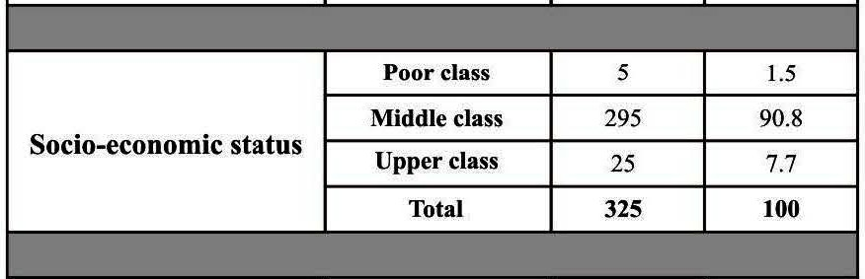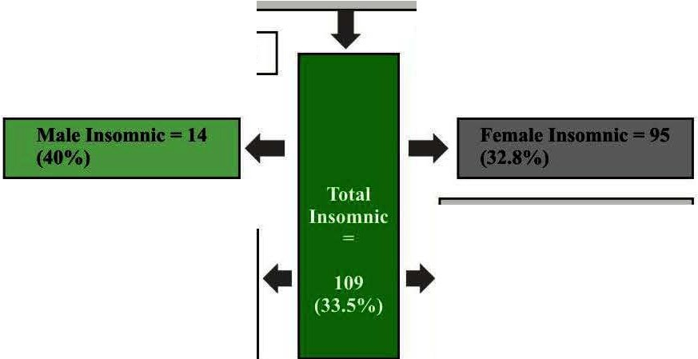

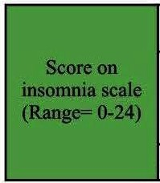Difference between student with normal sleep and insomnia on student sample t test

**Poor Class** • I **(20%) Middle Class -'J7 (32.9%) Upper Class** • **11 (44.4%)**

**Single= 105 (33.Uo/o)**

**Married** • **3 (60%)**

**Engaged** • **0 (00%)**

**Separated•** I **(100%)**

|  |  |  |  |  |
| --- | --- | --- | --- | --- |
|  | | | | |
|  | df | Sig. (2-tailed) | Mean Difference | **95% Confidence Interval**  of the Difference |
| **Lower Upper** |
| 25.135 | 324 | .000 | 4.895 | 4.51 5.28 |

**Figure 2.**



Insomnia among medical students

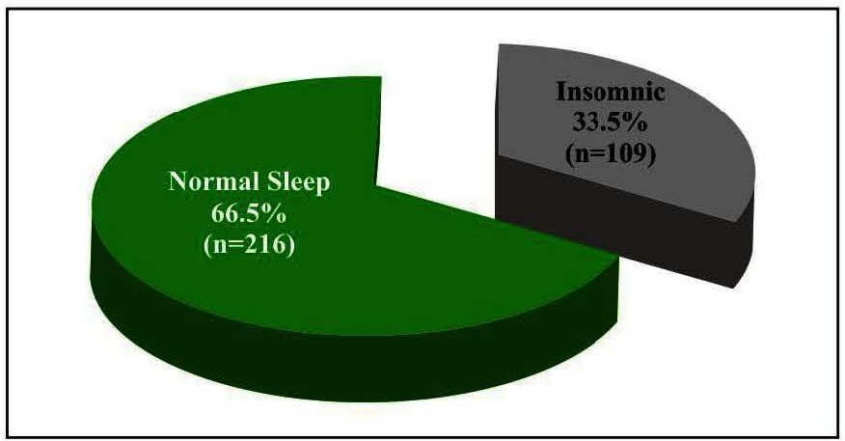

## DISCUSSION

The current study has assessed the medical students (MBBS) of a college in Karachi and found that about one third (33.5%) of sample was affected with insomnia. Findings of our study are comparable with contemporary studies. A study from Brazil reported that prevalence of insomnia among medical students was 28.15%1 . A study from Iran found that at least 42% medical students/ interns were affected of insomnia1 . Other studies have estimated that prevalence of sleep disorders may be as high as 68.1%16. Waqas and

colleagues reported that in Lahore 77% medical students were insomniac due to high stress level with mean ± SD, PSS-14 score of 30 ± 6.979.The mean ± SD score of insomnia noted by a study from Iran was 7.0 ± 2.317 which is higher than our study participants (4.90

± 3.51). Though medical students in Pakistan face very high

incidence of insomnia during their education, but we think that this difference between studies is due to region, lifestyle of students and overall difference of institutes.

Mean age of students reported by current study was 20.55 ± 1.67 years which coincides with those of contemporary studies9,13,16-18.

Regarding medical students in our study, we noted that there was increase in the frequency of insomnia asage was increased.This may be due to promotion of study year, increase in number of different subjects and clinicalpostingsetc;whichincreasethe work burden on the students. In simulation are the findings of other studies 9,13,14- 18 . These studies documented that insomnia among medical students increased with increasing age. However; a local study predicted that among general population, gender, age, income or occupational status were not significantly found to be associated withinsomnia and married person tended to enjoy better sleep.3

## LIMITATIONS

The current study is limited by the fact that it was conducted only in single public sector medical college. Second; we had not investigated much about medical/ psychological comorbid in this study which could also give a different picture. The results of this study therefore; cannot be inferred to the entire population of students pursuing for a degree, yet this study provides an insight to the health indicatoroffuturehealthprofessionals.

## CONCLUSION AND RECOMMENDATIONS

The current study had noted that future healers of nation are themselves at risk of developing ill health which may lead to poor

performance resulting in poor outcome and suffering of their patients. How can unhealthy doctors provide health to their patients?Insomnia is affecting every thirdmedical student. Insomnia can devastate their health on one side and the learning and delivering abilities on the other. With this there arises a need to change and modify the medical curriculum as well as the teaching techniques, learning facilities. Simultaneously courses and lectures on improving sleep habitsof medical students isthe need of hour.

## REFERENCES

1. Atkinson G, Davenne D. Relationships between sleep, physical activity and human health.PhysiolBehav.2007;90(2-3):229-35.
2. Drake CL,RoehrsT,RothT.Insomnia causes, consequences, and therapeutics:anoverview.Depress Anxiety.2003;18(4):163-76.
3. Gonzalez DM, Obermeyer WH,.BencaRM.Comorbidity of insomnia with medical and Psychiatric disorders.Primary Psychiatry.2002;9(8):37-49.
4. Kripke DF. Hypnotics cause insomnia: evidence from clinical trials.Sleep Med.2014 Sep;l 5(9):1168-9.
5. LeBlanc M,MeretteC,SavardJ,lversH,Baillargeon L, Morin CM. Incidence and risk factors of insomnia in a population based sample.Sleep.2009;32(8):1027-37.
6. Kidwai R, Ahmed SH. Prevalence of insomnia and use of sleep medicines in urban communities of Karachi, Pakistan.JPMA. 2013;63:1358-63.
7. Kelly WE, Kelley KE, Clanton RC.The relationship between sleep

length and grade-point average among college students. Coll Stud J.2001;35(1):84-6.

1. Eliasson AH, Lettieri CJ, Eliasson AH. Early to bed, early to rise! Sleep habits and academic performance in college students. Sleep Breath.2010;14(1):71-5.
2. Shah M, Hasan S, Malik S, Sreeramareddy CT. Perceived stress, sources and severity of stress among medical undergraduatesin a Pakistani medical school.BMC MedEdu.2010;10:2.
3. Waqas A, Khan S, Sharif W, Khalid U, Ali A. Association of academic stress with sleeping difficulties in medical students of a Pakistani medical school: a cross sectionalsurvey. Peer J.2015 Mar 12;3:e840.
4. Lemma S, Gelaye B, Berhane Y, Worku A, Williams MA. Sleep quality and its psychological correlates among university students in Ethiopia: a cross-sectional study. BMC Psychiatry. 2012Dec28;12:237.
5. . Lee K-H, Human GP,FourieJJ, LouwWAN,Larson CO,JoubertG.

Medical students' use of caffeine for 'academic purposes' and their knowledge of its benefits, side-effects and withdrawal symptoms. SA FamPract.2009;51(4):322-7.

1. LundHG, Reider BD,Whiting AB, Prichard JR.Sleep patterns and predictors of disturbed sleep in a large population of college students.J Adolesc Health.2010;46(2):124-32.
2. Loayza H MP1, Ponte TS, Carvalho CG, Pedrotti MR, Nunes PV, Souza CM, et al. Association between mental health screening by self-report questionnaire and insomnia in medical students. ArqNeuropsiquiatr.2001 Jun;59(2-A):180-5.
3. Mirghani HO, Ahmed MA, Elabadawi AS. Daytime sleepiness and chronic sleep deprivation effects on academic performance among the Sudanese medical students. JTaibaUni Med Sci. Dec 2015;10(4):467-70.
4. Eller T, Aluoja A, Vasar *V,* Veldi M. Symptoms of anxiety and depression in Estonian medical students with sleep problems.

Depress Anxiety.2006;23(4):250-6.



1. Nojomi M, GhalheBandi MF, Kaffashi S. Sleep pattern in medical students and residents.Arch IranMed. 2009 Nov;l 2(6):542-9.
2. Kazim M, Abrar A. Sleep patterns and academic performance in students of a medical college in Pakistan. KUST Med J. 2011;3(2):57-60.

|  |  |  |  |  |
| --- | --- | --- | --- | --- |
| **Sr.#** | **Author Name** | **Affiliation of Author** | **Contribution** | **Signature** |
| 1 | **Dr. Daulat Ram** | JPMC, Karachi | **Researchideaand manuscript writing** |  |
| **2** | **Prof M. Iqbal Afridi** | JPMC, Karachi | **Supervisionof study** |  |
| **3** | **Dr. Choonl Lal** | JPMC, Karachi | **Literaturereview, discussionwrtting and** editing |  |
| **4** | **Dr. M. Ashar Waheed Khan** | SMDC, Karachi | **Analysisof resultsand referencesin lightlatest research** | M� |
| **5** | **Dr. Fatima Tauflque** | JPMC, Karachi | Matenalizing the study | *w* |
| **6** | **Vijai Kumar**  **Gemnani** | SMBBMU, Larl<ana | Matenalizing the study | - |

*APRIL -JUNE* 2017 I *VOLUME 14 NUMBER 2 PAGE29*